VAssistX 安装及在VS2010中使用

有时候，我们要编码实现某个功能，或许如行云流水一气呵成，但就是懒得给这代码添注释。过短时间，等需要改动的时候，那种费力耗时的再去重新理解的过程就不用描述了吧。所以说，规范的代码注释对于开发者来说意义重大，然而，阻碍我们写代码注释的一大原因就是太麻烦、无规范。

这时，我们的主角+好助手——VAssistX出现了。在这里介绍一下VAssistX安装及在VS中的使用。

在VS中使用VAssistX会大大的提高你的工作效率，可以为你快速便捷的添加统一规范的注释。无论怎样，你用或不用，它就是那里，一动不动。下面进入正题：

VAssistX百度云盘下载地址：<http://pan.baidu.com/s/1qXI4UPe>

1. 安装VAssistX，安装时关闭正在运行的VS。

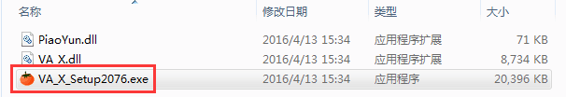

1. 选择你安装的VS版本

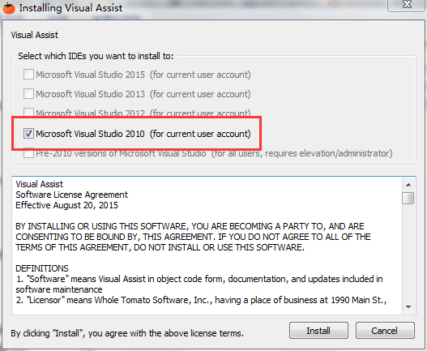

1. 安装完成后，打开VS2010，菜单栏中会出现VAssistX菜单项，说明安装成功。

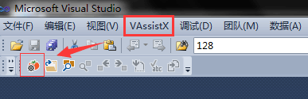

1. 打开VAssistX选项，自定义注释，话不多说，直接上图。

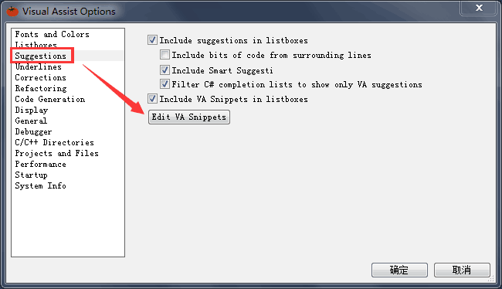

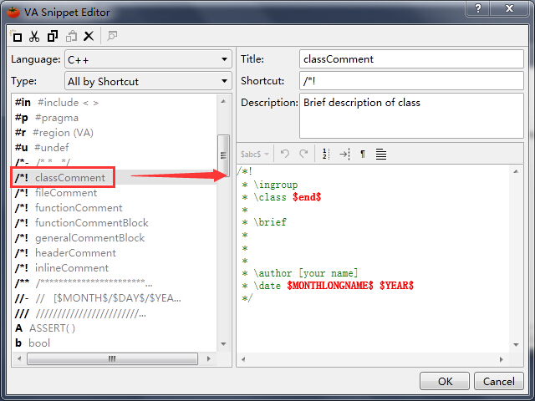

$YEAR$, $DATE$ $HOUR$: $MINUTE$: $SECOND$等从字面就能猜到就是当前的时间， 除此之外，VA中还有很多宏提供使用。

1. 在代码编写中，输入快捷键，会自动弹出我们定义的注释规范，选择需要的，看效果。

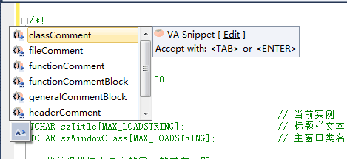

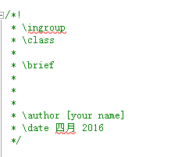

这个时候class头注释是不是已经出来了，很方便吧。

1. VAssistX规范注释示例 （参考：<https://github.com/gaohr/SEIMS/blob/master/doc/Developers.md>）

最基本的注释，对任何对象（file，function，class…）均适用，使用格式如下

//! Brief description, can span only 1 line

/*!

* More detailed description.

* Feel free to span as many lines

* as you wish... All allowed.

*/

在VA中设置如下（Title，Description可以按照自己想法设置，下面均不再重复）：

Title: generalCommentBlock

Shortcut: /*!

Descrition: General Doxygen Commen Block

Code:

//! $end$

/*!

* \ingroup

*

*/

对于一些变量或函数的定义，希望在一行内对其注释，使用格式如下：

void function1(); //!< Correct

void function2(int i); //!< WRONG! Comment on parameter i, but function not documented!

//! Some other function.

void function3(int i); //!< Some int. Correct - both function and parameter documented

上面的例子说明，对于含有参数的函数定义，不能用in-line comment的方式。VA中的设置如下：

//!<

在*.h, *.cpp文件头部的注释,使用格式：

/*!

* \file [filename]

* \brief

*

*

* \author [your name]

* \date

*

* [your comment here]

*/

在VA中设置：

/*!

* \ingroup

* \file $FILE_BASE$.$FILE_EXT$

* \brief

*

*

* \author [your name]

* \version

* \date $MONTHLONGNAME$ $YEAR$

*

* $end$

*/

类定义的注释

/*!

* \ingroup <group label>

* \class [class name]

*

* \brief [brief description]

*

* [detailed description]

*

* \author [your name]

* \date

*/

VA中的设置：

/*!

* \ingroup

* \class $end$

*

* \brief

*

* \author [your name]

* \date $MONTHLONGNAME$ $YEAR$

*/

函数注释块

/*!

* \ingroup <group label>

* \brief [brief description]

*

* [detailed description]

*

* \param[in] [name of input parameter] [its description]

* \param[out] [name of output parameter] [its description]

* \return [information about return value]

* \sa [see also section]

* \note [any note about the function you might have]

* \warning [any warning if necessary]

*/

VA中设置：

/*!

* \ingroup

* \brief

*

* $end$

*

* \param[in]

* \param[out]

* \return

* \sa

* \note

* \warning

*/

其他一些有用的标签

\attention … paragraph where a message that needs attention may be entered

\author … paragraph where one or more author names may be entered

\brief … paragraph that serves as a brief description

\bug … paragraph where one or more bugs may be reported

\date … paragraph where one or more dates may be entered

\deprecated … paragraph indicating that this documentation block belongs to a deprecated entity

\exception <exception-object> or \throw <exception-object> … exception description for an exception object with name <exception-object>, followed by a description of the exception

\invariant … paragraph where the invariant of an entity can be described

\note … paragraph where a note can be entered

\par [(paragraph title)] … if a paragraph title is given this command starts a paragraph with a user defined heading

\param <parameter-name> … parameter description for a function parameter with name <parameter-name>; multiple adjacent \param commands will be joined into a single paragraph; direction of the attribute may be specified:

e.g.

\param[in] param1 Description

\param[out] param1 Description

\param[in,out] param1 Description

\remarks … paragraph where one or more remarks may be entered

\return … return value description for a function

\retval <return value> … return value description for a function with name <return value>

\sa or \see … paragraph where one or more cross-references to classes, functions, methods, variables, files or URL may be specified; two names joined by either :: or # are understood as referring to a class and one of its members; one of several overloaded methods or constructors may be selected by including a parenthesized list of argument types after the method name

\since … used to specify since when (version or time) an entity is available

\test … paragraph where a test case can be described

\todo … paragraph where a TODO item is described

\version … paragraph where one or more version strings may be entered

\warning … paragraph where one or more warning messages may be entered

就说这么多!