VINAYAK GAONKAR

soware Engineer

Phone: +91 8722682638

Email: vinayak.gaonkar@mobinius.com

Linkedin prole: www.linkedin.com/in/vinayak-gaonkar-9725a214a

Address: No.23 3rd oor, nagabhairava 1st main 7th cross, ittamadu layout BSK 3rd stage

SKILLS ( TECHNOLOGY /

SHORT SUMMARY / INTRODUCTION

FUNCTIONAL )

Enthusiastic professional with around 2+ years of experience in software

engineering and application development. Eective worker and mentor and

committed to leading exceptionally gifted teams. Ready to work closely with both

teams and customers to identify most e cient and benecial solutions for

process improvement.

Javascript

Node.js

MongoDB

Angular 6+

Python

EDUCATION

Bachelor of Engineering in Computer Science Maharaja Institute of

Technology | 67

SQL

Aug 2014 - Jun 2018

LANGUAGES

INTERESTS

PROFESSIONAL ENHANCEMENTS

English, Hindi

Certications

MongoDB Aggregation Framework

Data Analysis with Python by cognitiveclass.ai

Python for data science

Machine learning, Algorithms

MORE INFORMATION

Website: https://www.vinayakg.xyz

EXPERIENCE / INTERNSHIP

Software Developer Intern Mobinius Technologies

Jan 2018 – Feb 2018

Introduced to various technologies, including Javascript,HTML5/CSS to develop

website

Learnt Basics of creating API's

Developed and implemented online Bus Booking using SQL Server

Software Engineer Mobinius Technologies

Jul 2018 Present

Maintained CAWI.AI which provides chatbot service, ensuring proper

functioning for each client

Used programming capabilities in JavaScript,MongoDB and Angular6 and other

libraries as needed

Communicated with customers to request information and ensure completion

of work

Managed escalated customer orders to meet aggressive deadlines and special

orders

Kept abreast of emerging technologies, software and trends and project

applications

Hands-on experience using UNIX and NGNIX web servers

Hands-on experience deployment using GCP,HEROKU

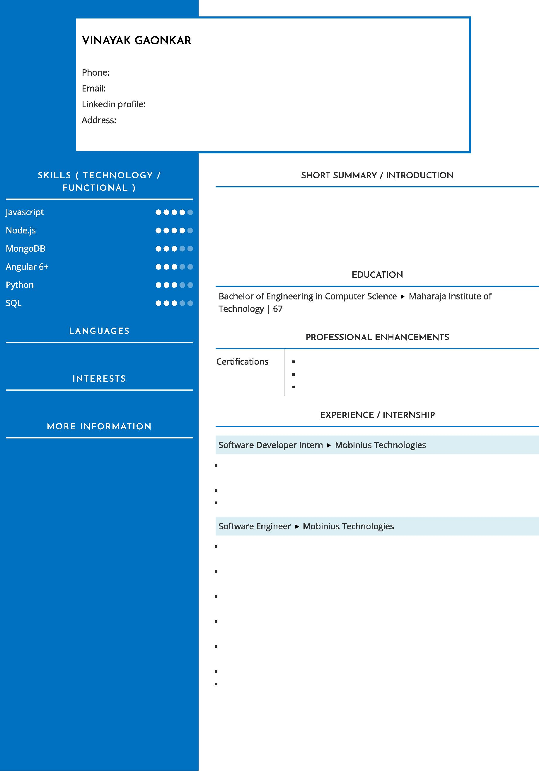

PROJECTS

CAWI.AI

Jan 2019 - Oct 2019

https://cawi.ai

Chat Bot providing service based on the specic customer requirements.

Worked as Backend developer used Node.js for REST API and Socket.io for web

sockets.

Used Angular 6 framework for frontend.

Developed customer specic requirements and maintain existing features.

Responsible for deployments and end to end delivery.

MAESTRO

Dec 2019 - Mar 2020

IoT based project, live devices health to be shown in the application.

Worked as a backend engineer, with limited team members.

Technologies used are Node.js, GCP, IoT-Core, pub/sub, cloud functions, Big-

Query.

Responsible for requirements gathering and deployments.

Trephoria

Mar 2020 - Present

Web app which is helpful for musicians and artists.

Working as backend developer.

Using Node.js and MongoDB.

