DATA STRUCTURES AND ITS APPLICATIONS

UE22CS252A

3rd Semester, Academic Year 2023

MINI PROJECT

LIBRARY MANAGEMENT SYSTEM

**Team Members:**

**Aarav Raj - PES2UG22CS007**

**Aathil Nishad - PES2UG22CS011 Abhishek R Rathod - PES2UG22CS020**

**Akash G Gaonkar - PES2UG22CS043**

**PROJECT CODE:-**

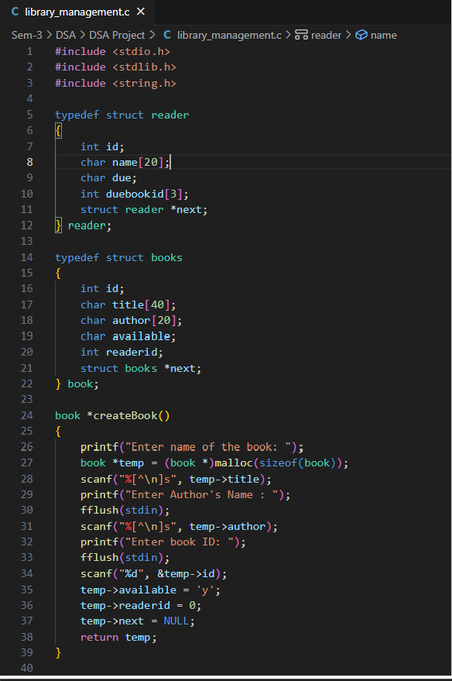

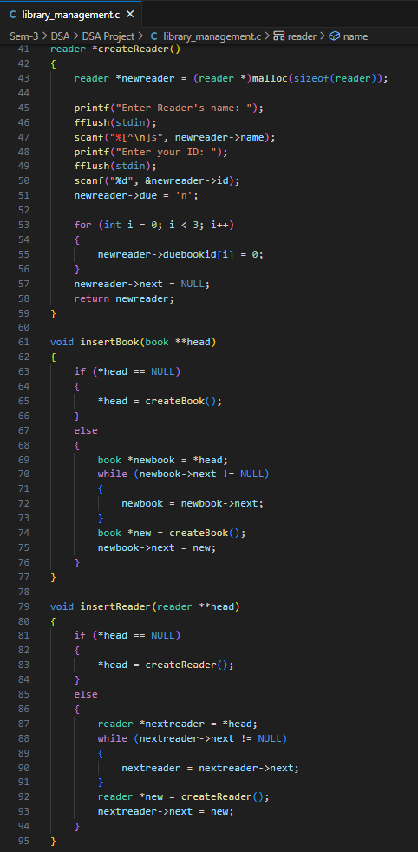

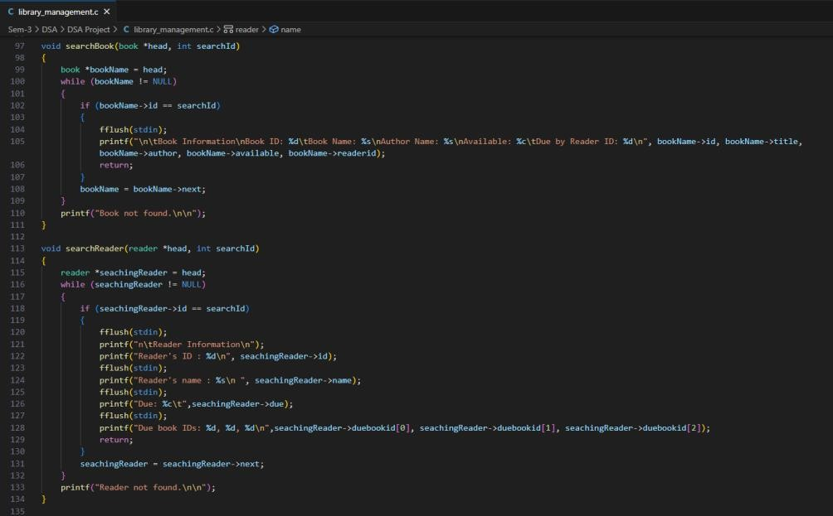

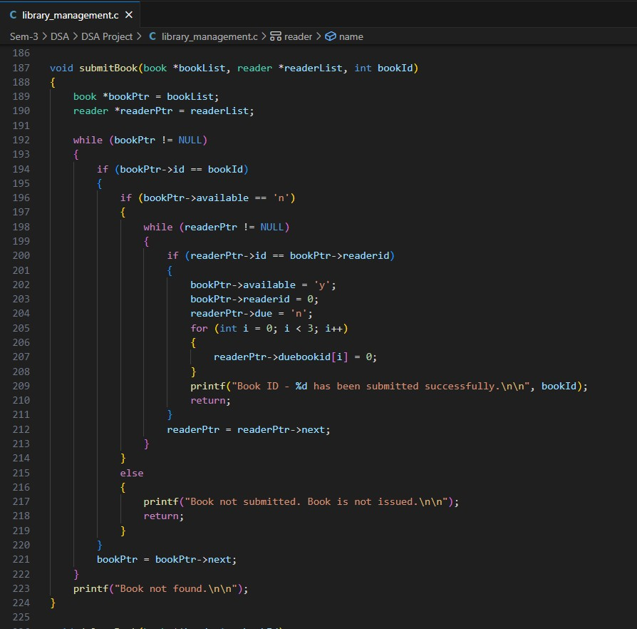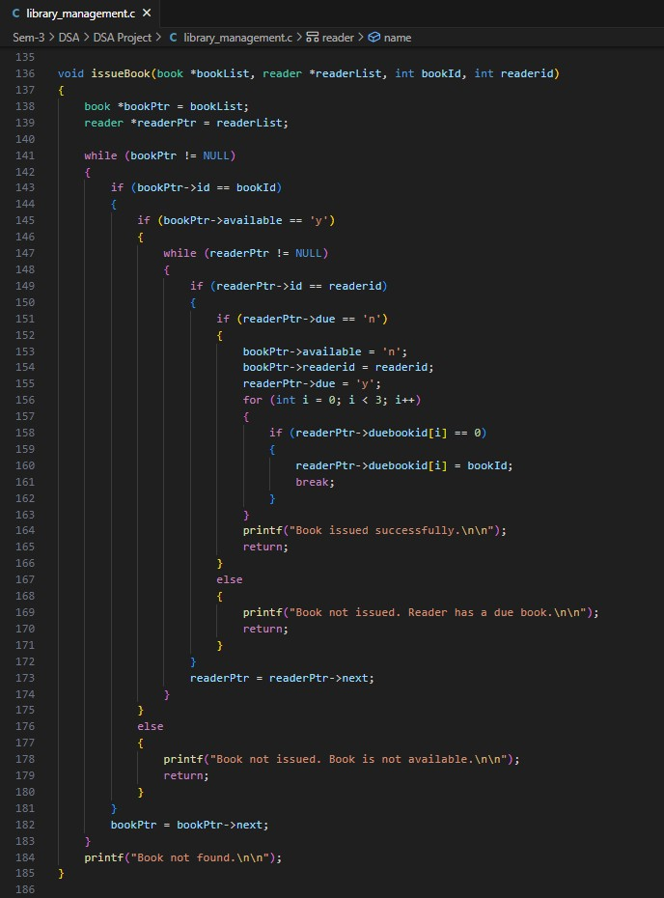

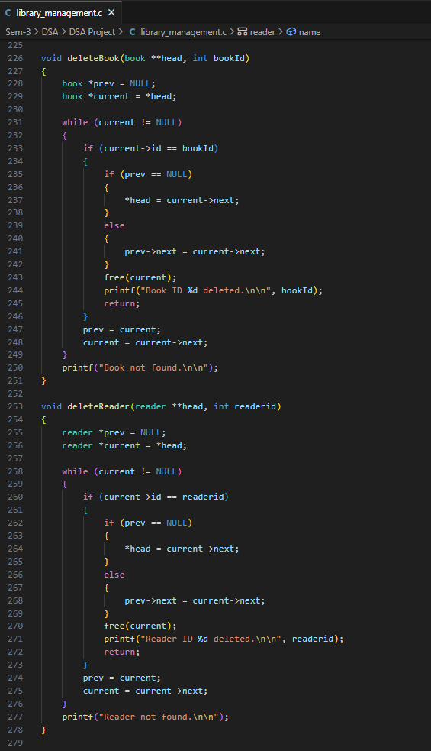

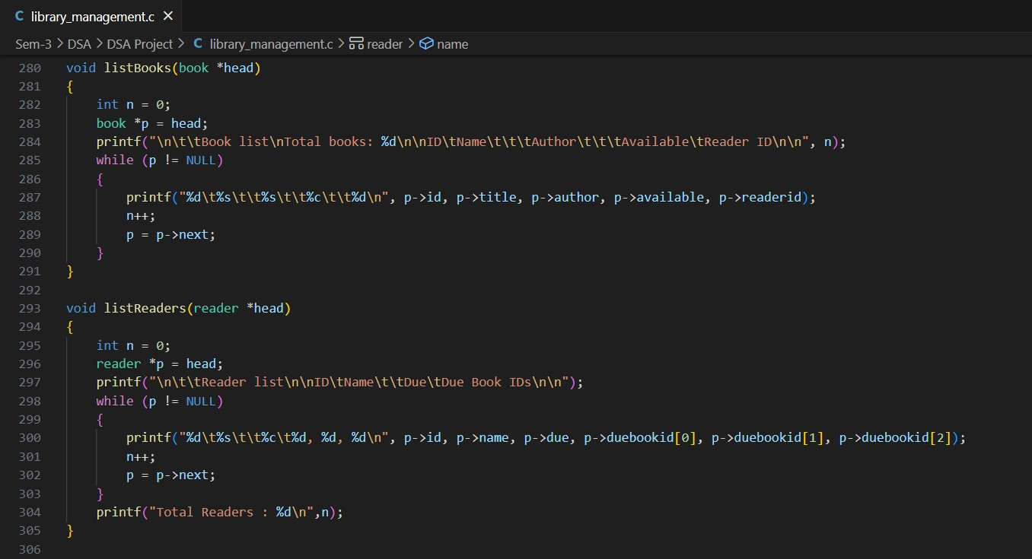

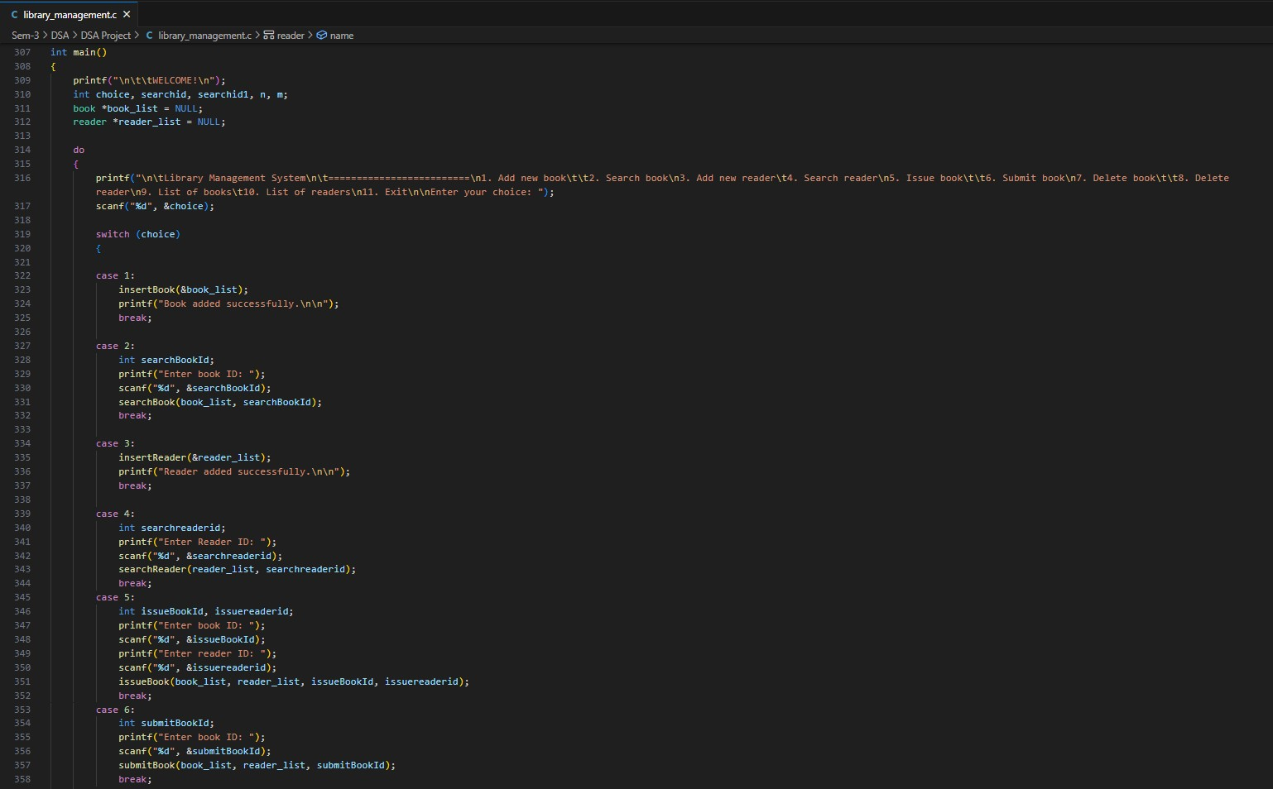

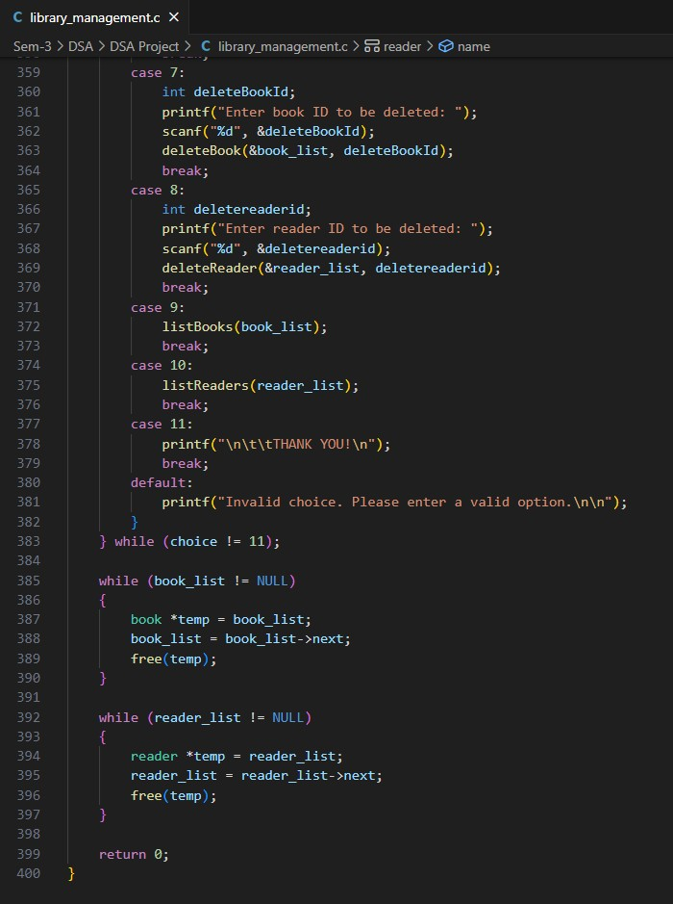

OUTPUT :-

Working of the Switch case :

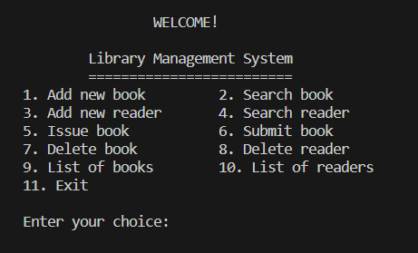

Insertbook function (Add new book) :

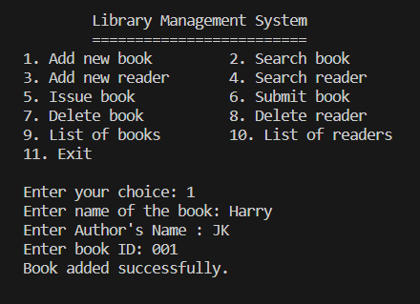

Searchbook function:

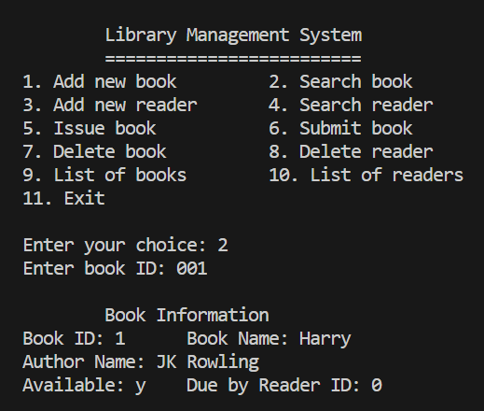

Insertreader function (Add new reader):

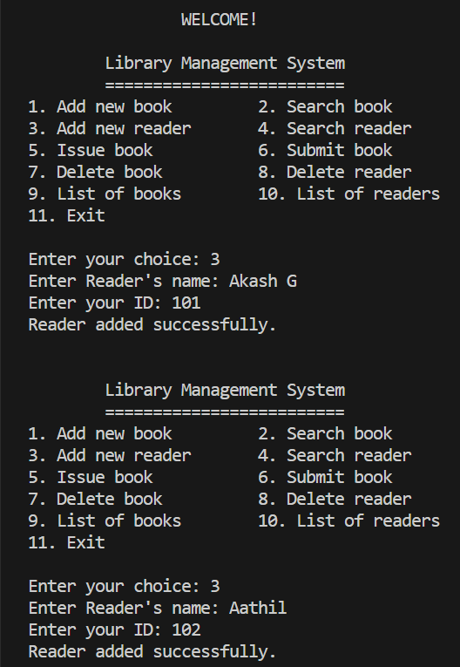

Searchreader function:

* **When valid readerId is entered:**

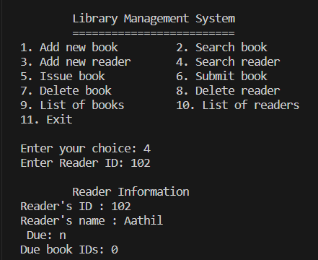

* 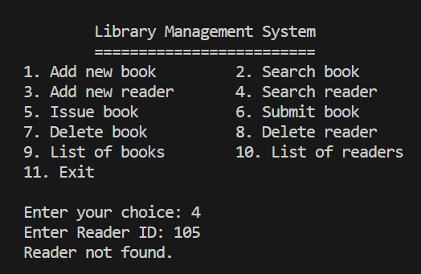**When INVALID readerId is entered:**

Issuebook function :

* 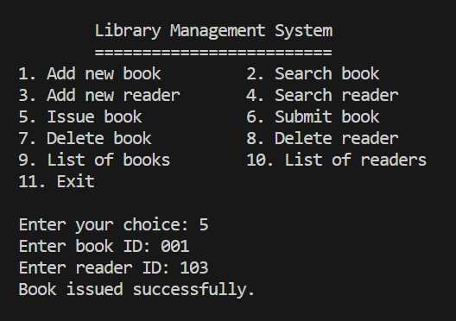**When a new book is issued:**
* 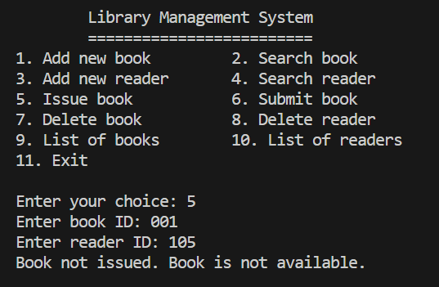**When an already issued book is tried to issue again :**

Submitbook function :-

* **When an issued book is been submitted :**

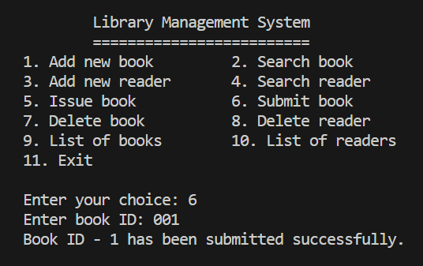

* **When a book which is not issued/added to library is been submitted:**

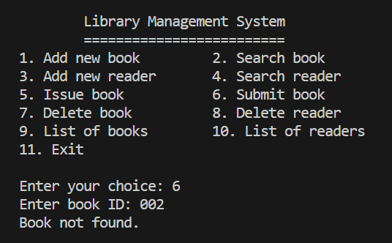

Deletebook function :-

* **When a book which exist in library is deleted :**

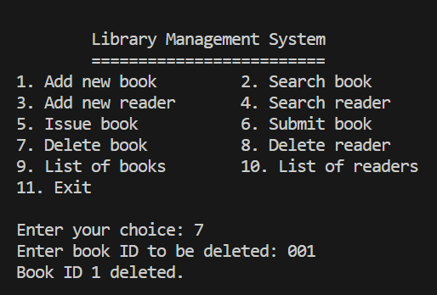

* **When a book which does NOT exist in library is tried to delete :**

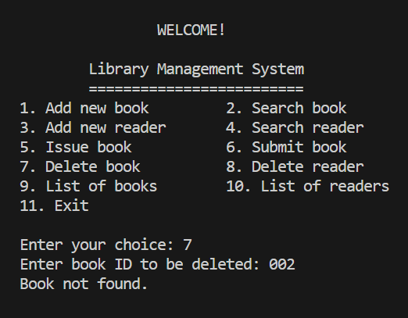

Deletereader function :-

* **When a reader’s data is deleted :**

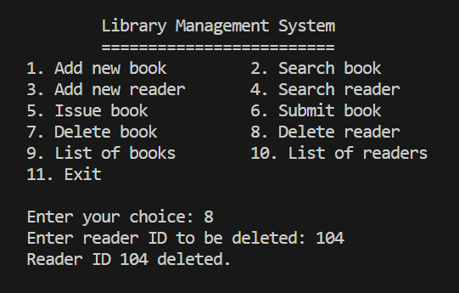

* **When trying to delete the reader’s data which does NOT exist :**

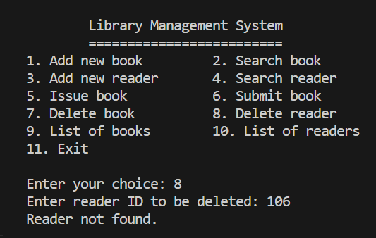

Listbooks function (List of Books) :-

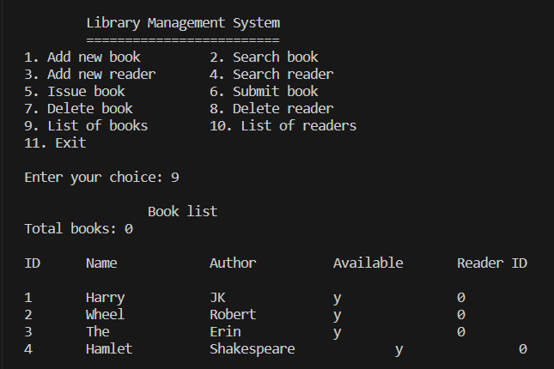

Listreaders function (List of Readers) :-

