Bioaerosol Infection Risk Assessment Report
  - Automatically generated by the airqmra R package
2026-05-23

1. Executive Summary
This report is prepared in accordance with Chapter 6 “Infection Risk Assessment of Bioaerosols in the Atmospheric Environment” of the Technical Guideline for Health Risk Assessment of Bioaerosols in the Atmospheric Environment (T/CSES XXXX-XXXX). It quantitatively evaluates the infection risk posed by specific infectious pathogens under defined exposure scenarios.
- Target pathogen: legionella pneumophila
- Exposed population: Adult
- Microenvironment: Outdoor, Season: Annual
- Simulation method: One‑dimensional Monte Carlo (variability only)
- Assessment tool: airqmra R package (version 0.0.0.9000)

2. Data Sources
- Exposure concentration: Obtained from field sampling and laboratory analysis.
- Dose‑response parameters: Sourced from the built‑in pathogen database (pathogen_db) of airqmra, with original references provided in Appendix A.
- Exposure factors: Primarily derived from the Chinese Exposure Factors Handbook.

3. Assessment Methods

3.1 Hazard Identification
legionella pneumophila has been identified as a typical infectious pathogen. The primary route of exposure is inhalation, which can lead to infection in exposed populations.

3.2 Dose‑Response Assessment
The dose‑response relationship is quantified using the exponential model.
$$P=1−exp\left(−k⋅d\right)$$
Parameter k = 4.99e-05

3.3 Exposure Assessment
The inhaled dose is calculated as:
$$d=C×IR×T×f_{\text{survival}}×f_{\text{deposition}}$$
## **Inhalation rate (IR)**: Automatically loaded for the `r scen$exposure_group` group (long‑term breathing rate, m³/h), using a log‑normal distribution.
## **Exposure time (T)**: Obtained from the time‑activity database based on microenvironment and season.
## **Survival fraction (f_survival)**: Empirical log‑normal distribution (μ = -1.322, σ = 0.427).
## **Deposition fraction (f_deposition)**: Pulmonary deposition for `r dep_pop` population, log‑normally distributed.

3.4 Risk Characterization
- Single‑exposure infection risk: Directly computed from the dose‑response model.
- Annual infection risk:
$$P_{\text{annual}}=1−{\left(1−P_{i}\right)}^{n}$$
- where n is the number of exposure events per year.
- Uncertainty analysis: Monte Carlo simulation combined with multiple sensitivity analysis methods.

4. Results

4.1 Single‑Exposure Infection Risk
## **Summary statistics**
## Min. 1st Qu. Median Mean 3rd Qu.
## 6.173e-06 1.154e-04 2.304e-04 3.860e-04 4.538e-04
## Max.
## 1.300e-02
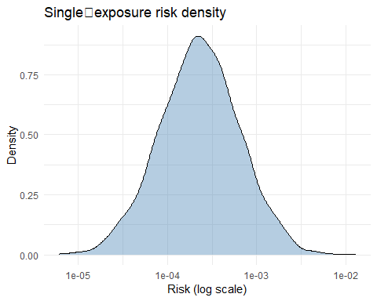

4.2 Annual Infection Risk
## **Summary statistics**
## Min. 1st Qu. Median Mean 3rd Qu.
## 0.0001235 0.0023047 0.0045975 0.0076412 0.0090366
## Max.
## 0.2302102
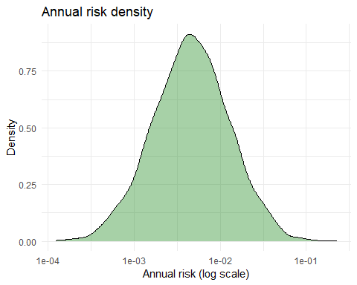

5. Sensitivity Analysis

5.1 Spearman Rank Correlation
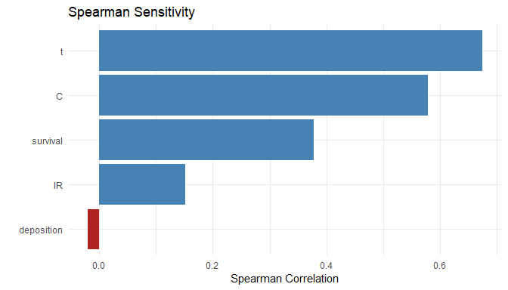

5.2 PRCC (Partial Rank Correlation Coefficient)
## PRCC analysis not provided.

5.3 Morris Elementary Effects
## Morris analysis not provided.

5.4 Sobol’ Variance Decomposition
## Sobol' analysis not provided.

6. Uncertainty Analysis

6.1 Propagation of Parameter Uncertainty
## 2D simulation results not provided.

7. Conclusions and Recommendations
For the scenario where Adult individuals are exposed to legionella pneumophila in a Outdoor environment: - The median single‑exposure infection risk is approximately 2.3^{-4}. - The median annual infection risk is approximately 0.0046. The annual risk median exceeds the commonly acceptable benchmark (≤10⁻⁴), indicating a potential health concern. Control measures are recommended.

8. Appendices
- Appendix 1: Summary of main exposure and dose‑response parameters.
- Appendix 2: Detailed sensitivity analysis charts.

End of Report

