Shijie Gao, USC ID:6037-6293-25

2023-02-03

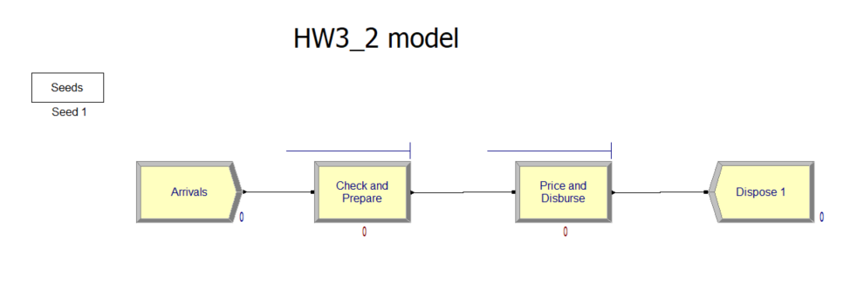

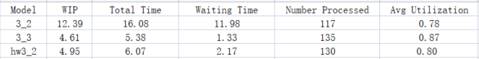

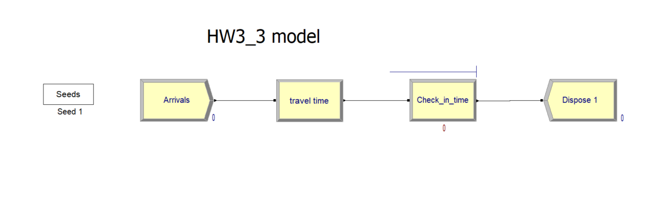

580_HW3_3_sol