**UFA toolbox update**

Gaoxing Zheng

July 18, 2024

Since the original UFA toolbox can only analyze the microstructural and macrostructural properties of superficial U-fibers, there is a lack of a quantitative pipeline for whole brain white matter fibers including both superficial and deep white matter. Here we update the UFA toolbox to allow quantification of 16 superficial white matter fibers and 58 deep white matter fibers (<https://whitematteranalysis.readthedocs.io/en/latest/bundles.html>).

1. Click on the 'U-fiber clustering' button and select the 'whole_brain' option to cluster and quantify the white matter fibers of the whole brain. If you select the 'U_fiber' option, the superficial U-fibers will be clustered and quantified.

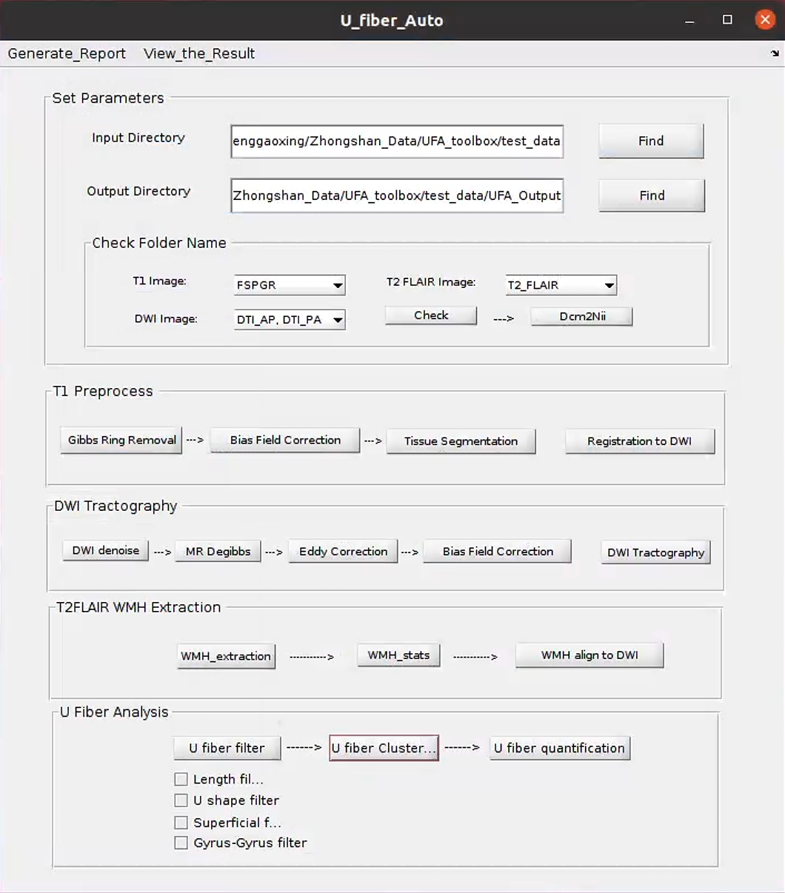

1. Export the whole brain white matter fiber quantitative result to Excel.

By clicking on the drop-down menu ‘Generate_Report’ at the top left and selecting the third option ‘Excel_74_tracts_dti’, you can generate an excel spreadsheet with 74 quantitative results (**test_data_74_tracts.xlsx**) of the whole brain white matter fibers under the output folder.

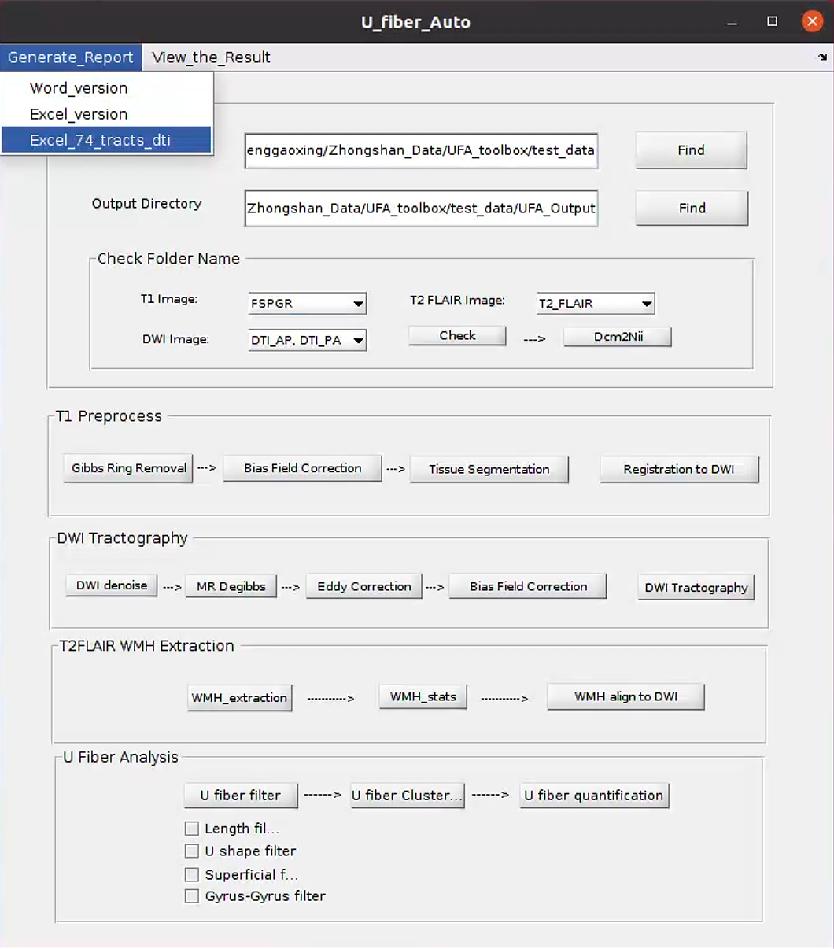

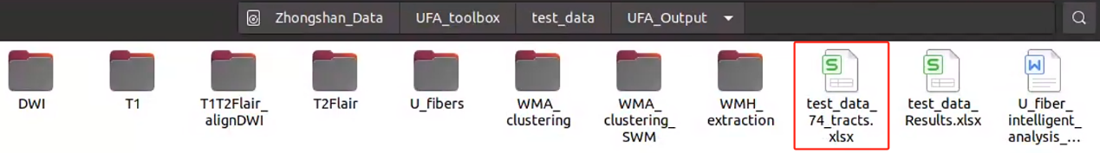

Reference:

[1] <https://github.com/SlicerDMRI/whitematteranalysis>

[2] Zhang, F., Wu, Y., Norton, I., Rathi, Y., Makris, N., O'Donnell, LJ. An anatomically curated fiber clustering white matter atlas for consistent white matter tract parcellation across the lifespan. NeuroImage, 2018 (179): 429-447

[3] O'Donnell LJ, Wells III WM, Golby AJ, Westin CF. Unbiased groupwise registration of white matter tractography. In MICCAI, 2012, pp. 123-130.

[4] O'Donnell, LJ., and Westin, CF. Automatic tractography segmentation using a high-dimensional white matter atlas. Medical Imaging, IEEE Transactions on 26.11 (2007): 1562-1575.

[5] Zheng, G., Fei, B., Ge, A., Liu, Y., Liu, Y., Yang, Z., ... & Ding, J. (2024). U-fiber analysis: a toolbox for automated quantification of U-fibers and white matter hyperintensities. Quantitative Imaging in Medicine and Surgery, 14(1), 662.