**Part II**

1)

2)

3)

4)

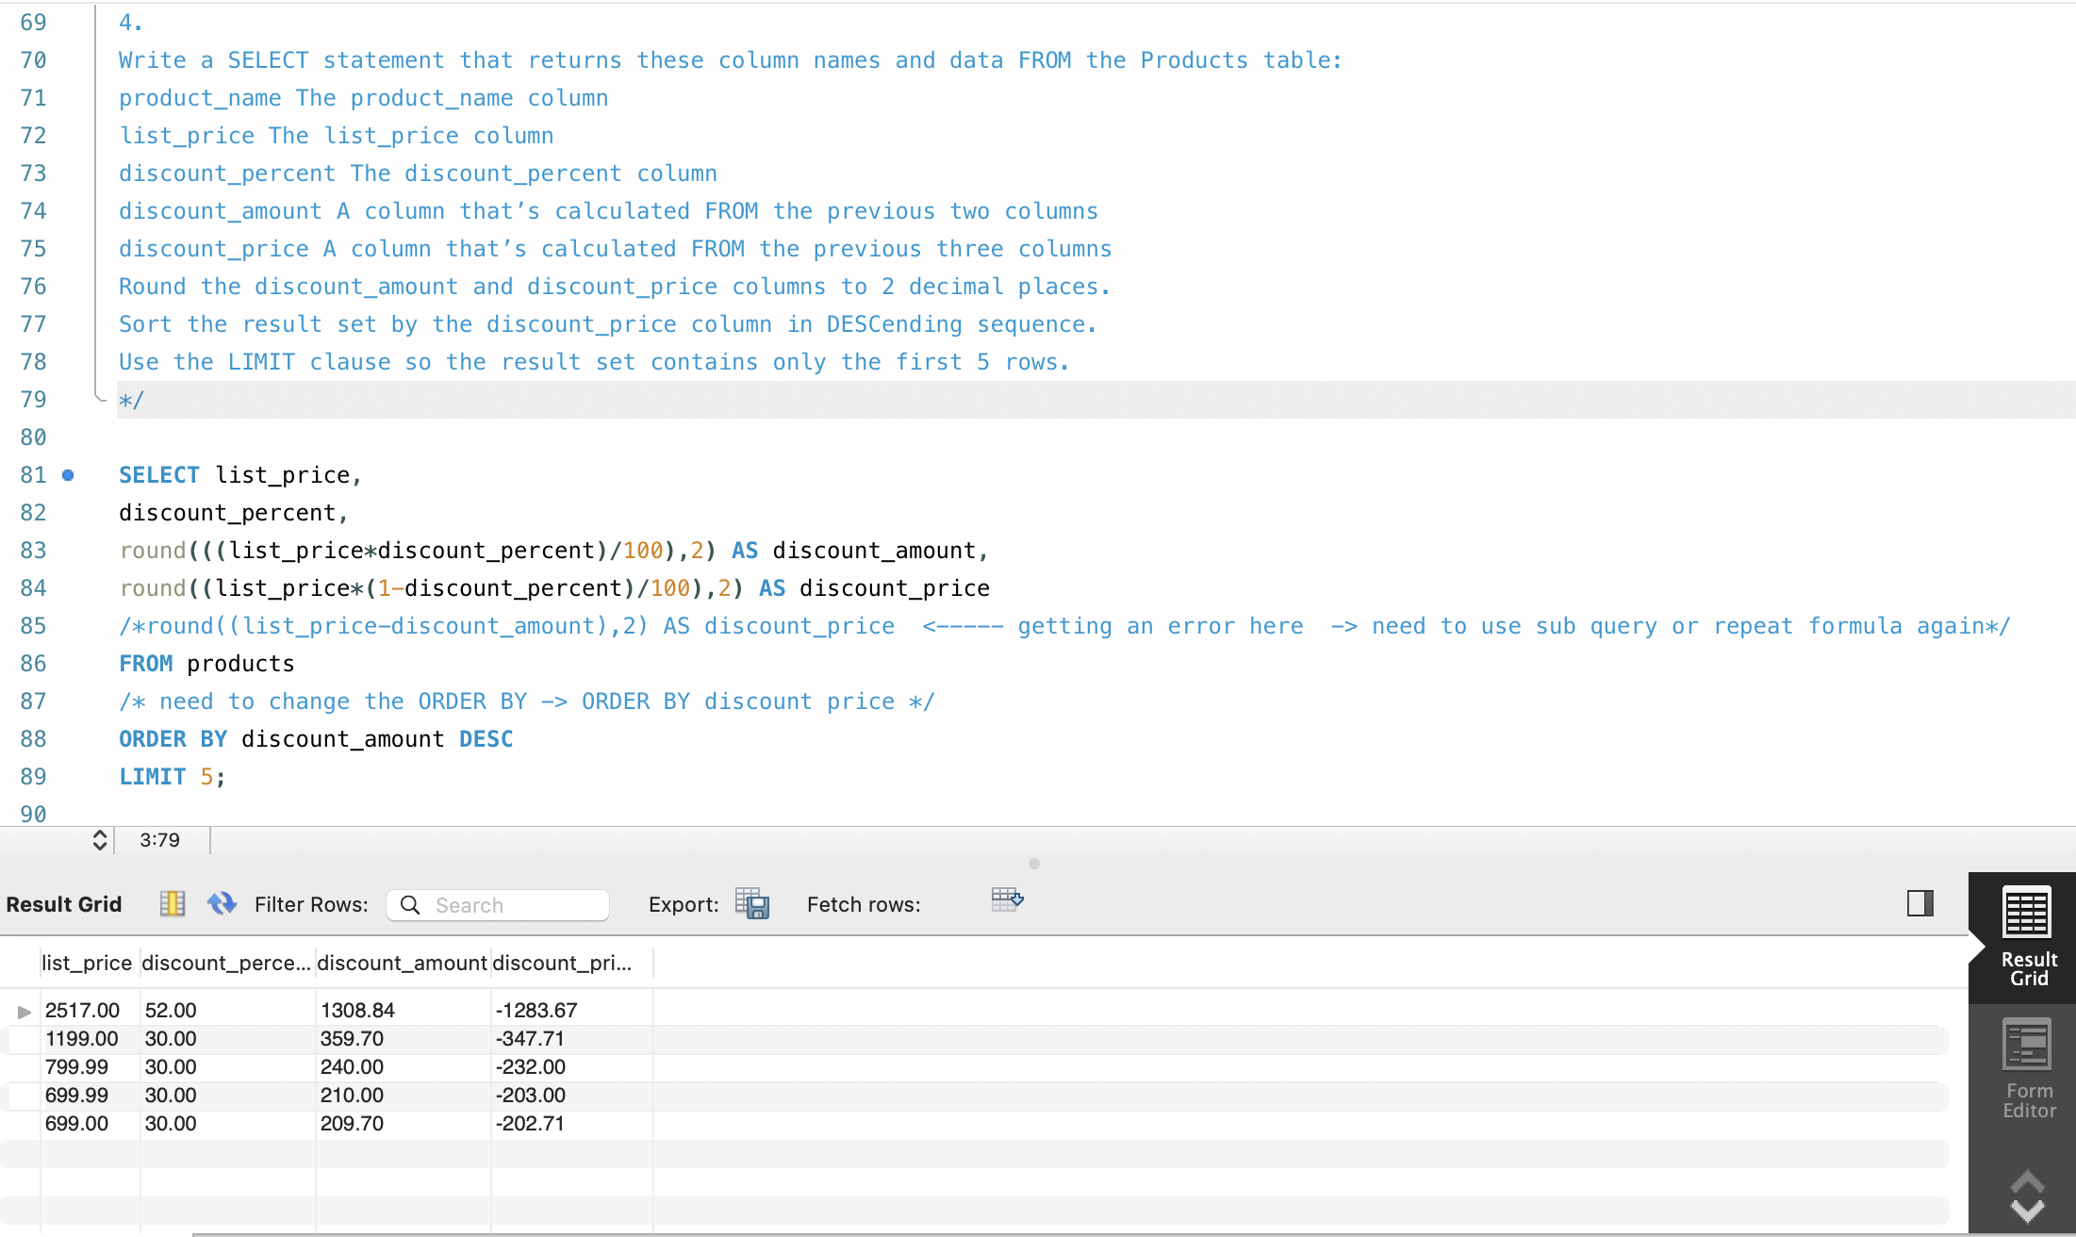

5)

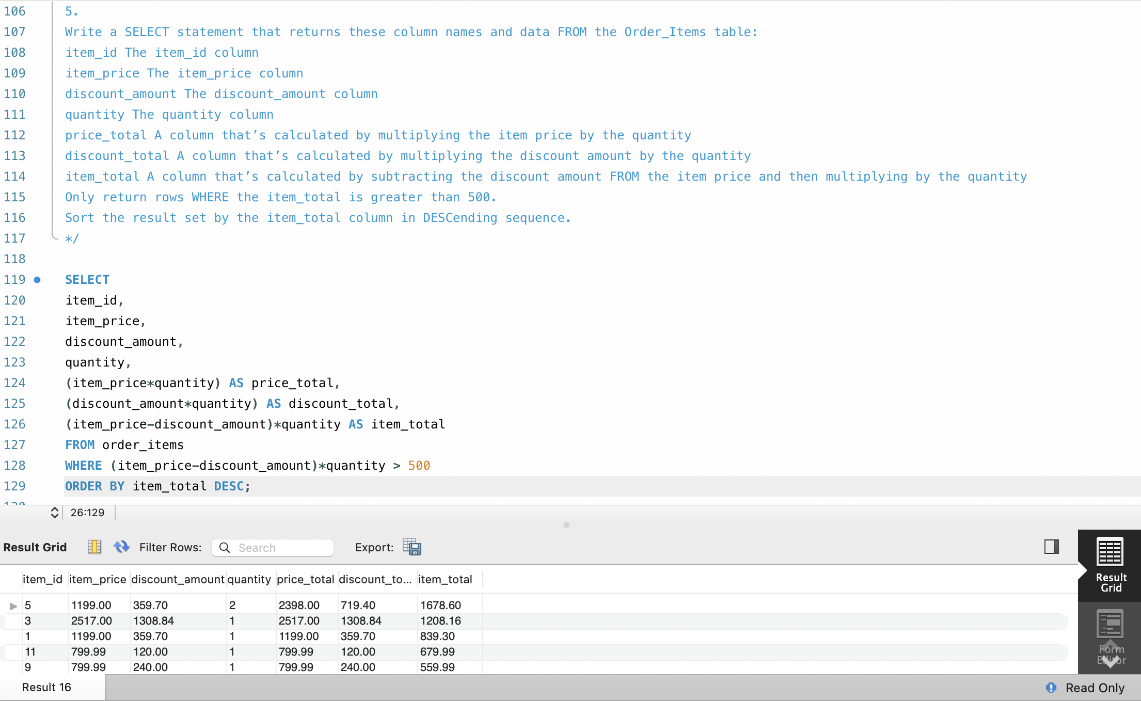

6)

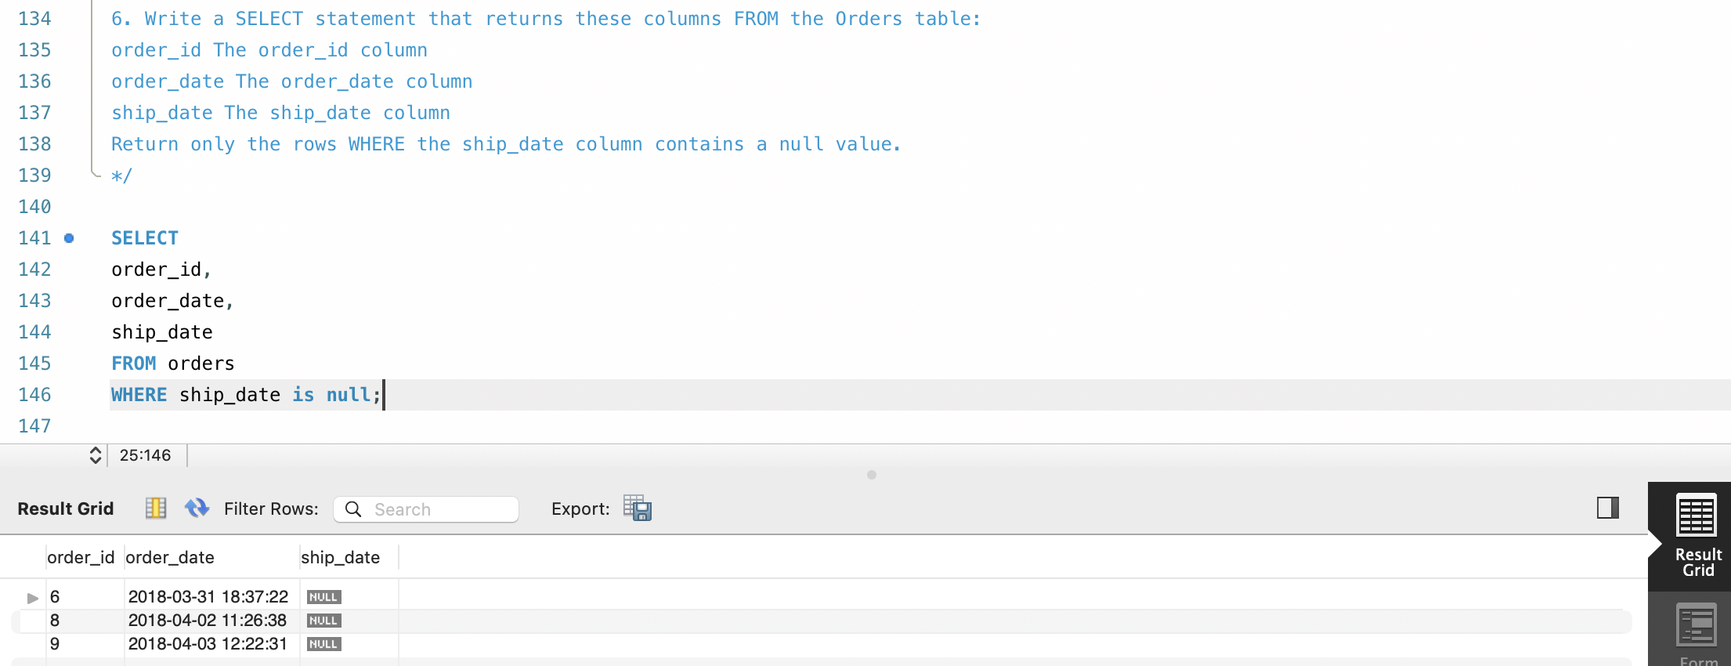

7)

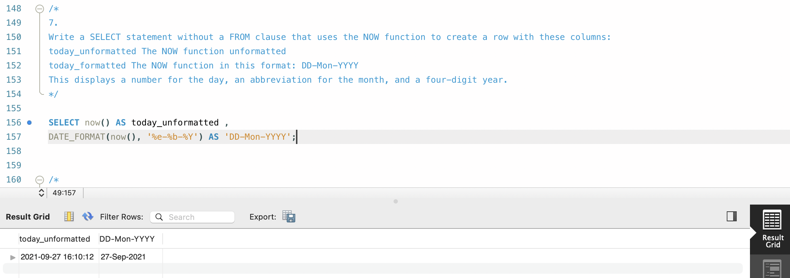

8)

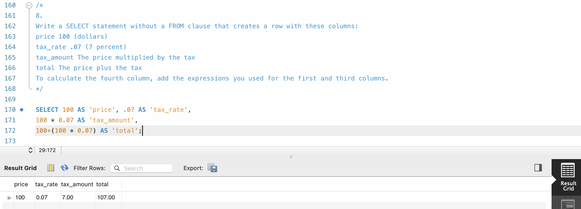

**Part III**