**Homework 1: Group 5**

**Part II: Query Challenges**

1)

2)

3)

4)

5)

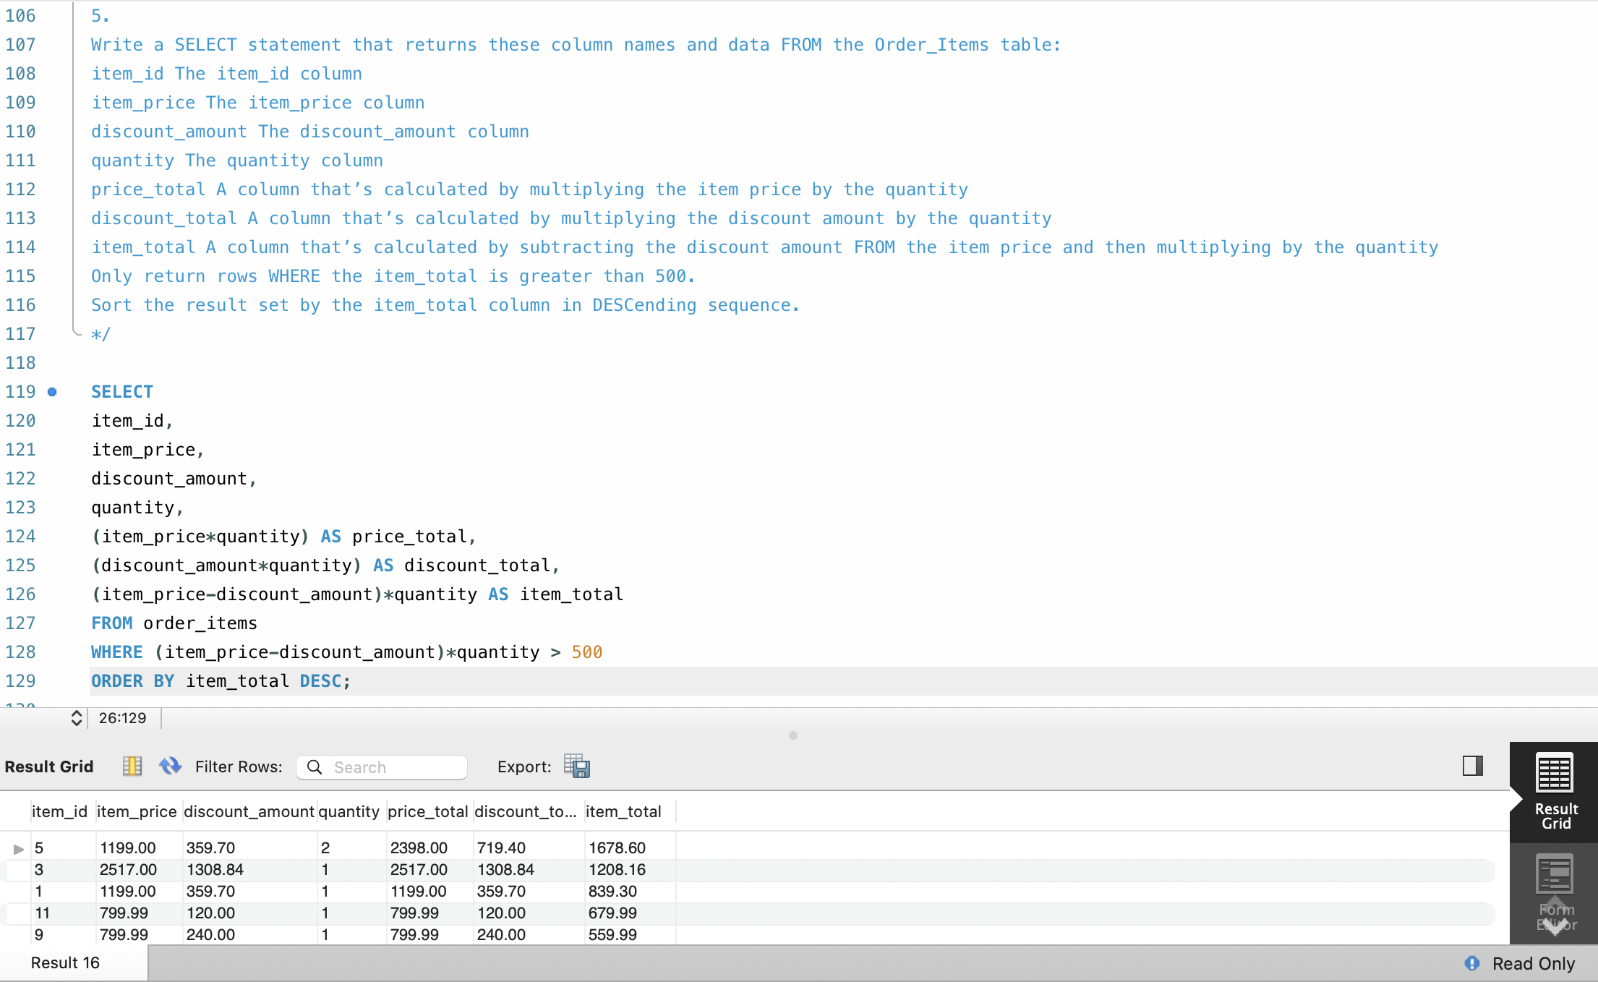

6)

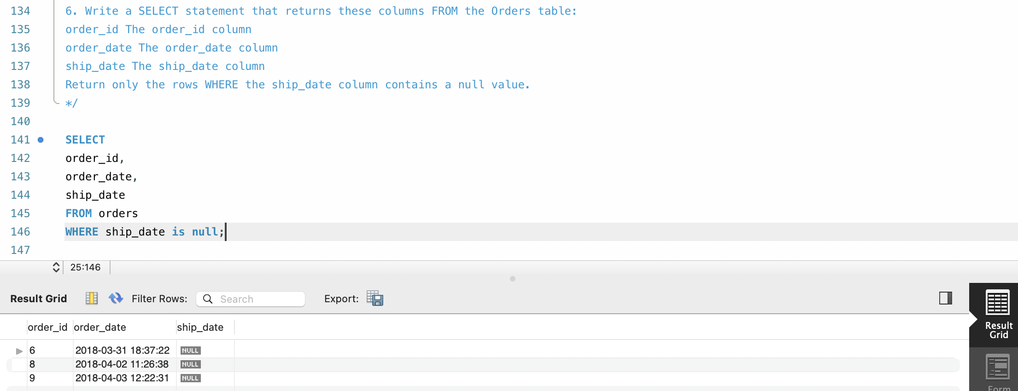

7)

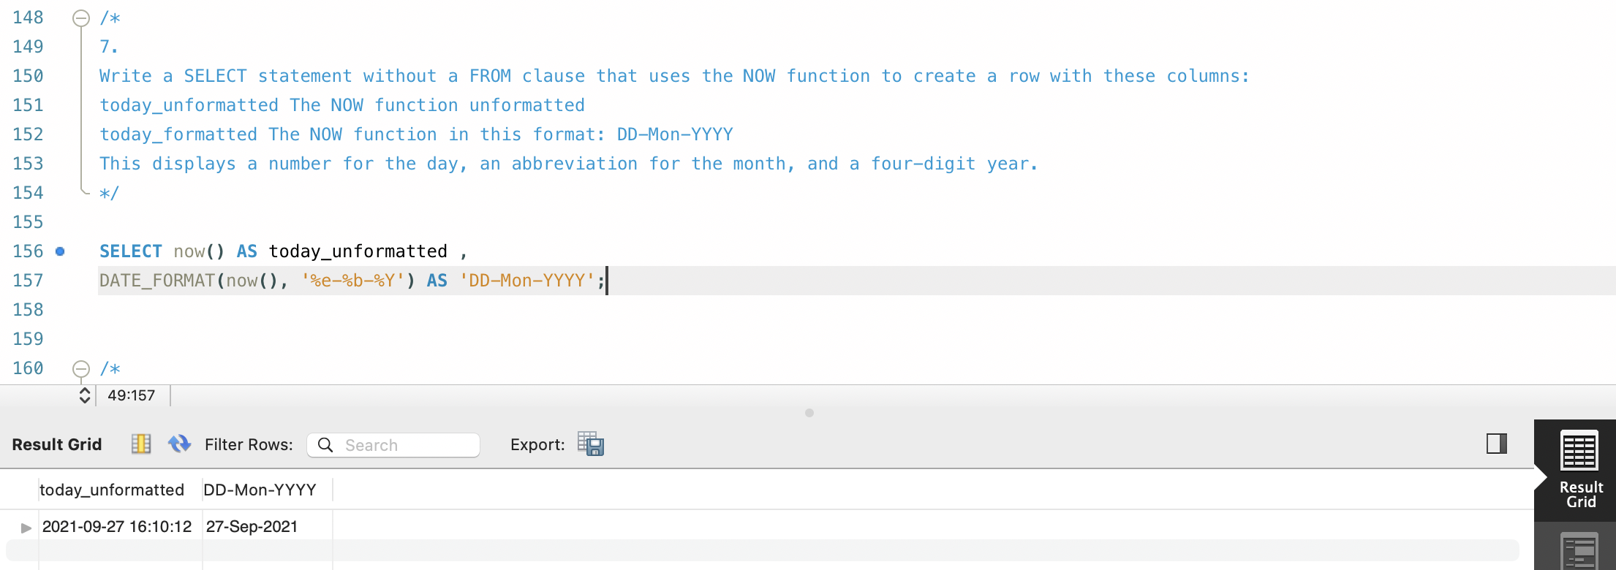

8)

**Part 3. ERD Challenges**

1. Yes because they are different entities and different tables and plan is optional for customer.
2. No, there is no crow’s feet on the line connecting Handset toward the Plan.
3. In this database, a customer can have many family members – customers can be grouped with other customers. The cardinality is one to many and the degree is unary.
4. Without changing the model, the current version does not accommodate this. However, if you change the relationship from handset type to multiple operating systems to many to many relationship, it would be possible.

