Assignment 2 – Part 2 Solution

Question 1

Transforming an E-R diagram to relations (parts a and b),

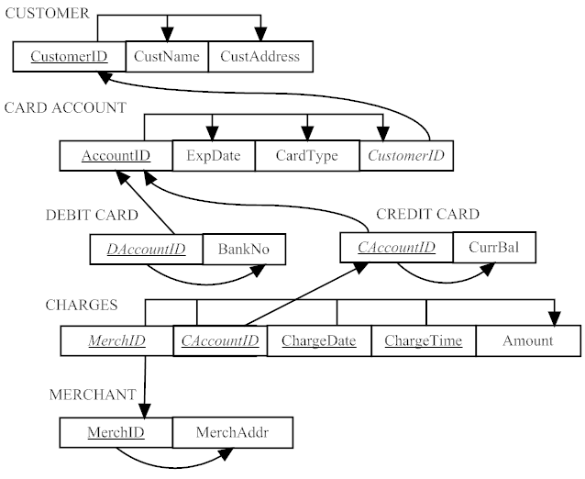

c. Using an enterprise key (*Foreign keys* shown in italics)

OBJECT (OID, ObjectType)

CUSTOMER (OID, CustomerID, CustName, CustAddress)

CARD ACCOUNT (OID, AccountID, ExpDate, CardType, *CustomerID*)

DEBIT CARD (OID, DAccountID, BankNo)

CREDIT CARD (OID, CAccountID, CurrBal)

CHARGES (OID, *MerchID*, *CAccountID*, ChargeDate, ChargeTime, Amount)

MERCHANT (OID, MerchID, MerchAddr)

QUESTION 2

Transforming Table to relations:

1. *PART SUPPLIER relation*

PART SUPPLIER (PartNo, Description, VendorName, Address, UnitCost)

(Illustrated with sample data)

|  |  |  |  |  |
| --- | --- | --- | --- | --- |
| PartNo | Description | VendorName | Address | UnitCost |
| 1234 | Logic Chip | Fast Chips | Cupertino | 10.00 |
| 1234 | Logic Chip | Smart Chips | Phoenix | 8.00 |
| 5678 | Memory Chip | Fast Chips | Cupertino | 3.00 |
| 5678 | Memory Chip | Quality Chips | Austin | 2.00 |
| 5678 | Memory Chip | Smart Chips | Phoenix | 5.00 |

1. *Functional dependencies*

Description

Address

UnitCost

PartNo

VendorName

PartNo, VendorName

Possible (Composite) Candidate Key: PartNo + VendorName

1. *Anomalies*

Insert anomaly: We cannot insert a new vendor unless we also include a part number that the supplier provides (and vice-versa).

Delete anomaly: If we delete the last part information for a given supplier, we also lose information about that vendor. (For example, Part *5678* from *Quality Chips* Vendor)

Modification anomaly: If a vendor’s address changes, we have to modify all records (or rows) for that vendor.

1. *Functional dependencies*

PartSupplier

PartNo

Description

VendorName

Address

UnitCost

1. *Which normal form?*

1NF

1. *Normalized relations*

PART

PartNo

Description

PartNo

VendorName

UnitCost

VendorName

Address

PART SUPPLIER

VENDOR

1. *3NF relations in Visio notation*

