HOW TO USE

1. To use this script, **Machine** must be in **client's network.** For example – we cannot access 192.168.3.50 until we are connected to Andheri VPN, in the same way we cannot access POS until we are in the client’s network.
2. Ensure that the **Java runtime environment** is installed on the machine on which this JAR is going to execute. Double tap on the jar file to run the Marker Deletion Script (you don’t need to run as administrator)
3. This is how the GUI will look which will have only 1 user field i.e. **Marker Issues** & 3 buttons i.e. **SUBMIT, CLEAR & HOW-TO-USE**.

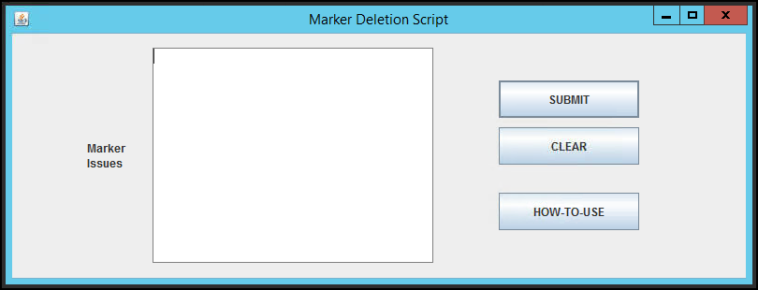

* **Marker Issue User Field –**
  + This is where you will paste your marker issues.
  + Please make sure you paste marker issues at user field in a way that the POS Name comes 1 below 1 without any blank line in between. For example –

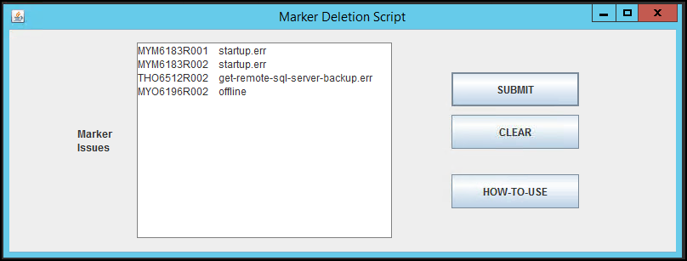

* **SUBMIT Button –**
  + Clicking on **SUBMIT** button will start the execution of script and it’ll go line by line as entered by user to every POS and delete the markers present inside \\PosName\c$\environment\marker folder.

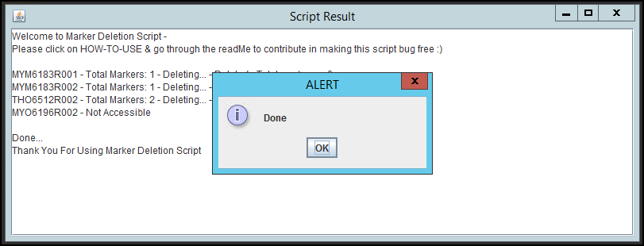

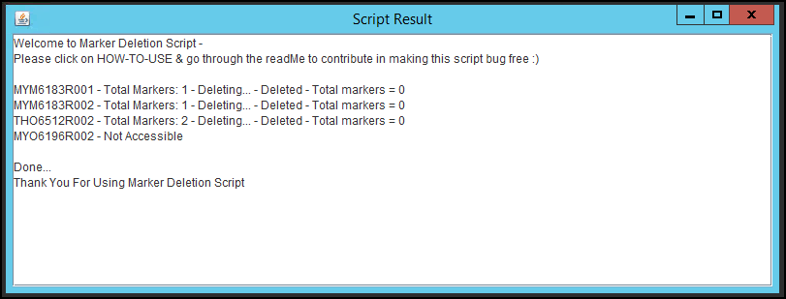

* If there is no marker file in the folder, it will look like below

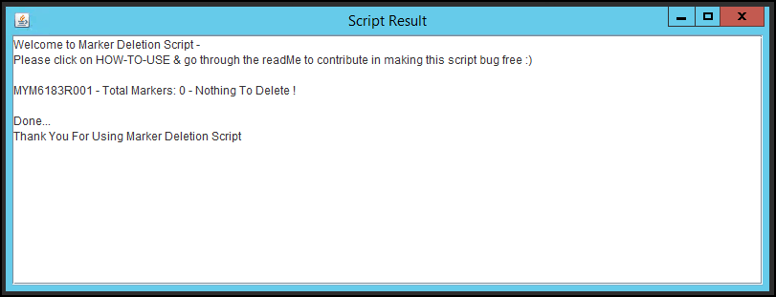

* + This script is programmed in such a way that if there are **more than 5 markers** in the folder, it will **NOT** **DELETE** any marker file at that POS, instead it will show the user an **ALERT** message box with details. For example –

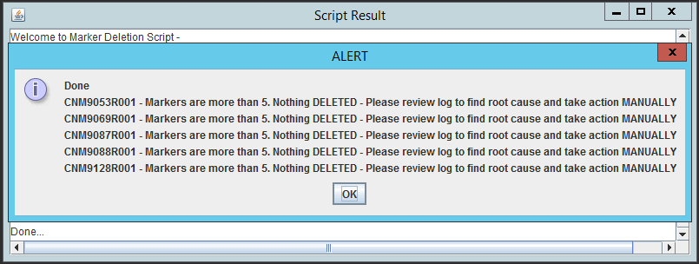

* **CLEAR Button –**
  + As name suggest user can use this button to clear the user field
* **HOW-TO-USE Button** 
  + This button can be use in accessing all the important files related to this **Marker Utility.**
  + This button is linked with One Drive folder where we’ll be keeping important documents related to this as well as all the future releases will also be kept here.

**IMPORTANT – Please go through the ReadMe file and contribute in making this script Bug Free 😊**