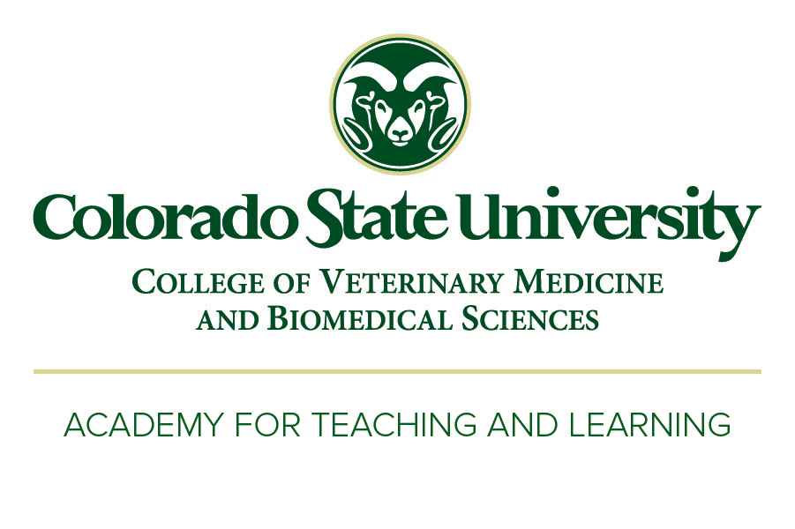Academy for Teaching & Learning

College of Veterinary Medicine

and Biomedical Sciences

Colorado State University

1601 Campus Delivery

Fort Collins, CO 80523

andrew.west2@colostate.edu

970-491-2184

June 21, 2018

To the review committee:

I would like to express my support of “Improving reproducibility of recording and pre-processing experimental biomedical data”, a proposal that Dr. Brooke Anderson and her co-investigators are submitting in response to RFA-GM-18-002: Training Modules Training Modules to Enhance the Rigor and Reproducibility of Biomedical Research (R25).

I am the director of Colorado State University’s Academy for Teaching and Learning, which promotes excellence in teaching and learning in CSU’s College of Veterinary Medicine & Biomedical Sciences, of which Dr. Anderson and her co-investigators are all members. Our group performs a number of roles in improving teaching and learning in the College, including providing detailed teaching evaluations and advice to faculty members and supporting research-related educational projects. This includes a project in which we are converting face-to-face lectures into interactive and visually rich eBooks and investigating the impact of these “eLectures” on student learning.

Dr. Anderson and her co-investigators plan to create a series of training modules, which they will post online, collected in an online book. Each module will include a video-recorded lecture. My group is happy to help her and her team in filming these video lectures. Our center has a Computer Assisted Teaching Support (CATS) laboratory that Dr. Anderson can use to record the lecture content that she and her collaborators develop and to transfer this material into a format that can be uploaded to YouTube. The CATS laboratory also includes tools for video editing, with the guidance and expertise of the CATS Lab staff.

Please feel free to contact me if you have any questions.

Best,

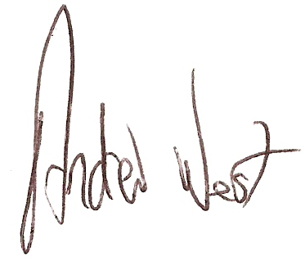

Andrew West, PhD, MEd

Director – Academy for Teaching and Learning

College of Veterinary Medicine and Biomedical Sciences

Colorado State University

andrew.west2@colostate.edu

970-491-2184