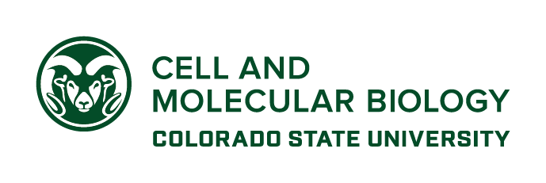**GRADUATE PROGRAM IN CELL & MOLECULAR BIOLOGY**

Mail Drop 1682

Fort Collins, Colorado 80523-1682

cmb.colostate.edu

tel: 970 491 4919

email: cwilusz@colostate.edu

June 20, 2018

Dear Brooke, Mercedes, Mike and Marcela,

I am excited to write this letter of support for your application entitled “Improving reproducibility of recording and pre-processing experimental biomedical data". As Director of the CSU Interdisciplinary Graduate Program in Cell & Molecular Biology, and Associate Director of the Interdisciplinary NSF-NRT GAUSSI training program in Computational Biology, I advise and support a number of students from various departments with a wide range of interests and training. I firmly believe most, if not all, of these trainees can benefit greatly from the modules you are developing and am happy to work with you to engage these graduate students as evaluators. The diverse nature of our student population (students are housed in 13 departments and 5 different colleges at CSU) will ensure that you modules are broadly accessible and relevant.

Once established I anticipate these modules will be a required and essential component of initial training for students entering these two programs. More importantly, the quality of research across campus will be improved by providing this training to researchers.

I wish you the best of luck in your application!

Sincerely,



Carol J. Wilusz Ph.D.

Director