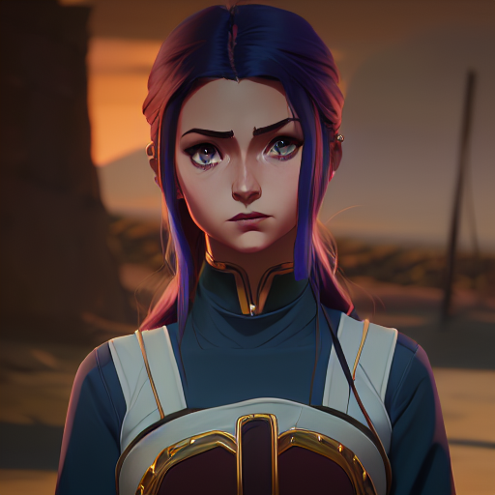

Snow | 6846 | gapsimisiminoonesnow@gmail.com

# About me

I am cold

# Work Experience

**Google** *2022-2023*It was great

**YouTube** *2022-2023*It was amazing

# Skills

* Coding
* Cooking