Alau Term diploma project: materials for 20 October 2026
Project scope, individual responsibilities and first pre-defence materials
Students: Galym Gapar Azamatuly (Gapo-7, SE-2418) and Nurlan Ramazan (Tenma24, SE-2431). Supervisor: Aigerim Balgabayevna Kydyrbekova. Draft dated 14 October 2026.
The proposed product is a bilingual public website and an internal CRM for Alau Term. Customers will search for industrial heating equipment and request sales or repair services. Managers will process leads, schedule field technicians and track repair visits; administrators will control content, roles and work status. A company representative has agreed orally to the topic and main functions. The agreement has not yet been recorded in writing.

1. Who will do what
Student | Area of responsibility | Deliverables and evidence
Galym Gapar — Gapo-7 | Requirements, data and server logic | Define scope and acceptance criteria; design the database and access rules; implement sales leads, service requests, technician assignment, visit statuses and CRM reports. Evidence: his branches, PRs, migrations and server tests.
Nurlan Ramazan — Tenma24 | Interfaces, UX and evaluation | Analyse comparable systems; design the public RU/KK pages and CRM screens for managers and administrators; connect forms to the server; check translation, accessibility and user tasks. Evidence: mock-ups, his PRs and test records.
Both students | Integration and project control | Confirm requirements with Alau Term, review each other’s PRs, link tasks to evidence, run end-to-end tests and present the result. The proposed division requires supervisor confirmation.

The Git history already shows separate contributions to the imported prototype: Gapo-7 contributed Stages 1, 3, 5 and 7; Tenma24 contributed Stages 2, 4 and 6. These imports demonstrate collaboration, but they do not constitute a working CRM.

2. Current state and evidence
Confirmed as of 14 October | Still to be completed
The GitHub repository contains an imported RU/KK static website snapshot. An audit counted 1,234 saved pages against 2,252 sitemap addresses. | Build the application, database, forms, CRM workflows and tests. Resolve missing pages and resources needed by the selected scenarios.
The Alau Term representative orally agreed to the subject and functions. | Record the representative’s name, role, meeting date, decisions and open questions; obtain manager/technician input and supervisor comments.
Individual Git branches and reviewed PRs exist for Stages 1–7. | Create YouTrack tasks with owners and acceptance criteria, link them to PRs, and tag the reviewed pre-defence version.

The static snapshot has no verified backend or database. Several original pages display errors, and saved forms do not process a request. It is a visual prototype and source of content, not evidence that the proposed website or CRM is already implemented.

3. Proposal, users and boundaries
Problem statement. A buyer needs clear equipment information and a reliable route to a sales enquiry. A repair customer needs a route from request to an actual field visit. Inside the company, managers need one record of each enquiry, technician assignment and visit status; administrators need oversight. The exact workflow is a working hypothesis until it is confirmed with staff.
Users are customers, sales and service managers, field technicians and administrators. The project goal is to implement and evaluate a RU/KK platform that links a public catalog and service pages to an internal CRM for sales and repair dispatch.
Included in the first planned version | Outside the first planned version
Catalog and search; product and service pages; sales and repair forms; CRM lists and records; assignment of technician and visit date; departure, arrival and completion statuses; status history; administrator roles and overview; RU/KK public content; tests. | Online payment; live inventory or ERP/1C integration; automatic route optimization; payroll; a technician mobile app; automatic diagnosis from photographs. These would require a separate decision.

Expected outputs are application source code, schema and migrations, the RU/KK public interface, role-based CRM screens, tests and documented evaluation. Technical difficulty lies in connecting customer requests to internal work orders while keeping status changes auditable and access controlled.

4. Relevance and customer evidence
The Alau Term representative is Galym’s father and represents the company. He has orally approved the topic and main functions. There is no interview transcript or written approval yet; this document does not present a planned interview as a completed one.
Participant | Questions to verify | Record to collect
Company representative | Priorities, sales and repair process, responsibility for approvals, essential CRM reports. | Dated meeting note with confirmed and unresolved points.
Manager and field technician | Required request fields; who assigns visits; how departure, arrival, delay and completion are recorded. | Short anonymised notes and a workflow diagram checked by participants.
Two or three potential customers | How products are found; clarity of RU/KK pages; whether a repair request is understandable. | Task observations and changes linked to requirements.

Suggested interview questions: What starts a sales or repair request? Who receives it? Which facts are needed before assigning a technician? How is a visit rescheduled? What proof closes a job? Which data may each role see? Observations will be mapped to requirements and priorities, with assumptions marked explicitly.

5. Literature and design implications
Sources [1–8] are scholarly publications; [9–12] are standards and technical documentation. Studies of consumer commerce inform usability methods but cannot prove outcomes for a Kazakhstani industrial B2B service. Customer and employee validation remains necessary.
Sources | Use in the project | Limit
[1] Industrial B2B platforms | Treat equipment and follow-up service as linked processes. | Conceptual model, not an Alau Term specification.
[2–5] Website use and usability | Check information clarity, search, task completion and errors. | Mostly consumer settings; effects cannot be copied.
[6] Accessibility review; [9] WCAG 2.2 | Check keyboard access, labels, contrast and form errors. | Conformance must be tested on the built screens.
[7] Perceived risk; [8] language translation | Make request outcomes clear and test RU/KK tasks with users. | Contexts differ from industrial repair in Kazakhstan.
[10] OWASP; [11] Django; [12] PostgreSQL | Set security checks and compare implementation options. | Standards and manuals are not independent field evidence.

Design conclusion: first make product data, service request fields and CRM handover accurate; then measure whether customers and staff complete realistic tasks. Personalisation and complex recommendations are deferred.

6. Existing systems and the project gap
The matrix records features visible in publicly accessible pages of four Kazakhstan-based suppliers checked on 14 October 2026. “Unconfirmed” means the feature was not established during this review, not that it does not exist.
Criterion | Flame Tech | EKSTRA | TEPLOSHOP | EnKo
Equipment catalog | Yes | Yes | Yes | Yes
Spare parts | Yes | Yes | Yes | Yes
Service description | Yes | Partners | Unconfirmed | Unconfirmed
Search | Yes | Yes | Unconfirmed | Unconfirmed
Enquiry channel | Form | WhatsApp/phone | Web order | Email/phone
RU/KK interface | Unconfirmed | Unconfirmed | Unconfirmed | Unconfirmed
Technician visit tracking | Unconfirmed | Unconfirmed | Unconfirmed | Unconfirmed
Visible CRM workflow | Unconfirmed | Unconfirmed | Unconfirmed | Unconfirmed

Sources: https://flame-tech.kz/ ; https://vectortepla.kz/katalog/ ; https://teploshop.kz/ ; https://enko.kz/ . This is a desk review, not a comparative user study. The proposed Alau Term distinction is a single traceable path from public sales or repair request to internal processing and field visit; market uniqueness is not claimed.

7. Technology choice
Decision | Alternatives | Proposed choice and reason
Server | Django; FastAPI; Express/Node.js | Django offers authentication, permissions, forms, ORM and administration with less setup for a two-student team. FastAPI is suitable for APIs but needs a separate admin UI; Express needs more application conventions.
Data | PostgreSQL; SQLite; MongoDB | PostgreSQL supports linked products, leads, work orders, users and status history with constraints and transactions. SQLite remains useful locally; document storage weakens relational checks here.
Interface | Django templates; React SPA; static HTML | Server-rendered templates can adapt the current HTML and support both public pages and CRM forms. A React SPA adds an API and client state; static HTML cannot persist requests.

This is a proposed stack, not a claim of completed implementation. The final choice will be checked against requirements and supervisor feedback.

8. Requirements with acceptance criteria
ID | Functional requirement | Acceptance check
F-01 | Publish and search product catalog. | Admin creates a product with code and specifications; a customer finds it by name, code and category.
F-02 | Show service information in RU/KK. | Customer opens a service page and reaches the matching request form in either language.
F-03 | Record a sales enquiry. | Valid form creates a numbered lead; invalid form gives field errors and creates no record.
F-04 | Record a repair request. | Customer supplies equipment, fault, contact and location; manager sees a new service case.
F-05 | Manage sales pipeline in CRM. | Manager changes lead owner and stage; every change is saved and visible to permitted users.
F-06 | Schedule and assign a field technician. | Manager assigns worker and visit time to a repair case; conflict and missing fields are shown.
F-07 | Track visit and repair status. | Departure, arrival, work result and completion are timestamped; manager sees history and overdue visits.
F-08 | Admin control and oversight. | Admin manages catalog, users and roles and sees open sales/service work; a public user is denied access.
F-09 | Bilingual public journey. | Catalog, service and request flows retain the selected RU/KK language and equivalent fields.
F-10 | Notify responsible staff. | A saved request triggers a test notification; a mail failure does not erase the request.

ID | Non-functional requirement | Verification
N-01 | Role access, server validation and CSRF protection. | Test unauthorised access to CRM records and forms; use applicable OWASP ASVS checks.
N-02 | No secrets or real customer data in Git. | Inspect new PRs and configuration examples before merge.
N-03 | Accessible main journeys. | Keyboard and label checks; evaluate main screens against WCAG 2.2 AA.
N-04 | Responsive public and CRM screens. | Test core screens at 360 px and desktop width without horizontal scrolling.
N-05 | Persistent, traceable work records. | Restart the server and verify lead, visit assignment and status history remain intact.
N-06 | Measured response under an agreed load. | Provisional target: p95 under 2 seconds for 50 concurrent virtual users in a recorded test environment.

F-01–F-09 and N-01–N-05 form the proposed minimum scope. Priorities and numerical targets require customer and supervisor confirmation.

9. Architecture and diagrams
The public customer submits sales and repair requests. A manager processes the CRM record and dispatches a technician. The technician reports visit milestones; the administrator manages access and reviews work. Contact data and work history remain in the application database with role-based access.
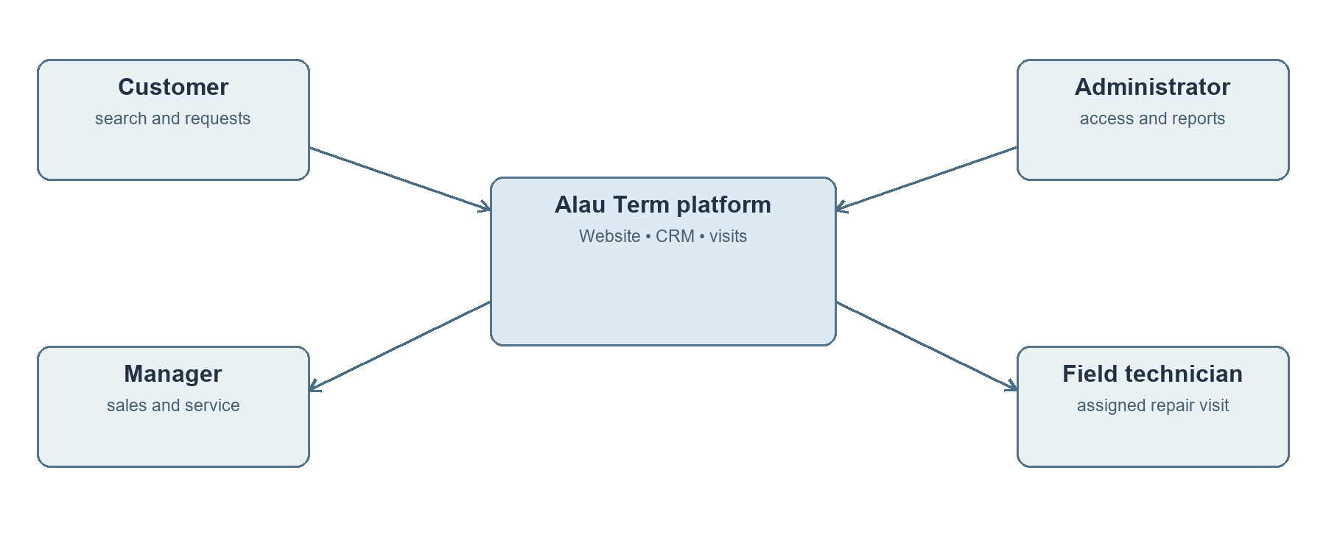
Figure 1. Proposed system context
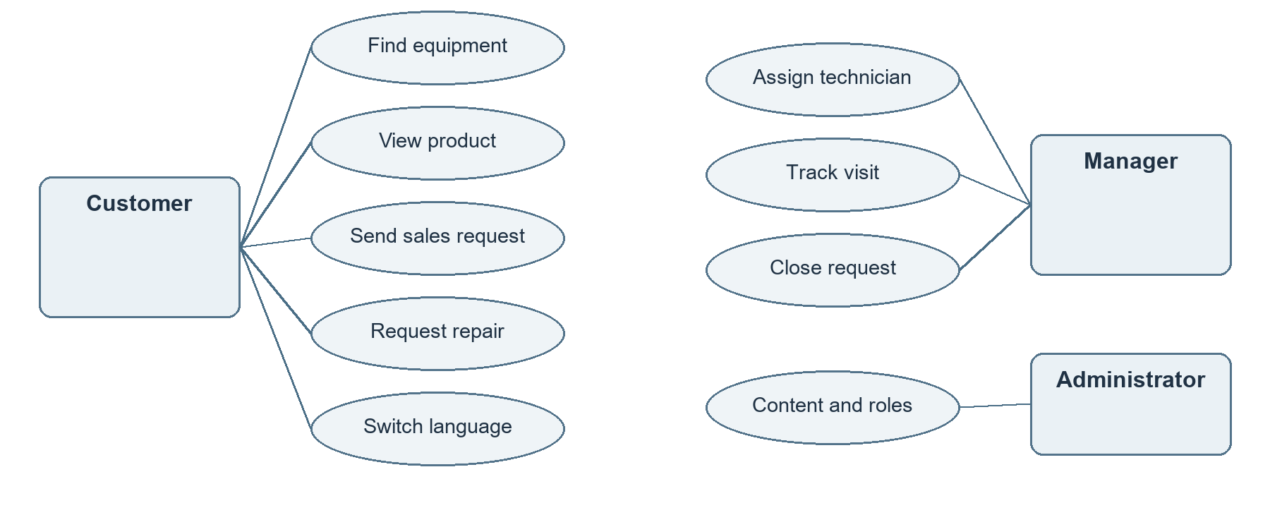
Figure 2. Main use cases
The browser uses server-rendered public and CRM screens. The Django application checks forms and roles, domain services handle catalog, sales cases and dispatch, and PostgreSQL stores related records. Files and email are separate dependencies.
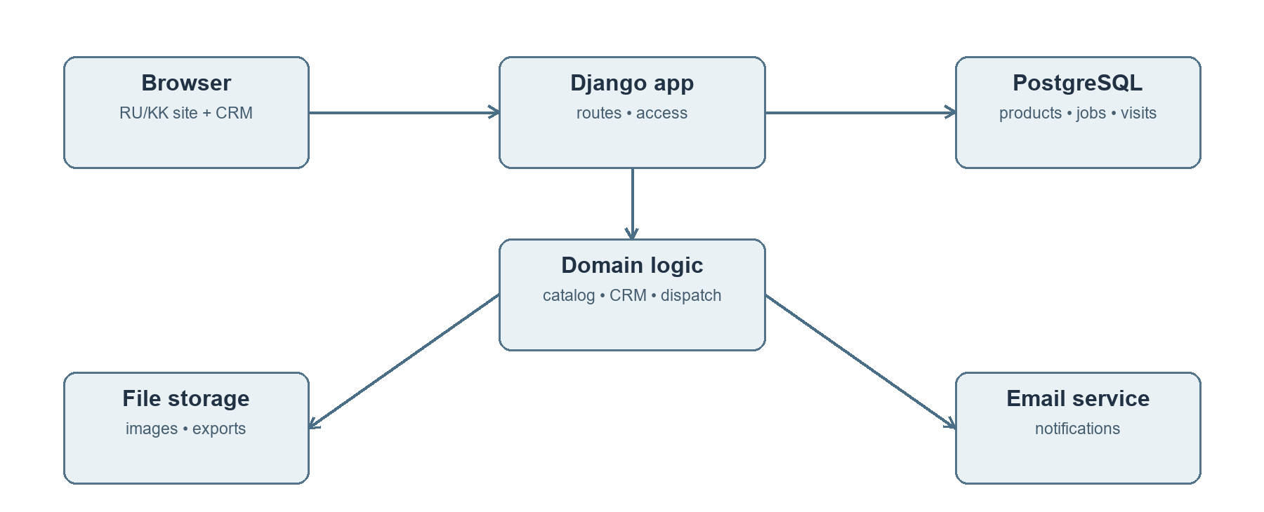
Figure 3. Proposed components
Core entities: Product, ProductTranslation, Service, ServiceTranslation, SalesLead, ServiceCase, WorkOrder, Visit, StatusEvent and User. A ServiceCase may have a WorkOrder with assigned technician and planned time; each visit event stores actor, time and status. Data retention and field visibility must be agreed with the company.

10. Prototype and user journeys
The repository prototype under prototype/snapshot/ru and prototype/snapshot/kk supplies page content and visual references. It does not yet contain working CRM screens. In a demonstration, each screen should be labelled as snapshot, mock-up or implemented to make its status clear.
Journey | Screen sequence | Success condition
Sales enquiry | Home → catalog → product → request → CRM lead | Customer submits a request and manager sees its source and status.
Repair and dispatch | Service page → repair form → CRM case → technician assignment → visit log | Manager assigns a worker and can trace departure, arrival and result.
Administration | Sign-in → overview → users/catalog → service work | Admin sees the open workload and manages access without exposing CRM publicly.
Language choice | RU journey → KK → same task | Core meanings and form fields remain consistent across languages.

11. Verification plan
Check | Baseline | Planned evidence
Functionality | Static forms do not persist data. | Acceptance tests for all mandatory F requirements on a test database.
Staff workflow | No working CRM yet. | Create a repair case, assign a technician, record visit milestones and verify status history and permissions.
User tasks | No user study completed. | At least five participants; record completion, time and errors for catalog, enquiry and repair tasks.
RU/KK, accessibility and security | Not verified on a working app. | Paired language review, keyboard checks, role tests and a report of resolved critical issues.
Performance | No server baseline. | Record machine, data volume, workload and result for N-06.

Each result will include a date, Git version, test data and limitation. An impossible task in the snapshot will be marked “cannot complete” rather than assigned an artificial time or score.

12. Tasks, schedule and repository control
GitHub already provides visible individual contributions and peer review. YouTrack has not been set up. The “PLAN” codes below are placeholders, not real issue IDs; after project creation they should be replaced in branch and PR descriptions.
Task | Owner | Evidence | Due
PLAN-01 Confirm scope and customer workflow | Gapo-7 | Dated meeting note, decisions, open questions | 15 Oct
PLAN-02 Record staff/customer conversations | Tenma24 | Anonymised notes linked to requirements | 17 Oct
PLAN-03 Review 12 sources and four systems | Both | Source table and competitor matrix | 17 Oct
PLAN-04 Finalise requirements and diagrams | Gapo-7 | Accepted IDs and editable diagrams | 19 Oct
PLAN-05 Design public and CRM UX | Tenma24 | Customer, manager and admin screens | 19 Oct
PLAN-06 Create YouTrack, README and test plan | Both | Task links, methods and responsibilities | 20 Oct
PLAN-07 Build catalog, data model and access | Gapo-7 | Migrations, code and tests | After review
PLAN-08 Build RU/KK site and CRM UI | Tenma24 | Working forms and responsive screens | After review
PLAN-09 Integrate sales, repair and dispatch | Both | End-to-end tests and reviewed PRs | After review
PLAN-10 Apply supervisor feedback and tag | Both | Decision log and pre-defense-1 tag | By 24 Oct

Repository: https://github.com/Gapo-7/DIPLOMA . The README should state the topic, team roles, current status, planned website and CRM, setup instructions once available, and links to documents and YouTrack. Work proceeds in separate branches with peer-reviewed PRs. Tag pre-defense-1 only after the reviewed package is on main.
Main risks are unrecorded customer decisions, absent staff evidence, a large incomplete snapshot, RU/KK inconsistencies and limited time. The immediate response is to document decisions, prioritise the minimum website-plus-CRM workflow and keep every claim tied to a deliverable.

13. Items awaiting confirmation
Decision needed | From whom | Record
Sales stages, repair statuses, assignment authority and visit evidence | Alau Term representative and staff | Dated workflow approval and updated requirements
Scope, scholarly review and individual contribution | Supervisor | Written comments and team response
Test tasks, user sample and deadlines | Supervisor and company representative | Approved evaluation plan

No supervisor review, YouTrack project or interview record is claimed as complete at the date of this draft. The team should add genuine evidence after it exists.

References
[1] Bauer et al. A survey of digital B2B platforms and marketplaces for purchasing industrial product service systems. Procedia CIRP 97 (2021), 331–336. https://doi.org/10.1016/j.procir.2020.05.246
[2] Ayalew M., Zewdie S. What Factors Determine the Online Consumer Behavior in This Digitalized World? Human Behavior and Emerging Technologies (2022). https://doi.org/10.1155/2022/1298378
[3] Guo J., Zhang W., Xia T. Impact of Shopping Website Design on Customer Satisfaction and Loyalty. Sustainability 15(8), 6347 (2023). https://doi.org/10.3390/su15086347
[4] Assessing Interactive Web-Based Systems Using Behavioral Measurement Techniques. Future Internet 15(11), 365 (2023). https://doi.org/10.3390/fi15110365
[5] Kumar B. et al. E-Commerce Website Usability Analysis Using the Association Rule Mining and Machine Learning Algorithm. Mathematics 11(1), 25 (2023). https://doi.org/10.3390/math11010025
[6] Bercaru V., Popescu N. A Systematic Review of Accessibility Techniques for Online Platforms. Applied Sciences 14(22), 10337 (2024). https://doi.org/10.3390/app142210337
[7] Phamthi et al. The influence of perceived risk on purchase intention in e-commerce. International Journal of Consumer Studies (2024). https://doi.org/10.1111/ijcs.13067
[8] Nayak A., Aravindakshan Nair A. Language translation effects in Chatbots: Evidence from a randomized field experiment on a mobile commerce platform. Journal of Business Research 190, 115158 (2025). https://doi.org/10.1016/j.jbusres.2024.115158
[9] W3C. Web Content Accessibility Guidelines (WCAG) 2.2. https://www.w3.org/TR/WCAG22/
[10] OWASP. Application Security Verification Standard. https://owasp.org/www-project-application-security-verification-standard/
[11] Django documentation. Internationalization and localization. https://docs.djangoproject.com/en/5.2/topics/i18n/
[12] PostgreSQL documentation. Full Text Search. https://www.postgresql.org/docs/current/textsearch.html

