Alau Term: pre-defence project dossier
Working version for the 20 October 2026 checkpoint | revised 14 October 2026
Team: Ғалым Ғапар Азаматұлы (given name: Ғапар; Gapo-7) and Нұрлан Рамазан (Tenma24). Academic supervisor: Aigerim B. Kydyrbekova (name as supplied in the template; confirm official spelling).
This dossier defines the proposed bilingual public website and internal CRM for equipment sales and repair visits. It is a planning and evidence document. A static site snapshot in GitHub demonstrates page structure; it is not yet a working CRM or an operational pilot.

1. Project proposal and responsibility
Proposed title: Design and development of a bilingual web platform with a sales and field-service CRM for Alau Term. The public part will present boiler equipment and services in Russian and Kazakh and accept enquiries. The internal part will help administrators and managers process sales leads, assign repair work and track technician visits.
Member | Primary contribution | Reviewable output
Ғапар / Gapo-7 | Analysis, data and server side | Scope and requirements; process/data models; roles, catalogue, enquiry and CRM server logic; persistence and access tests.
Рамазан / Tenma24 | Interface and user evaluation | Comparable-system analysis; scenarios and wireframes; responsive RU/KK public and CRM screens; form integration, language and usability checks.
Both | Integration and academic evidence | Customer clarification, source review, architectural decisions, cross-review of PRs, final verification and presentation.

This allocation is proposed by the team and awaits supervisor confirmation. The existing Git history contains Gapo-7 work in Stages 1, 3, 5 and 7 and Tenma24 work in Stages 2, 4 and 6. Those stages capture a static website; their division does not by itself prove completed CRM functions.
Scope for the diploma: product catalogue and service information; RU/KK content; sales and repair enquiry forms; manager CRM; administrator role/content controls; assignment and visit-event history; verification. Excluded from the first version unless agreed later: online payment, inventory/ERP integration, automated route optimisation, GPS tracking and a technician login/mobile application.

2. Relevance and customer evidence
Alau Term needs a coherent public entry point and an internal record of what happens after a customer contacts the company. In a repair case, a useful record links the request, responsible manager, assigned worker, planned visit and reported outcome. This rationale is supported by research on SME digital customer service and field-service scheduling [2–6], but the size of the local problem still needs measurement with Alau Term.
Evidence status | What is known / what must be obtained
Confirmed in conversation | A company representative verbally agreed to the project topic and functions. No date, written minutes, exact role statement or signed approval has been recorded.
Repository evidence | A static archive and audit are available in the DIPLOMA repository. The audit lists 2,252 sitemap entries, 1,234 saved pages, 1,018 absent entries, nine missing static assets and no populated CSRF values. These are archive-quality figures, not business outcomes.
To record before claims about practice | Interview a representative and at least one manager; if possible, a field worker and customer. Log date, role, consent, answers and decisions. Obtain a short confirmation of the agreed requirements.
Current limitation | No interview notes, time measurements or supervisor review have been supplied. A YouTrack project now tracks 15 open tasks; no claim is made that the remaining evidence exists.

Interview guide: How are sales and repair requests received now? Which fields are essential? Who assigns workers and changes a visit status? How is completion confirmed? What response time is expected? Which customer data may be retained? What RU/KK terms need approval? Record answers and revise the requirements below; do not treat these questions as answered evidence.

3. Literature review
Eleven scholarly works were checked for relevance. The literature informs design choices; it does not verify that Alau Term currently uses or needs a particular workflow. Full bibliographic data and links are in References.
Ref. | Finding used in this project | Transfer limit
[1] | Industrial B2B platforms combine product and service information. | Conceptual industrial-marketplace study, not an Alau Term user study.
[2] | Digital service innovation requires coordinated customer and service processes. | Broad servitization context.
[3] | On-site maintenance links spare parts, visits and uncertain repair demand. | Its optimisation model is outside this diploma MVP.
[4] | Technician scheduling depends on task and worker constraints. | Routing algorithm is not proposed for version one.
[5] | SME service digitalisation has organisational as well as technical drivers. | Cross-sector evidence, not a local baseline.
[6] | SME customer-service tools can be evaluated through effects and adoption conditions. | Polish sample; local validation needed.
[7] | Usability and trust affect shopping-site satisfaction. | Public-site insight, mainly consumer commerce.
[8] | Behavioural measurements can support web-interface evaluation. | Different application setting.
[9] | Accessibility techniques should be assessed systematically. | Review paper, not an audit of our screens.
[10] | Perceived risk shapes online purchase intent. | Consumer purchase context, indirect for service visits.
[11] | Language choices can affect interaction outcomes. | Chatbot experiment; motivates, but does not prove, RU/KK benefit here.

Design implication: measure task completion on both languages and record the repair hand-off as a traceable sequence. There is no evidence that adding translation or a CRM alone will improve sales or response time; those outcomes must be tested against a local baseline.

4. Existing-system review
The first three examples are public supplier websites; their private tools cannot be inspected. Zoho FSM and Salesforce Field Service are workflow benchmarks, not direct local storefront competitors. V = publicly visible or officially documented, U = unverified from public evidence, — = not applicable to the reviewed surface. Criterion definitions are the same for each row.
System / public evidence | Cat. | Svc. | RU/KK | Web request | Work order | Assign | Visit status | Roles
Flame Tech [16] | V | V | U | V | U | U | U | U
EKSTRA / Vector Tepla [17] | V | V | U | V | U | U | U | U
Teploshop [18] | V | U | U | U | U | U | U | U
Zoho FSM [19] | — | V | U | V | V | V | V | V
Salesforce Field Service [20] | — | V | U | V | V | V | V | V
Alau Term target | Planned | Planned | Planned | Planned | Planned | Planned | Planned | Planned

Criteria: Cat. = public product catalogue; Svc. = public service description or service workflow; RU/KK = confirmed two-language interface; Web request = online contact/intake; Work order = internal repair record; Assign = worker assignment; Visit status = recorded visit progress; Roles = restricted staff permissions. A U value does not mean the feature is absent. This comparison supports integrating the public entry point with the internal process rather than claiming a novel CRM feature.

5. Technical decisions and alternatives
Decision | Alternatives considered | Reason and condition
Application: Django (proposed) | FastAPI; Express | Django offers forms, authentication, admin tools and localisation in one framework [13]. FastAPI is suitable for an API-first split; Express gives flexibility but requires more assembly. Choose Django if the team keeps a server-rendered first version.
Data: PostgreSQL (proposed) | SQLite; MongoDB | Relational constraints and transactions fit leads, cases, assignments and status events [14]. SQLite is simpler locally but weaker for concurrent staff use. MongoDB is flexible but gives fewer natural relational safeguards.
UI: server-rendered templates (proposed) | React SPA; static-only HTML | Templates reduce integration work for a two-person team. React offers richer client interaction but adds a separate application. A static archive alone cannot persist requests or support staff roles.
Tracking: append-only status events (proposed) | Overwrite current status; external FSM | An event log keeps actor/time and supports review. A single mutable status loses the path. An external FSM adds dependency/cost and may not match the diploma scope.

These are design choices, not claims of completed implementation. Final stack and hosting will be recorded in the repository after a working prototype is built.

6. Requirements, priorities and acceptance
Priority scale: P1 = required for the first working demonstration; P2 = useful if P1 is stable. Each requirement has an observable acceptance check. Customer and staff details below are proposed and require company confirmation.
ID / priority | Functional requirement | Acceptance check
F01 P1 | Show products and service descriptions in RU and KK. | A user changes language; equivalent core product/service fields appear in both languages.
F02 P1 | Search/filter the catalogue and open a product page. | Given a known item, user finds and opens its detail page.
F03 P1 | Submit a sales enquiry from the public site. | Valid input creates one lead and confirmation; invalid required fields show errors.
F04 P1 | Submit a repair request with contact, equipment, problem and address. | Valid form creates one service case; missing required data is rejected.
F05 P1 | Authenticate staff and restrict admin/manager actions. | Anonymous requests cannot access CRM; manager cannot change admin-only users/roles.
F06 P1 | Show a searchable manager queue for sales and repair cases. | Manager filters by type/status and opens a case.
F07 P1 | Record sales stages and next action. | Manager changes New → Contacted → Quoted → Won/Lost and sees actor/time.
F08 P1 | Assign a repair case to a worker and planned visit slot. | Case shows worker, slot, manager and an assignment event.
F09 P1 | Track departure, arrival, result and rescheduling. | Manager enters technician-reported events; order, reporter, event time and entry time remain visible.
F10 P1 | Close a repair case with outcome and notes. | Closure requires an outcome; history remains readable after closure.
F11 P2 | Admin edits products, translations and service text. | Saved revision appears publicly and is attributable to an admin.
F12 P2 | Admin reviews workload and exports basic case totals. | Counts reconcile with filtered stored records for a chosen period.

Status model: sales = New, Contacted, Quoted, Won or Lost. Repair = New, Triaged, Scheduled, En route, On site, Completed or Cancelled. Rescheduling records a new planned slot and an event; it does not erase the earlier plan. In version one, a manager receives updates from the technician by phone/message and records them in CRM. No technician account or automatic location tracking is assumed. The representative must confirm this hand-off before implementation.
ID / priority | Non-functional requirement | Acceptance check
N01 P1 | Protect staff sessions and personal data [15]. | Role/anonymous access tests pass; sensitive fields are absent from public pages and logs.
N02 P1 | Preserve record integrity. | Invalid transitions and orphan assignments are rejected; event history survives reload.
N03 P1 | Make the core flow usable on desktop and mobile. | Forms, queue and case view work without horizontal clipping at 360 px and desktop width.
N04 P1 | Provide equivalent RU/KK core content. | Language checklist finds no untranslated required field or broken navigation.
N05 P1 | Meet selected WCAG 2.2 AA checks [12]. | Keyboard flow, labels, focus visibility and contrast are checked on core screens.
N06 P2 | Support practical response time. | On agreed test data, catalogue/queue pages meet a target set after baseline measurement.
N07 P2 | Make recovery possible. | A documented database backup/restore restores sample cases and events.

Roles: customer submits/view public information; manager reads and updates assigned or permitted leads/cases and visit events; administrator manages staff access/content and can audit all cases. A field worker is an operational participant, but receives assignments and reports progress outside the application in the proposed first version. Permissions will be checked against actual company practice.

7. System architecture and models
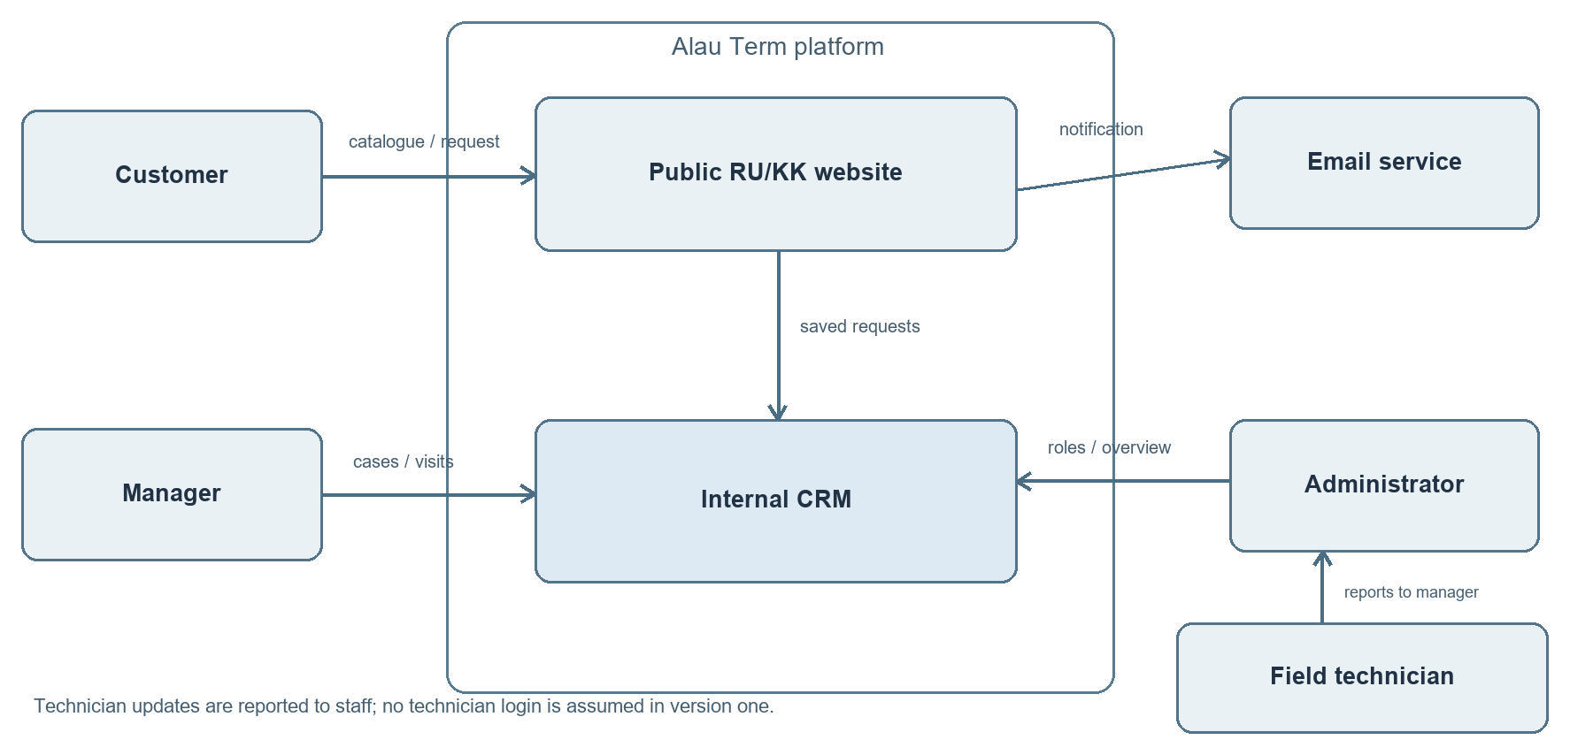
Figure 1. Context: public website, internal CRM and external participants. Technician reports reach staff; no technician login is assumed.
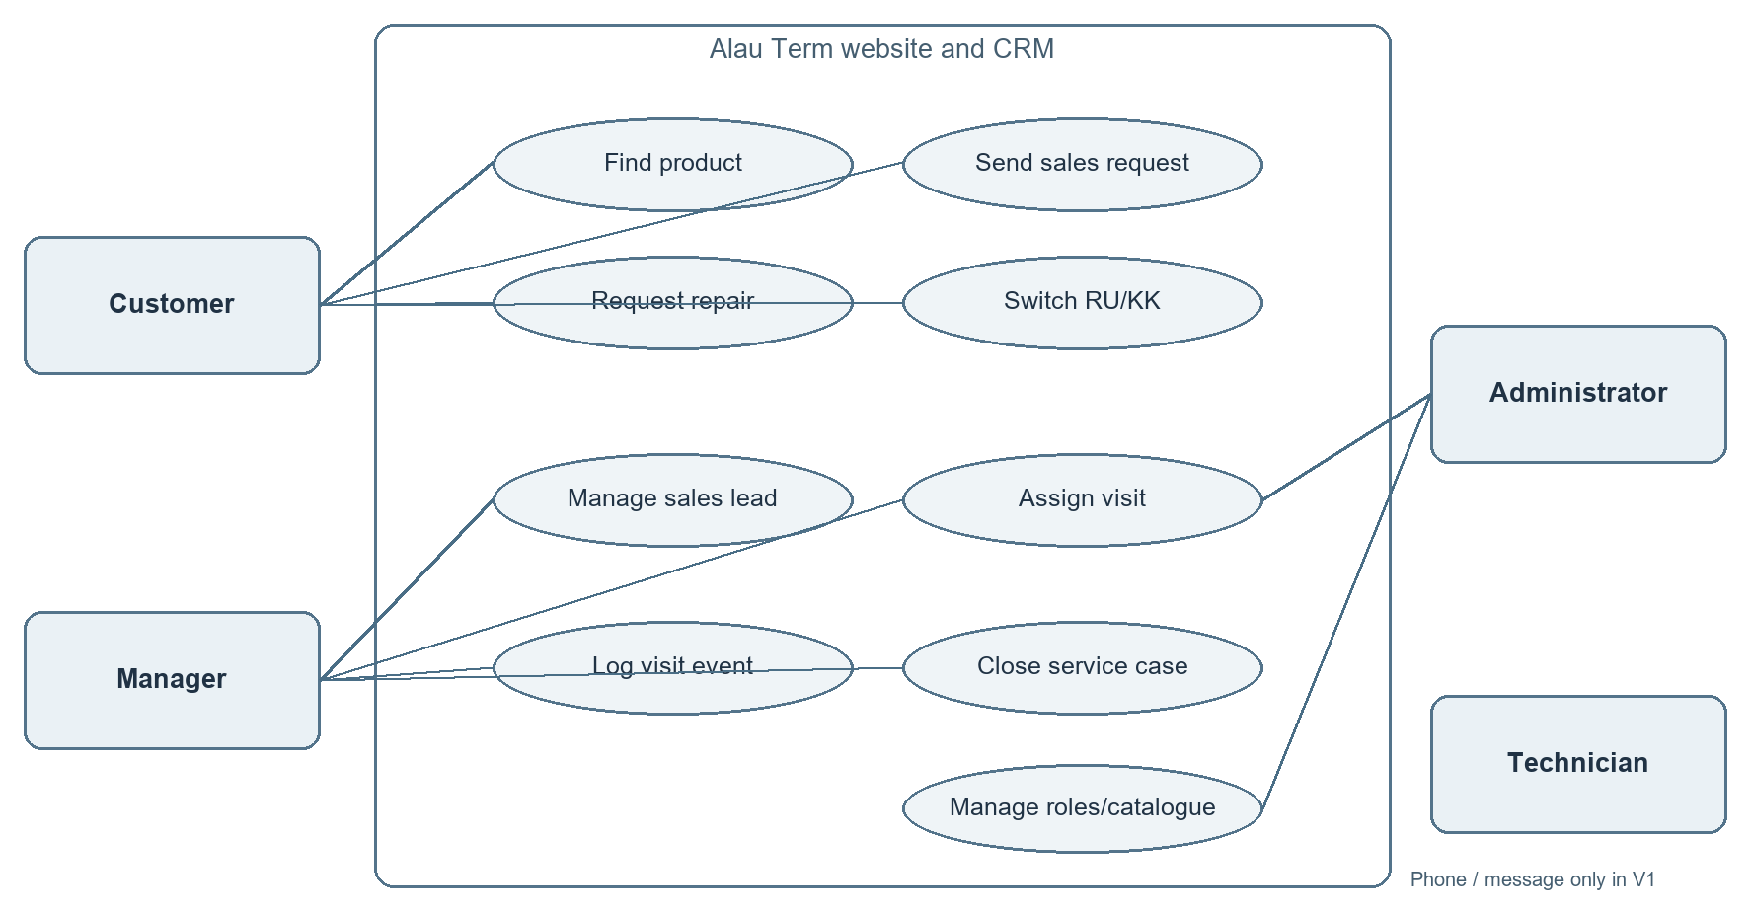
Figure 2. Core use cases by role; field-worker communication is outside the version-one system boundary.
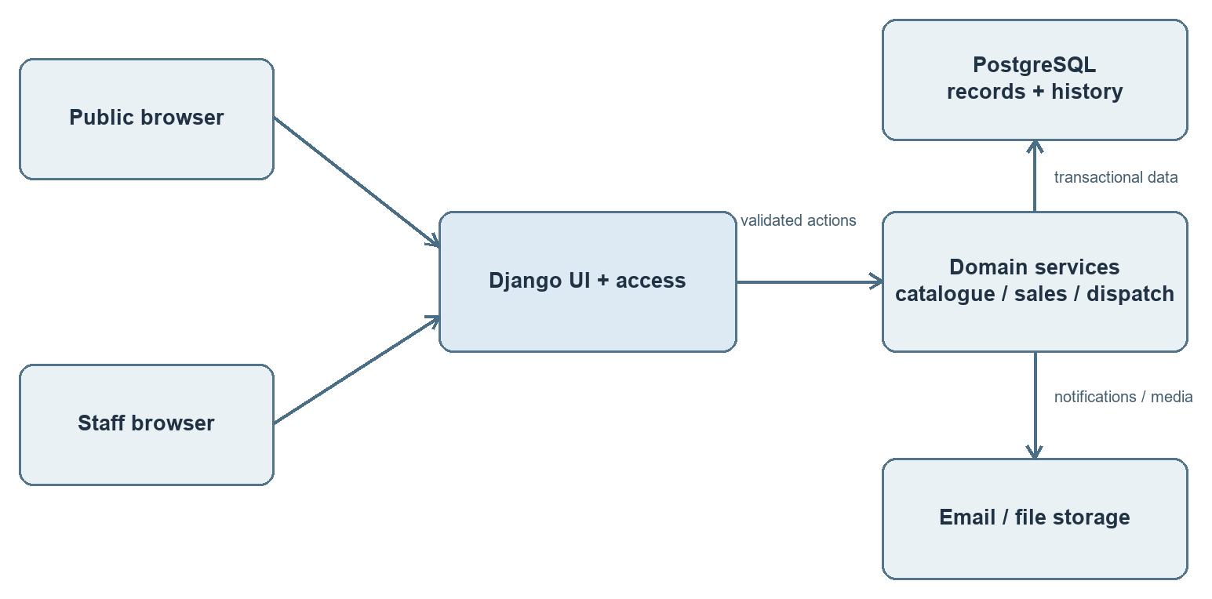
Figure 3. Proposed components. Application services own database access and append status history.
Core data objects: Product and ProductTranslation; SalesLead; ServiceCase; WorkOrder; Visit (worker and planned slot); StatusEvent (event type, reported event time, entry time, recording staff user); User and Role. One case may have multiple visits, and each visit may have multiple events. Customer identifiers and contact details are stored only where needed for processing, subject to a retention policy to be agreed.

8. UX scenarios and draft screens
All names, counts and records in the following wireframes are fictitious. These are design artifacts to review with the representative and intended staff, not evidence of completed functionality.
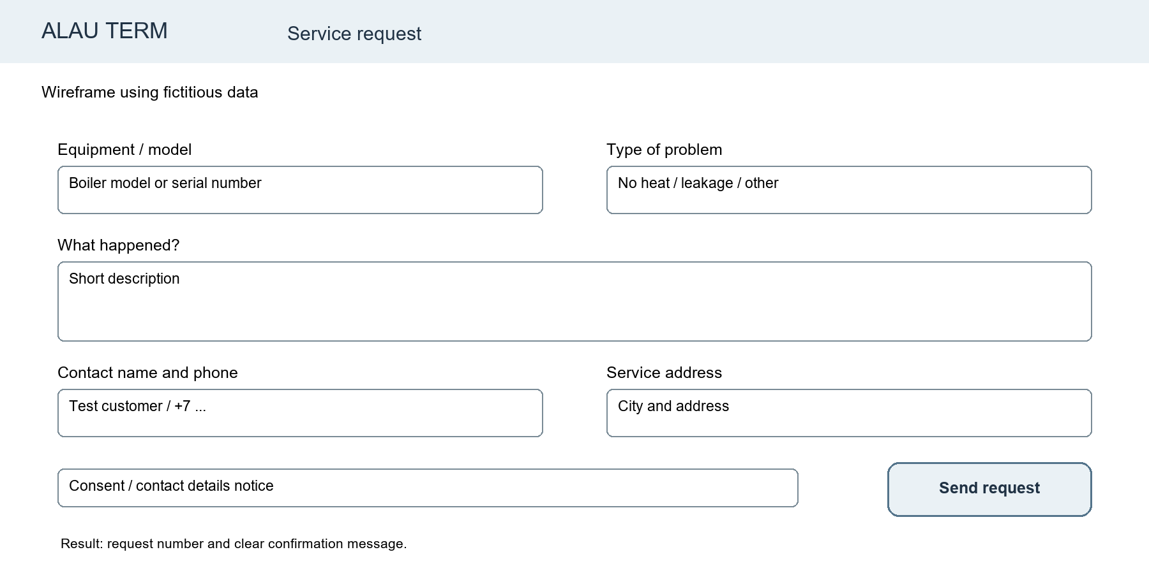
Figure 4. Public repair request: essential details, validation and clear confirmation.
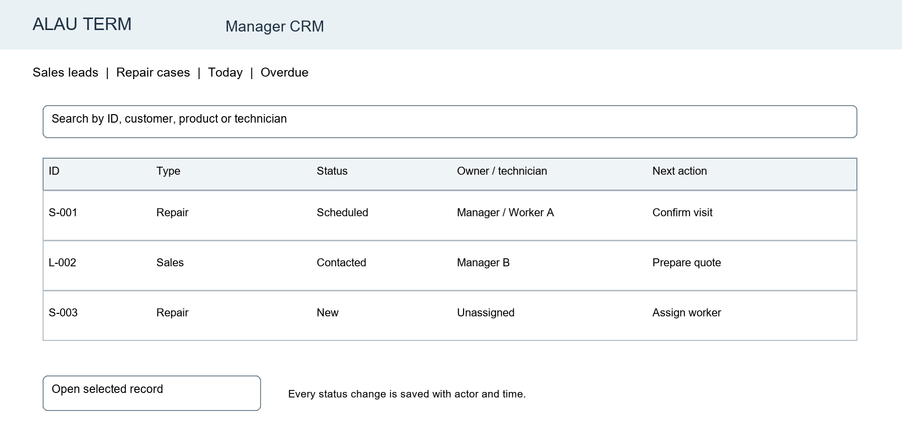
Figure 5. Manager queue: shared search, type/status filters and next action.
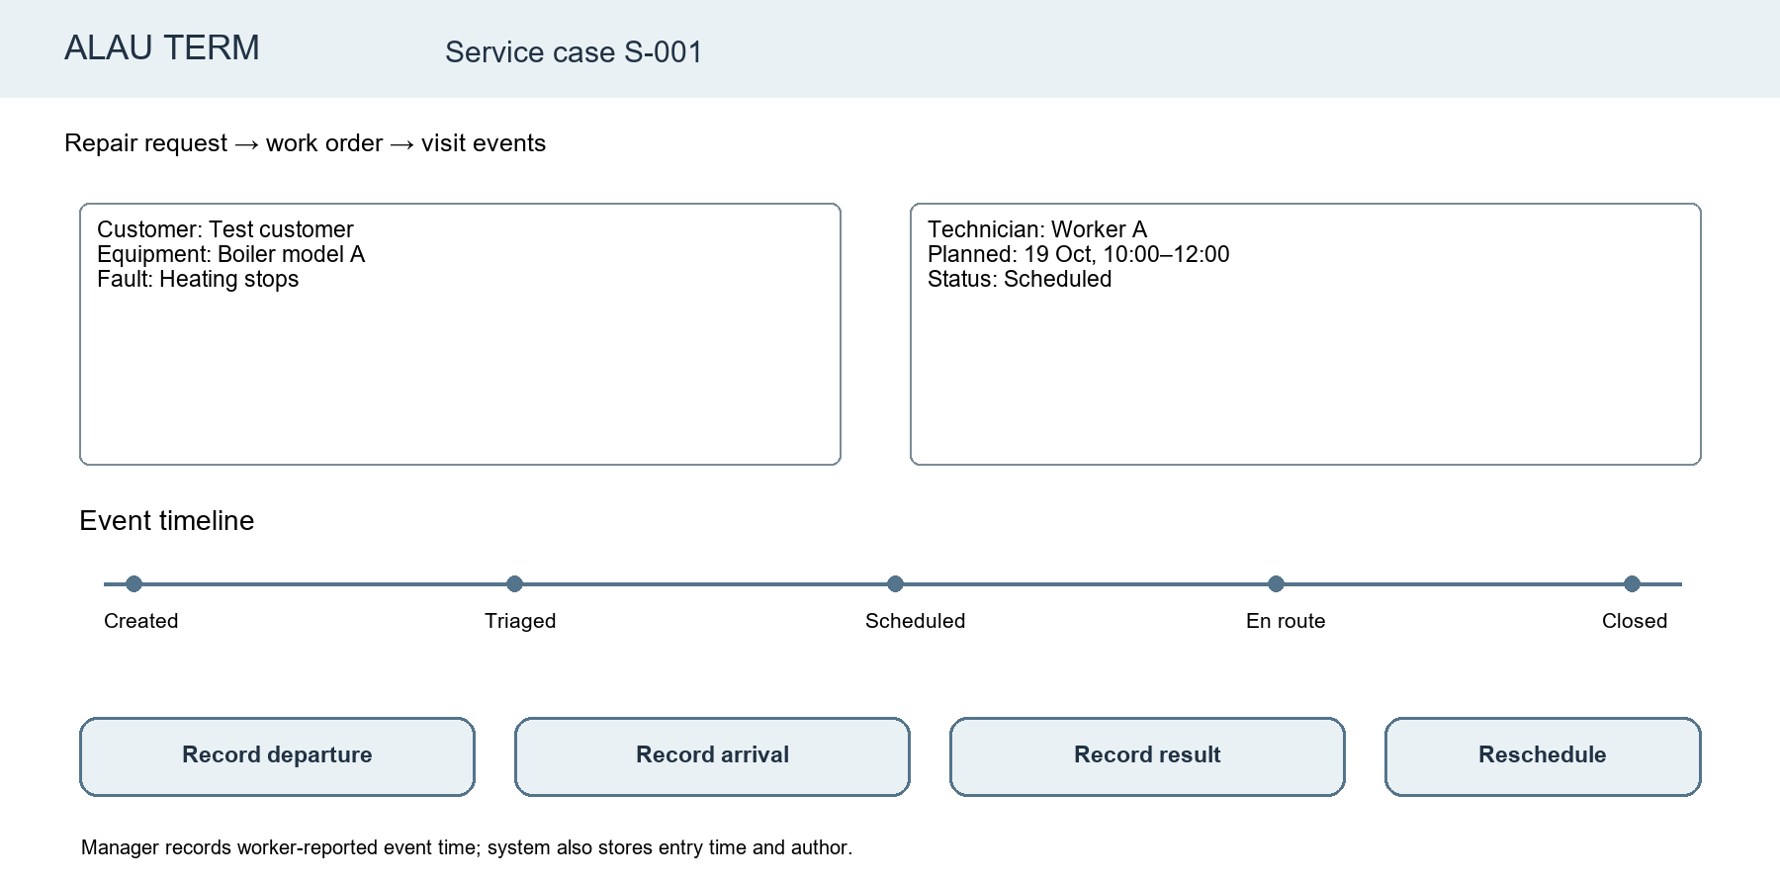
Figure 6. Service case: assignment, visit timeline and manager-entered technician updates.
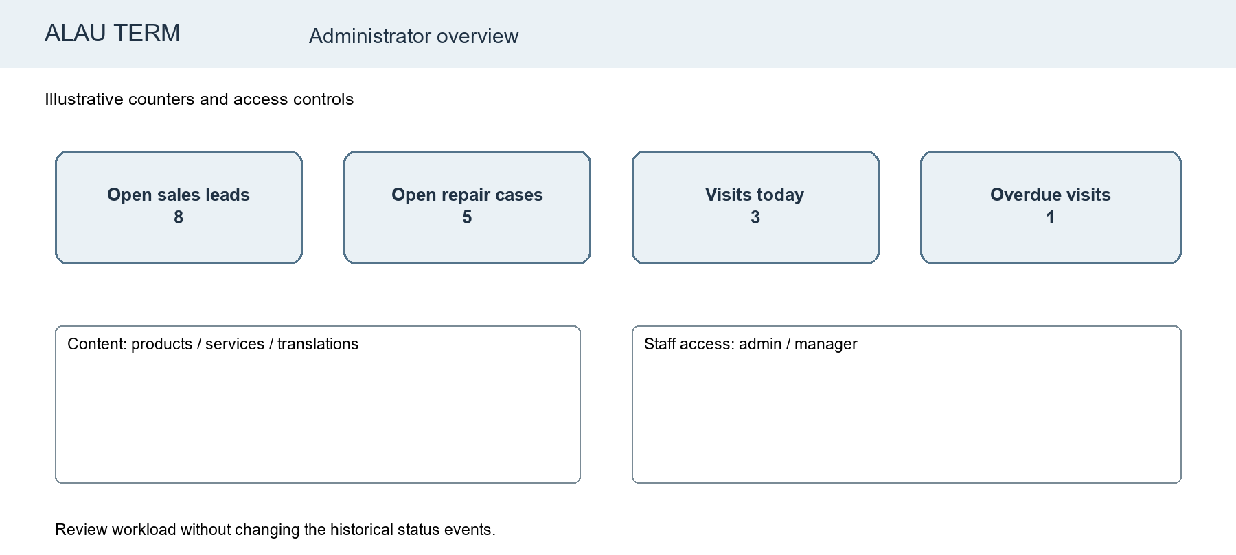
Figure 7. Administrator overview: workload summary, content and staff controls.
Scenario | Task success criterion
Customer requests repair | Completes RU or KK form, receives confirmation and case ID; manager sees same case.
Manager schedules visit | Finds new case, assigns worker and slot, then verifies both in case history.
Worker reports progress | Manager records departure/arrival/result with event time; previous events remain visible.
Administrator checks workload | Opens period view and matches totals to underlying cases.

9. Verification plan and baseline
Two baselines must be kept separate. Technical baseline: the existing static snapshot and its audit figures in Section 2; forms and CRM persistence are not proven there. Operational baseline: current time from request to assignment, missed hand-offs and staff effort; no measured values are available yet. Record these with the company before claiming improvement.
Method / metric | Procedure and evidence
Functional checks | Run F01–F12 acceptance scenarios with synthetic data; save date, build, expected/actual result and defect link.
Access and integrity | Test anonymous/manager/admin permissions, invalid input, duplicate submission, forbidden status transitions, and event-history persistence after reload.
Usability | Ask available staff to complete queue/visit tasks and, if possible, at least five external users to complete a public request. Measure completion, time, errors and 1–5 ease rating. These are proposed samples, not completed tests.
Localisation/accessibility | Review both languages for completeness and terminology; test keyboard navigation, labels, focus and contrast on the four core screens [12].
Performance/recovery | Agree representative data volume and device/network; record load time with median and worst observed run; restore a sample backup and compare case/event counts.

Comparison rule: only compare a later pilot with a measured operational baseline using the same task definitions. Report raw counts and sample size even when results are unfavourable. No measured improvement or customer satisfaction is claimed in this dossier.

10. Repository, task tracking and risk plan
Repository: https://github.com/Gapo-7/DIPLOMA. Stages 1–7 form the static-source history. A working backend, CRM and test evidence must be separately traceable through issues/tasks, branches, PRs, reviewer and commit links. YouTrack project ALAU now contains 15 open tasks (ALAU-1 to ALAU-15); the plan codes below remain planning labels. The final repository package should include README, requirements, diagrams, source list, test evidence, the YouTrack project link (https://gapar1.youtrack.cloud/projects/ALAU) and a checkpoint tag after review.
Plan code / owner | Deliverable | Acceptance / target
P01 Gapar | Confirm customer workflow and log meeting | Dated notes, company role, agreed/changed requirements; 15–17 Oct.
P02 Ramazan | Comparable systems and UX revision | Source links and four reviewed wireframes; 17–19 Oct.
P03 Gapar | Data/role model and CRM proof of concept | Schema, F05/F08/F09 demonstration, tests; after checkpoint.
P04 Ramazan | RU/KK public and staff interface | F01–F04/F06 flows, language checks; after checkpoint.
P05 Both | Literature, decisions and verification dossier | This document revised from evidence; supervisor comments logged; by 20 Oct.
P06 Both | Repository checkpoint package | README, docs, diagrams, task link and tag; by 24 Oct.

Risk | Response / owner
Customer workflow differs from assumed manager hand-off | Interview representative and staff before finalising F08–F10; Gapar.
CRM scope exceeds two-person capacity | Deliver P1 path first; defer analytics and integrations; both.
Archive mistaken for operational software | Label snapshot clearly; show separate functional tests; both.
Missing task history or feedback | Link the created YouTrack project to GitHub; record supervisor review as pending until received; both.
Personal data or translation errors | Use synthetic demos, role checks and approved terminology; Ramazan/Gapar.

11. Supervisor feedback and decisions
No supervisor comments have been received for this version. The following review log is intentionally blank; it should be completed after the supervisor reads the dossier. The team should request confirmation of the project title, role split, scope, customer evidence, requirements and checkpoint format.
Date / reviewer | Comment or decision | Change made / evidence
Pending | Pending | Pending

References
[1] Mourtzis, D., Angelopoulos, J., & Panopoulos, N. (2021). A survey of digital B2B platforms and marketplaces for purchasing industrial product service systems: A conceptual framework. Procedia CIRP, 97, 331–336. https://doi.org/10.1016/j.procir.2020.05.246
[2] Raddats, C., Naik, P., & Ziaee Bigdeli, A. (2022). Creating value in servitization through digital service innovations. Industrial Marketing Management, 104, 1–13. https://doi.org/10.1016/j.indmarman.2022.04.002
[3] Pham, D. T., & Kiesmüller, G. P. (2022). Multiperiod integrated spare parts and tour planning for on-site maintenance activities with stochastic repair requests. Computers & Operations Research, 148, 105967. https://doi.org/10.1016/j.cor.2022.105967
[4] Nowak, M., & Szufel, P. (2024). Technician routing and scheduling for the sharing economy. European Journal of Operational Research, 314(1), 15–31. https://doi.org/10.1016/j.ejor.2023.09.023
[5] Costa, A. C. F., et al. (2024). Digitalization of customer service in small and medium-sized enterprises: drivers for the development and improvement. International Journal of Entrepreneurial Behavior & Research, 30(2/3), 305–341. https://doi.org/10.1108/IJEBR-10-2022-0953
[6] Szwajca, D., & Rydzewska, A. (2025). Effects and determinants of implementing digital customer service tools in Polish SMEs. Sustainability, 17(3), 1022. https://doi.org/10.3390/su17031022
[7] Guo, J., Zhang, W., & Xia, T. (2023). Impact of shopping website design on customer satisfaction and loyalty: The mediating role of usability and the moderating role of trust. Sustainability, 15(8), 6347. https://doi.org/10.3390/su15086347
[8] Al Salem, T. S., & Alshamari, M. A. (2023). Assessing interactive web-based systems using behavioral measurement techniques. Future Internet, 15(11), 365. https://doi.org/10.3390/fi15110365
[9] Bercaru, V., & Popescu, N. (2024). A systematic review of accessibility techniques for online platforms: Current trends and challenges. Applied Sciences, 14(22), 10337. https://doi.org/10.3390/app142210337
[10] Phamthi, V. A., Nagy, Á., & Ngo, T. M. (2024). The influence of perceived risk on purchase intention in e-commerce—Systematic review and research agenda. International Journal of Consumer Studies, 48(4), e13067. https://doi.org/10.1111/ijcs.13067
[11] Nayak, A., & Aravindakshan Nair, A. (2025). Language translation effects in Chatbots: Evidence from a randomized field experiment on a mobile commerce platform. Journal of Business Research, 190, 115158. https://doi.org/10.1016/j.jbusres.2024.115158
[12] W3C. Web Content Accessibility Guidelines (WCAG) 2.2. https://www.w3.org/TR/WCAG22/
[13] Django Software Foundation. Django documentation: Forms, authentication and internationalization. https://docs.djangoproject.com/
[14] PostgreSQL Global Development Group. Documentation: Constraints. https://www.postgresql.org/docs/current/ddl-constraints.html
[15] OWASP. Application Security Verification Standard. https://owasp.org/projects/asvs
[16] Flame Tech. Services and burner catalogue. https://flame-tech.kz/services ; https://flame-tech.kz/goreliki
[17] EKSTRA / Vector Tepla. Public catalogue and services. https://vectortepla.kz/
[18] Teploshop. Public catalogue. https://teploshop.kz/
[19] Zoho FSM. Requests, work orders and scheduling documentation. https://www.zoho.com/fsm/requests.html ; https://www.zoho.com/fsm/schedule-and-dispatch.html
[20] Salesforce. Field Service work-order documentation. https://help.salesforce.com/s/articleView?id=service.fs_manage_wo.htm&language=en_US&type=5

