Laboratory Work No. 9
Security

Student | Galym Gapar
Group | SE-2418
Course | Advanced Operating Systems

Objective
The objective of this lab is to explore important Windows security mechanisms. In this work, we inspected Windows Security, Event Viewer, ACL permissions, authentication settings, cryptography tools, malware protection, firewall rules, UAC, and system integrity checks.

Screenshot Checklist
- Windows Security main page, Virus & threat protection, Firewall & network protection, App & browser control
- Event Viewer -> Windows Logs -> Security
- C:\GroupSecurityTest folder, Security permissions, icacls output
- Password Policy, User Rights Assignment, BitLocker/Device Encryption, whoami /all, manage-bde -status
- Full scan, Task Manager, Resource Monitor, Get-MpThreat, process list, Startup apps, Task Scheduler
- Windows Defender Firewall, Inbound/Outbound rules, UAC, sfc /scannow, DISM result, Installed apps

Part 1: The Security Environment and Threats
Role: Threat Analyst
How to open
- Start -> search Windows Security
- Settings -> Privacy & security -> Windows Security
- Win + R -> eventvwr.msc -> Windows Logs -> Security
What to do
- Open Windows Security and check Virus & threat protection.
- Check Firewall & network protection.
- Check App & browser control.
- Open Event Viewer and review Security audit events.
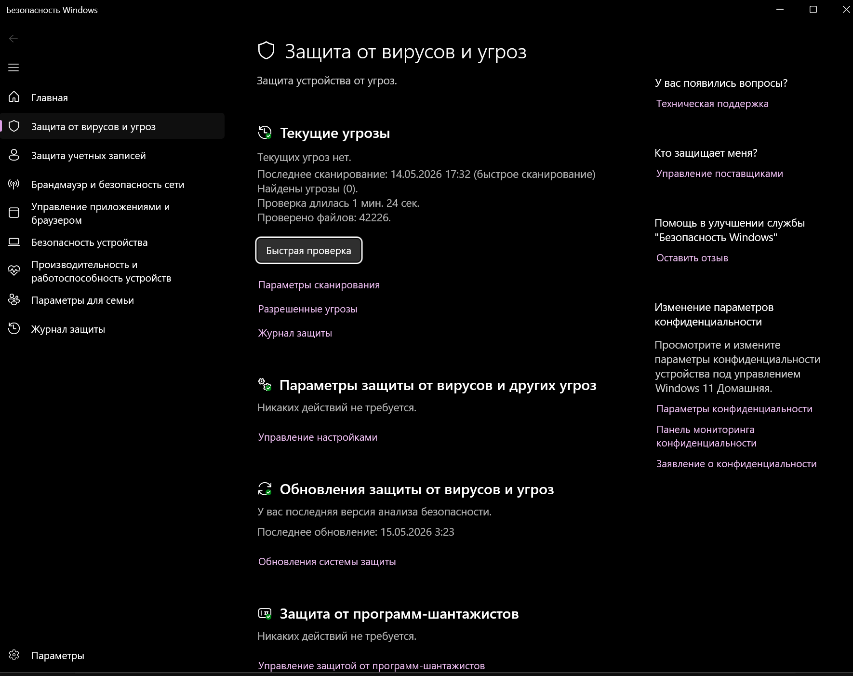



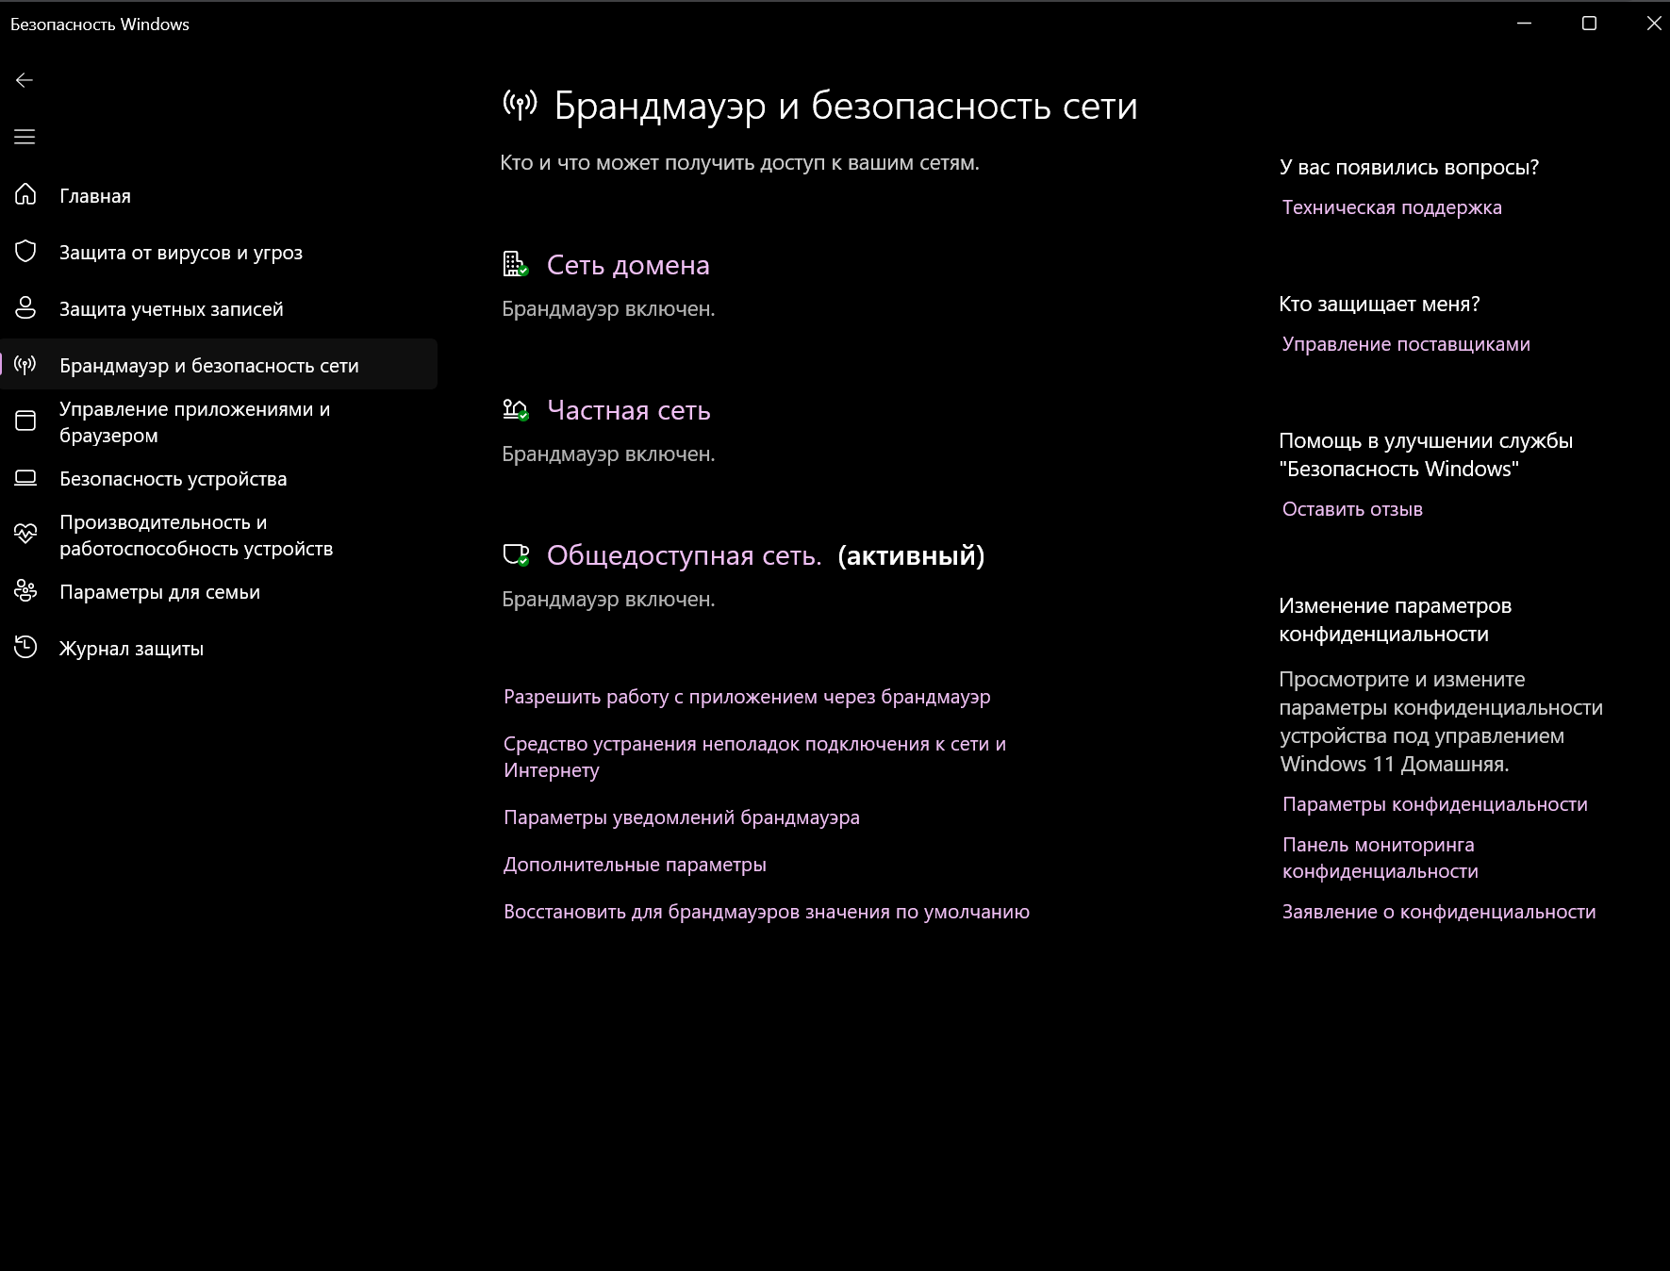

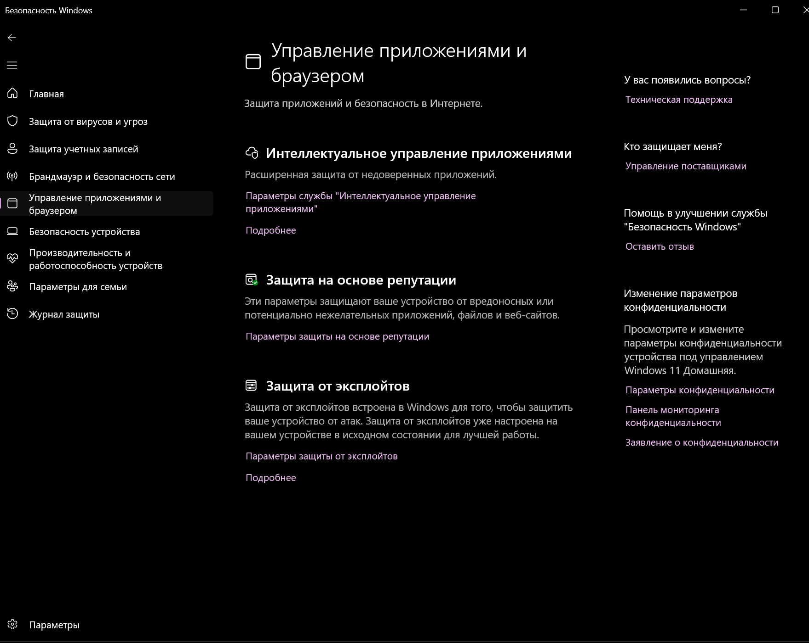

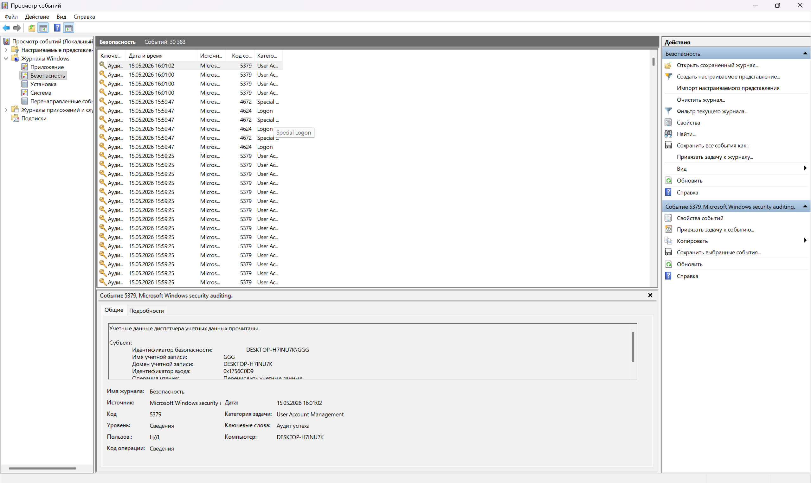

Question 1. What are the main types of threats and attackers described in Chapter 9.1?
The main security threats include malware, unauthorized access, data theft, denial of service, spyware, ransomware, and system exploitation. Attackers can be external hackers, cybercriminals, insiders, or automated malware programs. Their goal can be to steal data, damage the system, get unauthorized privileges, or stop normal system work.
Question 2. What suspicious activities can you detect in Event Viewer?
In Event Viewer, suspicious activity may include failed logon attempts, unusual successful logons, privilege use events, account changes, and system audit events. In our case, no clearly dangerous activity was detected. Most events were normal security audit events created by Windows.

Part 2: ACLs and Protection Domains
Role: Access Control Specialist
How to open
- File Explorer -> Local Disk (C:) -> create folder GroupSecurityTest
- Right click folder -> Properties -> Security -> Edit
- Start -> type cmd -> Run as administrator
Command
icacls "C:\GroupSecurityTest"
What to do
- Create C:\GroupSecurityTest.
- Open folder Security tab and view permissions for users/groups.
- Modify permissions, for example give Users only Read/Read & execute.
- Run icacls command and save the output screenshot.
- If there is no standard user account, explain that permissions were tested through Security tab and icacls.
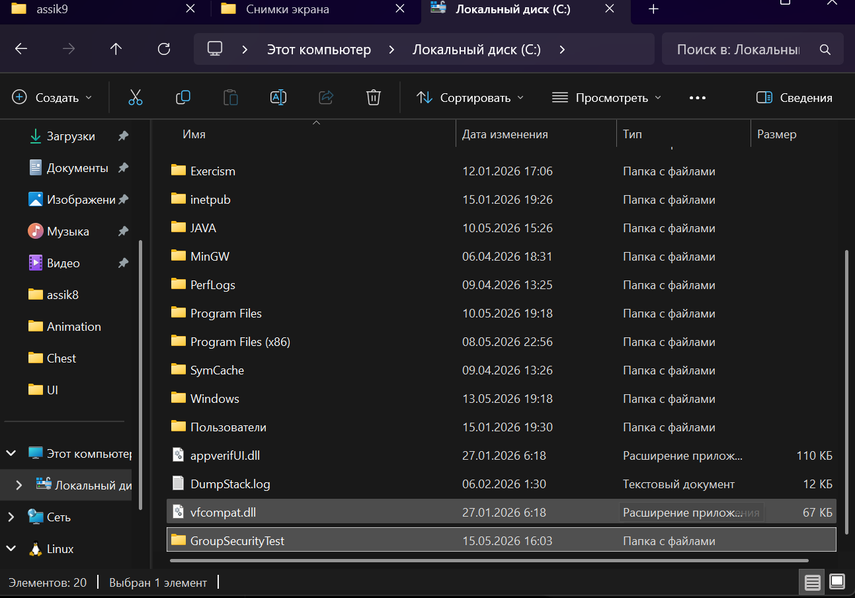

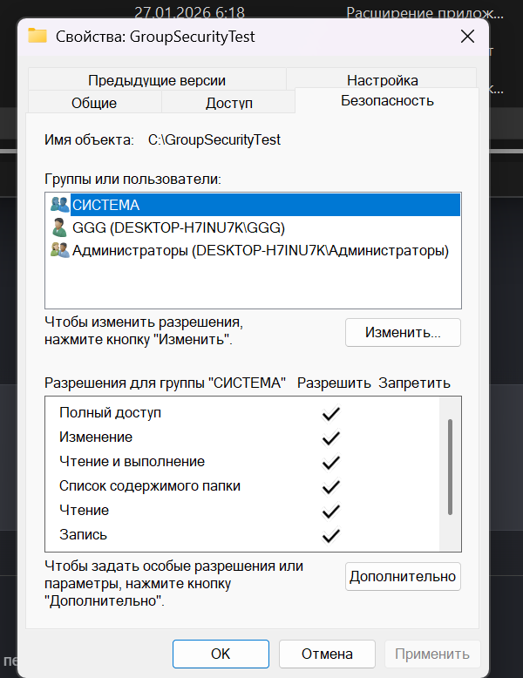

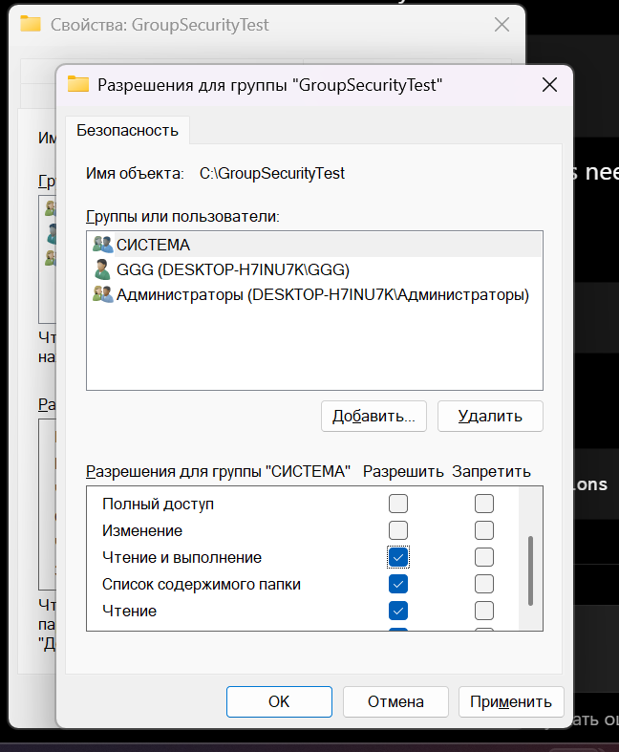

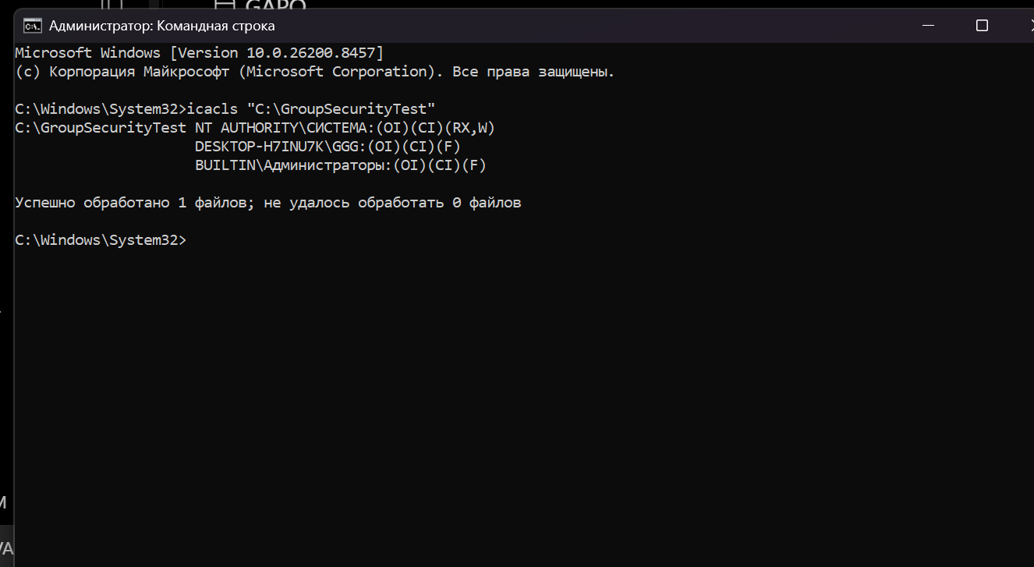

Question 1. How are ACLs and Protection Domains implemented in Windows?
Windows implements ACLs through NTFS permissions. Each file or folder has a security descriptor that stores which users and groups can access it. Protection domains are represented by user accounts, groups, and security tokens. When a user tries to access a resource, Windows checks the user token against the ACL.
Question 2. What is the difference between NTFS permissions and sharing permissions?
NTFS permissions control access to files and folders both locally and over the network. Sharing permissions apply only when the folder is accessed through the network. If both are used, the most restrictive effective permission usually applies.
Question 3. How does this relate to the principle of least privilege?
The principle of least privilege means users should receive only the permissions they really need. For example, a normal user may only need Read permission instead of Full Control. This reduces the risk of accidental or malicious changes.

Part 3: Authentication and Cryptography
Role: Authentication and Crypto Specialist
How to open
- Win + R -> secpol.msc -> Account Policies -> Password Policy
- Local Security Policy -> Local Policies -> User Rights Assignment
- Settings -> Privacy & security -> Device encryption OR search BitLocker
- Command Prompt as administrator
Commands
whoami /all
manage-bde -status
What to do
- Check Password Policy settings.
- Check User Rights Assignment.
- Check BitLocker or Device Encryption status.
- Run whoami /all and manage-bde -status.
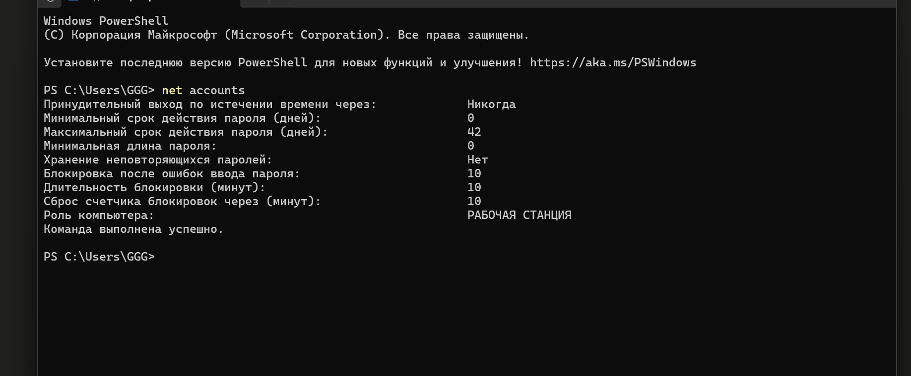

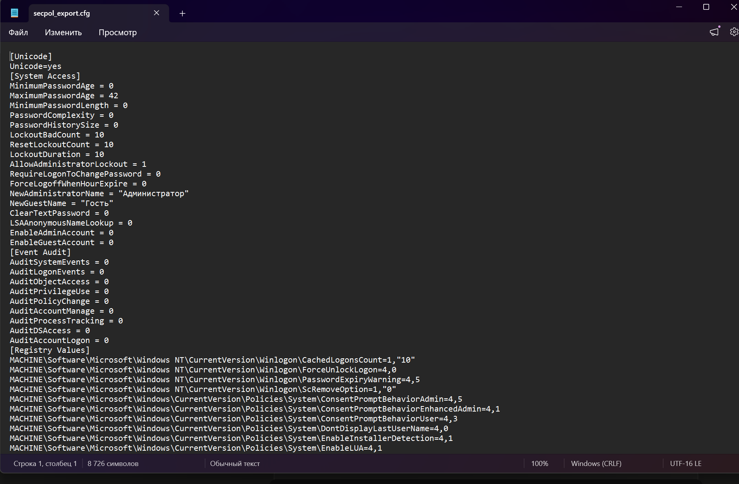

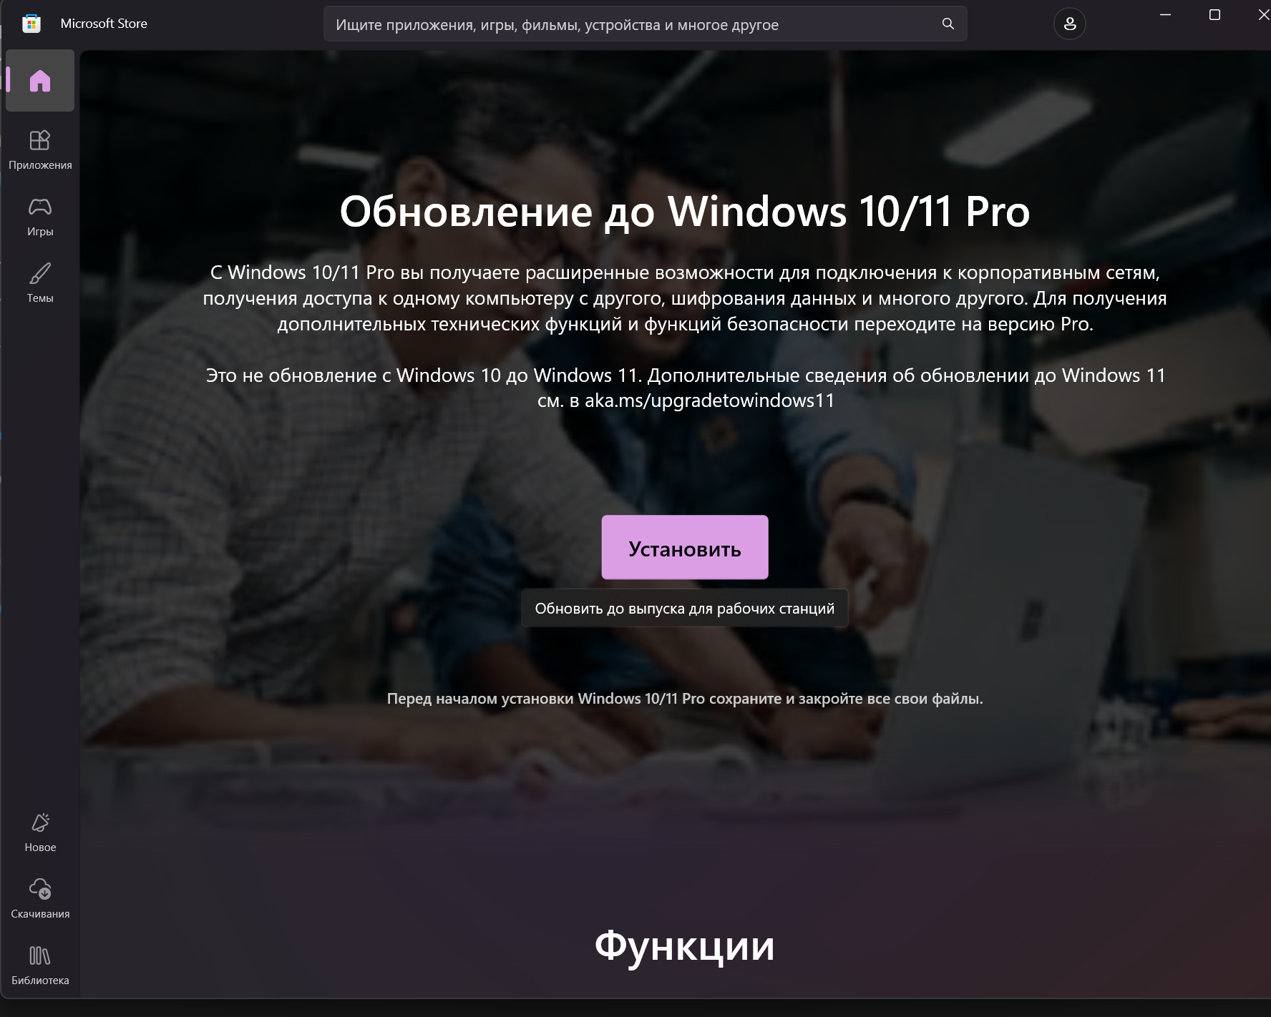

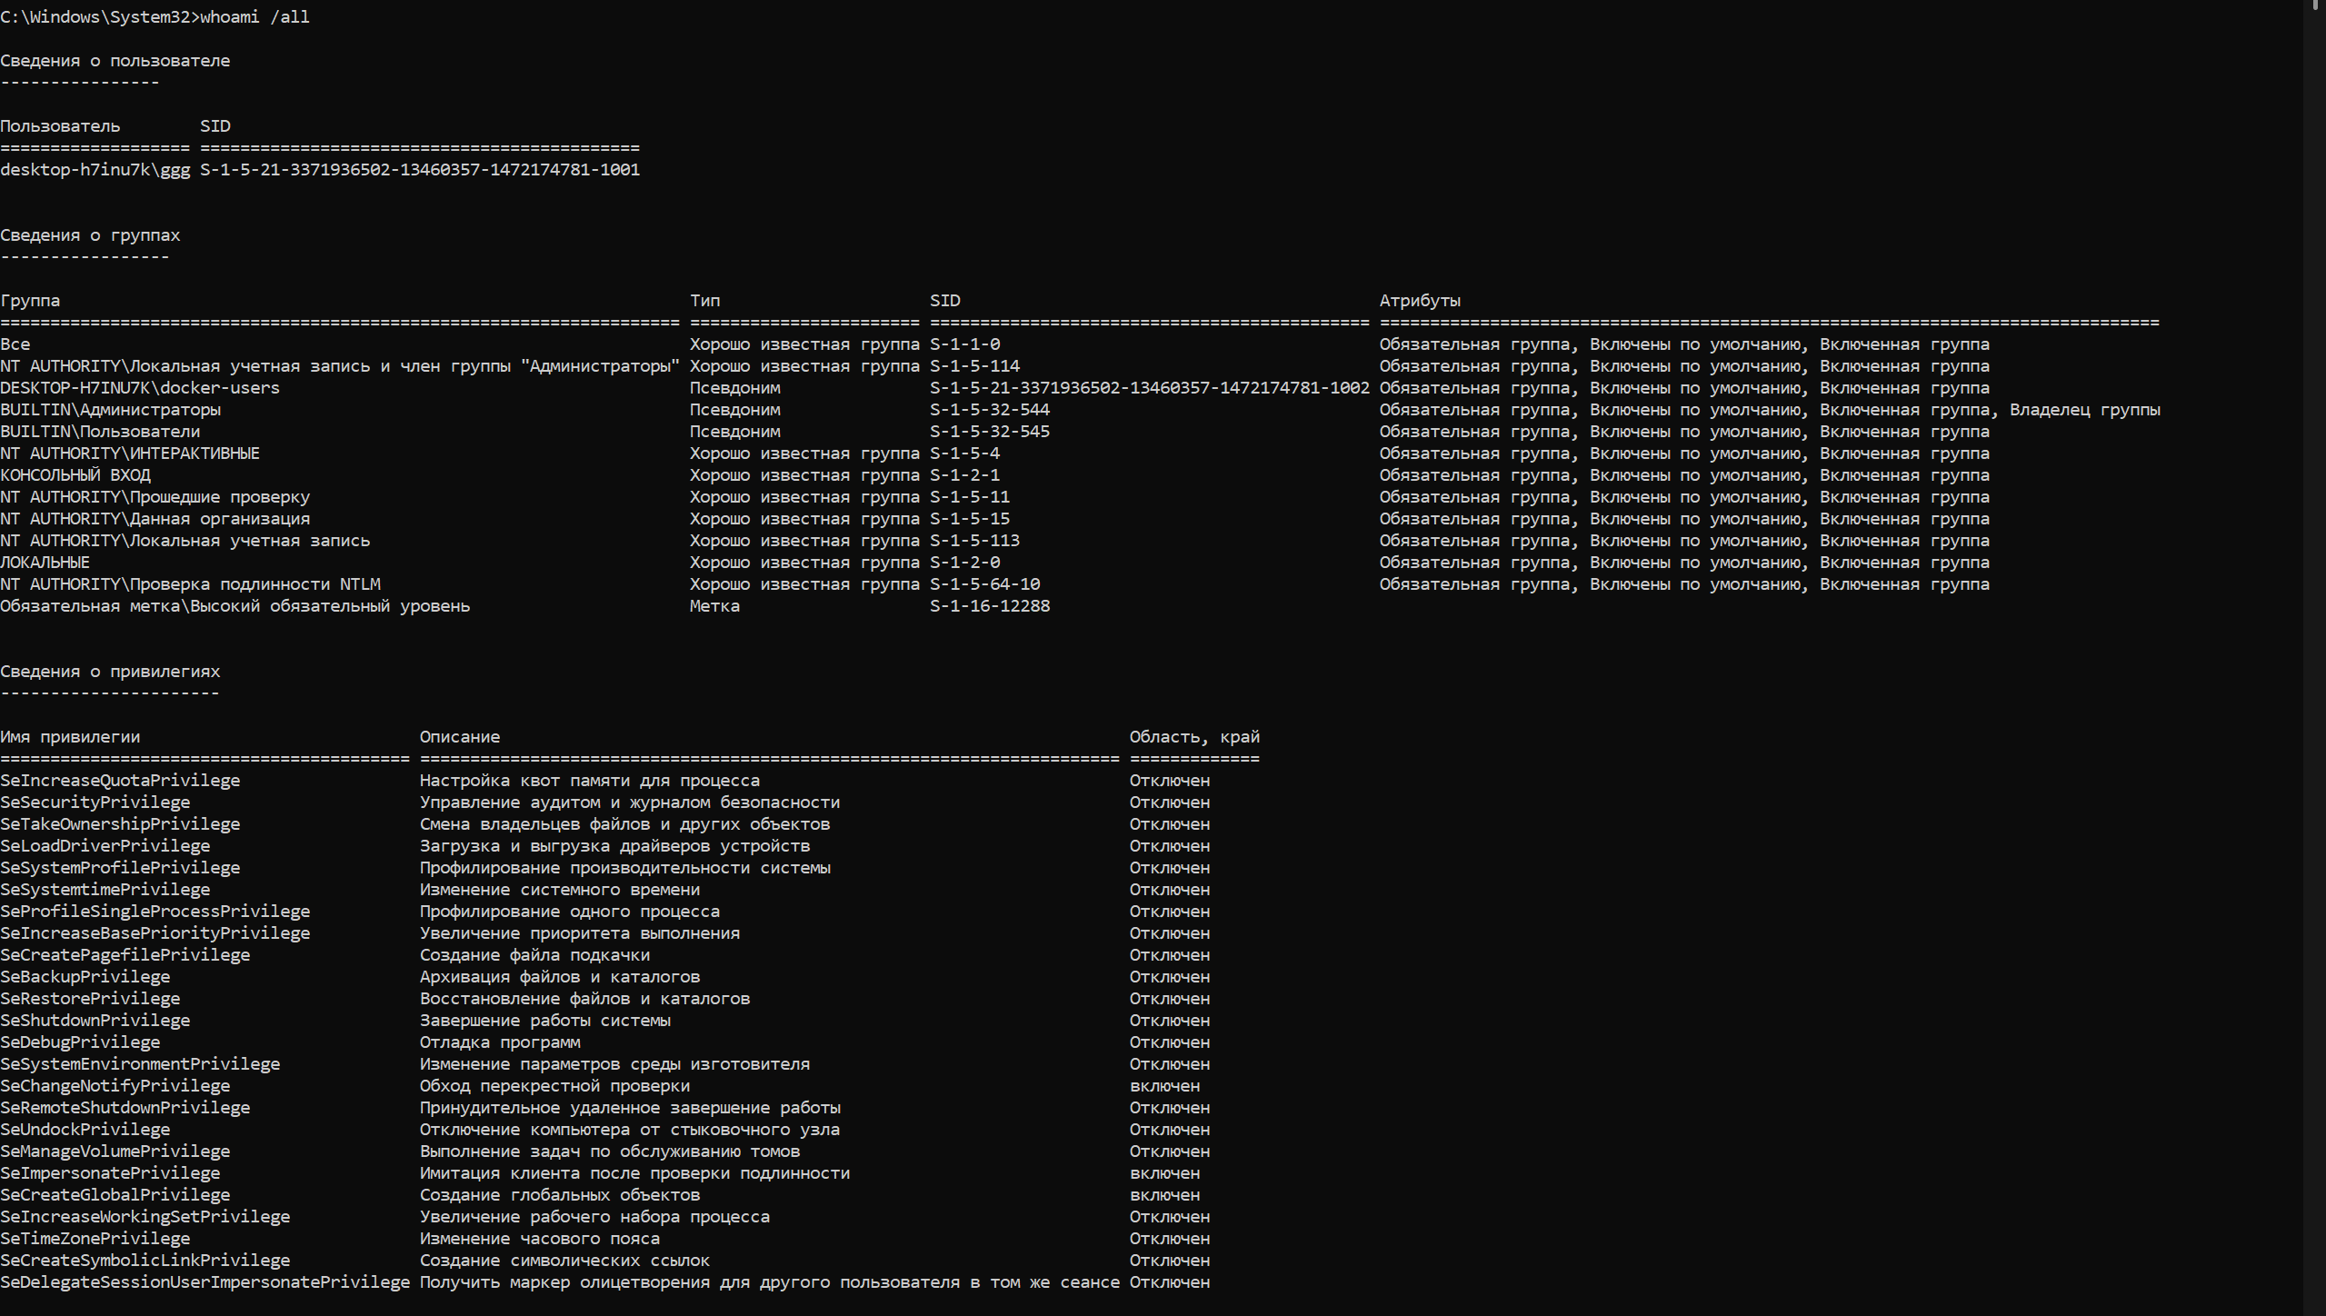

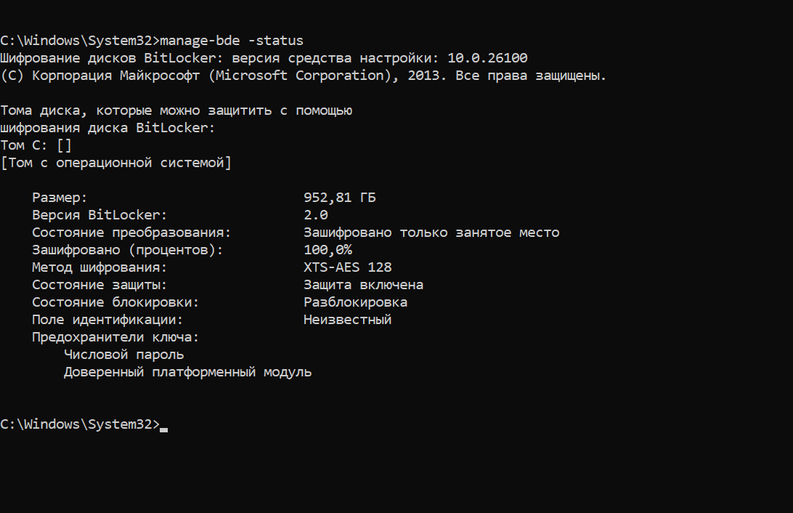

Question 1. What authentication mechanisms does Windows support?
Windows supports password authentication, PIN, Windows Hello biometrics, local accounts, Microsoft accounts, domain accounts, smart cards, and multi-factor authentication in enterprise environments. These mechanisms help verify the identity of a user before giving access to the system.
Question 2. How does BitLocker relate to secret-key and public-key cryptography?
BitLocker mainly uses symmetric encryption to protect disk data. Symmetric encryption means the same secret key is used for encryption and decryption. BitLocker can also use TPM and recovery keys to protect the encryption key. Public-key ideas can be used in key protection and enterprise recovery scenarios, but the actual disk data encryption is mainly symmetric.

Part 4: Malware and Software Exploitation
Role: Malware Analyst
How to open
- Windows Security -> Virus & threat protection -> Scan options -> Full scan
- Ctrl + Shift + Esc -> Task Manager -> Processes
- Win + R -> resmon -> CPU tab
- PowerShell as administrator
- Ctrl + Shift + Esc -> Startup apps
- Start -> search Task Scheduler
PowerShell commands
Get-MpThreat
Get-Process | Select Name, Id, Path | Out-GridView
Alternative if Out-GridView does not work: Get-Process | Select Name, Id, Path
What to do
- Start or run a Full scan in Windows Security.
- Inspect running processes in Task Manager.
- Inspect CPU/process activity in Resource Monitor.
- Run Defender and process-list PowerShell commands.
- Check Startup apps and Task Scheduler.
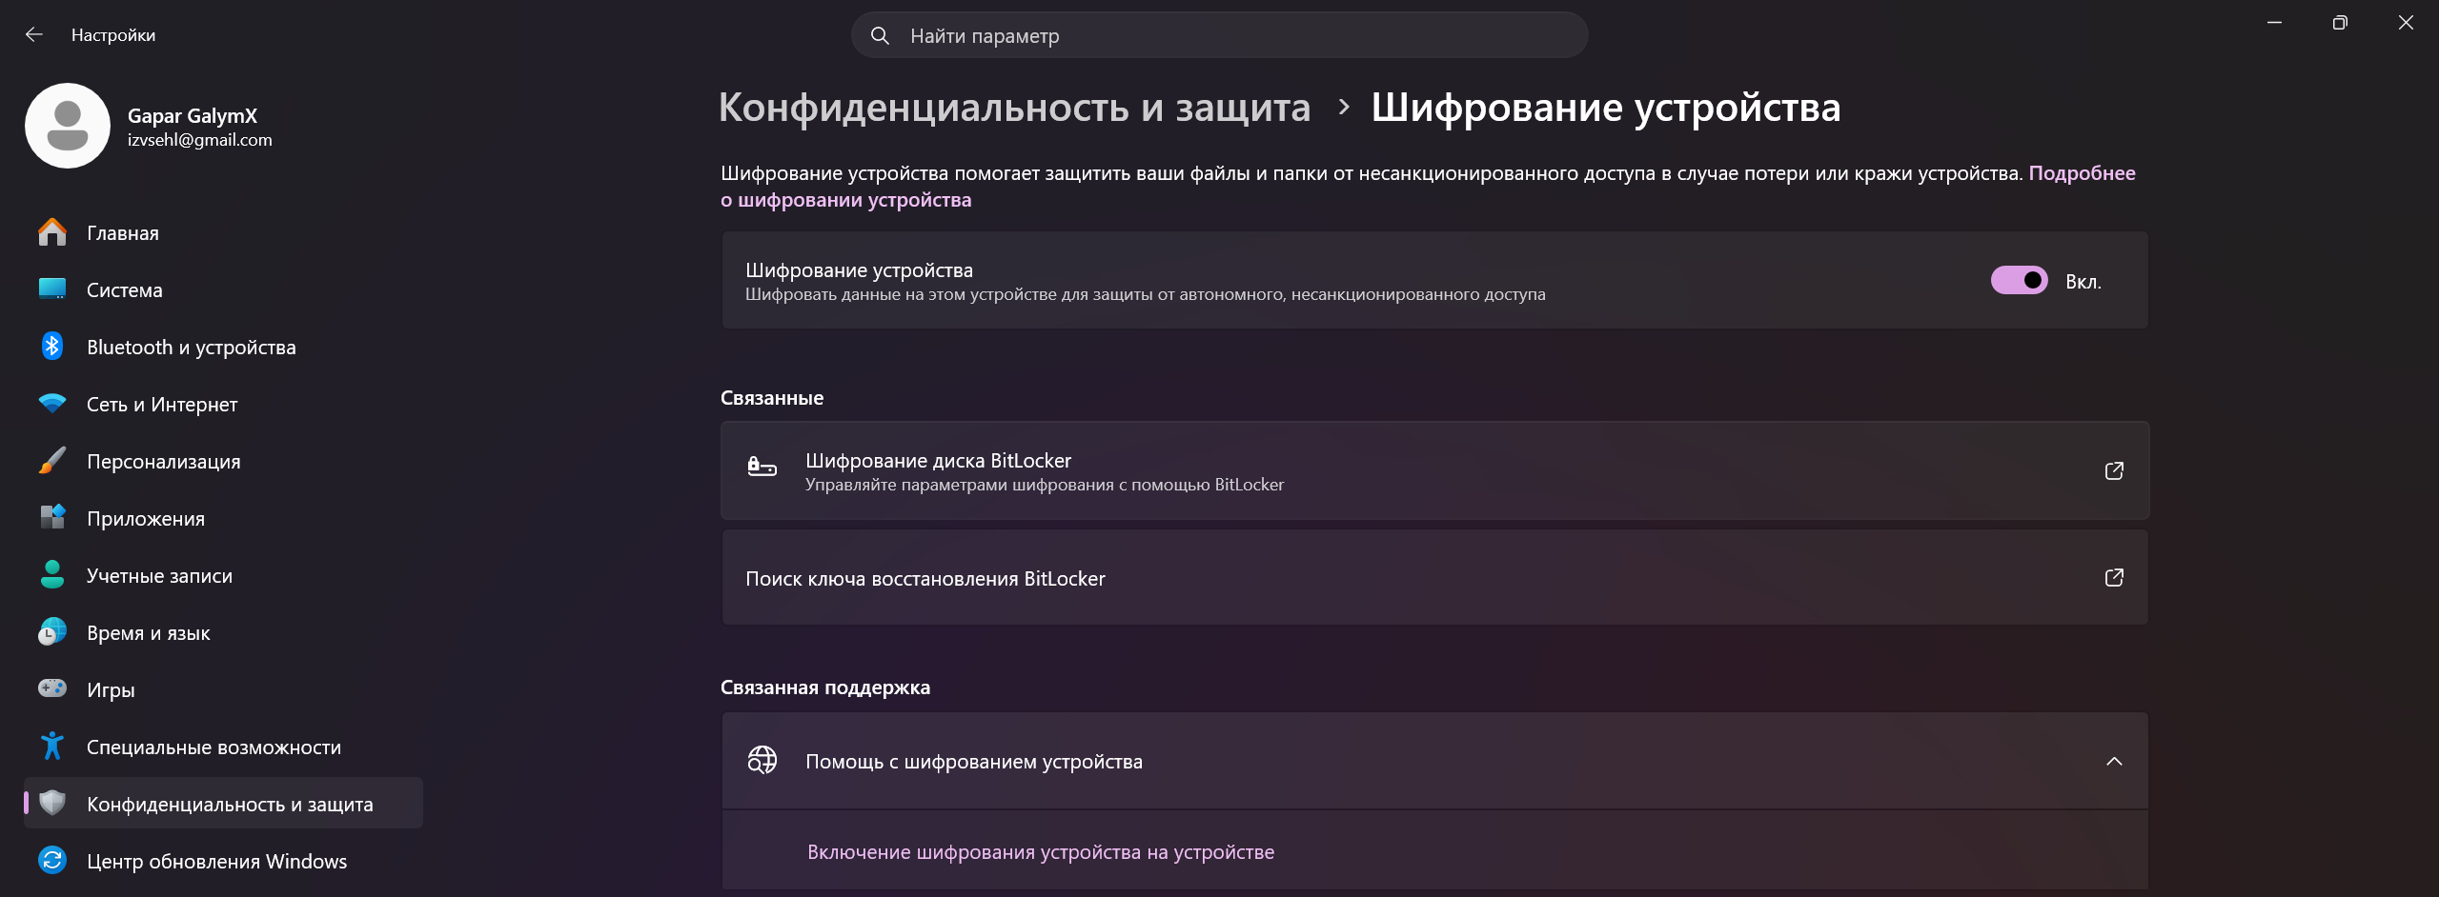

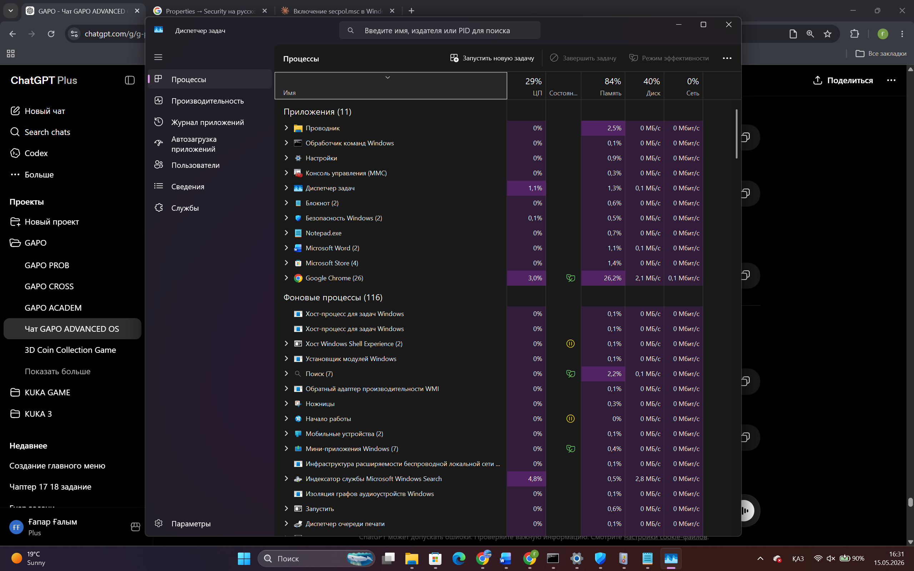

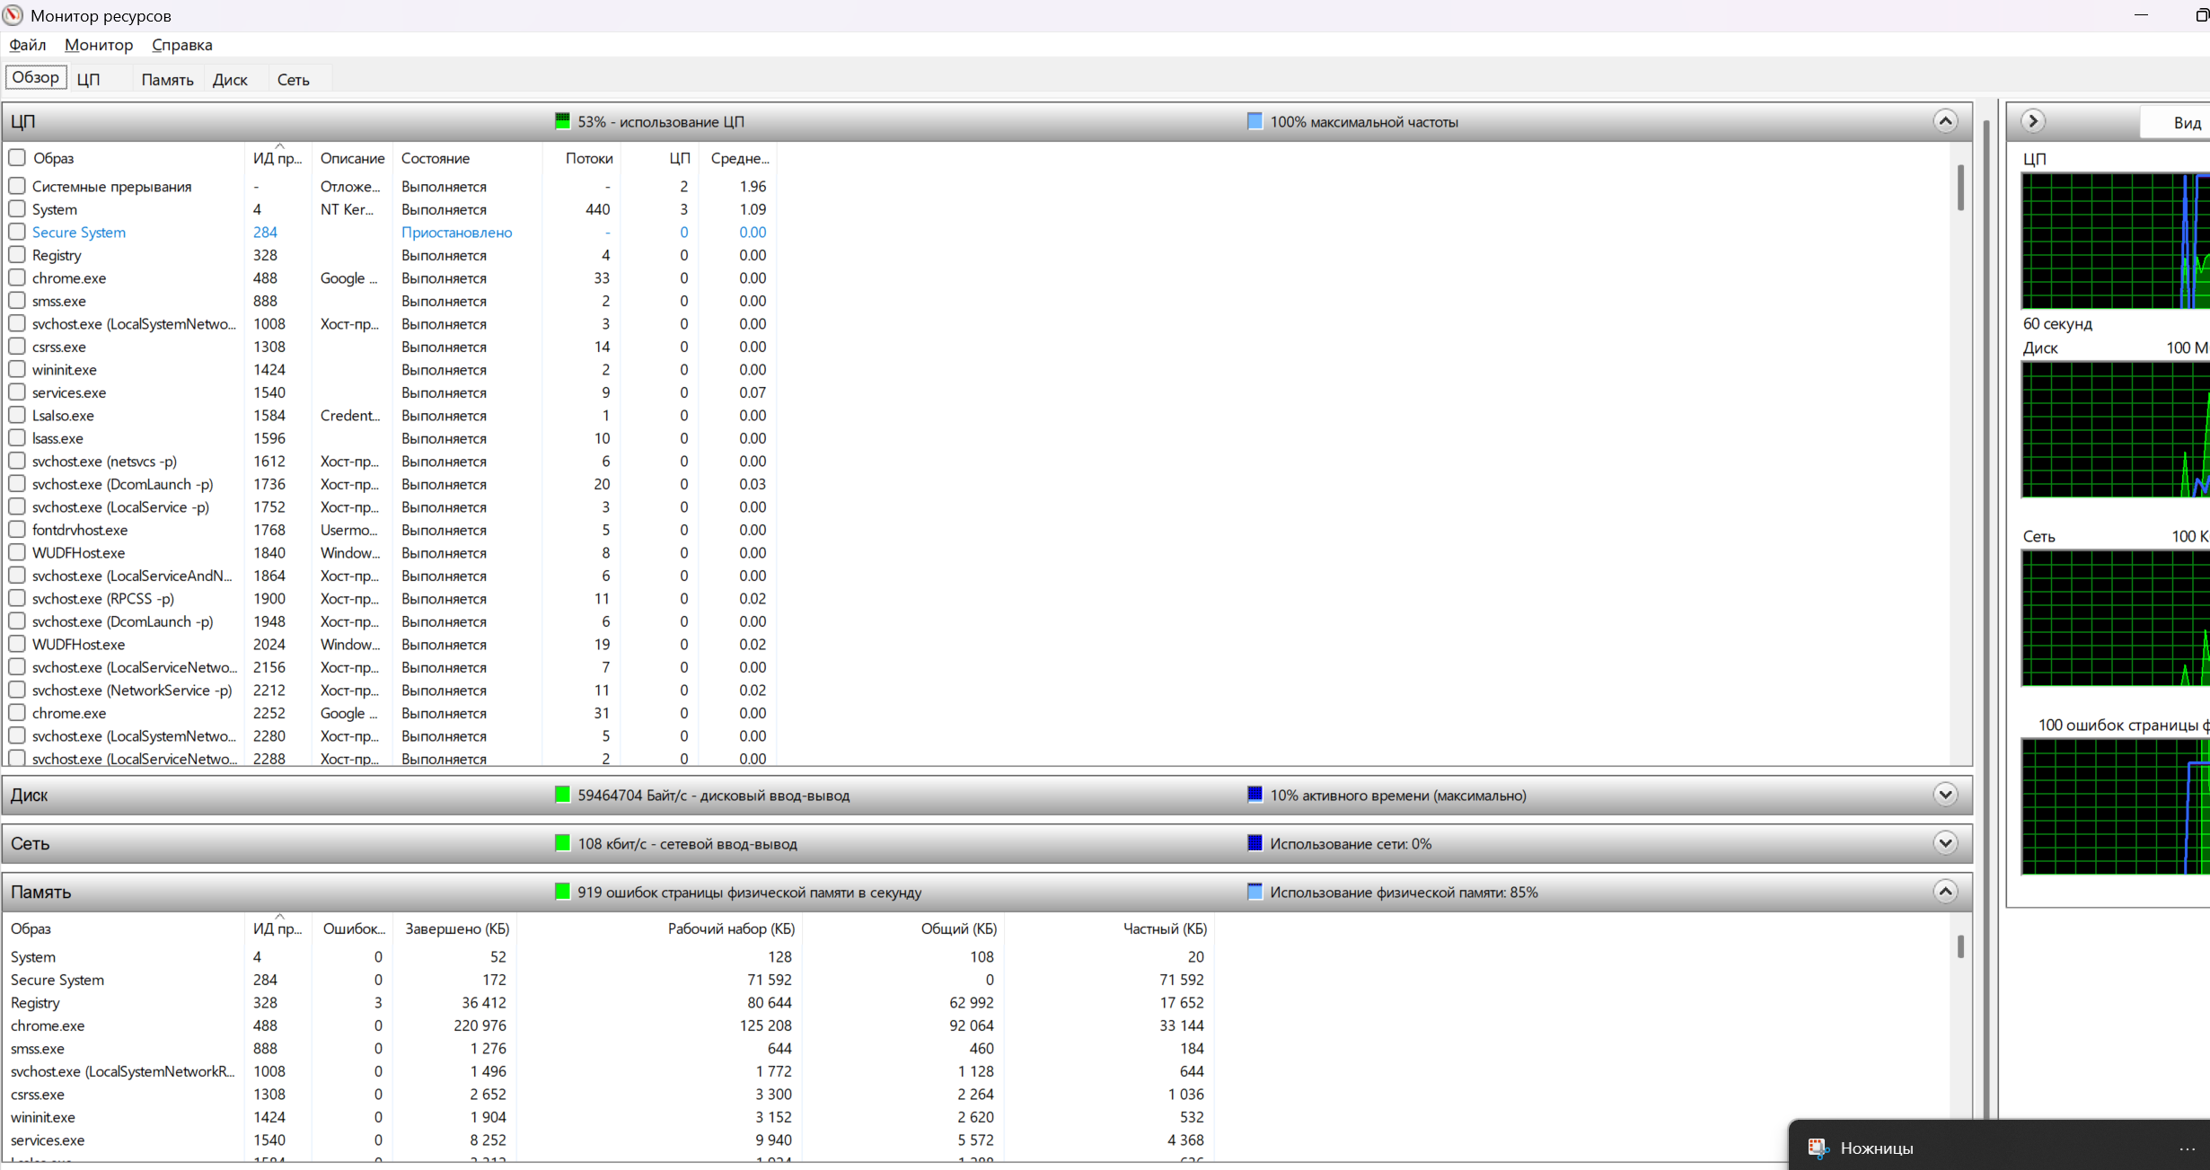

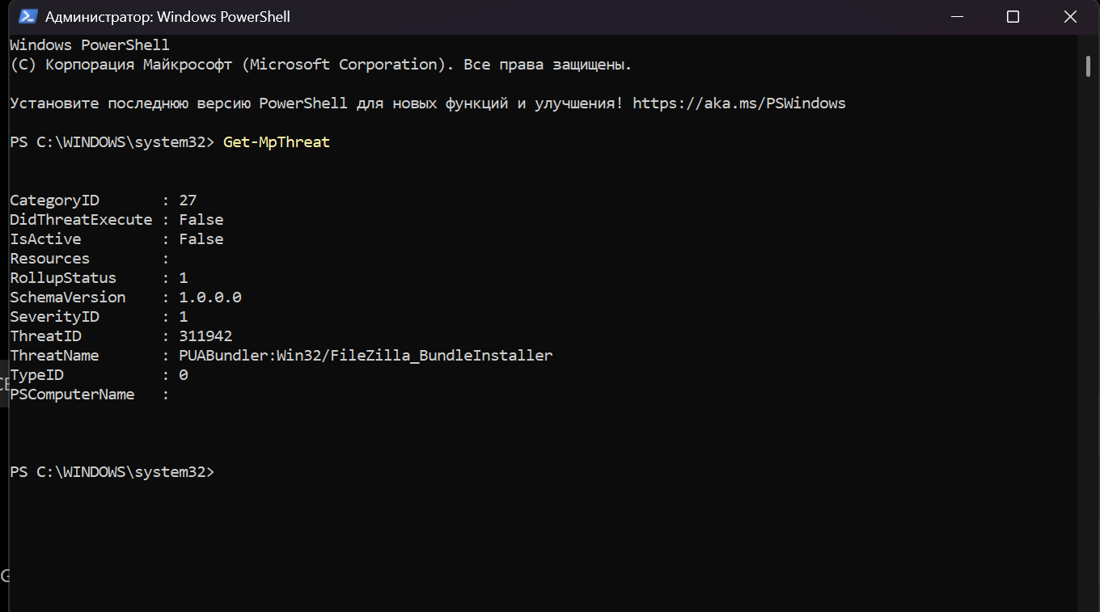

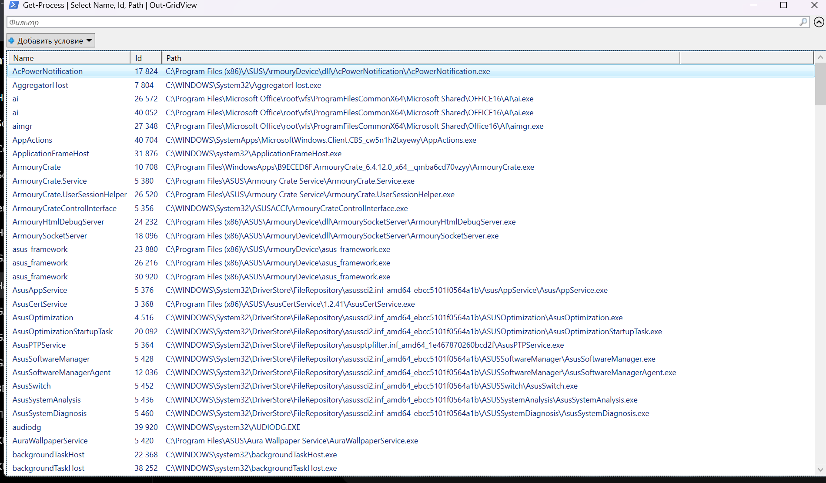

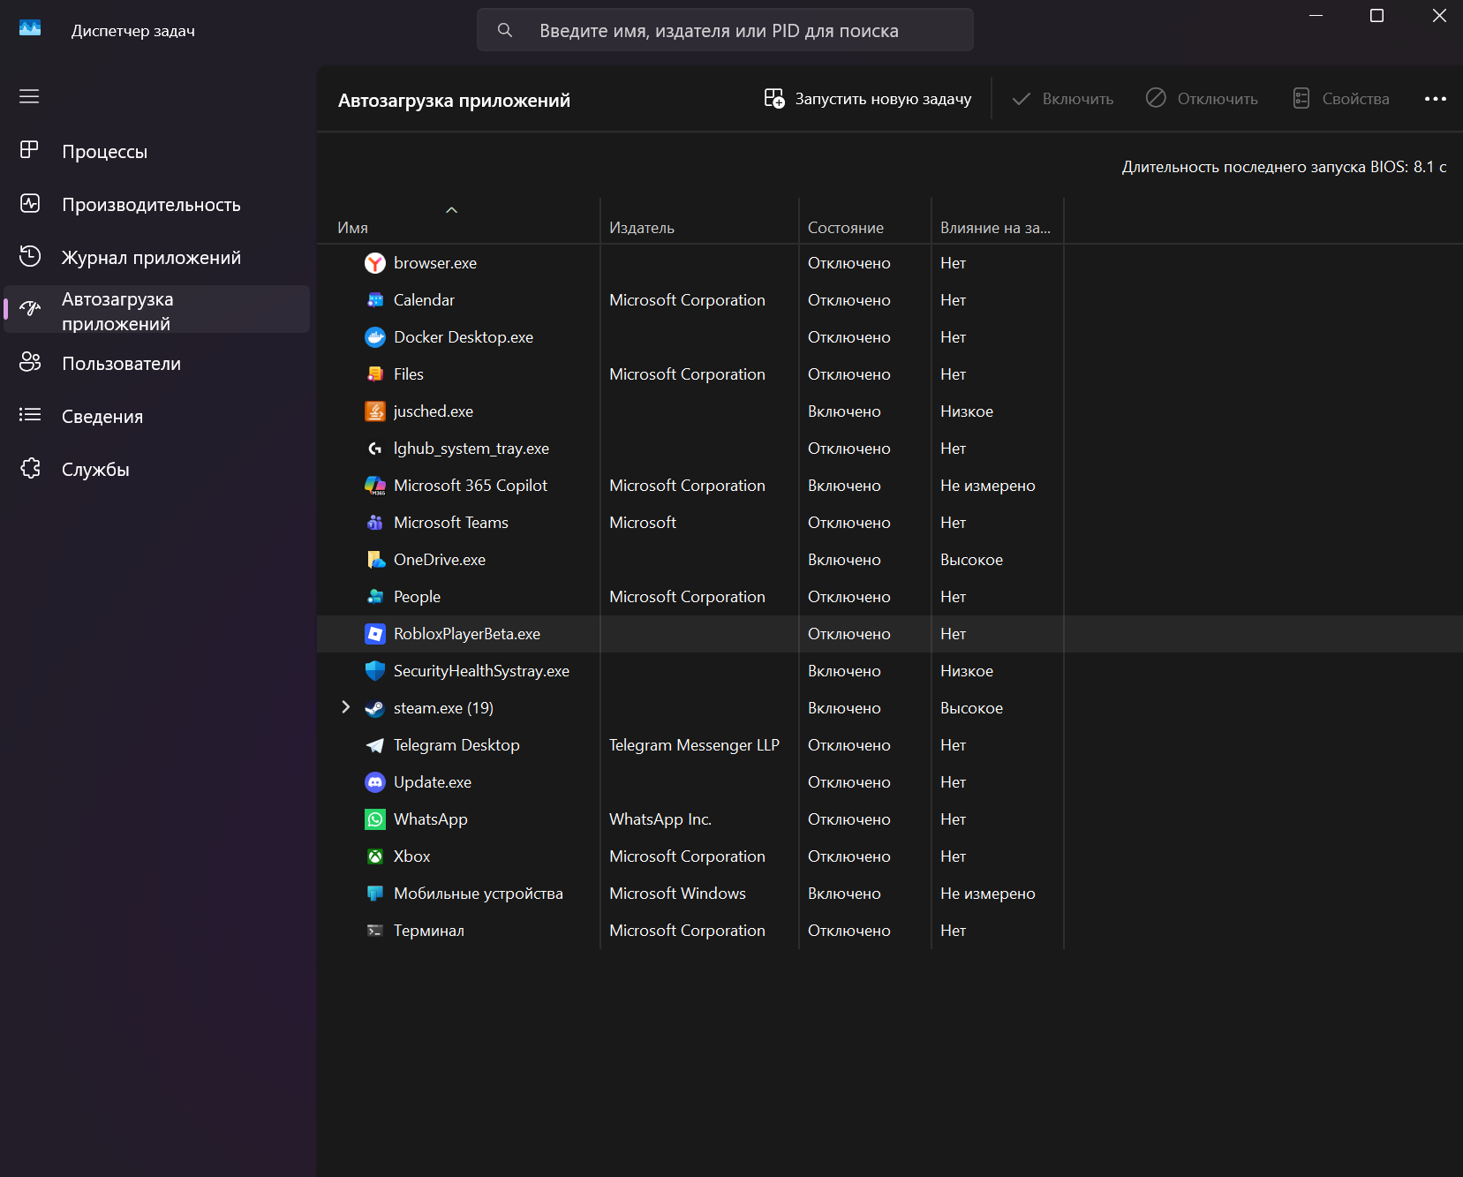

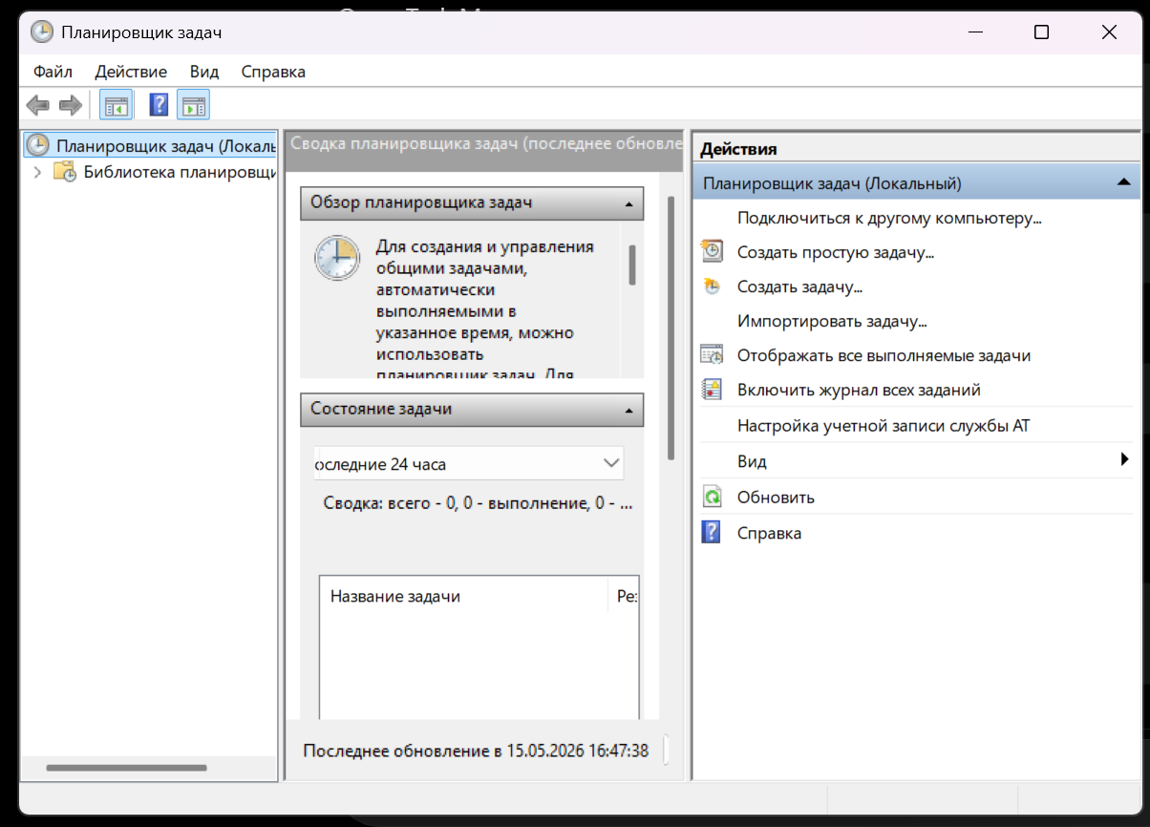

Question 1. What types of malware are most relevant today?
The most relevant malware types today are Trojans, ransomware, spyware, worms, rootkits, and phishing-based malware. Trojans are often used to hide malicious actions inside normal-looking software. Ransomware is especially dangerous because it encrypts user files and demands payment.
Question 2. How does Windows Defender implement defense techniques?
Windows Defender uses real-time protection, malware signatures, behavior monitoring, cloud-based protection, controlled folder access, firewall integration, and threat history. These tools help detect suspicious files, block malicious behavior, and warn the user about threats.

Part 5: Defenses and System Protection Mechanisms
Role: Defense Specialist
How to open
- Win + R -> wf.msc -> Windows Defender Firewall with Advanced Security
- Start -> search Change User Account Control settings
- Command Prompt as administrator
- Settings -> Apps -> Installed apps
Commands
sfc /scannow
DISM /Online /Cleanup-Image /RestoreHealth
What to do
- Open Windows Defender Firewall and check inbound/outbound rules.
- Open UAC settings and observe the protection level. Do not disable it.
- Run sfc /scannow and wait for the result.
- Run DISM command and wait for the result.
- Review installed applications. Do not delete important programs.
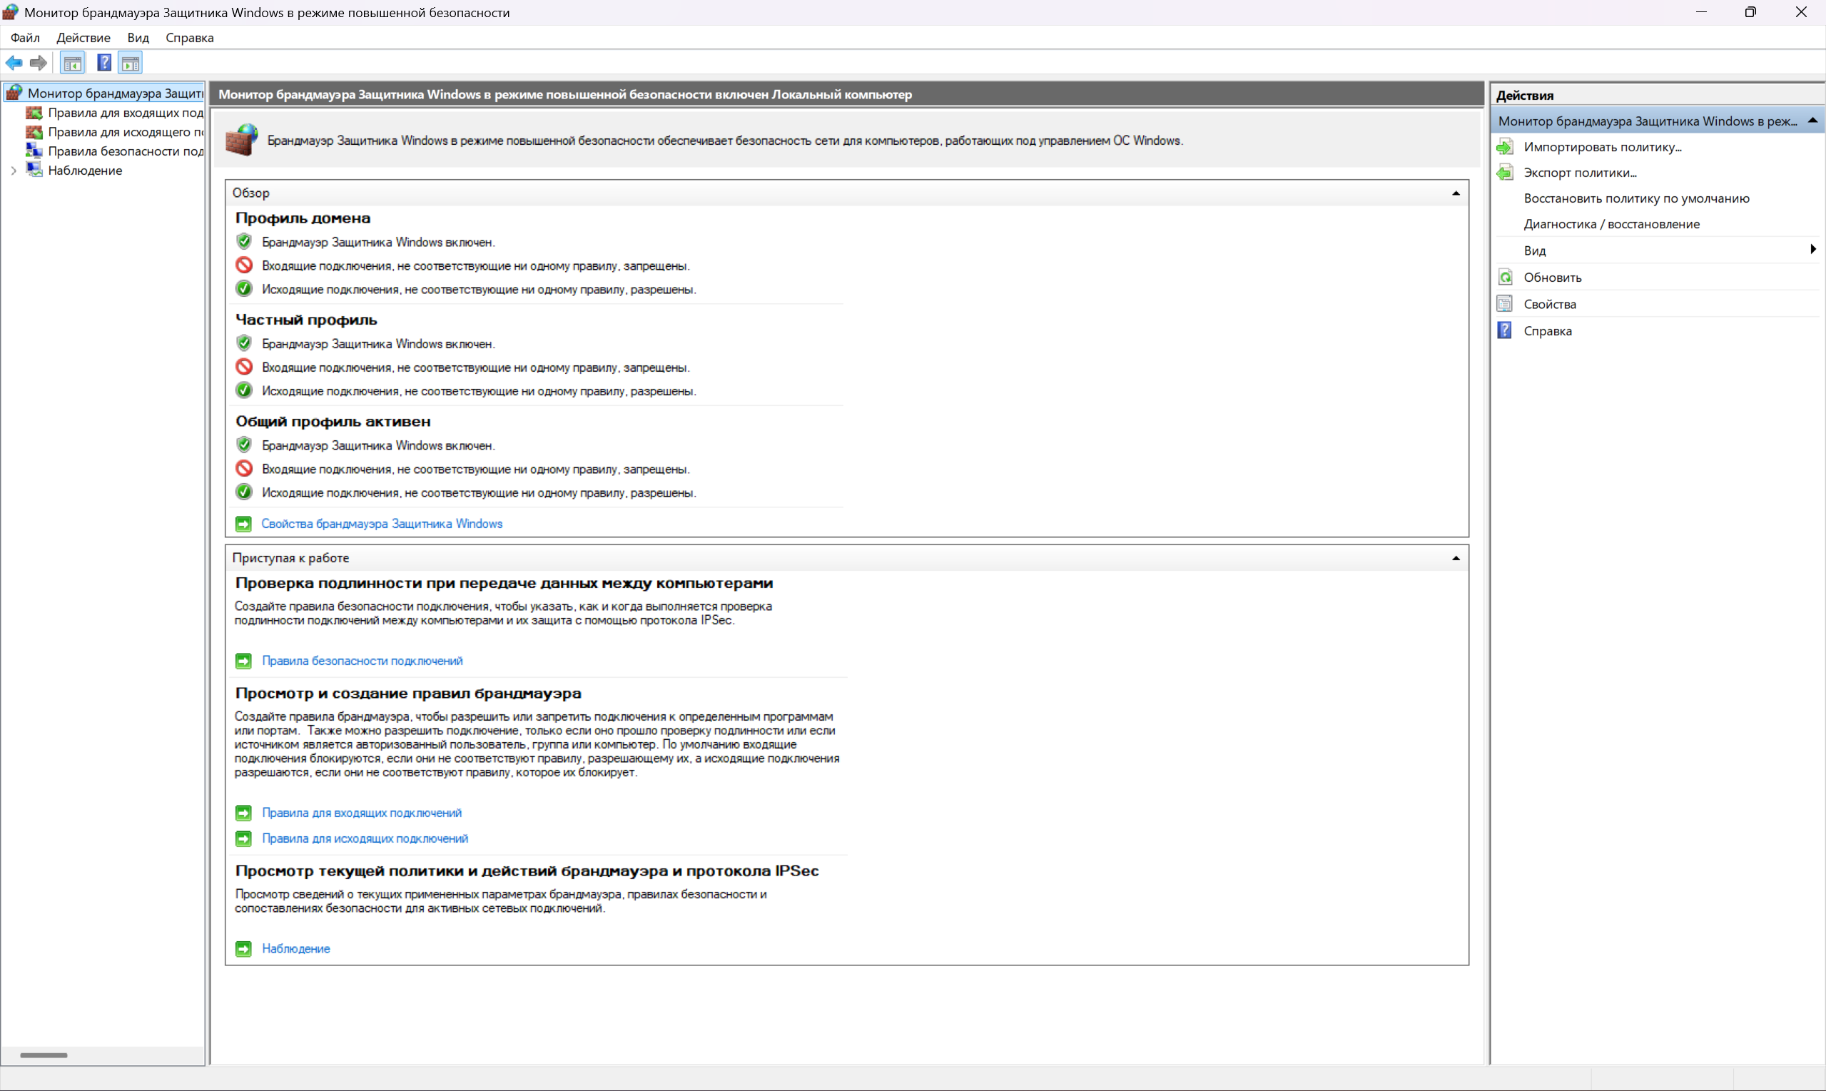

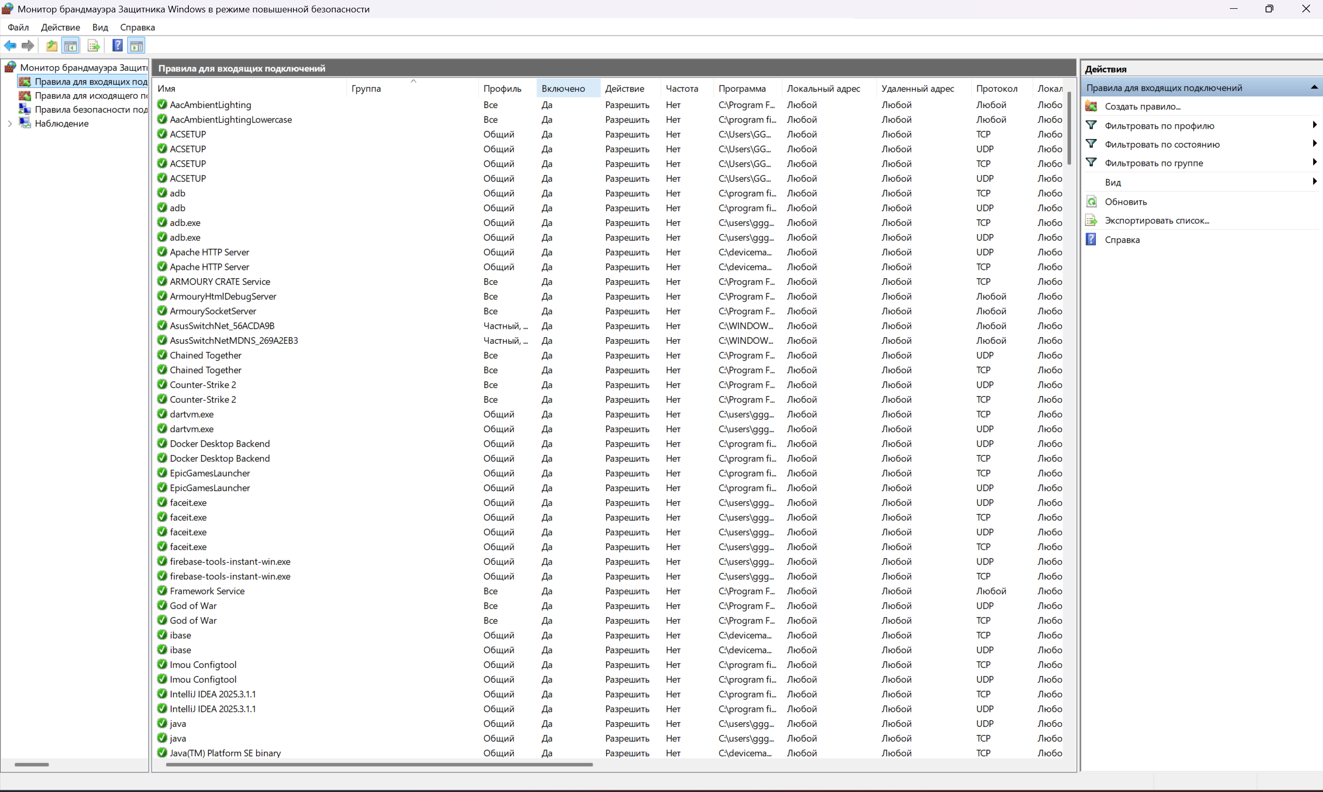

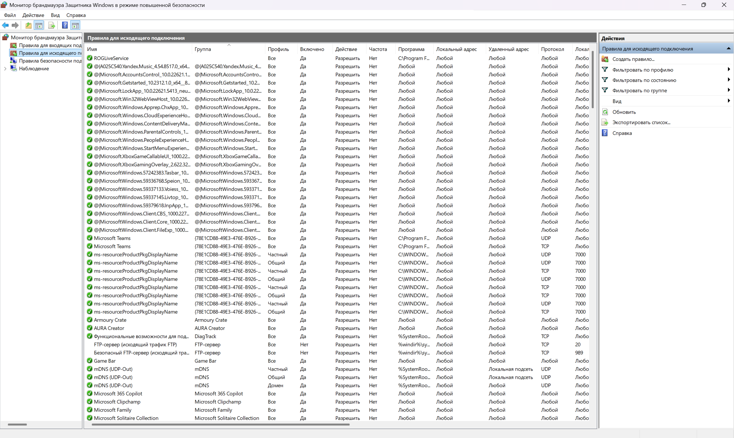

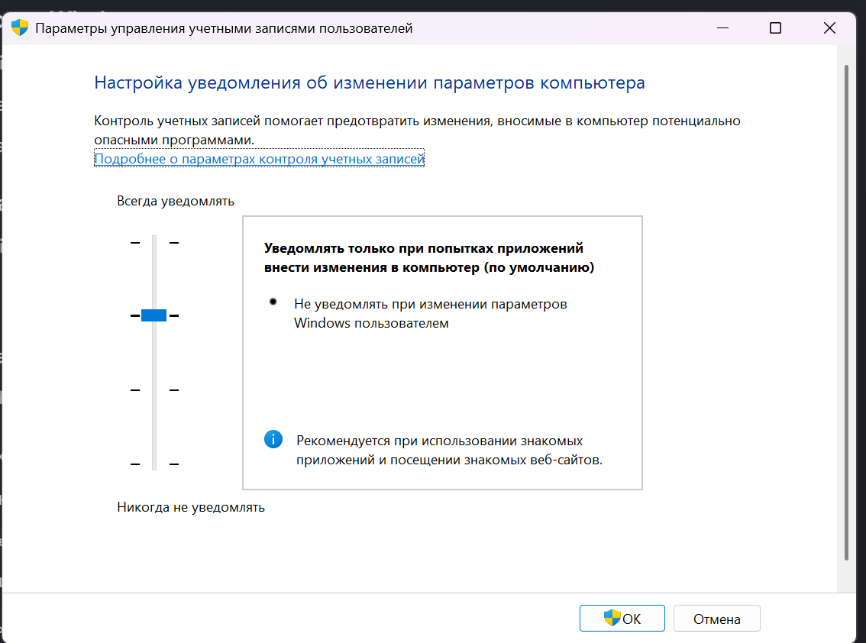

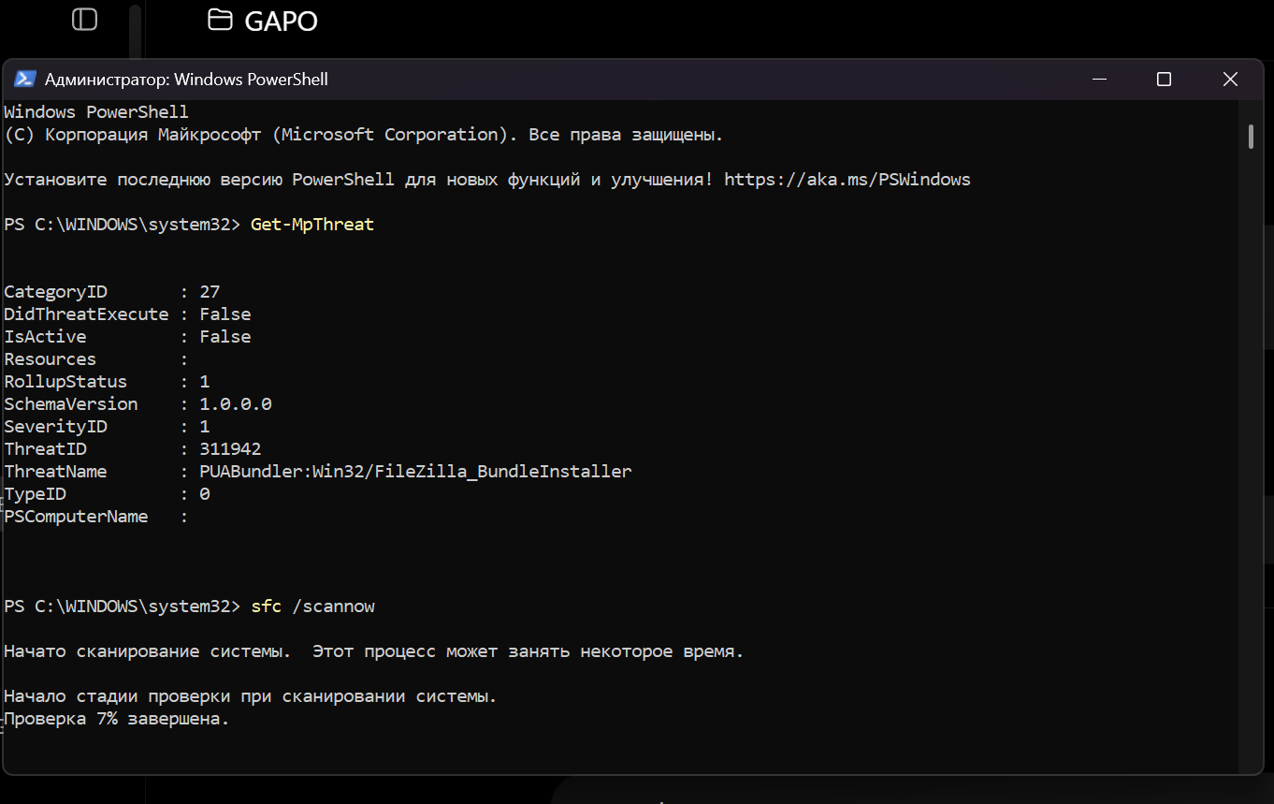

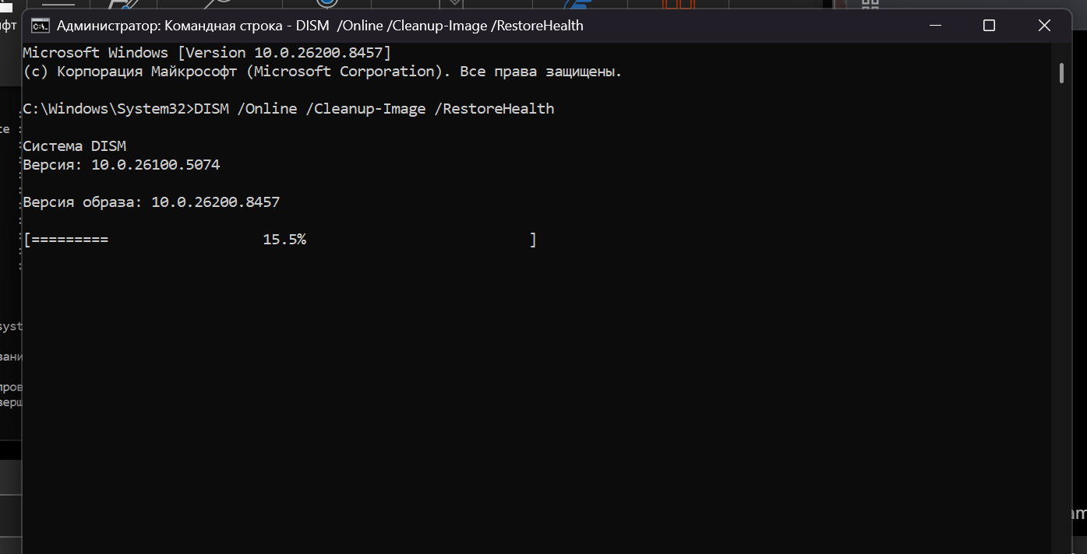

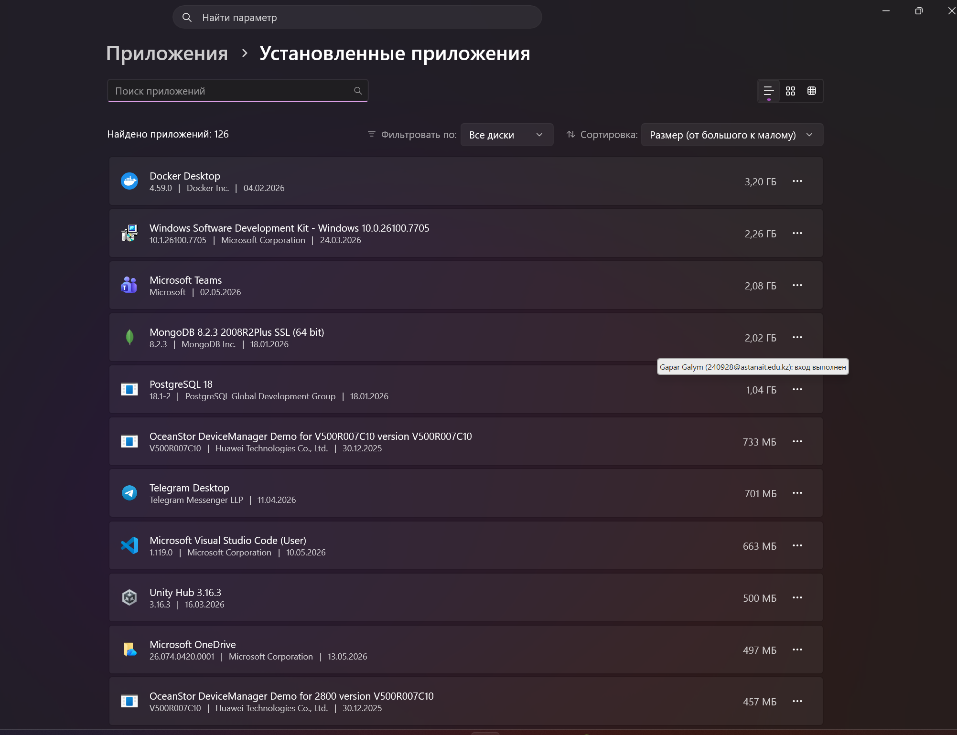

Question 1. How does Windows implement Firewalls, Code Signing, and Sandboxing?
Windows implements firewall protection through Windows Defender Firewall, which controls inbound and outbound network traffic. Code signing helps verify that software comes from a trusted publisher and was not changed. Sandboxing is used in browsers, Defender, and app isolation mechanisms to limit the damage that unsafe programs can cause.
Question 2. What is the role of UAC in protection?
User Account Control prevents programs from automatically getting administrator privileges. When a program wants to make system-level changes, UAC asks for confirmation. This helps stop unwanted or malicious changes.
Question 3. What are the risks of disabling security features?
Disabling security features increases the risk of malware infection, unauthorized access, privilege escalation, data theft, and system damage. It also makes it easier for attackers or unsafe programs to change important system settings.

Conclusion
In this laboratory work, we explored the main Windows security mechanisms. We checked Windows Security, Event Viewer, access permissions, authentication settings, BitLocker status, malware protection, firewall rules, UAC, and integrity tools. This lab showed how Windows protects the system from threats using access control, authentication, encryption, malware detection, and defense mechanisms.

