Assignment 1 Creating 3D Scene and Main Menu in Unity
Turganbek Nurhan
SE-2435
Objective:
The goal of this assignment was to create a 3D scene and a main menu with a functional UI in Unity, including a button to switch between scenes.
Procedure:
1. 3D Scene (GameScene):
- Added a ground plane and several 3D objects (cubes, spheres).
- Set up a camera and directional lighting.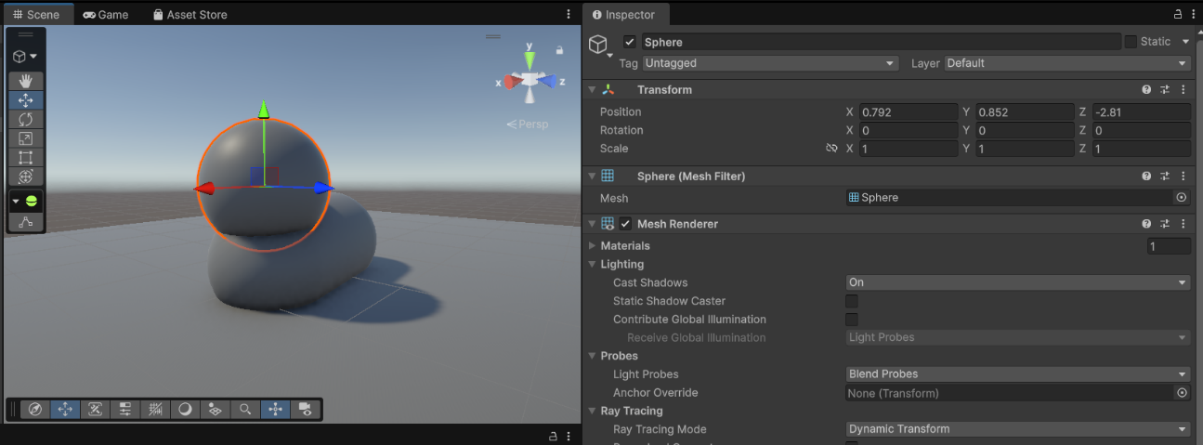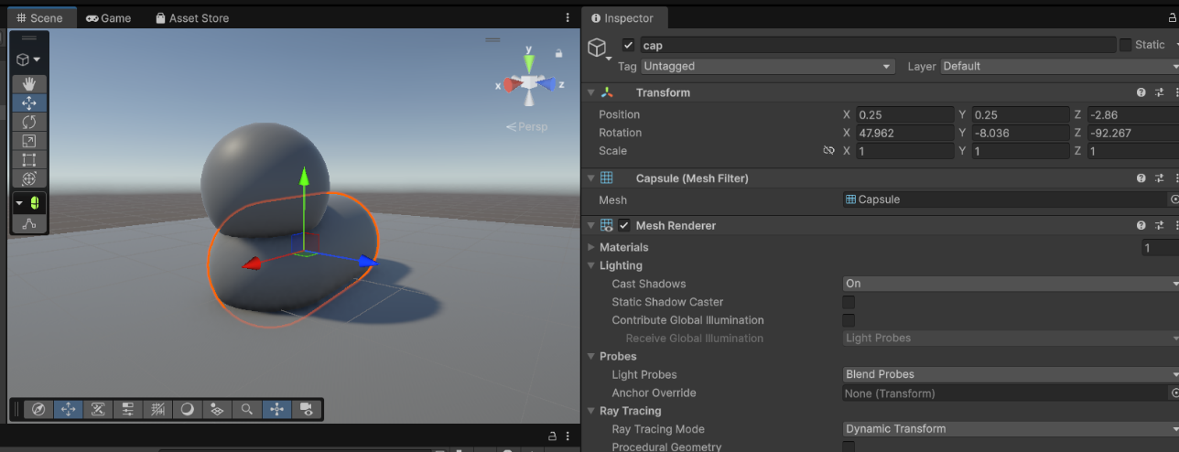
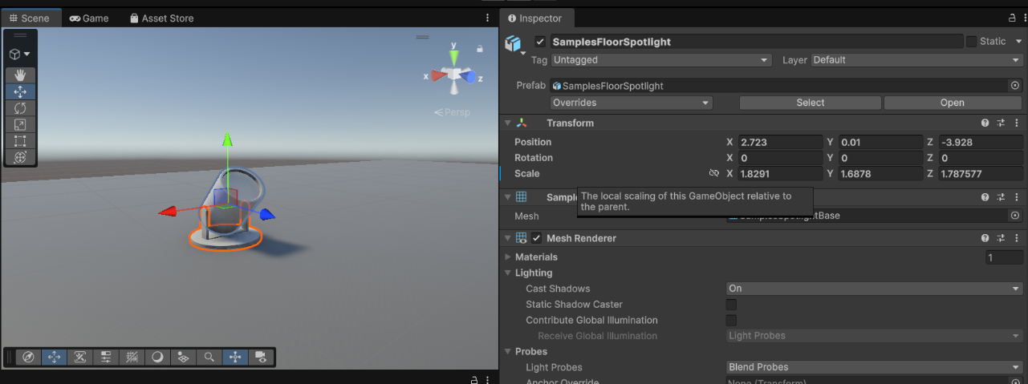
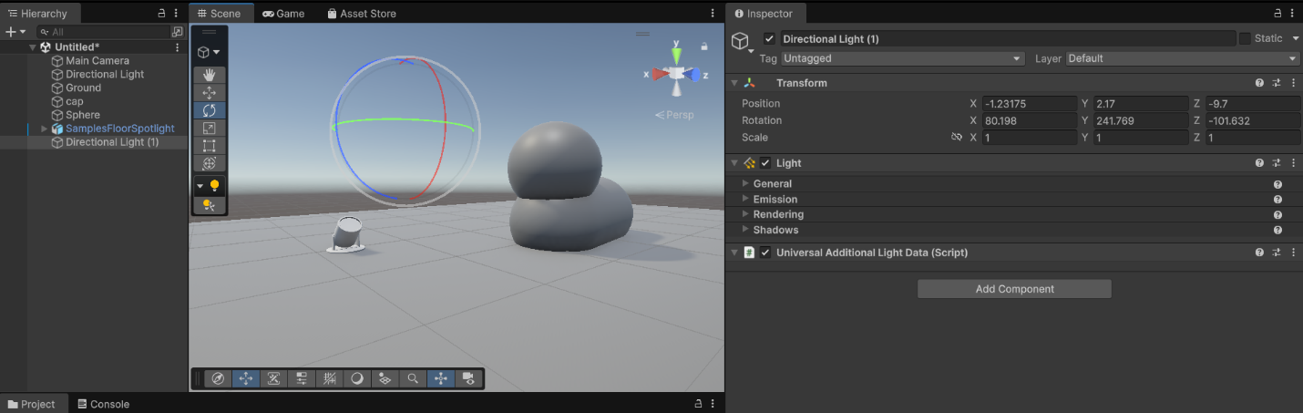
2. Main Menu (MainMenu):
- Created a Canvas with a centered title "MAIN MENU".
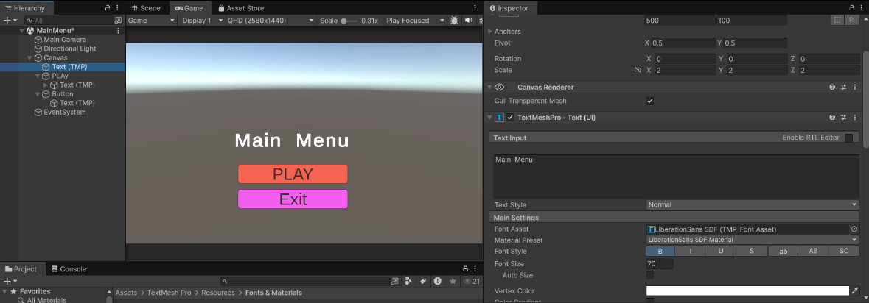
- Added a PLAY button below the title.
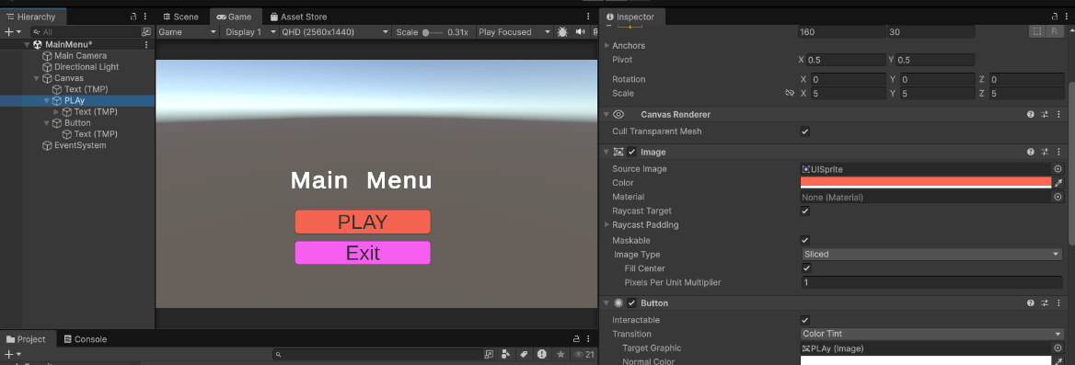
- Connected the button to a script (PlayButton.cs) with a public method LoadGame() to switch scenes.
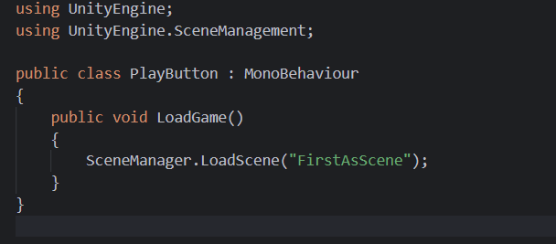

3. Scene Setup:
- Both scenes added to Build Settings / Build Profiles → Scenes In Build.
- MainMenu set as the first scene for launch.
Result:
- When running the project, MainMenu displays the title and PLAY button.
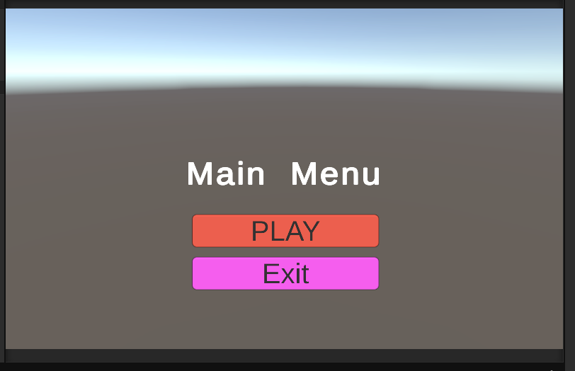
- Clicking PLAY successfully switches to GameScene with 3D objects and lighting.
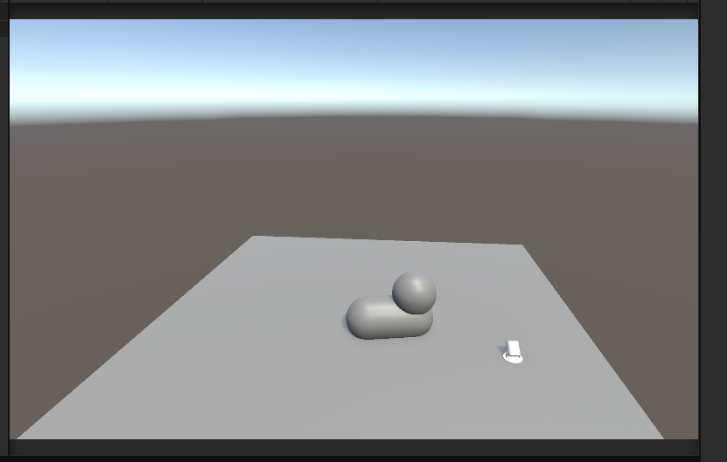
Conclusion:
- Learned to create and manage 3D scenes and UI in Unity.
- Implemented button interaction with scripts to switch scenes.
- Configured scenes for building and testing.

