Explainable Artificial Intelligence for Chest CT in 2025 and 2026: A Focused Narrative Review and a Proposed Concept-Based Reference Framework

Abstract
Deep learning models for chest computed tomography (CT) reach high accuracy, but clinicians and regulators increasingly ask how their outputs can be inspected. This focused narrative review examines how explanations for chest CT models were produced and evaluated in work published in 2025 and 2026. Crossref, arXiv and publisher sites were searched in October 2026, and 85 sources were included. The literature is organised into five families: post hoc attribution maps; concept-based models; anatomically structured, case-based and counterfactual methods; report-grounded vision-language explanations; and the evaluation of explanations. Of 27 chest CT studies charted, 15 showed the explanation only through examples or reported no assessment of it, seven reported a quantitative measure, three an expert rating or agreement measure, and two a reader study. Concept-based models remain few, lobe-level structure is rarely used for explanation, and report-generating models link text to organs or regions rather than to lesions. Evidence on whether explanations help readers comes mainly from other modalities. The review proposes five desiderata for clinically usable explanations, a reference design that combines lobar pooling with a radiological concept layer, and a non-compensatory index of explanation quality. Both proposals are untested, and a staged validation plan is outlined.
Keywords Explainable artificial intelligence; Tomography, X-ray computed; Lung; Deep learning; Concept bottleneck models

1 Introduction
Lung cancer was the most frequently diagnosed cancer and the leading cause of cancer death worldwide in 2022, with almost 2.5 million new cases and about 1.8 million deaths [14]. Low-dose computed tomography (CT) screening is now being delivered to large high-risk populations [10], and projections based on insurance claims indicate that imaging use will continue to rise with population growth and ageing [18]. Chest CT is therefore one of the settings in which deep learning is most likely to be used at scale.
Recent evaluations show both the promise and the fragility of such models. A nodule malignancy-risk model trained on one screening trial reached areas under the curve (AUC) between 0.94 and 0.98 when tested on 4,146 participants pooled from three European screening trials [4], and dedicated artificial intelligence (AI) software has shown promise as a first reader for ruling out negative baseline screening scans [76]. Performance does not always transfer, however. When an open-source lung cancer risk model was tested in 18,057 adults from an Asian health check-up centre, its AUC for predicting future cancers fell to 0.56 in never-smokers and light smokers [47]. A reader who cannot see why a model produced a given output has little basis for recognising when it has moved outside the conditions in which it works.
This is the practical case for explanation, and it is contested. One position holds that post hoc explanation of black-box models is unreliable in high-stakes settings and that models should be interpretable by design [64]. A review of the published arguments concluded that fully autonomous black-box use is ruled out, but that a general requirement for explainability is not established where a clinician remains in the loop [11]. Guidance has nevertheless moved towards explanation as something to be justified and tested. The FUTURE-AI consensus guideline, developed by 117 experts from 50 countries, lists explainability among its six principles and recommends that the need for explanations be decided with end users and that explanations be evaluated both computationally and with end users [48]. The European Society of Radiology notes that medical imaging AI falls in the high-risk class of the European AI Act, which requires trained human oversight, and that methods and standards for transparency and explainability are still under development [42]. A recent special report adds that the interaction between radiologists and AI output, including automation bias and interface design, has received far less study than stand-alone model accuracy [39].
Explainable AI in medical imaging has been reviewed repeatedly, from general surveys [2, 25, 65] to reviews of inherently interpretable models [33, 77], of clinician-centred evaluation [74], of shortcut learning [75], and of single domains such as echocardiography [36], cancer imaging [26] and lung cancer [43]. Table 1 compares these reviews. None of them is dedicated to chest CT. The closest in subject covers lung cancer across CT, chest radiography, histopathology and other modalities, and 19 of its included articles concern histopathology [43]; in the scoping review of cancer imaging, CT accounted for 37.5% of studies and lung for 23.5% [26]. Chest CT nevertheless has properties that matter for explanation: it is volumetric, the lungs have a lobar anatomy that radiologists already use to report location, thoracic imaging has a standard descriptive vocabulary [8], and scans paired with reports are now available in large public collections [30].
This review therefore has three aims. The first is to describe how explanations for deep learning models on chest CT were produced in work published in 2025 and 2026. The second is to chart how those explanations were evaluated. The third is to propose, from the gaps identified, a set of desiderata, a reference design and an explanation-quality index that later experimental work can implement and test. The proposed design and index have not been implemented or validated, and they are presented as proposals throughout.
Table 1 Earlier reviews of explainable artificial intelligence in medical imaging compared with the present review
Review | Scope | Method and size | Explanation families covered | Evaluation of explanations | Chest CT focus
Ahmed et al. [2] | Radiology and pathology imaging | PRISMA systematic review, 133 studies | Attribution, attention, LIME and SHAP, rule-based | Lack of standard measures noted | No
Saw et al. [65] | Radiology | Narrative review | Inherent and post hoc methodsª | Not statedª | No
Durak et al. [25] | Radiology | Narrative educational review | Attribution, concept-based, example-based | Major theme | No
Hou et al. [33] | All medical imaging | Survey, more than 200 papers | Attention, concept, prototype, text, counterfactual; post hoc attribution excluded | Dedicated section | No
Wang et al. [77] | General machine learning, with attention to healthcare | Surveyª | Concept-based only | Evaluation and intervention standards | No
Ud Din et al. [74] | All medical imaging, clinician-evaluated studies | PRISMA systematic review, 51 studiesª | Attribution, example-based, concept-based | Subject of the review | No
Vásquez-Venegas et al. [75] | All medical imaging, shortcut learning | Scoping review, 37 studies analysed in detailª | Not statedª | Not the focus | No
Ishii et al. [36] | Echocardiography | PRISMA-ScR scoping review, 170 studies | Attribution, intrinsically interpretable models | Central theme | No
Fotopoulos et al. [26] | Radiological cancer imaging | PRISMA-ScR scoping review, 371 studies | All families counted; post hoc 82.2% | Counted for every study | Partly (CT 37.5%, lung 23.5%)
Koutoulakis et al. [43] | Lung cancer, several modalities | PRISMA-guided critical review | Attribution, attention, SHAP and LIME | Discussed | Partly (CT is one of several modalities)
Present review | Chest CT | Focused narrative review, 85 sources | Attribution, concept, anatomical and case-based, counterfactual, report-grounded | Charted for 27 chest CT studies | Yes
ª Taken from the abstract only; "not stated" means the abstract does not say and does not mean that the review omits the topic. LIME local interpretable model-agnostic explanations, SHAP Shapley additive explanations, PRISMA Preferred Reporting Items for Systematic reviews and Meta-Analyses, PRISMA-ScR PRISMA extension for scoping reviews

2 Methodology

2.1 Search Strategy and Sources
This is a focused narrative review. It is not a systematic or scoping review, no protocol was registered, and the search was not designed to be exhaustive. The description of the search borrows items from the Preferred Reporting Items for Systematic reviews and Meta-Analyses (PRISMA) extension for scoping reviews where they apply [71], but that guideline was not followed in full. Searches were run on 9 and 10 October 2026. The sources were the Crossref bibliographic database, the arXiv preprint server (queried through the alphaXiv interface), general web search, and the article pages of publishers and proceedings series, including Springer Nature, BMC, the Radiological Society of North America, Frontiers, MDPI, BMJ, JMIR, the Proceedings of Machine Learning Research, and the proceedings of the NeurIPS, IJCAI and ICLR conferences. PubMed, PubMed Central, Europe PMC, ScienceDirect and IEEE Xplore could not be queried directly during the search. Articles in Elsevier and IEEE journals were therefore reached only through Crossref records, repository copies or preprint versions, and they are likely to be under-represented.
Seven themes were searched: earlier reviews of explainable AI in medical imaging; post hoc attribution on chest CT; concept-based models; anatomically structured, prototype-based, counterfactual and attention-based methods; vision-language and report-generating models for CT; the evaluation of explanations; and the clinical, regulatory and reporting context. Search terms combined the method names of each theme (for example gradient-weighted class activation mapping (Grad-CAM), Shapley additive explanations (SHAP), concept bottleneck, prototype, counterfactual, report generation, faithfulness and reader study) with terms for chest CT, lung and thoracic imaging.

2.2 Eligibility and Selection
Records were eligible if they were published or first posted online between 1 January 2025 and 10 October 2026, were written in English, and either applied or evaluated an explanation method for a deep learning model on chest CT, or provided methodological, human-factors or regulatory evidence directly relevant to explaining such models. Peer-reviewed journal articles and papers from established conferences were preferred. Preprints were retained only where no peer-reviewed source covered the same point, and they are identified as preprints in the reference list. Because few studies have evaluated explanations on chest CT itself, studies from chest radiography, mammography, other radiological modalities, dermoscopy and ophthalmology were admitted for the evaluation theme, and their modality is stated wherever they are cited. Older sources were limited to original method papers, datasets and current standard documents, with one exception described below. The window was limited to these two years so that the review acts as an update on recent work; earlier studies are covered, for medical imaging in general, by the reviews compared in Table 1.
Each candidate was opened on its publisher, proceedings or repository page, its bibliographic details were checked against that page or its Crossref record, and the page was checked for a retraction notice. In total 147 records were verified and charted, and 85 were included: 72 from 2025 or 2026 and 13 older sources (Fig. 1). One of the older sources is a reader study on chest CT from 2022. It was found while the statement that no such study had been published in the window was being checked, and it is included because it bears directly on that statement; it is cited in the section on how explanations are evaluated. The 62 records not included were older sources beyond those needed as originals or standards (n = 21), preprints without a peer-reviewed version that were not essential (n = 13), studies outside chest CT for which a closer source was retained (n = 12), records whose details could not be verified sufficiently or whose reporting was internally inconsistent (n = 11), and studies redundant with a retained study of the same task (n = 5). For 13 included sources only the abstract, or a preprint version of the full text, could be read; these are cited for their main conclusions only. Four included articles carry a published correction that could not be read, and no numerical result is quoted from them.
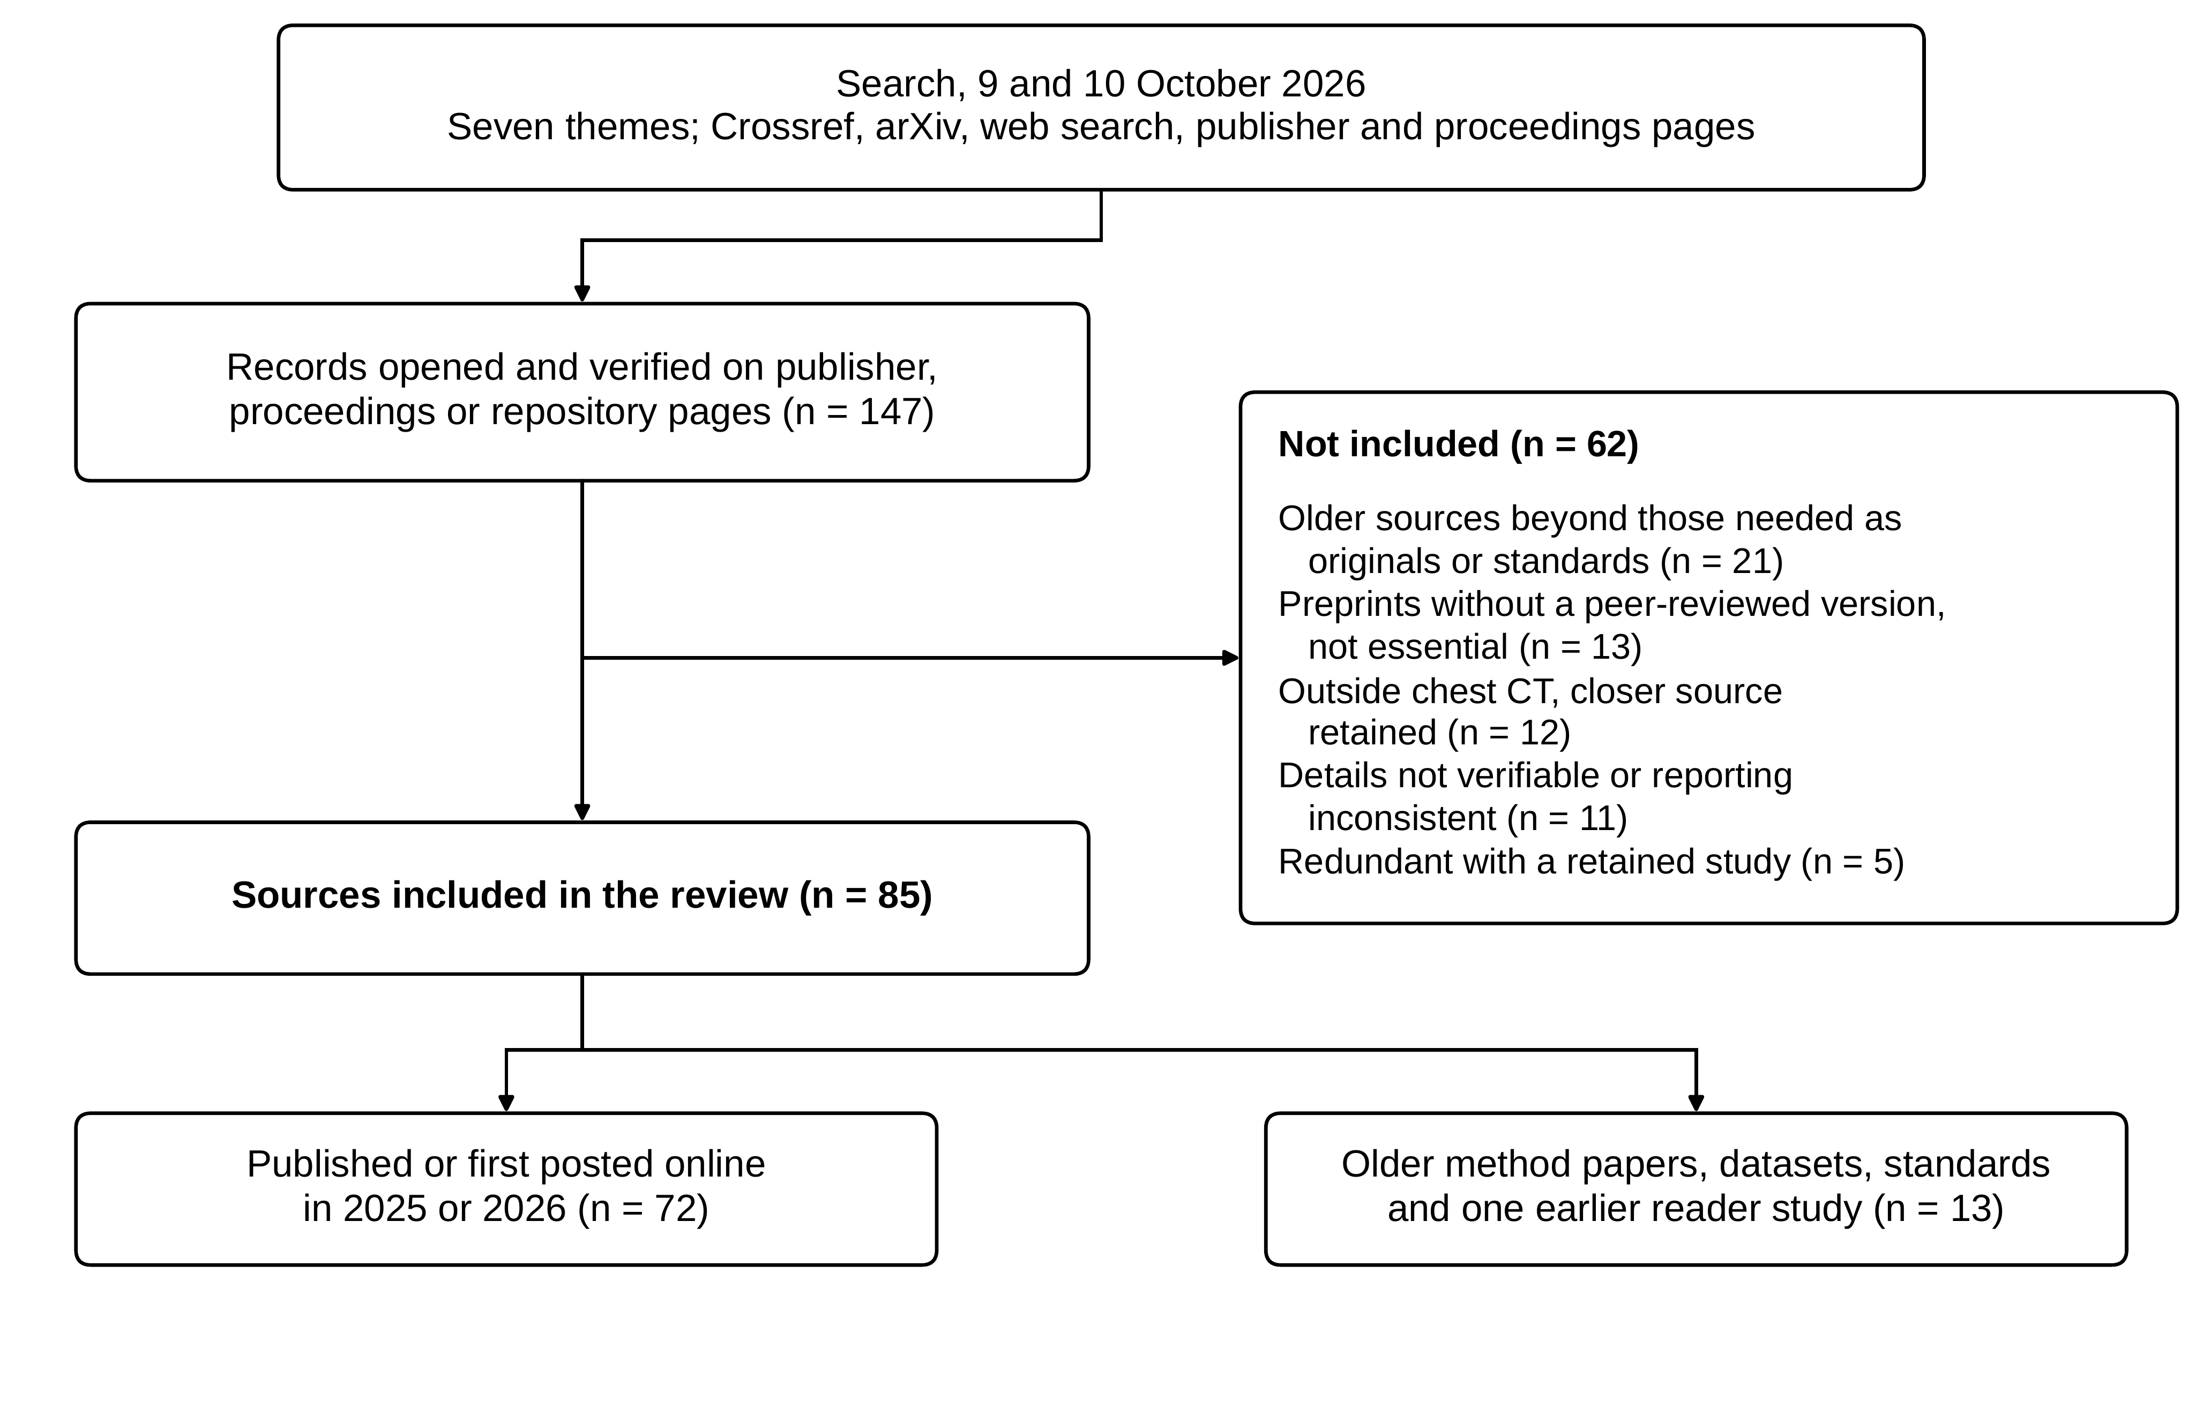
Fig. 1 Selection of sources. Records were opened and verified before charting; counts of records seen but not opened were not kept
For each included chest CT study that offered an explanation, the task, the data, the explanation method and the way in which the explanation was assessed were charted. No formal risk-of-bias assessment was performed. The search was not exhaustive and was limited to 2025 and 2026. Statements in this review that no study of a given kind was found refer to that period and should be read with these limitations in mind.

2.3 Use of Generative AI Tools
A generative AI tool (Claude, Anthropic) was used under the direction of the authors to search for candidate sources, to retrieve and tabulate their bibliographic details and abstracts, and to prepare a first draft of the text from the authors' outline and from the authors' earlier description of the proposed framework. The five figures were drawn with plotting code written with the assistance of the same tool, from the counts and definitions given in this article. The authors opened and checked every included source, verified each citation and each statement against its source, revised the text, and are responsible for the arguments, interpretations and conclusions. No AI tool is listed as an author.

3 Review
The included work is organised into five families, defined by what the reader is shown (Table 2, Fig. 2). Table 3 charts the 27 chest CT studies that offered an explanation or a structured output, together with the way in which that explanation was assessed; Fig. 3 summarises the same chart by family.
Table 2 Families of explanation considered in this review
Family | What the reader is shown | Typical methods | Chest CT studies charted
Post hoc attribution maps | A heat map over the image, computed after training | Grad-CAM and variants, SHAP, LIME, integrated gradients, attention maps | 12
Concept-based models | Named clinical descriptors and their contribution to the output | Concept bottleneck models, attribute prototypes, concept-supervised vision-language models | 4
Anatomically structured, case-based and counterfactual methods | Evidence per lobe or region, similar past cases, or the change that would alter the output | Lobe-level models and quantification, case retrieval, prototype networks, counterfactual generation, attention pooling | 6
Report-grounded and vision-language explanations | Generated text, in some models linked to an organ or region | Contrastive image-report pretraining, region-guided report generation | 5
Evaluation of explanations | Evidence that an explanation is faithful, plausible, stable or useful | Deletion and insertion tests, randomisation checks, expert rating, reader studies | Not applicable
Grad-CAM gradient-weighted class activation mapping, SHAP Shapley additive explanations, LIME local interpretable model-agnostic explanations
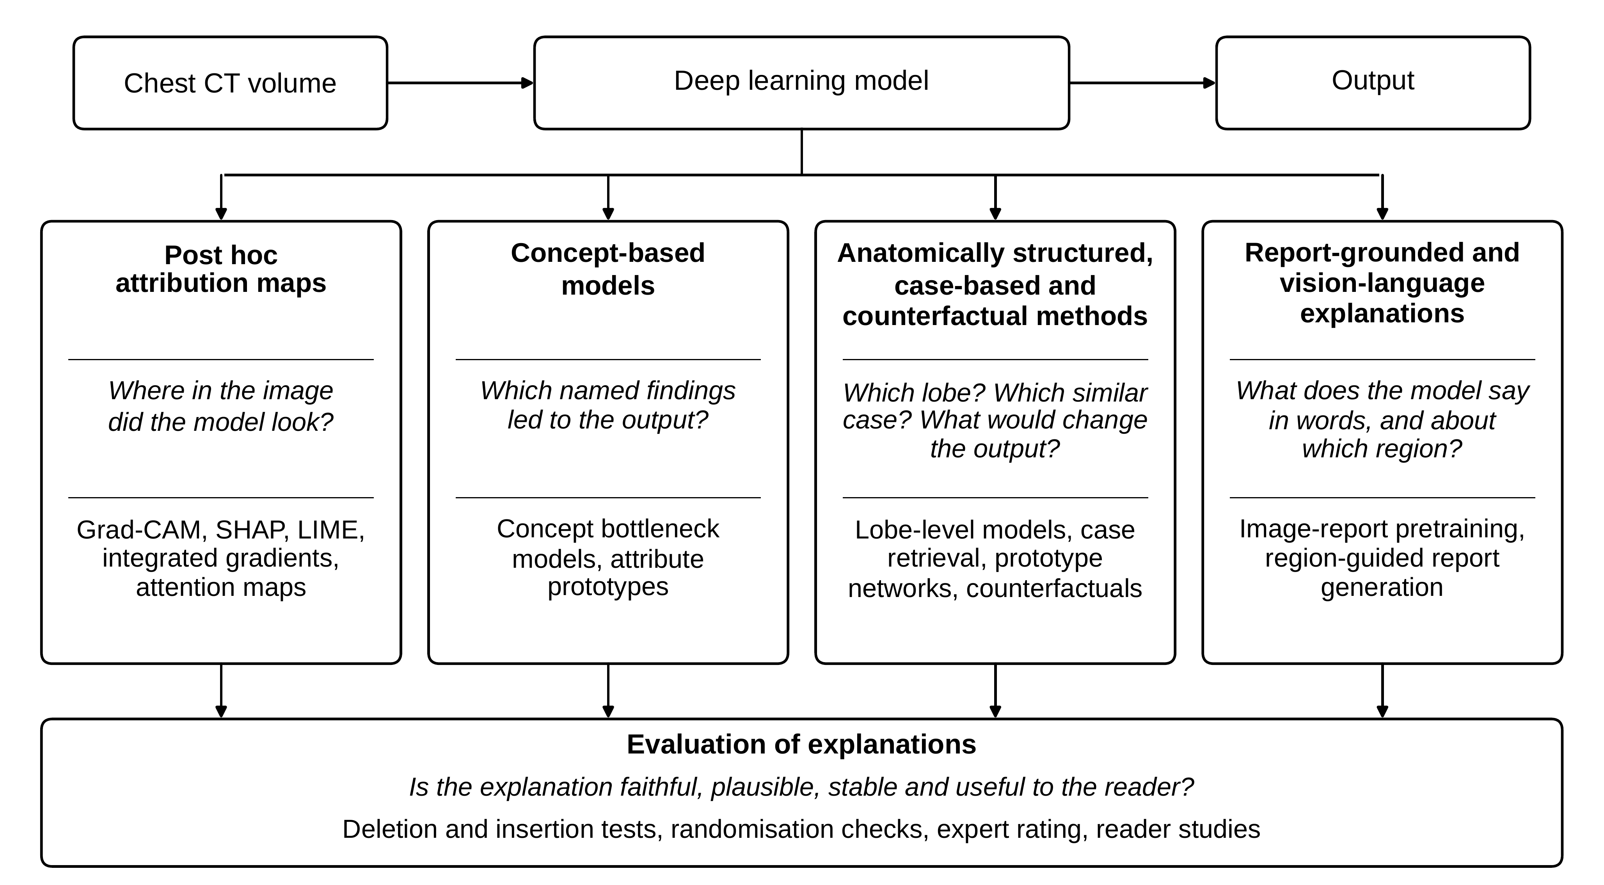
Fig. 2 Families of explanation for chest CT models considered in this review and the question each answers for the reader. Grad-CAM gradient-weighted class activation mapping, SHAP Shapley additive explanations, LIME local interpretable model-agnostic explanations
Table 3 Chest CT studies from 2025 and 2026 that offered an explanation or a structured output, and how the explanation was assessed
Study | Task | Data | Explanation | Assessment of the explanation | Category
Müller-Franzes et al. [55] | Nodule malignancy | LIDC-IDRI, 722 patients | Attention maps and Grad-CAM | One radiologist rated 150 maps pooled over three datasets | Expert rating
Wang et al. [80] | Resolving screen-detected nodules | NELSON trial, 344 nodules | Grad-CAM++ | Maps shown for four cases | Examples only
Hassan et al. [31] | Normal, benign or malignant slices | IQ-OTH/NCCD, 1,097 slices | LIME variant | Deletion, insertion and stability metrics | Quantitative
Kodipyaka et al. [40] | Benign or malignant lesions | 61 development volumes, two external sets | Grad-CAM and KernelSHAP | Two raters of unstated expertise, six cases | Expert rating
Yan et al. [82]ª | Occult lymph node metastasis | 900 patients, two hospitals | Grad-CAM | None stated | Not stated
Wang et al. [79] | Extranodal extension | 369 patients, three centres | SHAP and Grad-CAM | Example figures | Examples only
Rahat et al. [62] | COVID-19 or normal | 25,408 images, nine public sources | Grad-CAM and LIME | Maps checked on two images | Examples only
Zhang et al. [83] | Interstitial lung disease pattern | 629 patients, one hospital | Class activation mapping | Maps shown for five patients | Examples only
Mou et al. [54] | Normal, PRISm or COPD | 776 patients and 190 external | Grad-CAM | Visual inspection | Examples only
Li et al. [49] | Pulmonary thromboembolism | 1,368 patients and 98 external | Grad-CAM | Overlays, not compared with annotations | Examples only
Liu et al. [51] | Nontuberculous mycobacterial disease or colonisation | 413 patients and 196 external | Grad-CAM, integrated gradients, SHAP | Maps shown for two cases | Examples only
Di Piazza et al. [23] | 18 abnormalities | CT-RATE, with test on Rad-ChestCT | Grad-CAM | Example maps in one figure | Examples only
Zhuang et al. [85] | Nodule malignancy | NLST and LIDC-IDRI, three external cohorts | Radiologist semantic features through a vision-language model | Accuracy of predicted features | Quantitative
Gallée et al. [27] | Nodule malignancy | LIDC-IDRI | Attribute scores with prototypes | Attribute accuracy; study with six radiologists | Reader study
Dumaev et al. [24]ª | Nodule malignancy | LIDC-IDRI | Concept scores in an additive model | Attribute scoring performance | Quantitative
Tushar et al. [73]^{a,b} | Nodule malignancy | LIDC-IDRI, LUNA25, external cohort | Concept bottleneck on CT foundation models | Concept fidelity | Quantitative
Curiale et al. [21] | Emphysema progression per lobe | COPDGene and ECLIPSE | Lobe-level output | Compared with measured lobar decline | Quantitative
Kuzmanovic et al. [44] | Interstitial lung disease extent per lobe | 107 patients | Per-lobe, per-pattern volumes | Agreement with expert visual score | Expert agreement
Böttcher et al. [13] | Interstitial lung disease diagnosis | 28 cases, three readers | Retrieved similar cases | Reader accuracy, confidence and time | Reader study
Cohen et al. [19]^{b} | Pleural effusion and other classifiers | 399 test volumes | Counterfactual volumes | Change in classifier score | Quantitative
Paolo et al. [58] | Survival in lung cancer | LUNG1, 422 patients, and a private cohort | Slice attention weights | Averaged weights and one case inspected | Examples only
Hu et al. [34] | Pulmonary embolism | RSPECT, 6,958 training examinations | Grad-CAM | Example maps | Examples only
Hamamci et al. [30]ª | Multi-abnormality detection and chat | CT-RATE, 25,692 scans | Scores and free text | Report quality only | Not stated
Shui et al. [67] | Zero-shot diagnosis | 69,086 patients | Prediction tied to a named organ | Example activation maps | Examples only
Chen et al. [17] | Report generation | RadGenome-ChestCT | Text tied to one of 10 regions | Region recognition score | Quantitative
Di Piazza et al. [22] | Report generation | CT-RATE | One sentence per predicted abnormality | None reported | Not stated
Kyung et al. [45]ª | Report generation | Multi-institutional structured reports | Text organised by region | Report quality only | Not stated
ª Abstract only, or details taken from a preprint version. ^{b} Preprint. Categories: examples only or not stated (n = 15); expert rating or agreement (n = 3); quantitative measure (n = 7); reader study (n = 2). The expert rating or agreement group includes one study in which the expertise of the raters was not stated. PRISm preserved ratio impaired spirometry, COPD chronic obstructive pulmonary disease, Grad-CAM gradient-weighted class activation mapping, SHAP Shapley additive explanations, LIME local interpretable model-agnostic explanations

3.1 Post Hoc Attribution Maps
Attribution methods produce a map of the input regions that most influenced an output of a trained model. Grad-CAM weights the feature maps of the last convolutional layer by the gradients of the class score, giving a coarse heat map that needs no change to the network [66]. SHAP assigns each input feature an additive importance value for an individual prediction [52]. Both remain the default in chest CT. A class activation mapping method appeared in every one of the 12 attribution studies charted, in one of them only as a comparator, and in six it was used alongside SHAP, local interpretable model-agnostic explanations (LIME), integrated gradients or attention maps (Table 3).
The clinical tasks were broad. They covered nodule malignancy on LIDC-IDRI [55], resolution of screen-detected nodules in the NELSON trial [80], classification of lesions as benign or malignant [31, 40], occult lymph node metastasis [82] and extranodal extension [79] in lung cancer, COVID-19 [62], patterns of interstitial lung disease [83], preserved ratio impaired spirometry and chronic obstructive pulmonary disease [54], pulmonary thromboembolism on CT pulmonary angiography [49], nontuberculous mycobacterial disease [51], and classification of 18 abnormalities on volumetric scans [23]. Seven of the 12 studies tested their model on data from another centre or another public dataset, so multi-centre validation of the prediction is now common.
Validation of the explanation has not kept pace. In nine of the 12 studies the maps were shown for a few examples or no assessment was stated: four cases in one study [80], two in another [51], two images [62], five patients [83], a single figure [23], overlays that were not compared with the annotated emboli [49], visual inspection for attention to lung parenchyma [54], example figures alongside feature-level SHAP plots [79], and no assessment mentioned in the abstract [82]. Three studies went further. One radiologist rated 150 maps pooled across chest CT and two magnetic resonance datasets and found that transformer attention maps marked the correct slice in 136 of them, against 37 for Grad-CAM applied to a three-dimensional convolutional network [55]. A variant of LIME with lung-region masking was tested with deletion, insertion and stability metrics on a public set of 1,097 CT slices, without a reader study [31]. Two raters, whose expertise is not stated, judged the clinical relevance of Grad-CAM maps in six cases, with a Cohen kappa of 0.45 [40]. None of the 12 studies scored the overlap between a map and a lesion annotation.

3.2 Concept-Based Models
A concept bottleneck model first predicts concepts that people have specified and labelled, and then predicts the target from those concepts alone, so that a user can correct a concept and see the output change [41]. The approach has a known weakness: when soft concept predictions are passed to the label predictor, information unrelated to the concepts can leak through, which lowers concept accuracy and makes interventions less effective [32]. Recent surveys describe a rapid growth of such models, including concepts generated by large language models [33, 77] and designs that relax the strict bottleneck [77].
On chest CT the evidence is thin and concentrated on one task. Four studies were found, all on pulmonary nodule malignancy and all relying on radiologist-rated nodule attributes from LIDC-IDRI, a public collection of 1,018 CT cases annotated by four thoracic radiologists [5]. One fine-tuned a vision-language model so that nodule views align with sentences built from radiologist-annotated semantic features, and tested it on three external cohorts; prediction of the features themselves was acceptable for margin and pleural attachment but poor for most internal features [85]. A second tied each capsule of a capsule network to one attribute and built the malignancy output from attribute prototypes; in a study with six radiologists, the attribute scores and prototypes tended to raise diagnostic accuracy when the model was right and to lower it when the model was wrong [27]. A third combined concept learning with an additive model that exposes the contribution of each attribute to the malignancy score [24]. A fourth, a preprint, distilled concept bottlenecks from frozen CT foundation models and reported modest concept fidelity, with external discrimination no better than nodule size alone [73]. None of the four reports an analysis of concept leakage in the text that could be read, and no concept-based model for diffuse lung disease on CT was found.
Work outside chest CT indicates what such models can offer. An expert-guided concept bottleneck for chest radiographs gave concept explanations closer to radiologist reasoning than post hoc methods [61]. A model that matches concepts generated by a large language model to the layers of a biomedical vision-language encoder outperformed other concept-based models on seven datasets; its results tables report classification metrics only [78]. A concept-querying model that accounts for the uncertainty of each concept prediction was the most accurate interpretable-by-design approach on four of five datasets [56]. In ophthalmology, concept-based support raised the accuracy of six inexperienced doctors, while two senior doctors were essentially unchanged [81], and a concept-enhanced biomedical foundation model was reported to help clinicians verify predictions [57]. For thoracic imaging, the Fleischner Society glossary supplies a current, consensus vocabulary from which a concept set could be drawn [8].

3.3 Anatomically Structured, Case-Based and Counterfactual Methods
A second route to interpretability is to build structure into the model so that the output itself is the explanation [64]. On chest CT the natural structure is the lobe. A lobe-based transformer on the COPDGene and ECLIPSE cohorts predicts the progression of emphysema separately for each lobe, so that its output is a lobe-by-lobe statement that can be compared with measured decline [21]. A commercial tool that reports the volume of each interstitial pattern per lobe was compared with expert visual scoring in 107 patients. Agreement on overall extent was good for ground-glass opacity (kappa 0.70) and consolidation (0.60), moderate for reticulation (0.37) and poor for honeycombing (0.16), and agreement at the level of individual lobes was lower [44]. Any lobe-level method depends on the lobe masks. In a benchmark on 164 scans, public lobe segmentation tools lost accuracy on complex anatomy; a locally trained model segmented more of the few cases with missing lobes, although the authors caution that these cases were too few to generalise [3]. No study was found that uses lobe masks to aggregate the evidence of a classifier lobe by lobe as an explanation.
Case-based reasoning explains an output by pointing to similar examples. The prototypical part network classifies an image by comparing its parts with learned prototypes [16]; it has been applied to breast tomosynthesis with assessment through radiologist feedback [9], but no peer-reviewed prototype network for chest CT was found other than the attribute prototypes described above [27]. A reader study of a similar-case retrieval system for interstitial lung disease, with 28 cases and three readers, found that resident accuracy rose from 35.7% to 53.6% when retrieval was optional, a difference that was not statistically significant; overall time per case did not differ significantly [13].
Counterfactual methods show what would have to change for the output to change. A preprint extends a latent-shift method to whole three-dimensional CT classifiers and reports that the mean pleural effusion score of 77 positive scans fell from 0.24 to 0.15 for their counterfactuals, with no clinical reader validation [19]. On chest radiographs, counterfactual edits validated by radiologists exposed classifiers that relied on unrelated pathology as a shortcut [20].
Attention weights are often presented as explanations, with little support. In survival prediction for lung cancer, attention pooling over slices was not significantly better than average pooling, and the weights were inspected only qualitatively [58]. For pulmonary embolism, a model trained with about a quarter of the slice labels matched full supervision (AUC 0.928 against 0.932), but its explanations were limited to example Grad-CAM maps [34]. Uncertainty estimates are a complementary output. Conformal prediction on a head CT haemorrhage detector flagged 143 of 150 cases on which readers disagreed [28]; conformal risk control on a nodule detector reached 91.4% sensitivity at 2.25 false positives per scan for nodules marked by at least three radiologists [35]; and uncertainty-driven training reduced the calibration error of nodule classifiers by up to 65% [72]. None of these studies pairs the uncertainty output with an explanation method.

3.4 Report-Grounded and Vision-Language Explanations
Large collections of scans paired with reports have made text a possible form of explanation. CT-RATE provides 25,692 non-contrast chest CT scans from 21,304 patients with their reports and supports a contrastive model for zero-shot detection and a chat model [30]. These models return scores for the whole volume and free text that is not tied to a location. A CT vision-language model trained on abdominal scans with diagnosis codes and reports likewise offers generated text and organ segmentation, without grounding at the level of a finding [12].
Several designs bring the text closer to the image. Aligning each anatomical region with the report sentences that describe it ties a prediction to a named organ [67]. Region-guided report generation writes the findings region by region for 10 anatomical regions; the authors report that recognition of the region was high for eight of them but low for lung and pleura, and that the method works at organ level and can miss or mislocate individual lesions [17]. Generating one sentence for each predicted abnormality makes every sentence traceable to a named prediction, with no spatial localisation [22]. A region-aware language model organises the report by anatomical region and was evaluated on the quality of the report, not on whether the regional grounding was faithful [45]. In each case the unit of explanation is an organ or region, which is coarser than the lesion a radiologist would point to.
Two resources may change this. RadGenome-Chest CT adds to CT-RATE segmentation masks for 197 region categories, 665 thousand grounded reports and 1.2 million grounded question-answer pairs, built largely automatically, with the validation set checked manually [84]. A preprint describes 3,142 chest CT scans in which 8,028 report findings are linked to three-dimensional segmentations, with test sets annotated by radiologists [7]. The second makes it possible to test whether a model can point, voxel by voxel, to the evidence for a sentence.
Whether generated text is a faithful explanation is a separate question, and the available evidence comes from outside chest CT. In 478 emergency patients, with same-day CT as the reference, four of five models that generate chest radiograph reports produced hallucinated findings in 5.4% to 17.4% of reports [50]. A perturbation test of step-by-step rationales in six vision-language models found that answer accuracy and explanation quality diverged, and that mentioning a cue did not mean the reasoning was grounded in it [53]. In a randomised vignette experiment with 101 radiologists, a step-by-step explanation from a large language model raised diagnostic accuracy by 12.2 percentage points over no support [69]. No study of the faithfulness of text explanations for chest CT was found.

3.5 How Explanations Are Evaluated
An explanation can be wrong in ways that are not visible. Randomisation tests showed that some saliency methods produce maps that barely change when the parameters of the model are randomised [1], and on chest radiographs each of eight saliency methods failed at least one of four criteria of trustworthiness and localised abnormalities less well than dedicated networks [6]. Recent proposals separate the properties to be tested. Authors from the United States Food and Drug Administration set out four criteria for heat maps, namely consistency, plausibility, fidelity and usefulness, with a reporting card and a case study on synthetic mammograms [46], and an educational review for radiologists distinguishes plausibility from faithfulness and stresses that explanations are tools for oversight, not proof of correctness [25].
Three recent results show how fragile current measurements are. Many of ten explanation methods changed under perturbations that left the predicted class unchanged, and under natural corruptions none was best on every stability metric [63]. In a preprint on breast magnetic resonance imaging that compared seven saliency methods, the ranking of methods by deletion score depended on the masking strategy [60]. Among seven brain magnetic resonance models with similar accuracy, only two based their decisions on plausible structure according to Grad-CAM [37]. Shortcut learning has also been exposed: chest radiograph classifiers stayed well above chance with the lungs masked out [68], and an explanation method traced the errors of a COVID-19 detector to text-like marks on the images [38]. A scoping review concluded that most medical imaging studies neither test for nor report such shortcuts [75].
In practice, evaluation is uncommon. In radiological cancer imaging, 48% of 371 studies reported no validation of the explanation, and among those that did, 53.9% relied on expert or user judgement and 5.2% on quantitative metrics [26]. In echocardiography, explanations were evaluated only qualitatively in 40.4% of end-to-end model instances against 1.6% of instances in multistep pipelines with an interpretable intermediate representation [36]. A review of lung cancer studies found that only six articles compared explanation methods with each other [43], and a general systematic review named the lack of standard interpretability measures as a gap [2]. The chest CT studies charted here follow the same pattern: 15 of 27 presented examples only or reported no assessment, seven reported a quantitative measure, three an expert rating or agreement measure, and two a reader study (Table 3, Fig. 3).
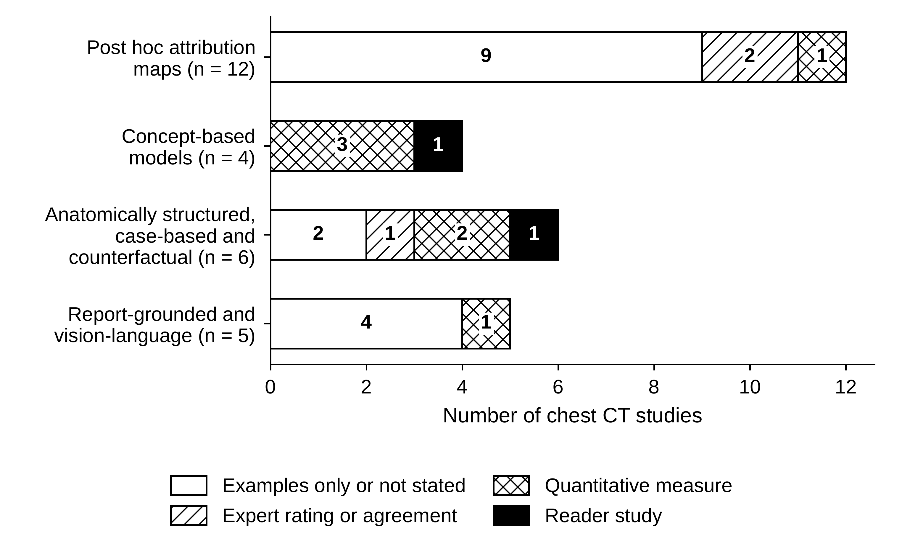
Fig. 3 How the explanation was assessed in the 27 chest CT studies charted, by family of explanation. Numbers inside the bars are counts of studies. The expert rating or agreement group includes one study in which the expertise of the raters was not stated
Studies with readers show that explanations can help and can mislead. A systematic review of 51 studies in which clinicians evaluated explanations found that example-based and concept-based explanations were associated with gains, whereas attribution maps mainly improved perception, and it judged the evidence methodologically fragile [74]. In mammography, heat maps reduced automation bias from 36.1% to 17.8% of deliberately manipulated readings among six radiologists [59]; yet region prompts from a commercial tool were associated with a fall in reader sensitivity from 71% to 39% for cancers that the tool had missed [70]. Among 76 dermatologists, balanced accuracy rose from 79.9% with a plain prediction to 82.7% with an explainable system [15]. A narrative review for radiologists concluded that current explanation methods are not yet mature enough for clinical use because their outputs are hard for medical experts to interpret [65]. No reader study of saliency explanations on chest CT published in 2025 or 2026 was found. In an earlier study, 36 radiologists described in reporting vocabulary the regions highlighted by occlusion-based saliency maps on 20 low-dose CT cases, and they agreed on the main label for only 5 of 41 regions [29].

4 Proposed Reference Framework
The gaps described above suggest what an explanation for a chest CT model should provide and how its quality might be summarised. This section sets out five desiderata, a reference design and an index. All three are proposals. They have not been implemented, and no performance is claimed for them.

4.1 Desiderata for Clinically Usable Explanations
Table 4 lists five requirements, each stated so that it can be measured. Faithfulness and stability correspond to the fidelity and consistency criteria proposed for heat maps [46]. Anatomical grounding is intended to follow the lobar description of location that is conventional in chest imaging. Semantic expressibility asks that the explanation can be stated in standard terminology [8]. Actionability asks that the explanation supports a counterfactual question. On the evidence reviewed, attribution maps address faithfulness only in part and the other requirements hardly at all, and concept-based models address semantic expressibility but, without spatial supervision, not anatomical grounding.
Table 4 Proposed desiderata for a clinically usable explanation of a chest CT model
Code | Requirement | Proposed measurement | Component of CMXI
E1 | Faithfulness: removing the evidence that the explanation identifies should lower the output more than removing other evidence | Normalised gap between insertion and deletion curves | F
E2 | Anatomical grounding: evidence is reported by lung lobe | Share of positive attribution that falls in the lobes annotated as containing the finding | P
E3 | Semantic expressibility: the explanation can be stated in standard radiological terms | Accuracy of predicted concepts against radiologist annotation | Assessed separately
E4 | Stability: inputs that cannot be told apart give explanations that cannot be told apart | Local sensitivity of the attribution to small perturbations of the input | S
E5 | Actionability: the explanation answers what would have to change for the output to change | Counterfactual necessity and sufficiency of the identified evidence | Enters F
CMXI Clinically Meaningful eXplanation Index. Conciseness (component Q of the index) is an additional property and not a separate desideratum

4.2 CLARITY-CT Reference Design
CLARITY-CT is the name given here to a design in which the representation is divided by lobe before any prediction is made and every prediction passes through named radiological concepts (Fig. 4). A lobe segmentation model supplies masks $A_{l}$ for the five lobes, $l=1,…,L$, and their union $A^{+}$; the reliability of these masks limits everything that follows [3]. Features from a volumetric encoder are pooled within each lobe, and the lobar descriptors are combined in proportion to lobe volume. Concepts are predicted for each lobe and for the whole lung with shared weights, so that a concept has the same meaning wherever it is evaluated, and each finding is predicted from the concepts through non-negative weights, so that raising a concept can only raise the probability of a finding that it supports. A residual pathway carries information that the concepts cannot express. Because a residual pathway could let information bypass the concepts, which is the leakage problem described for concept bottleneck models [32], the design reports a leakage gap, defined as the loss of discrimination when the residual is switched off. The equations of the design are given in Online Resource 1.
An initial vocabulary of 23 descriptors based on Fleischner Society terminology [8] is listed in Online Resource 1; it is a starting point to be revised with thoracic radiologists. The uncertainty of each concept prediction can be carried forward, as has been done for concept-querying models [56].
Anatomical grounding is encouraged during training. Let $a_{u}^{(c)}$ be the attribution of finding $c$ at voxel $u$ and $M_{c}$ the set of lobes recorded as containing the finding. The anatomical evidence mass of lobe $l$ and the alignment penalty are
${AEM}_{l}(c)=\frac{\sum_{u∈A_{l}}{{\left[a_{u}^{(c)}\right]}_{+}}}{\sum_{u∈A^{+}}{{\left[a_{u}^{(c)}\right]}_{+}}+ϵ}, L_{align}=\frac{1}{|C^{+}|}\sum_{c∈C^{+}}{\left(1-\sum_{l∈M_{c}}{{AEM}_{l}(c)}\right)}$ (1)
where $[x]_{+}=max(x,0)$, $ϵ$ is a small constant and $C^{+}$ is the set of findings present. The penalty needs only a record of which lobes contain each finding, which is weaker supervision than voxel-level masks. It constrains where evidence may come from and not its shape, and because the denominator runs over the lungs it does not by itself penalise evidence placed outside them.
Lobar pooling has one property that can be stated exactly. Because the pooled descriptor is a weighted sum of the lobar descriptors, the contributions of the lobes add up exactly to the gradient-times-input attribution of the prediction head, with no interpolation between a coarse map and the image. The statement and its short proof are given in Online Resource 1. It concerns the assignment of evidence among lobes; the mapping from voxels to features within a lobe remains approximate. It follows from the linearity of the pooled descriptor, would hold for any partition of the features, and says nothing about whether the evidence is clinically correct. Alongside the lobar and concept outputs, the design returns similar past cases through prototypes of the lobar descriptors [16] and a prediction set from conformal calibration [28, 35].
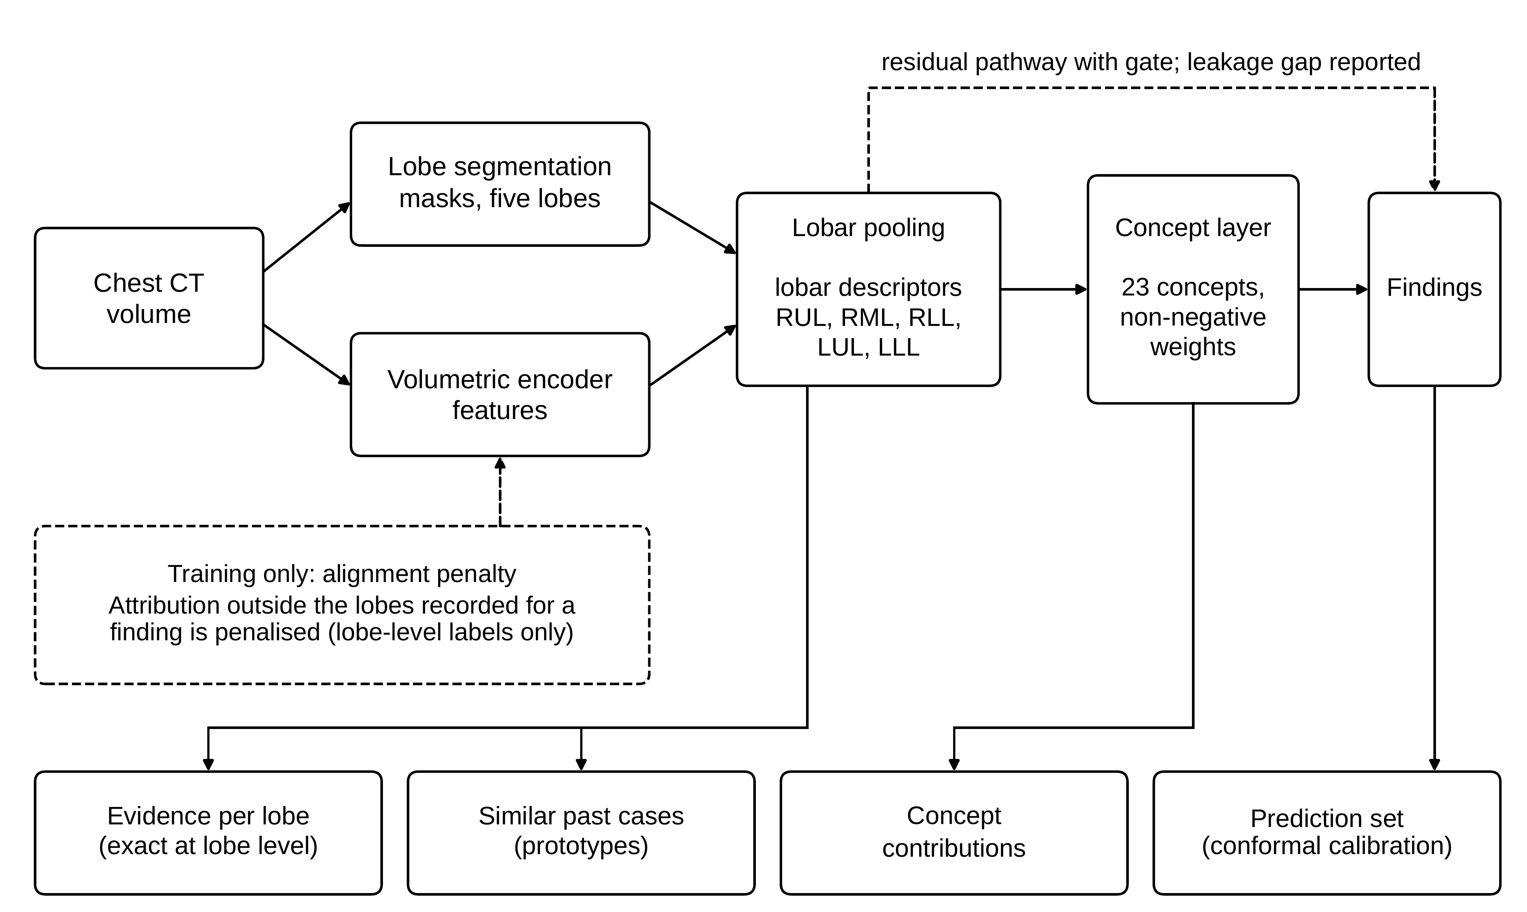
Fig. 4 CLARITY-CT reference design. The representation is divided by lobe before prediction, and each finding is predicted through named radiological concepts. Solid arrows show the flow of information, the dashed arrow at the top shows the residual pathway, and the dashed box shows a penalty used only in training. The bottom row lists the outputs shown to the reader. The design has not been implemented. RUL right upper lobe, RML right middle lobe, RLL right lower lobe, LUL left upper lobe, LLL left lower lobe

4.3 CMXI Explanation-Quality Index
The Clinically Meaningful eXplanation Index (CMXI) summarises four measurements of an explanation, each scaled to the interval from 0 to 1. Let $ins(q)$ be the output retained when only the top fraction $q$ of attributed voxels is kept and $del(q)$ the output retained when that fraction is removed, both divided by the original output and limited to the unit interval. Faithfulness $F$, plausibility $P$, stability $S$ and conciseness $Q$ are defined as
$F=\frac{1}{2}\left[1+\int_{0}^{1}{\left(ins(q)-del(q)\right)dq}\right], P=\sum_{l∈M_{c}}{{AEM}_{l}(c)}$ (2)
$S=exp\left(-κ\max_{‖δ‖_{2}≤ε‖x‖_{2}}\frac{‖a(x+δ)-a(x)‖_{2}}{‖δ‖_{2}}\right), Q=\frac{2\sum_{i=1}^{N}{i {\tilde{a}}_{(i)}}}{N\sum_{i=1}^{N}{{\tilde{a}}_{(i)}}}-\frac{N+1}{N}$ (3)
where $κ>0$ and $ε>0$ are constants fixed in advance, and ${\tilde{a}}_{(1)}≤…≤{\tilde{a}}_{(N)}$ are the sorted absolute attributions, so that $Q$ is their Gini coefficient. Removal of voxels is proposed to use replacement by healthy tissue from the same lobe and not zeroing. Whatever strategy is used must be declared, because rankings of methods by deletion score depend on it [60]. The index is the weighted geometric mean
$CMXI=F^{w_{1}}P^{w_{2}}S^{w_{3}}Q^{w_{4}}, w_{i}>0, \sum_{i=1}^{4}{w_{i}}=1$ (4)
The geometric form is chosen for four properties, proved in Online Resource 1. The index is zero whenever any component is zero. It increases strictly with each component. It is non-compensatory, in that the gain in one component needed to offset a small loss in another grows without bound as the second approaches zero. It scales in proportion when all components are scaled together. A weighted arithmetic mean has neither the first nor the third property: it gives a positive score to an explanation with zero faithfulness, and it allows a map concentrated on a single voxel to offset near-zero faithfulness through high conciseness (Fig. 5).
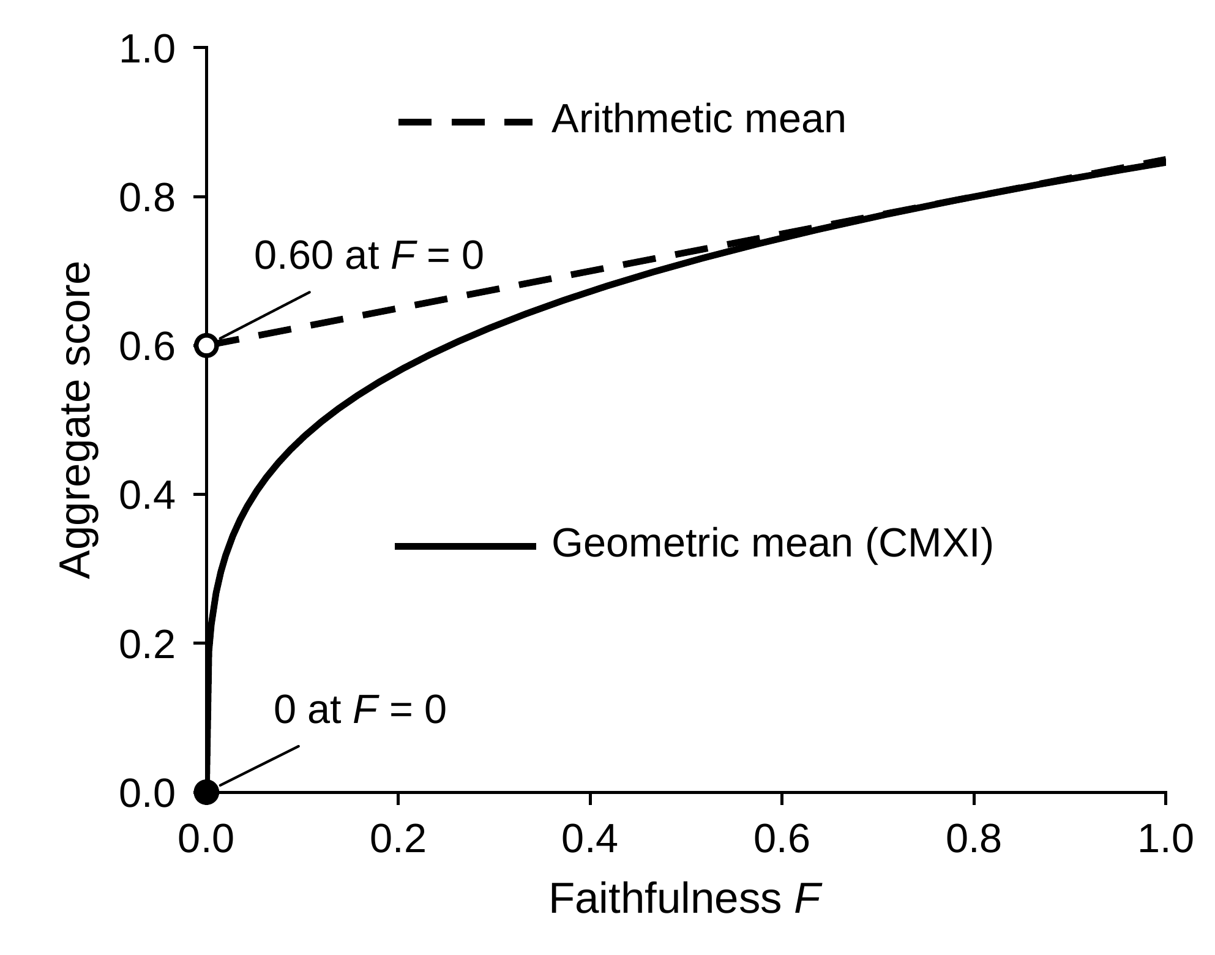
Fig. 5 Behaviour of the geometric aggregate used in CMXI compared with an arithmetic mean as faithfulness approaches zero, with the other three components held at 0.8 and equal weights. The curves are computed from the definitions and are not experimental results
The index has clear limits. The weights are not fixed here; they should be set by structured elicitation with thoracic radiologists before the index is used, and equal weights are the neutral default. Plausibility requires lobe-level annotation of findings. Stability is defined as a maximum over perturbations and can only be estimated by sampling, so the estimator and its error have to be reported. The insertion and deletion curves are undefined when the original output is zero, so faithfulness applies only to findings with a non-zero output, and the attribution method and the fractions at which the curves are sampled must be declared. Conciseness rewards concentrated attributions whether or not they are correct, and it is computed on absolute attributions whereas plausibility uses only positive ones; both choices remain open. The index covers desiderata E1, E2 and E4 and adds conciseness, while E3 and E5 are assessed alongside it (Table 4). It measures computational properties only. In the terms of the four criteria proposed for heat maps it does not measure usefulness [46], and guidance asks that explanations be evaluated with end users as well as computationally [48]. Whether a higher CMXI corresponds to explanations that help readers is an empirical question that this review cannot answer.

5 Discussion
Four observations follow from the work reviewed. First, post hoc heat maps remain the default explanation for chest CT models, and in most studies they are shown and not tested. This agrees with counts from cancer imaging [26] and echocardiography [36], and it persists even in studies whose predictions were validated across centres. Second, the alternatives that reviews of other modalities describe are barely represented on chest CT. Concept-based models were found only for nodule malignancy, and lobe-level structure is used to quantify disease but was not found in use to explain a classifier. Third, report-generating models have moved from text about the whole scan towards text tied to an organ or region, but not yet to the lesion, and their grounding has been evaluated less than their wording. Fourth, almost all evidence on whether explanations change what readers do comes from other modalities.
That evidence argues against treating any explanation as harmless. Attribute explanations tended to lower accuracy when the model was wrong [27], region prompts were associated with missed cancers when the tool missed them [70], and heat maps reduced but did not remove automation bias [59]. Evaluations with readers therefore need to include cases on which the model is wrong, and they need to record reliance and reading time as well as accuracy. Guidance already asks for this dual evaluation [48], and regulation in Europe requires human oversight while its standards for transparency are still being written [42]. The argument that explanation is not always required when a clinician stays in the loop [11] does not remove the need to know what an explanation does to that clinician.
Chest CT is well placed for progress on these points. The lobes give a reporting frame that is already clinical. A consensus vocabulary exists [8]. Public data now pair scans with reports [30], with region-level grounding [84], and, in a preprint, with lesion-level segmentations of reported findings [7]. The framework proposed here is one way to combine these resources. Its contribution is conceptual: it states requirements that can be measured, a design in which evidence is assigned to lobes exactly at the level at which it is reported, and an index that cannot be raised by one property at the expense of another.

5.1 Limitations
This review has several limitations. The search was not systematic, was run over two days, and could not query PubMed, ScienceDirect or IEEE Xplore directly, so relevant studies will have been missed and statements that no study was found are provisional. Searching and charting were assisted by a generative AI tool and checked by the authors, and no formal risk-of-bias assessment was made. The window of 2025 and 2026 excludes earlier work on chest CT explanation, which is represented only through original method papers and one earlier reader study. Thirteen sources were read as abstracts or preprint versions. The evidence map in Table 3 covers the studies selected and is not a census of the field. Evidence on reader effects was drawn from other modalities and may not transfer to volumetric CT. No radiologist took part in this review or in the design of the proposal, so the clinical statements, the proposed desiderata and the initial concept vocabulary have not been checked by a thoracic radiologist. Finally, the proposed design and index are untested. No claim is made about their accuracy, their computational cost or their value to readers, and the formal properties of the index do not establish that it measures what matters clinically.

5.2 Directions for Validation
A staged plan would test the proposal. The first stage is implementation on public data: CT-RATE for multi-abnormality prediction with reports [30], LIDC-IDRI for nodule attributes [5], and the grounded datasets for region-level and lesion-level evidence [7, 84], with the lobe masks checked on difficult anatomy before use [3]. The second stage is computational evaluation under a fixed protocol: the four components of CMXI for the proposed design and for standard attribution baselines, randomisation checks [1], a declared masking strategy [60], concept accuracy against radiologist labels, and the leakage gap. The third stage is external testing, because performance on one population does not guarantee performance on another [47]. The fourth stage, which requires ethics approval and thoracic radiologists, is a reader study that includes cases on which the model is wrong and measures accuracy, reliance and reading time, with the weights of the index elicited beforehand. Reporting should follow established reporting standards for AI studies, as consensus guidance asks [48].

6 Summary
In the work from 2025 and 2026 charted for this review, explanations for chest CT models were dominated by post hoc heat maps that were rarely tested: 15 of the 27 chest CT studies charted presented examples only or reported no assessment of the explanation. Among the studies found, concept-based models for chest CT were confined to nodule malignancy, lobe-level structure was used for quantification but not for explaining classifiers, and report-generating models grounded their text in organs or regions and not in lesions. Evidence that explanations help or harm readers comes from other modalities and points in both directions. This review proposes five measurable desiderata, a reference design that divides the representation by lobe and predicts through radiological concepts, and a non-compensatory index of explanation quality with stated formal properties. These proposals are untested. Their value depends on the implementation, external testing and reader studies outlined here.

Supplementary Information
Online Resource 1 Formal properties of the CMXI index with proof, the equations of the reference design, the statement and proof of the lobar evidence accounting property, the initial vocabulary of 23 radiological descriptors, and the number of records verified and included by search theme (ESM_1.pdf)

Declarations
Funding The authors declare that no funds, grants, or other support were received during the preparation of this manuscript.
Competing interests The authors have no relevant financial or non-financial interests to disclose.
Ethics approval Not applicable. This article is a review of published literature and involved no human participants, animals or patient data.
Consent to participate and consent to publish Not applicable.
Data availability No new data were created or analysed in this study. All sources are listed in the references.

References
1. Adebayo J, Gilmer J, Muelly M, Goodfellow I, Hardt M, Kim B (2018) Sanity Checks for Saliency Maps. Adv Neural Inf Process Syst 31. https://proceedings.neurips.cc/paper/2018/hash/294a8ed24b1ad22ec2e7efea049b8737-Abstract.html. Accessed 10 Oct 2026
2. Ahmed F, Naz NS, Khan S, Rehman AU, Ismael WM, Khan MA (2026) Explainable artificial intelligence (XAI) in medical imaging: a systematic review of techniques, applications, and challenges. BMC Med Imaging 26:37. https://doi.org/10.1186/s12880-025-02118-w
3. Amini E, Klein R (2025) Lung lobe segmentation: performance of open-source MOOSE, TotalSegmentator, and LungMask models compared to a local in-house model. Eur Radiol Exp 9:86. https://doi.org/10.1186/s41747-025-00623-9
4. Antonissen N, Venkadesh KV, Dinnessen R et al (2025) External Test of a Deep Learning Algorithm for Pulmonary Nodule Malignancy Risk Stratification Using European Screening Data. Radiology 316:e250874. https://doi.org/10.1148/radiol.250874
5. Armato SG 3rd, McLennan G, Bidaut L et al (2011) The Lung Image Database Consortium (LIDC) and Image Database Resource Initiative (IDRI): A Completed Reference Database of Lung Nodules on CT Scans. Med Phys 38:915-931. https://doi.org/10.1118/1.3528204
6. Arun N, Gaw N, Singh P et al (2021) Assessing the Trustworthiness of Saliency Maps for Localizing Abnormalities in Medical Imaging. Radiol Artif Intell 3:e200267. https://doi.org/10.1148/ryai.2021200267
7. Baharoon M, Luo L, Moritz M et al (2025) ReXGroundingCT: A 3D Chest CT Dataset for Segmentation of Findings from Free-Text Reports. arXiv:2507.22030 (preprint). https://arxiv.org/abs/2507.22030
8. Bankier AA, MacMahon H, Colby T et al (2024) Fleischner Society: Glossary of Terms for Thoracic Imaging. Radiology 310:e232558. https://doi.org/10.1148/radiol.232558
9. Berti A, Scapicchio C, Iacconi C et al (2025) An explainable-by-design end-to-end AI framework based on prototypical part learning for lesion detection and classification in Digital Breast Tomosynthesis images. Comput Struct Biotechnol J 27:2649-2660. https://doi.org/10.1016/j.csbj.2025.06.008
10. Bhamani A, Creamer A, Verghese P et al (2025) Low-dose CT for lung cancer screening in a high-risk population (SUMMIT): a prospective, longitudinal cohort study. Lancet Oncol 26:609-619. https://doi.org/10.1016/S1470-2045(25)00082-8
11. Blackman J, Veerapen R (2025) On the practical, ethical, and legal necessity of clinical Artificial Intelligence explainability: an examination of key arguments. BMC Med Inform Decis Mak 25:111. https://doi.org/10.1186/s12911-025-02891-2
12. Blankemeier L, Kumar A, Cohen JP et al (2026) Merlin: a computed tomography vision–language foundation model and dataset. Nature 652:1318-1328. https://doi.org/10.1038/s41586-026-10181-8
13. Böttcher B, van Assen M, Fari R et al (2025) Evaluation of a content-based image retrieval system for radiologists in high-resolution CT of interstitial lung diseases. Eur Radiol Exp 9:4. https://doi.org/10.1186/s41747-024-00539-w
14. Bray F, Laversanne M, Sung H et al (2024) Global cancer statistics 2022: GLOBOCAN estimates of incidence and mortality worldwide for 36 cancers in 185 countries. CA Cancer J Clin 74:229-263. https://doi.org/10.3322/caac.21834
15. Chanda T, Haggenmueller S, Bucher TC et al (2025) Dermatologist-like explainable AI enhances melanoma diagnosis accuracy: eye-tracking study. Nat Commun 16:4739. https://doi.org/10.1038/s41467-025-59532-5
16. Chen C, Li O, Tao D, Barnett A, Rudin C, Su JK (2019) This Looks Like That: Deep Learning for Interpretable Image Recognition. Adv Neural Inf Process Syst 32. https://proceedings.neurips.cc/paper/2019/hash/adf7ee2dcf142b0e11888e72b43fcb75-Abstract.html. Accessed 10 Oct 2026
17. Chen Z, Bie Y, Jin H, Chen H (2025) Large Language Model With Region-Guided Referring and Grounding for CT Report Generation. IEEE Trans Med Imaging 44:3139-3150. https://doi.org/10.1109/tmi.2025.3559923
18. Christensen EW, Drake AR, Parikh JR, Rubin EM, Rula EY (2025) Projected US Imaging Utilization, 2025 to 2055. J Am Coll Radiol 22:151-158. https://doi.org/10.1016/j.jacr.2024.10.017
19. Cohen JP, Blankemeier L, Chaudhari A (2025) Explaining 3D Computed Tomography Classifiers with Counterfactuals. arXiv:2502.07156 (preprint). https://arxiv.org/abs/2502.07156
20. Cooke LH, Jung M, Brendel JM et al (2026) RoentMod: a synthetic chest X-ray modification model to identify and correct image interpretation model shortcuts. NPJ Digit Med 9:324. https://doi.org/10.1038/s41746-026-02497-6
21. Curiale AH, Niethammer M, San José Estépar R (2026) Prediction of Lobar Emphysema Progression with a CT-Based Foundational Model. Radiology 319:e252958. https://doi.org/10.1148/radiol.252958
22. Di Piazza T, Lazarus C, Nempont O, Boussel L (2025) CT-AGRG: Automated Abnormality-Guided Report Generation from 3D Chest CT Volumes. In: Proc IEEE Int Symp Biomed Imaging (ISBI), pp 1-5. https://doi.org/10.1109/isbi60581.2025.10981073
23. Di Piazza T, Lazarus C, Nempont O, Boussel L (2026) Imitating Radiological Scrolling: A Global-Local Attention Model for 3D Chest CT Volumes Multi-Label Anomaly Classification. Proc Mach Learn Res 301:1313-1325. https://proceedings.mlr.press/v301/di-piazza26a.html. Accessed 10 Oct 2026
24. Dumaev RI, Molodyakov SA, Utkin LV (2025) A Model for the Explainable Malignancy Assessment of Pulmonary Nodules on CT Images. Sci Tech Inf Process 52:760-768. https://doi.org/10.3103/S0147688225700637
25. Durak G, Aktas HE, Akinci D'Antonoli T, Bagci U (2026) Explainable artificial intelligence in medical imaging: how to interpret, evaluate, and use artificial intelligence explanations. Diagn Interv Radiol. https://doi.org/10.4274/dir.2026.264319
26. Fotopoulos D, Ladakis I, Filos D, Moreno-Sánchez PA, van Gils M, Chouvarda I (2026) Explainable AI in Cancer Imaging: Scoping Review of Methods, Modalities, and Clinical Integration. J Med Internet Res 28:e80645. https://doi.org/10.2196/80645
27. Gallée L, Lisson CS, Ropinski T, Beer M, Götz M (2025) Proto-Caps: interpretable medical image classification using prototype learning and privileged information. PeerJ Comput Sci 11:e2908. https://doi.org/10.7717/peerj-cs.2908
28. Gamble C, Faghani S, Erickson BJ (2025) Applying Conformal Prediction to a Deep Learning Model for Intracranial Hemorrhage Detection to Improve Trustworthiness. Radiol Artif Intell 7:e240032. https://doi.org/10.1148/ryai.240032
29. Gandomkar Z, Khong PL, Punch A, Lewis S (2022) Using occlusion-based saliency maps to explain an artificial intelligence tool in lung cancer screening: agreement between radiologists, labels, and visual prompts. J Digit Imaging 35:1164-1175. https://doi.org/10.1007/s10278-022-00631-w
30. Hamamci IE, Er S, Wang C et al (2026) Generalist foundation models from a multimodal dataset for 3D computed tomography. Nat Biomed Eng 10:1610-1628. https://doi.org/10.1038/s41551-025-01599-y
31. Hassan SU, Abdulkadir SJ, Alhussian HS et al (2026) Explainable deep learning-based lung cancer diagnosis using clinically-guided local interpretable model-agnostic explanations. Sci Rep 16:16741. https://doi.org/10.1038/s41598-026-44127-x
32. Havasi M, Parbhoo S, Doshi-Velez F (2022) Addressing Leakage in Concept Bottleneck Models. Adv Neural Inf Process Syst 35:23386-23397. https://doi.org/10.52202/068431-1699
33. Hou J, Liu S, Bie Y et al (2027) Self-eXplainable AI for medical image analysis: A survey and new outlooks. Inf Fusion 139:104791. https://doi.org/10.1016/j.inffus.2026.104791
34. Hu Z, Lin HM, Mathur S et al (2025) High performance with fewer labels using semi-weakly supervised learning for pulmonary embolism diagnosis. NPJ Digit Med 8:254. https://doi.org/10.1038/s41746-025-01594-2
35. Hulsman R, Comte V, Bertolini L, Wiesenthal T, Puertas Gallardo A, Ceresa M (2025) Conformal Risk Control for Pulmonary Nodule Detection. Proc Mach Learn Res 266:445-463. https://proceedings.mlr.press/v266/hulsman25a.html. Accessed 10 Oct 2026
36. Ishii R, Edwards RA, Gelbach PE, Alexander J Jr (2026) A Scoping Review of Interpretable AI Model Approaches in Echocardiography: Frameworks, Model Types, Explanation Strategies, and Evaluation Practices. J Imaging Inform Med. https://doi.org/10.1007/s10278-026-02172-y
37. Jelitzki J, Reichenbach A, Windberger A (2026) Decision processes in 3D structural MRI schizophrenia classification evaluated with saliency maps. Sci Rep 16:18362. https://doi.org/10.1038/s41598-026-57667-z
38. Kauffmann J, Dippel J, Ruff L, Samek W, Müller KR, Montavon G (2025) Explainable AI reveals Clever Hans effects in unsupervised learning models. Nat Mach Intell 7:412-422. https://doi.org/10.1038/s42256-025-01000-2
39. Kim SH, Adams LC, Wiestler B, Hedderich DM (2026) Human-AI Collaboration in Radiology: The Blind Spots. Radiol Artif Intell 8:e260325. https://doi.org/10.1148/ryai.260325
40. Kodipyaka N, Suganya G, Johnson DR (2026) LungCraft: a hybrid 3D-2D deep learning and radiomics framework with explainable AI for precision diagnosis of lung cancer. Front Artif Intell 9:1853361. https://doi.org/10.3389/frai.2026.1853361
41. Koh PW, Nguyen T, Tang YS et al (2020) Concept Bottleneck Models. Proc Mach Learn Res 119:5338-5348. https://proceedings.mlr.press/v119/koh20a.html. Accessed 10 Oct 2026
42. Kotter E, Akinci D'Antonoli T, Cuocolo R et al (2025) Guiding AI in radiology: ESR's recommendations for effective implementation of the European AI Act. Insights Imaging 16:33. https://doi.org/10.1186/s13244-025-01905-x
43. Koutoulakis E, Trivizakis E, Markodimitrakis E, Agelaki S, Tsiknakis M, Marias K (2026) A critical review of explainable deep learning in lung cancer diagnosis. Artif Intell Rev 59:28. https://doi.org/10.1007/s10462-025-11445-x
44. Kuzmanovic Y, Benattia A, Laporte A et al (2026) AI-based chest CT quantification of interstitial lung disease in idiopathic inflammatory myopathies: agreement with expert visual assessment in 107 patients. BMC Pulm Med 26:153. https://doi.org/10.1186/s12890-026-04201-6
45. Kyung S, Seo J, Lim H et al (2026) Region-Aware Multimodal Large Language Model via SlowFast Tokenization and Pseudo-Mask Guidance for 3D CT Report Generation. Lect Notes Comput Sci 17039:628-646. https://doi.org/10.1007/978-3-032-37435-6_34
46. Lago MA, Zamzmi G, Eich B, Delfino JG (2026) Evaluating Explainability: A Framework for Systematic Assessment of Explainable AI Features in Medical Imaging. Bioengineering (Basel) 13:111. https://doi.org/10.3390/bioengineering13010111
47. Lee JH, Chae KJ, Lu MT et al (2025) External Testing of a Deep Learning Model for Lung Cancer Risk from Low-Dose Chest CT. Radiology 316:e243393. https://doi.org/10.1148/radiol.243393
48. Lekadir K, Frangi AF, Porras AR et al (2025) FUTURE-AI: international consensus guideline for trustworthy and deployable artificial intelligence in healthcare. BMJ 388:e081554. https://doi.org/10.1136/bmj-2024-081554
49. Li Y, Chen S, Chen G et al (2026) A deep learning model for the interpretable identification of pulmonary thromboembolism from computed tomography pulmonary angiography. Front Cardiovasc Med 13:1864916. https://doi.org/10.3389/fcvm.2026.1864916
50. Lim WH, Lee JY, Lee JH, Kim S, Kim H (2026) Comparative evaluation of generative AI models for chest radiograph report generation in the emergency department. Eur Radiol 36:7911-7924. https://doi.org/10.1007/s00330-026-12648-8
51. Liu CJ, Liu YC, Chen YH et al (2025) AI-assisted differentiation of nontuberculous mycobacterial pulmonary disease from colonization: a multi-center study. Insights Imaging 16:249. https://doi.org/10.1186/s13244-025-02131-1
52. Lundberg SM, Lee SI (2017) A Unified Approach to Interpreting Model Predictions. Adv Neural Inf Process Syst 30. https://papers.nips.cc/paper/2017/hash/8a20a8621978632d76c43dfd28b67767-Abstract.html. Accessed 10 Oct 2026
53. Moll J, Graf M, Lemke T et al (2026) Evaluating Reasoning Faithfulness in Medical Vision-Language Models using Multimodal Perturbations. Proc Mach Learn Res 297:424-448. https://proceedings.mlr.press/v297/moll26a.html. Accessed 10 Oct 2026
54. Mou Y, Bian X, Tian N et al (2026) Early identification of PRISm from chest CT: a multimodal for three-class stratification of normal, PRISm, and COPD. Front Radiol 6:1829853. https://doi.org/10.3389/fradi.2026.1829853
55. Müller-Franzes G, Khader F, Siepmann R et al (2025) Medical slice transformer for improved diagnosis and explainability on 3D medical images with DINOv2. Sci Rep 15:23979. https://doi.org/10.1038/s41598-025-09041-8
56. Nahiduzzaman M, Korevaar S, Ge Z, Xia F, Bab-Hadiashar A, Tennakoon R (2026) Uncertainty-Aware Information Pursuit for Interpretable and Reliable Medical Image Analysis. IEEE Trans Med Imaging 45:3974-3985. https://doi.org/10.1109/TMI.2026.3690077
57. Nie Y, He S, Bie Y et al (2026) An explainable biomedical foundation model via large-scale concept-enhanced vision–language pretraining. Nat Biomed Eng. https://doi.org/10.1038/s41551-026-01764-x
58. Paolo D, Greco C, Ippolito E et al (2026) Predicting lung cancer survival with attention-based CT slices combination. Health Inf Sci Syst 14:20. https://doi.org/10.1007/s13755-025-00404-z
59. Pesapane F, Latronico A, Abbate F et al (2026) Evaluating cognitive biases in AI-assisted mammography interpretation: a simulation reader study of explainable AI across radiologist experience levels. Eur Radiol 36:7639-7650. https://doi.org/10.1007/s00330-026-12666-6
60. Poolpol P, Detjen HHJ, Petersen E (2026) Faithful Faithfulness Evaluations: Challenges & Pitfalls Learned from a Breast MRI Case Study. arXiv:2609.25978 (preprint). https://arxiv.org/abs/2609.25978
61. Rafferty A, Ramaesh R, Rajan A (2025) Explainability Through Human-Centric Design for XAI in Lung Cancer Detection. In: Proc Int Joint Conf Artif Intell (IJCAI), pp 10325-10333. https://doi.org/10.24963/ijcai.2025/1147
62. Rahat MMA, Islam MI, Miah MSU, Alharbi T (2026) An efficient dual path deep learning framework for COVID-19 classification using lung CT scans with explainable AI. Sci Rep 16:3687. https://doi.org/10.1038/s41598-025-33178-1
63. Repetto S, Maljkovic I, Lotto M, Cinà AE, Vascon S, Roli F (2026) Evaluating the robustness of explainable AI in medical image recognition under natural and adversarial data corruption. Mach Learn 115:4. https://doi.org/10.1007/s10994-025-06919-6
64. Rudin C (2019) Stop explaining black box machine learning models for high stakes decisions and use interpretable models instead. Nat Mach Intell 1:206-215. https://doi.org/10.1038/s42256-019-0048-x
65. Saw SN, Yan YY, Ng KH (2025) Current status and future directions of explainable artificial intelligence in medical imaging. Eur J Radiol 183:111884. https://doi.org/10.1016/j.ejrad.2024.111884
66. Selvaraju RR, Cogswell M, Das A, Vedantam R, Parikh D, Batra D (2020) Grad-CAM: Visual Explanations from Deep Networks via Gradient-Based Localization. Int J Comput Vis 128:336-359. https://doi.org/10.1007/s11263-019-01228-7
67. Shui Z, Zhang J, Cao W et al (2025) Large-scale and Fine-grained Vision-language Pre-training for Enhanced CT Image Understanding. In: Int Conf Learn Represent (ICLR). https://iclr.cc/virtual/2025/poster/28403. Accessed 10 Oct 2026
68. Sourget T, Hestbek-Møller M, Jiménez-Sánchez A, Xu JJ, Cheplygina V (2026) Mask of Truth: Model Sensitivity to Unexpected Regions of Medical Images. J Imaging Inform Med 39:767-784. https://doi.org/10.1007/s10278-025-01531-5
69. Spitzer P, Hendriks D, Rudolph J et al (2026) The effect of medical explanations from large language models on diagnostic accuracy in radiology. NPJ Digit Med 9:333. https://doi.org/10.1038/s41746-026-02619-0
70. Taib AG, Partridge GJW, Phillips P et al (2026) Automation Bias in Action: Eye Tracking of Humans Reading Screening Mammograms with and without AI Prompts. Radiology 320:e252590. https://doi.org/10.1148/radiol.252590
71. Tricco AC, Lillie E, Zarin W et al (2018) PRISMA Extension for Scoping Reviews (PRISMA-ScR): Checklist and Explanation. Ann Intern Med 169:467-473. https://doi.org/10.7326/M18-0850
72. Tripodi G, De Rosis A, Rezaeiravesh S (2027) Uncertainty-Driven Training for Three-Dimensional Calibrated Lung Nodule Classification. Lect Notes Comput Sci 17092:260-271. https://doi.org/10.1007/978-3-032-38407-2_21
73. Tushar FI, Adamo S, Rubin GD (2026) Distilling CT Foundation Models into Editable Concept Bottlenecks for Lung Nodule Malignancy Prediction. arXiv:2608.07857 (preprint). https://arxiv.org/abs/2608.07857
74. Ud Din S, Kemna R, Ket JCF et al (2026) Which explainable AI methods in medical imaging are clinically impactful? A systematic literature review addressing the clinician's perspective. Front Artif Intell 9:1819422. https://doi.org/10.3389/frai.2026.1819422
75. Vásquez-Venegas C, Wu C, Sundar S et al (2025) Detecting and Mitigating the Clever Hans Effect in Medical Imaging: A Scoping Review. J Imaging Inform Med 38:2563-2579. https://doi.org/10.1007/s10278-024-01335-z
76. Walstra ANH, Lancaster HL, Heuvelmans MA et al (2025) Feasibility of AI as first reader in the 4-IN-THE-LUNG-RUN lung cancer screening trial: impact on negative-misclassifications and clinical referral rate. Eur J Cancer 216:115214. https://doi.org/10.1016/j.ejca.2024.115214
77. Wang C, Li F, Hu W, Yan R, Zhang K, Zhou SK (2026) Concept Bottleneck Models for Explainable Decision Making: A Survey of Progress, Taxonomy, and Future Directions. In: Proc Int Joint Conf Artif Intell (IJCAI), pp 8041-8049. https://doi.org/10.24963/ijcai.2026/892
78. Wang C, Zhang K, Liu Y, He Z, Tao X, Zhou SK (2025) MVP-CBM: Multi-layer Visual Preference-enhanced Concept Bottleneck Model for Explainable Medical Image Classification. In: Proc Int Joint Conf Artif Intell (IJCAI), pp 529-537. https://doi.org/10.24963/ijcai.2025/60
79. Wang J, Wang Y, Zhao X et al (2026) An explainable multimodal 2.5D deep learning-radiomics model for predicting extranodal extension in lung adenocarcinoma using preoperative CT: a multicenter retrospective cohort study. BMC Med Imaging 26:516. https://doi.org/10.1186/s12880-026-02584-w
80. Wang J, Zhang X, Tang W, van Tuinen M, Vliegenthart R, van Ooijen P (2025) A multi-view CNN model to predict resolving of new lung nodules on follow-up low-dose chest CT. Insights Imaging 16:138. https://doi.org/10.1186/s13244-025-02000-x
81. Wu Y, Liu Y, Yang Y et al (2025) A concept-based interpretable model for the diagnosis of choroid neoplasias using multimodal data. Nat Commun 16:3504. https://doi.org/10.1038/s41467-025-58801-7
82. Yan Z, Deng X, Dang J et al (2026) Interpretable Deep Learning with Multi-Scale CT for Predicting Occult Lymph Node Metastasis in Early-Stage NSCLC: A Multicenter Study. J Imaging Inform Med. https://doi.org/10.1007/s10278-026-01954-8
83. Zhang J, He L, Wei Y et al (2025) Deep learning for classifying imaging patterns of interstitial lung disease associated with idiopathic inflammatory myopathies. Sci Rep 15:31655. https://doi.org/10.1038/s41598-025-15960-3
84. Zhang X, Wu C, Zhao Z et al (2025) Development of a large-scale grounded vision language dataset for chest CT analysis. Sci Data 12:1636. https://doi.org/10.1038/s41597-025-05922-9
85. Zhuang L, Tabatabaei SMH, Salehi-Rad R et al (2025) Vision-language model-based semantic-guided imaging biomarker for lung nodule malignancy prediction. J Biomed Inform 172:104947. https://doi.org/10.1016/j.jbi.2025.104947

