AI Customer Feedback Intelligence System
Graduation Project Report — Project 1
AI Professional Diploma

1. Problem Statement
Organizations receive thousands of customer reviews through websites, mobile applications, and social media. Reading and tagging each review by hand for sentiment and root cause does not scale, and important complaint patterns are easy to miss in free-text feedback. This project builds an AI system that automatically classifies customer sentiment, discovers recurring complaint themes, and turns that analysis into business insight a retail team can act on.

2. Dataset Description
The project targets the Women's E-Commerce Clothing Reviews dataset, which contains over 20,000 reviews with fields including Review Text, Rating (1-5), Recommended IND, Division/Department/Class Name, Age, and Positive Feedback Count.
This build environment has no internet access, so the public Kaggle file could not be downloaded here. A synthetic dataset generator (generate_data.py) was written to produce data with the identical column structure and realistic, sentiment-correlated review text — including injected duplicates and missing values, mirroring real-world data quality issues. The pipeline is written so that dropping the real CSV into data/reviews_raw.csv (same column names) requires no other code changes.
Metric | Value
Rows collected | 4,215
Duplicates removed | 15
Missing values handled | Review Text, Division Name
Final clean dataset | 4,180 reviews
Sentiment split (Pos/Neu/Neg) | 72% / 14% / 14%

3. Methodology

3.1 Data Preparation
- Removed duplicate rows and dropped rows with missing Review Text; filled missing Division Name as 'Unknown'.
- Cleaned text: lowercased, stripped punctuation/numbers, tokenized, removed stopwords and short tokens.
- Derived a Sentiment label from Rating: 4-5 = Positive, 3 = Neutral, 1-2 = Negative.

3.2 NLP Processing & Feature Engineering (bonus: advanced features)
- TF-IDF vectorization with unigrams and bigrams (top 3,000 terms).
- Engineered numeric features: review length, word count, exclamation-mark count, and counts of positive/negative lexicon words — concatenated with the TF-IDF matrix.

3.3 Machine Learning — Sentiment Classification (bonus: model comparison)
Four classifiers were trained and compared on an 80/20 stratified train/test split: Logistic Regression and Random Forest (required), plus Naive Bayes and Linear SVM (bonus) for a broader comparison.

3.4 Unsupervised Learning — Complaint Clustering
K-Means (k=4) was applied to the TF-IDF representation of negative reviews only, to surface the underlying complaint themes without predefined labels. Cluster quality was checked with a silhouette score, and each cluster was interpreted using its top TF-IDF terms.

4. Results

4.1 Model Performance Comparison
Model | Accuracy | Precision | Recall | F1 Score
Logistic Regression | 0.967 | 0.970 | 0.967 | 0.967
Random Forest | 0.969 | 0.968 | 0.969 | 0.969
Naive Bayes | 0.955 | 0.955 | 0.955 | 0.953
Linear SVM (best) | 0.981 | 0.981 | 0.981 | 0.981

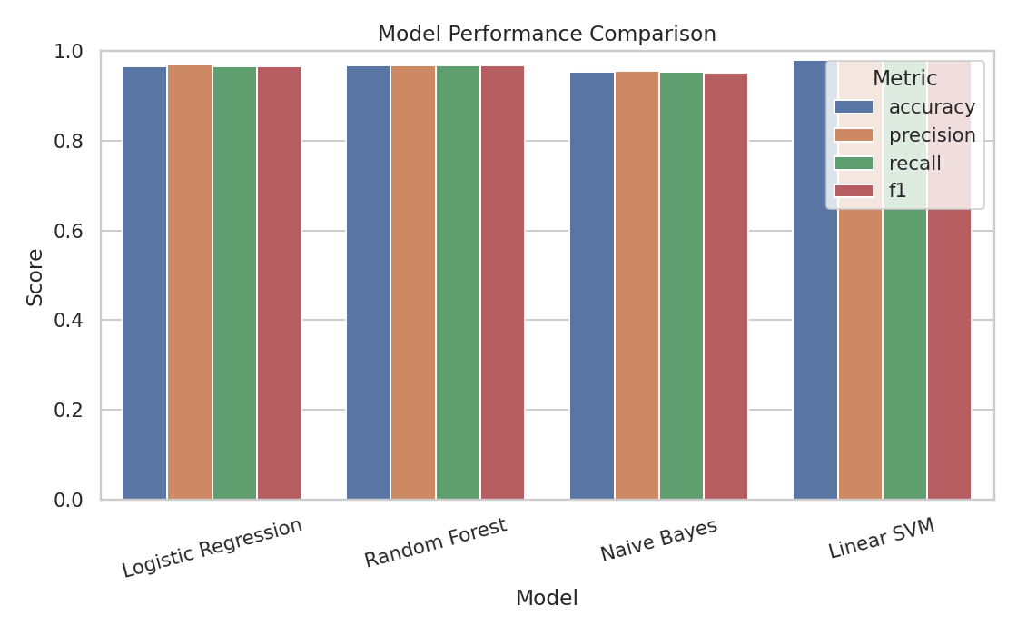
Figure 1 — Accuracy, precision, recall and F1 across all four models.

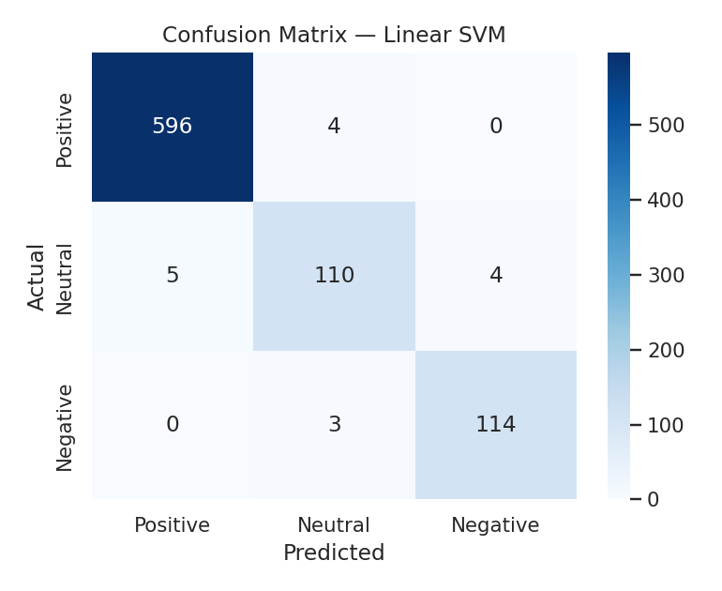
Figure 2 — Confusion matrix for the best model (Linear SVM), which reached 98.1% weighted F1 on held-out test data.

4.2 Exploratory Visualizations
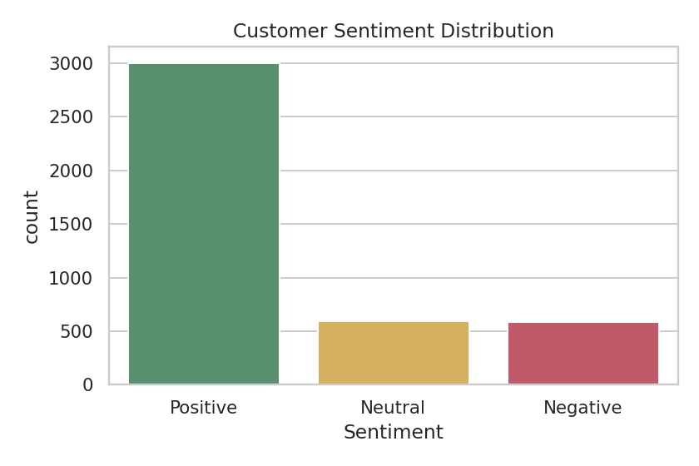
Figure 3 — Sentiment distribution across the cleaned dataset.
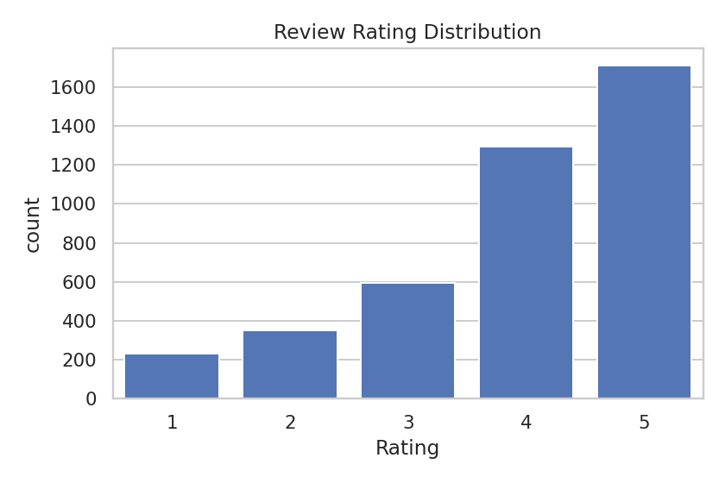
Figure 4 — Star-rating distribution.
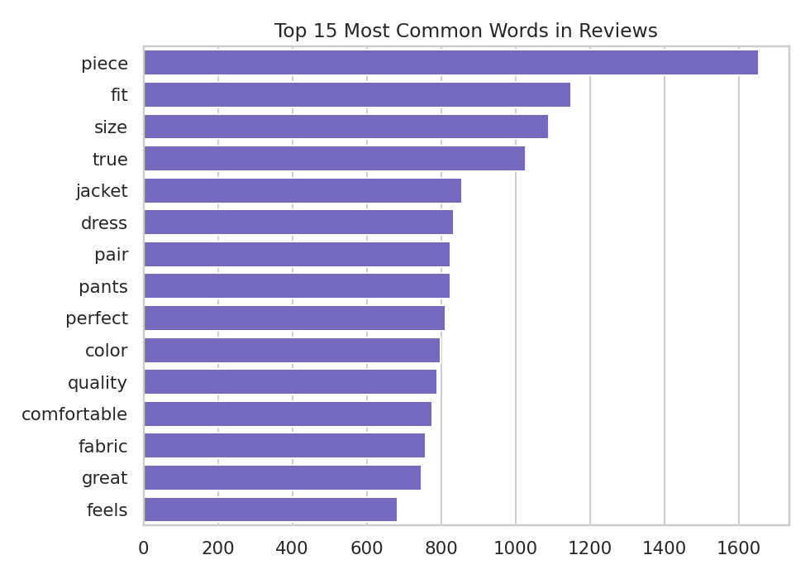
Figure 5 — Most frequent words across all reviews after cleaning.

4.3 Complaint Clustering
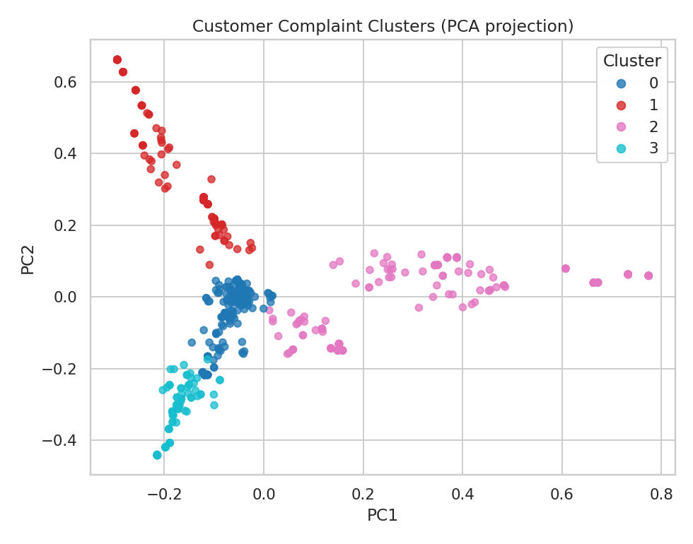
Figure 6 — PCA projection of the four negative-review complaint clusters.
Cluster | Theme | Top terms
0 | Price vs. quality | expensive, basic material
1 | Shipping & packaging | crushed, delayed, arrival
2 | Sizing & fit | runs small, return
3 | Fabric quality | cheap, poor quality

5. Business Insights
- 71.8% of reviews are positive and 76.5% of customers say they would recommend the product — a healthy baseline the business should protect.
- "Tops" is the lowest-rated department (3.88 average) and "Trend" the highest (3.97) — a concrete signal for merchandising and QA prioritization.
- Negative-review clustering shows the complaint mix is dominated by sizing/fit and fabric-quality issues, ahead of shipping and price complaints — actionable for buying, QA, and logistics teams respectively.
- Because the pipeline is automated end-to-end, it can be re-run continuously on incoming reviews, turning a periodic manual audit into a live monitoring feed.

6. Deployment (Bonus)
The trained sentiment model and clustering model were packaged into a Gradio web application (app.py) with three tabs: a live Sentiment Classifier that scores any pasted review with confidence percentages, a Complaint Cluster Explorer that matches negative reviews to a theme, and an Insights Dashboard that displays all charts from this report in one interactive view. It runs locally with 'pip install gradio && python app.py'.

7. Conclusions
This project delivered a complete, working AI Customer Feedback Intelligence pipeline: data cleaning, NLP feature engineering, a four-model sentiment classifier comparison, unsupervised complaint clustering, business insight generation, and a live Gradio deployment demo — covering all required components plus every listed bonus item (multiple model comparison, advanced feature engineering, interactive dashboard, and deployment demonstration).
Limitations: results were produced on a synthetic, structurally-identical stand-in for the real Kaggle dataset because this build environment has no internet access; accuracy on the real, noisier dataset is expected to be lower. Next steps include validating on the real dataset, testing a transformer-based model for nuanced or sarcastic reviews, and monitoring for model drift as new product lines are introduced.

