**CPL Maker Lab**

**Make a Flower Crown for Pride**

Today you will use Inkscape, a 2D design software to design a flower that will be cut out of cardstock. You will then assemble the flower you designed along with pre-cut flowers to make a flower crown.

**Tips**

Keyboard shortcuts: Undo (Ctrl+Z), Select All (Ctrl+A), Copy (Ctrl+C), Paste (Ctrl+V)

Feel free to talk with or assist your neighbor in this informal learning environment

**Let's Begin!**

**1. Open Inkscape**

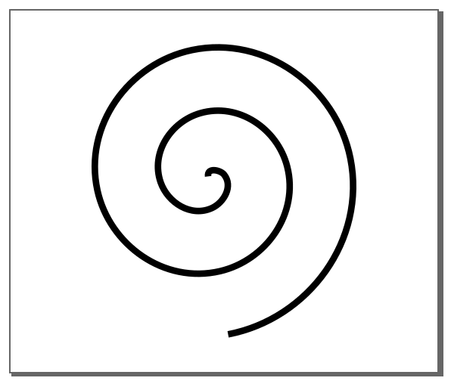Click on Inkscape on the desktop. Download the program for free at <https://inkscape.org/> if you don’t have it.

**2. Create a Spiral**

Use the **Spiral** tool to create a spiral, don’t worry about the dimensions just yet. Set it to these values: Turns = 2.5, Divergence = 1.0, & Inner Radius = 0.0

**3. Place a Circle in the Center**

Use the **Circle** tool to create a circle, place it at the very center of the spiral.



**4. Create a Petal**

Use the **Draw Bezier Curves** to create a petal that you will later duplicate around the spiral. Petal shapes that are purely circular are not recommended, as they do not cut out that well. Make the base wide.

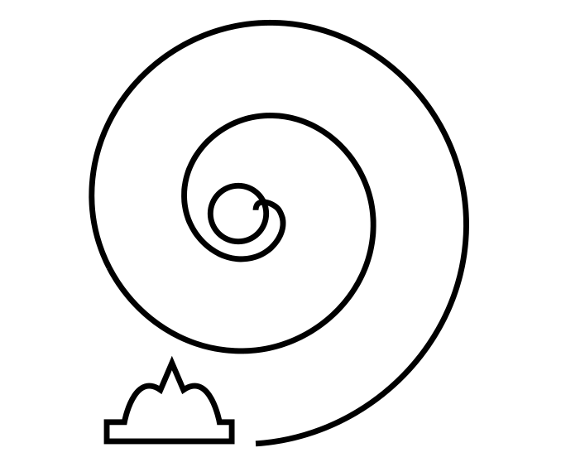

**5. Copy the Petal.**

Click on the petal. Then **Copy** (Ctrl+C) it.

**6. Select the Spiral and Use Path Effects**

Select the spiral. Go to **Path > Path Effects**. You will see a new window appear. Click the **+**, then search for **Pattern Along Path** and select it. Then set **Pattern Copie**s to **Repeated, Stretched**. Finally click on **Paste Path**.

**7. Offset the Design**

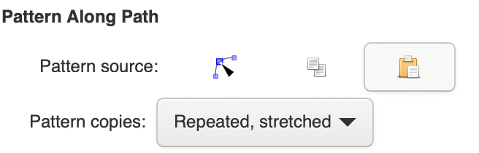Click on the **Edit Paths by Nodes** tool. Then use the **Inset** (Ctrl+() and **Outset**(Ctrl+)) tools to adjust the shape of the petals.

**8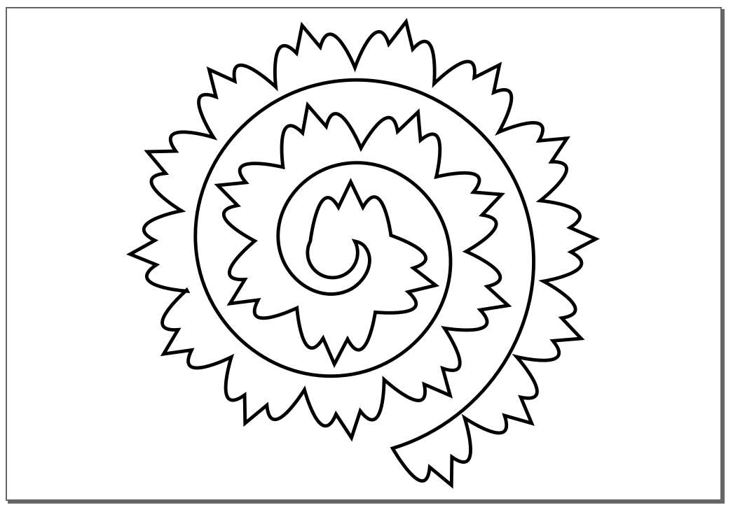. Clean Up and Union The Circle**

Select petals and the circle. Go to **Path > Union**.

**9. Copy & Paste More Flowers on the Page**

Fill up your 8.5 x 11 page with flowers between 2 x 2 and 5 x 5 inches.

**10. Save & Cut Your Design**

Go to File > Save As

Enter “YourName” and Save as type: .svg, for example, jeff.svg

Click Save. Staff will then collect your files and cut out your flowers.

**Flower Crown Assembly**

**1. Attach Foam to the Headband**

Attach adhesive foam to the pre-printed headband.

**2. Roll the Flowers**

Insert the end of the paper flower cut-out into the slotted tip of the quilling tool. (Start from the outer petals on the outer edge of the spiral shape, not the circle base in the center.)

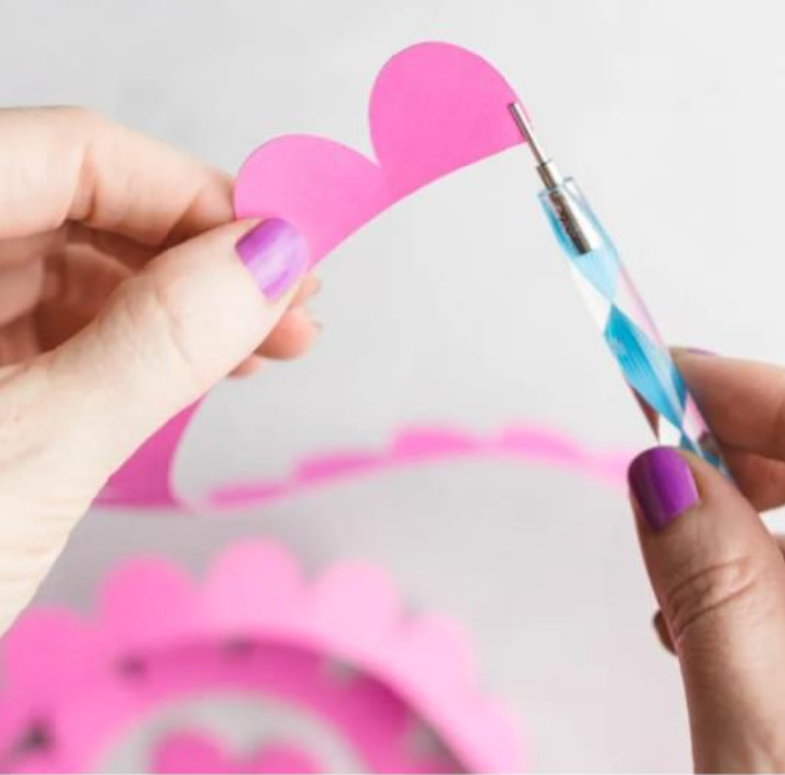

Keep slight tension on the paper as you roll up the flower. Try to keep the 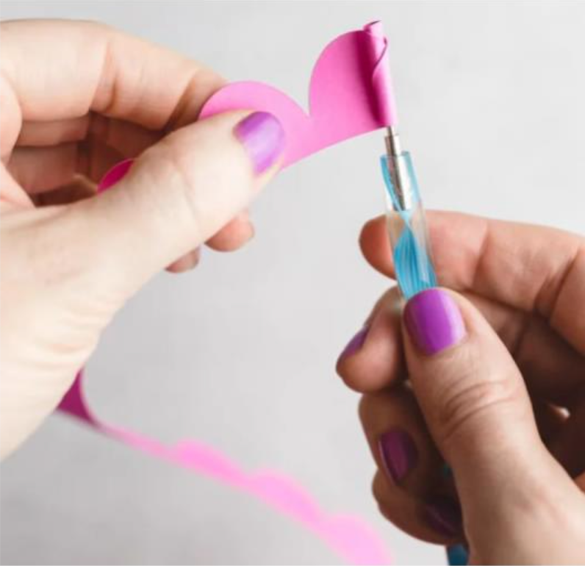bottom edge of the rolled flower aligned. (As you get to the end of the paper, it will get a bit harder to roll. Roll more slowly, and try to keep the bottom edge of the flower lined up.)

When you get the circle base at the middle of the spiral, stop rolling. Gently pinch the flower between your thumb and fingers, and slide the quilling tool out of the center of the flower.

Let the paper flower relax – just a little bit! You don’t want it to unroll completely. Add a small dab of glue from the hot glue gun to the circle part 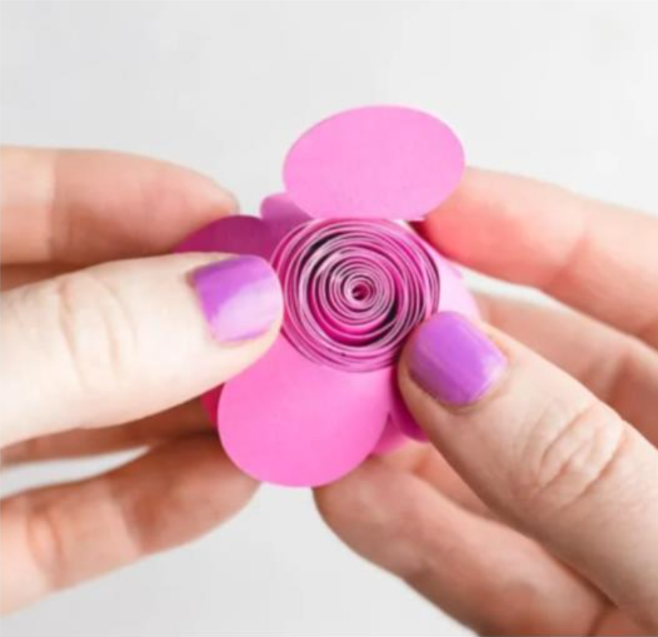at the end of the cut-out. Fold the center section down onto the bottom of the flower.

**3. Glue Flowers to the Headband**

Once you’ve rolled your flowers, use the hot glue to affix them to the 3D printed headband. You can arrange them however you’d like: you could make a simple row of them along the band or you could make a bouquet-like design by gluing some of the flowers to each other.

(Instructions and images for rolling the flowers from https://sarahmaker.com/cricut-paper-flowers/)