**CPL Maker Lab**

**Make a Zodiac Shadow Puppet**

Today you will use Inkscape, a 2D design software to design a zodiac shadow puppet that will cut out of cardstock. At the end of class we will load SVG files onto the electronic cutters to be cut.

**Tips**

Keyboard shortcuts: Undo (Ctrl+Z), Select All (Ctrl+A), Copy (Ctrl+C), Paste (Ctrl+V)

Feel free to talk with or assist your neighbor in this informal learning environment

**Let's Begin!**

**1. Go to** [**www.google.com**](http://www.google.com/)

Search for one of the 12 zodiac animals l with the word **silhouette,** you should select an image that has the animal in profile: rat, ox, tiger, rabbit, dragon, snake, horse, goat, monkey, rooster, dog and pig

**2. Saving**

Click on an image you want to use

Click View Original Image

Right click and Save As, Save Target As, or Save Image As

Save to the Desktop

**3. Open the image**

Right click the file on the Desktop and click Inkscape

File > Document Properties

In General, next to Default Units, open the drop down and select Inches. Make sure the document is 8.5 x 11 in.

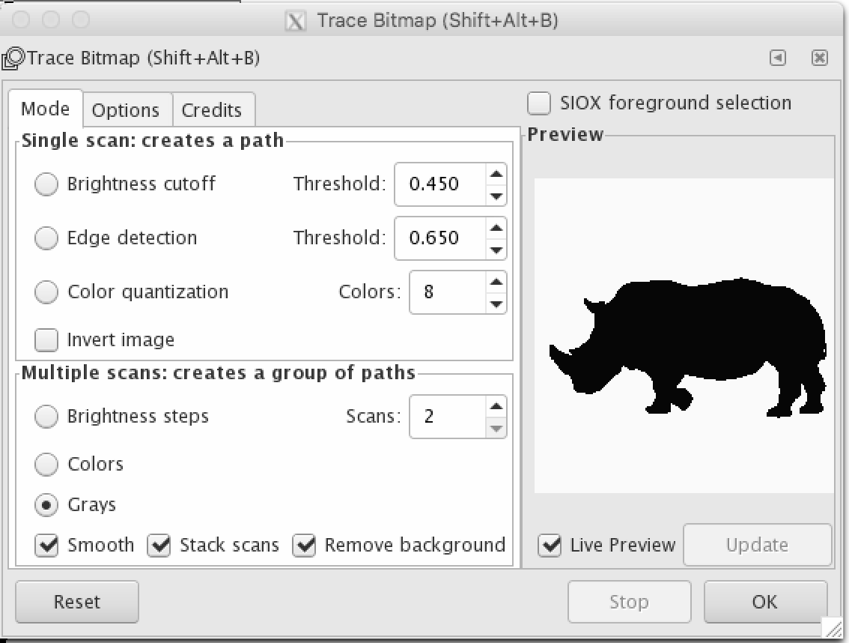

**4. Transforming the Image into a Vector**

Why do we need a vector? A PNG file *looks* like an empty square to the laser cutter. We need an SVG file to vector to cut and/or engrave.To transform the image into a vector, go to **Path>Trace Bitmap**.If you don’t see your image, make sure it is selected.

Adjust the settings under **Multiple** **Scans** to **Scans: 2**, **Grays**, **Stack Scans**, and **Remove Background**. Select Update, then OK.

Close the window.

**5. Delete the original bitmap/JPG/PNG**

There are now multiple copies of the original image. Click and move one copy. Double-click to reveal paths. Delete the copy that doesn’t have paths, keep the copy that does.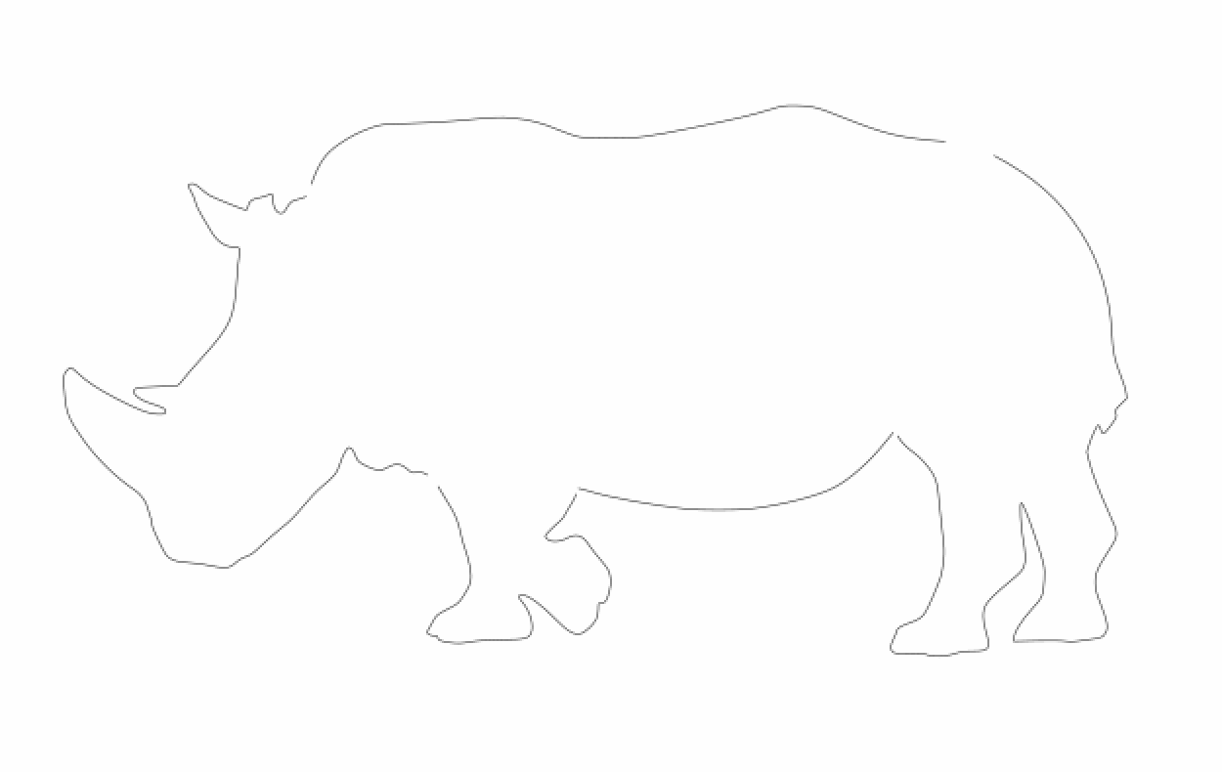

**6. Fill and Stroke Settings**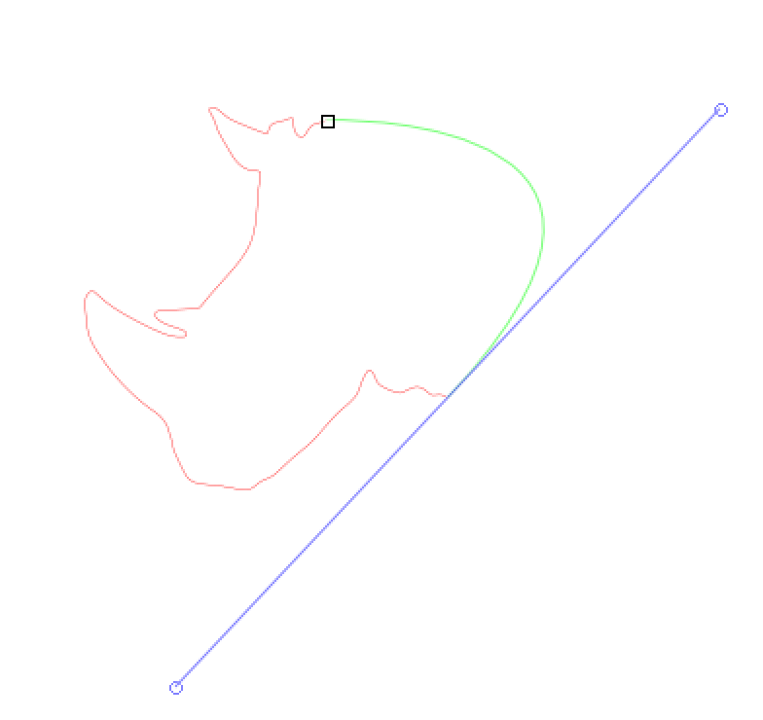

Click animal. For **Fill**, select **No Paint**. For **Stroke Paint**, select **Flat Color.** For **Stroke Style**, change width to 0.003 inches. We are doing this now to help us see the vector path more clearly in the next step.

**7. Break Bitmap into Segments**

Decide how many moving parts you want for your shadow puppet such as heads, arms and legs. This Rhino was broken into four segments. Using the **Edit Path by Nodes** tool, select two nodes by holding shift, then click the **Delete Segment Between Two Non-Endpoint Nodes** at the top**.** This will make the line between those two nodes disappear. Do this on the opposite side of that segment. Complete two times for each segment.

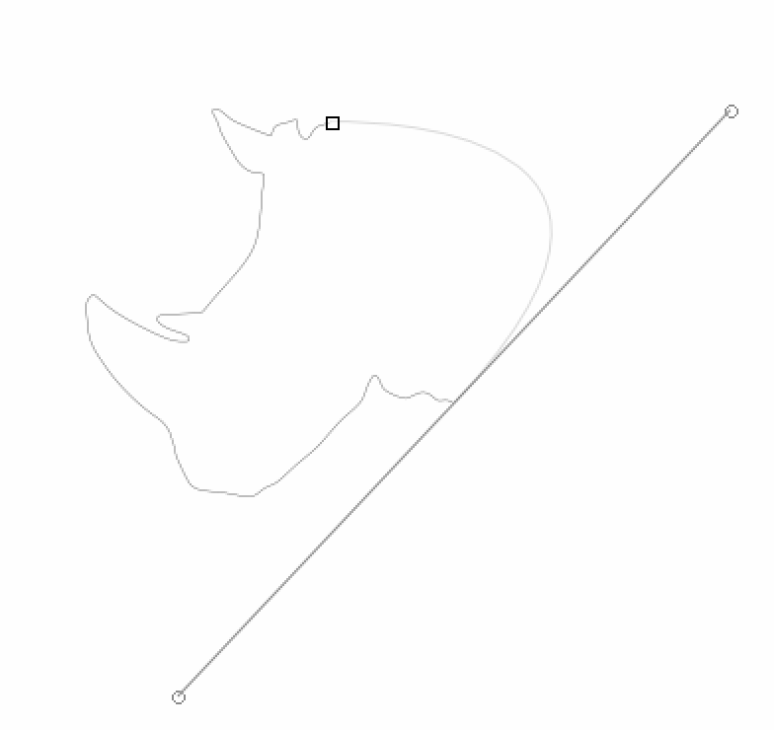**8. Break Apart.**

Highlight the entire animal silhouette and click **Break Apart** underneath **Path** at the top. The segments are now separate.

**9. Create Round Connections on Segments**

First, turn on the **Snap Cusp Nodes** node on the far right. Then, use the **Draw Bezier Curves** tool on the left to create round arcs. These round arcs are where we will later place rivets, so make sure they are big. To make arcs, click the first endpoint of a segment and then the second. As you click the second, hold down as you click and move your mouse until you create a large arc, then press enter. Repeat until all segments have round ends.

**10. Add in Eyes and Stripes**

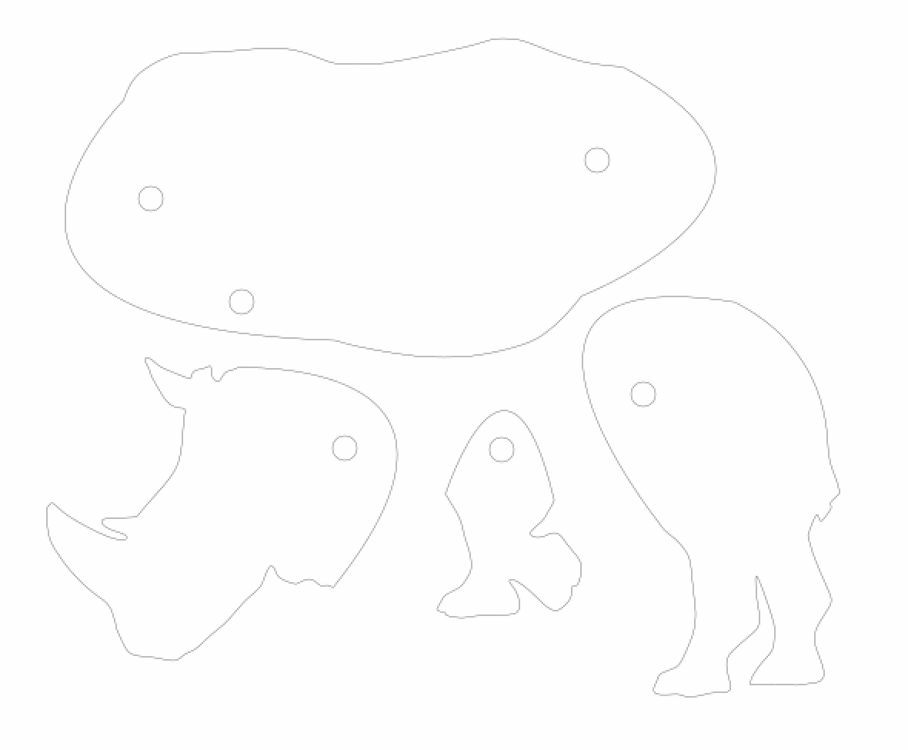Create additional shapes you would like to be cut out of your animal (such as eyes, stripes, scales) using different shape tools on the left.

**10. Finish the Design**

Using the **Circle** tool, place a circle that is .15 x .15 inches in size in each place you intend to put a rivet. Duplicate and move circles or copy/paste using keyboard shortcuts to save time.

**11. Save**

Save to the Desktop and to your personal thumb drive if you want to access it later.

Go to File > Save As

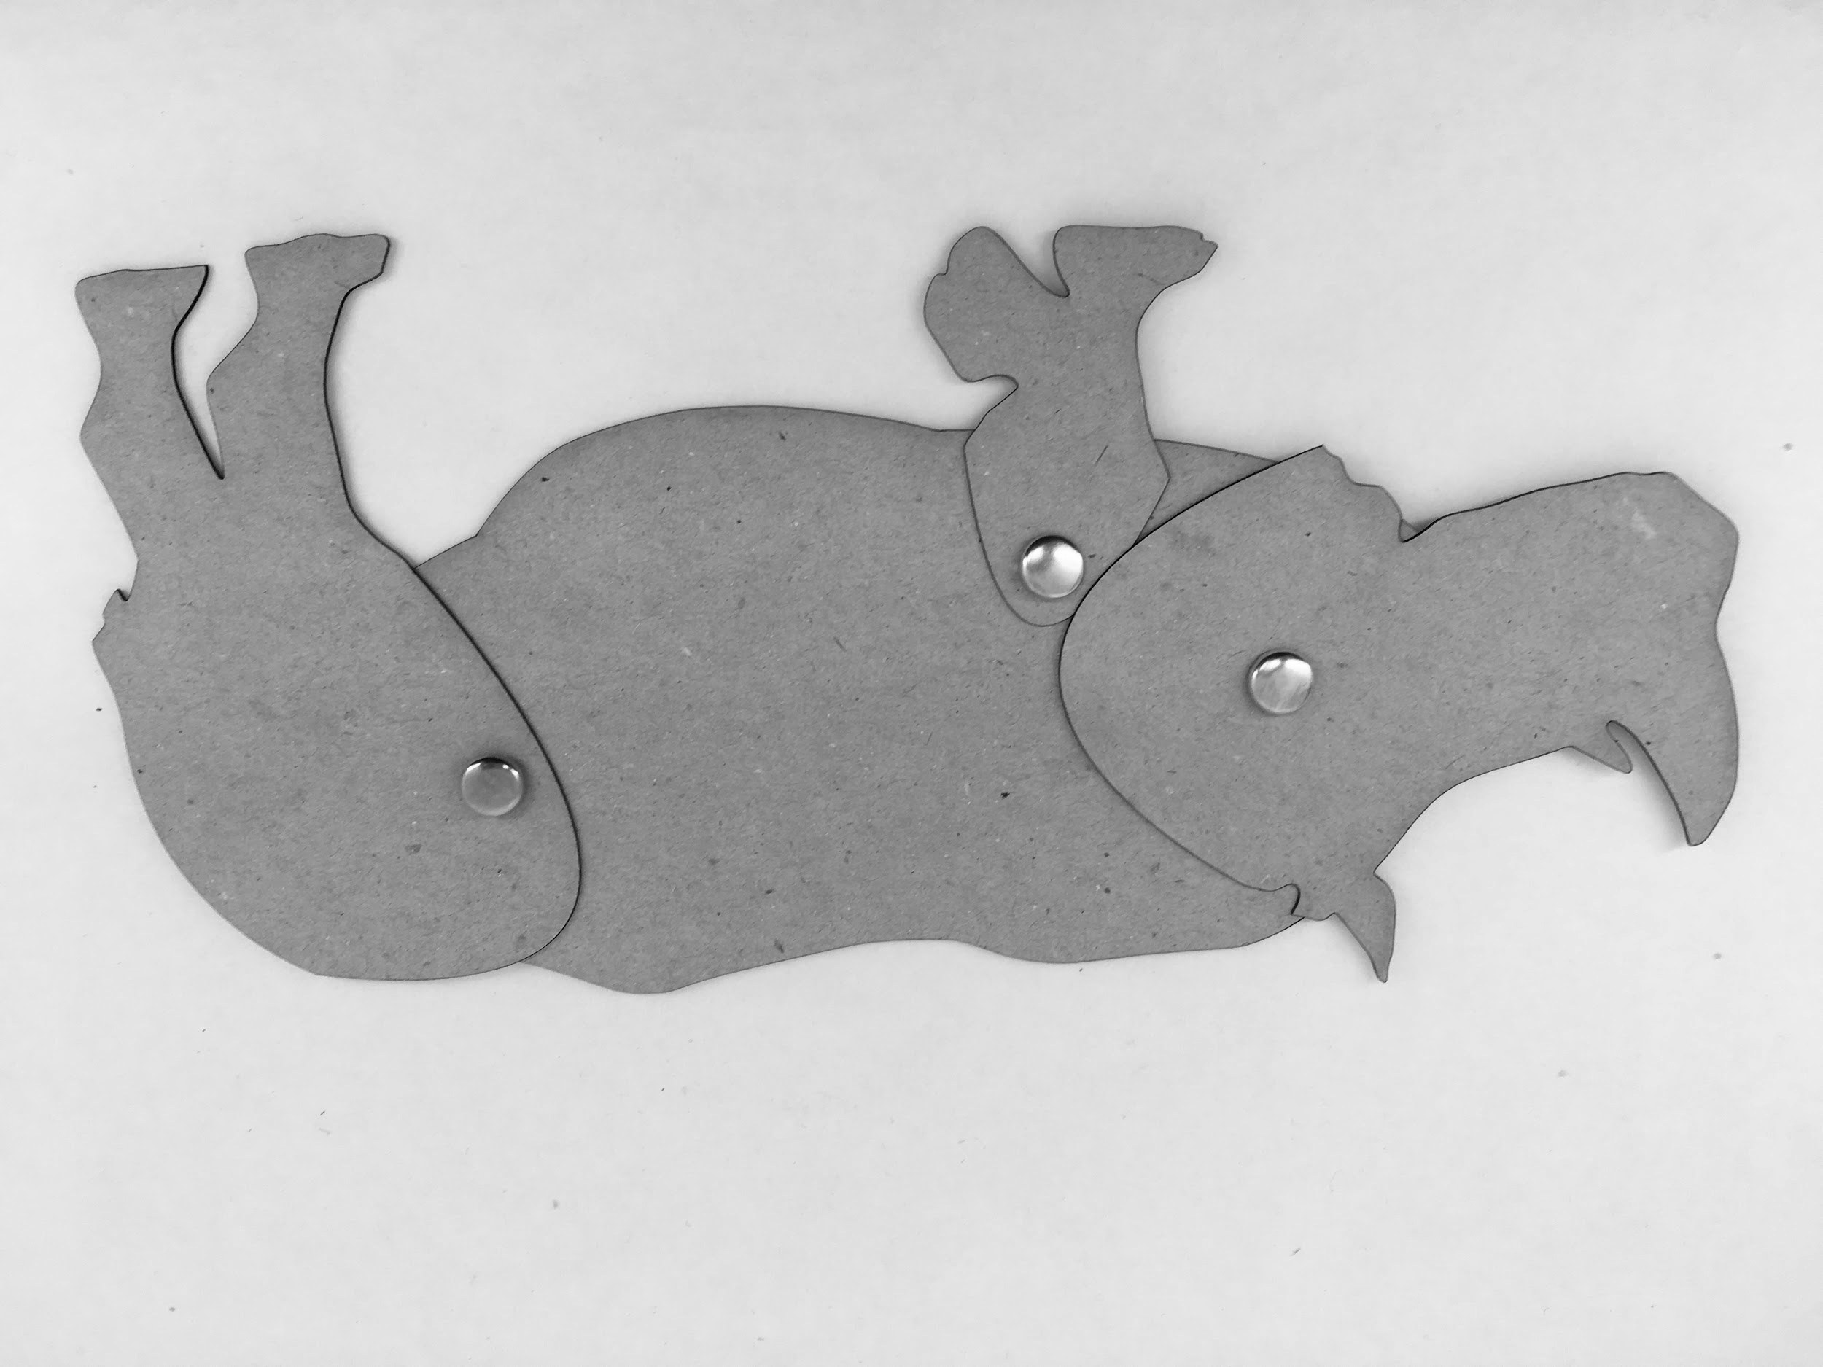Enter “YourName” and Save as type: .svg, for example, jeff.svg

Click Save

**12. Cutting Time**

We'll collect the files to a lab USB card and walk them to the Vinyl Cutters.

**13. Place Rivets & Add Sticks**

We will then give you rivets to place in the holes and sticks to glue to the segments to help your zodiac shadow puppets move. Add sticks to different segments if wanted using available tape and glue materials.

**14. Survey**

We'll direct you to the survey which helps us improve our workshops and learn about makerspaces in libraries.

Thanks for visiting!