**Live mRNA code – Installation and usage**

Hernan G. Garcia, updated July 2015 by AR

For questions or comments: [hggarcia@gmail.com](mailto:hggarcia@gmail.com).

**When editing the Google Doc version or adding with comments/suggestions: please use “Suggesting” mode. This can be found on the top-right corner of the browser window, just under “Share”.**

# Introduction

This manual includes instructions for the acquisition and analysis of live mRNA data obtained using methods such as MS2 or PP7 in the early embryo of the fruit fly *Drosophila melanogaster*. Throughout the text we will assume that the data consists of one channel of fluorescent puncta (MCP channel) and one channel of a nuclear marker such as Histone-RFP (Nuclear channel). Figure 1 shows these channels as well as the flow of analysis all the way from raw images to data structures that can be used for making plots and analyzing data.

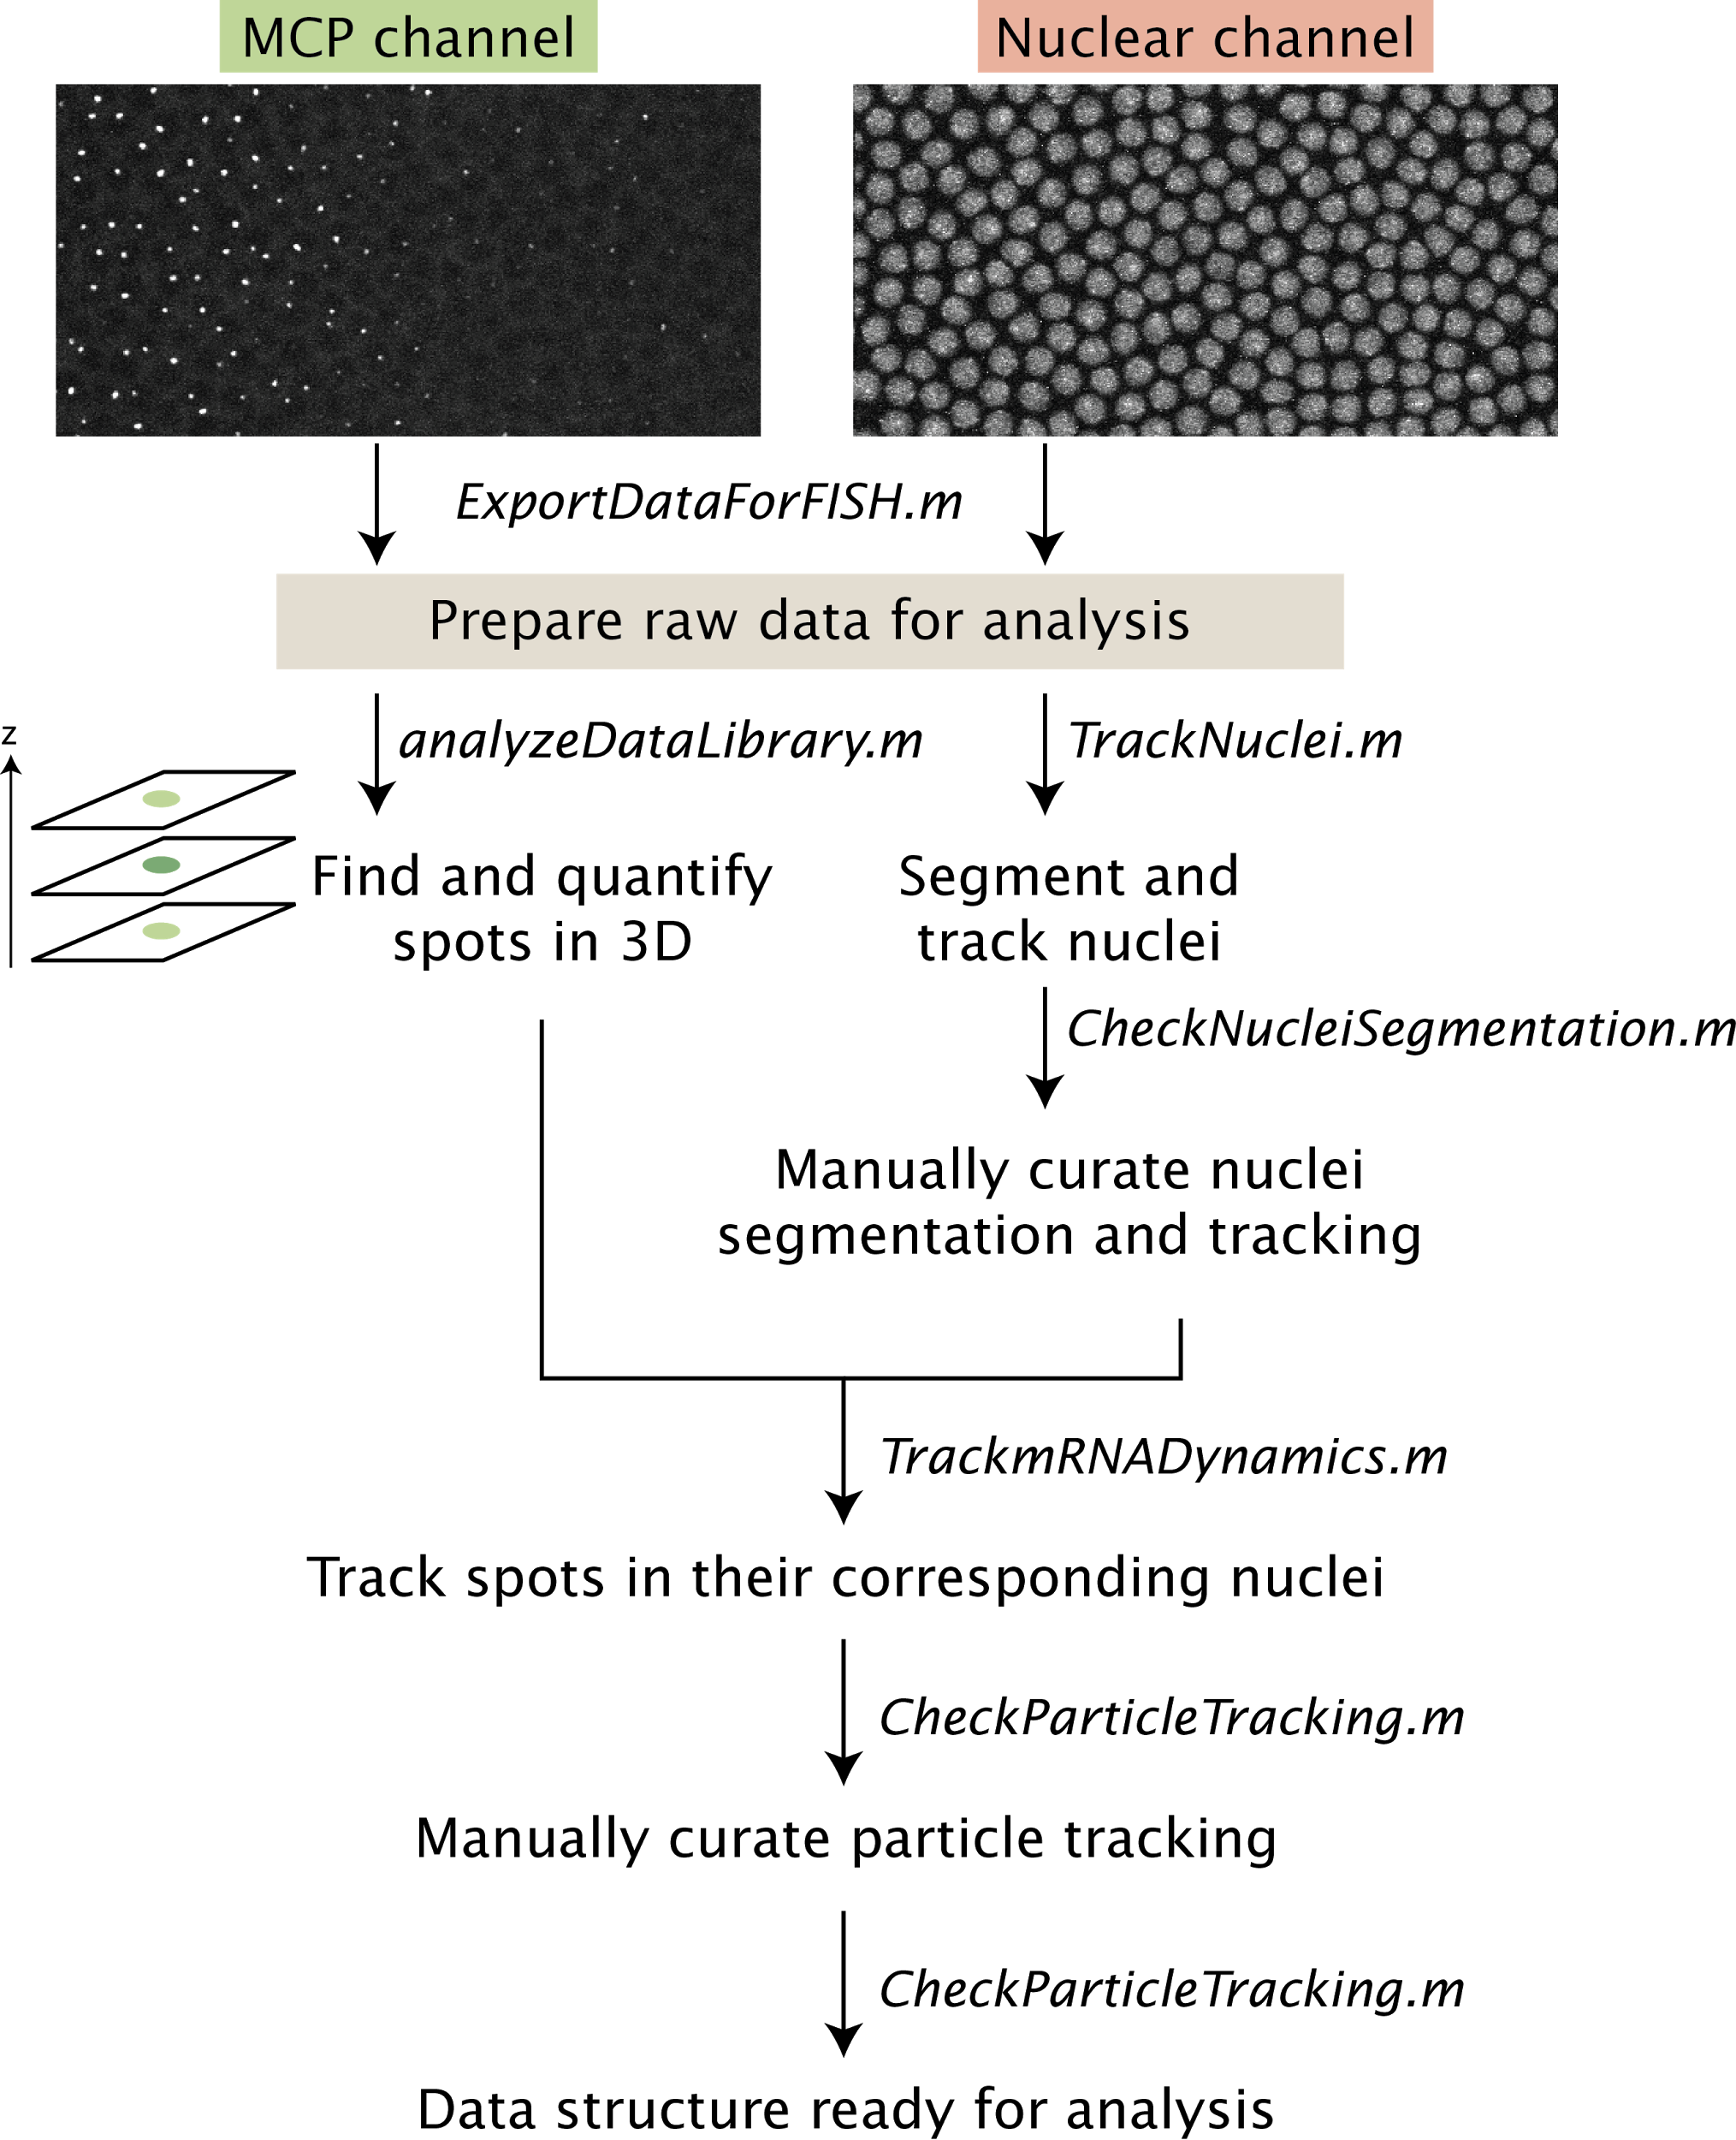

**Figure 1: Analysis flow for live mRNA dynamics measurements.** The different steps of the analysis and their associated Matlab files are shown.

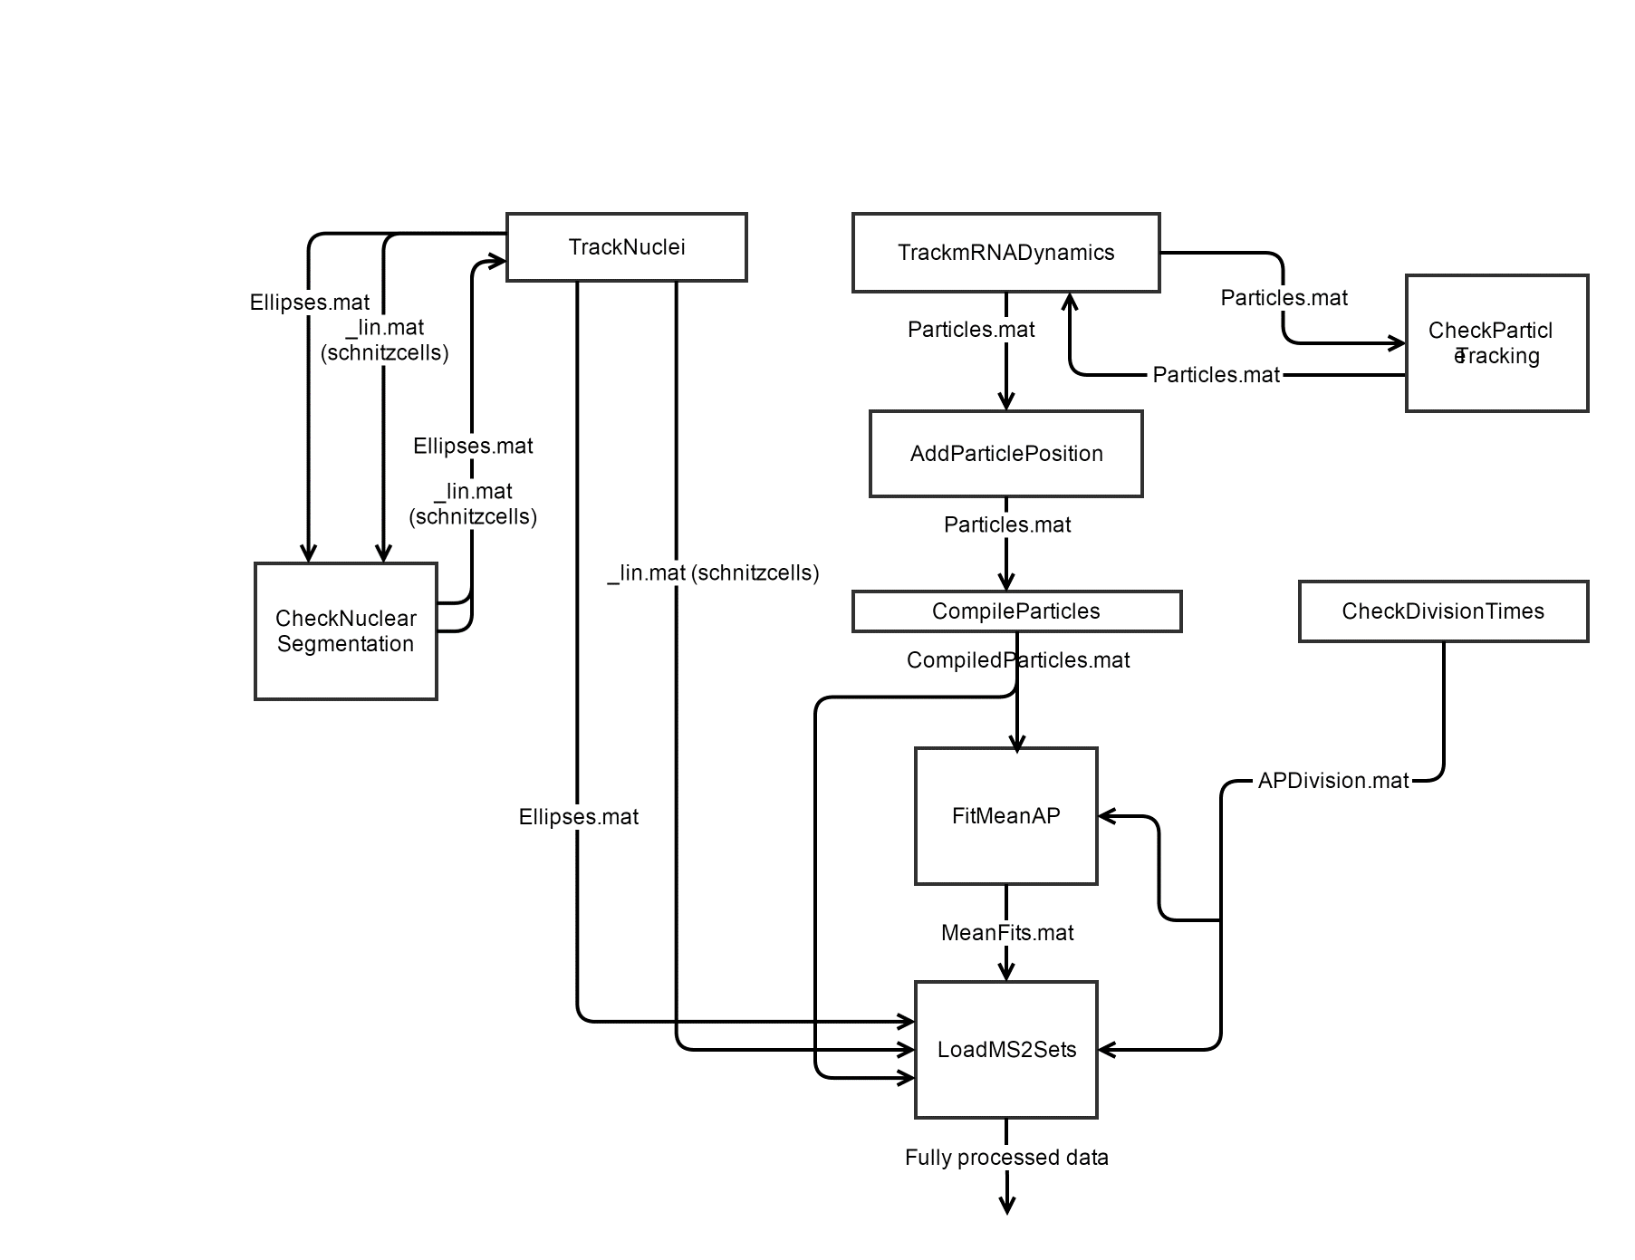

**Figure 2: Detailed data flow through live mRNA dynamics scripts.**

# Getting started

## System requirements

Mac users: Beware that this code seems to work with Matlab 2014a or newer, which requires Mac OS X 10.7.4 (Lion). This is related to “xlsread” which we use to read Excel files. Mac users should note that there appears to be a compatibility issue with using .xlsx files generated with ‘Numbers’ instead of Excel. Excel must be used. If you get it to work on an older version of Matlab (or with .xlsx files generated with Numbers) please let us know.

## Acquisition protocol

### Two-photon microscope using ScanImage 3.5.1

**Zeiss 780**

**Leica SP8 with White Light Laser**

**Data taking**

* High-zoom data:
  + If you have to readjust the z-position of your stack just start a new acquisition by clicking on “Start”. The code will later concatenate all of the different data sets.
* Full embryo picture:
  + Switch to 20x oil **without moving the slide**.
  + You might have to increase the power
  + Take a picture of the embryo in the mid-sagittal plane. Do four slices spaced by 1um around this mid-sagittal plane.
  + Without moving in x and y go to the embryo surface. Do four slices spaced by 1um around this surface plane.
* Flat field:
  + Go back to 63x.
  + Decrease the power to no more than 0.2% in each line of the white light laser
  + Take one frame with the same settings as the high-zoom data.

**Data saving:**

* High-zoom data:
  + Save as one project in the main folder for this embryo.
* Flat field data:
  + Save as a project called “FF” in the main embryo folder.
* Full embryo:
  + Create a folder called “FullEmbryo” within the main embryo folder.
  + Save the mid-sagittal data in a project called “Mid”.
  + Save the surface data in a project called “Surf”.

**Data exporting:**

* If you’re going to export on machine other than the microscope’s download the LASX software from <http://www.leica-microsystems.com/products/microscope-software/software-for-life-science-research/las-x/#downloads> by clicking on “Download free LAS X Core Offline version 1.1.0 for Windows7 64Bit”.
* Load your high-zoom project and export it “as TIFF” checking only the “Save raw data” option into the main embryo folder.
* At this point (if you haven’t already) move all the data into a folder with the corresponding data in “RawDynamicsData”.
* Make sure to also copy the original LIF file within this folder.

### 

## Installing the Live mRNA code

As you go through the steps in this section, make sure to look at Figure 2 in order to get the folder structure you will need for the multiple codes to work right.

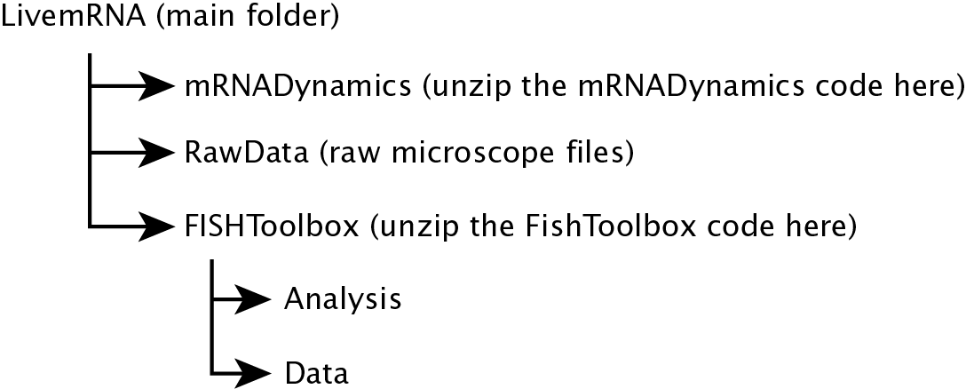

**Figure 2: Folder structure for the code.** Follow this folder structure as you install the different components of the code. **HG: This figure needs to be updated!**

1. Create a folder called “LivemRNAFISH” as shown in Figure 2. This will be our main repository of code and data.
2. Open Maltab in “Administrator Mode” by right-clicking on its icon.
3. Follow the FISHToolbox manual until item 1 in “Just get it done”. Install the contents of the provided ZIP file into a folder called “FISHToolbox” (you might have to rename that folder with respect to the folder name the ZIP file has in it originally). Step 1 ends once you run the following line successfully.

analyzeDataLibrary('fad',1,'quickAnalyze', 1000);

1. If you have GitHub access download the latest version of the “mRNADynamics” code from the “HernanDev” branch. You can ask Hernan for access. Otherwise, download the code from <https://www.dropbox.com/s/c8vn5uf5zsklgjj/mRNADynamics-HernanDev.zip?dl=0>.
2. Unzip the files in a folder such as “mRNADynamics” inside the “LivemRNAFISH” folder.
3. Go into the “mRNADynamics” folder and run “InstallmRNADynamics.m”.
4. Close and re-start Matlab so that all the changes are implemented.
5. Inside the “Data” folder one level up from “mRNADynamics” you will find two new folders: “RawDynamicsData” and “DynamicsResults”.
6. Also note that in “LivemRNAFISH” the file “ComputerFolders.xlsx” has been created. If you want to change the location of any of the folders just edit this file.

## Analyzing a sample data set – Leica SP8 Data

This example will allow you to go through the whole workflow of analyzing a data set taken using a confocal microscope running LAS X.

1. Download a sample data set from <https://www.dropbox.com/s/efdl1ag82cuoayj/2015-05-31.rar?dl=0>. Unzip it and place it in the “RawDynamicsData” folder. Notice that the data is organized as follows:
   1. A folder with the date. E.g., 2012-05-31
   2. Inside that folder there are flat field files corresponding to the data taken.
   3. Inside that folder there is the data set named “89B8-3-P2P”. There you will find one file per frame. Each frame corresponds to 21 slices taken in both channels. Each slice is taken three times and, in this version of the data, those slices are not averaged right away.
   4. Inside this folder you’ll find another folder called “FullEmbryo”. You’ll find files that correspond to imaging the embryo at 20x in order to determine the AP position of the data we took.
2. Open “MovieDatabase.xlsx” in “LivemRNA\Data\DynamicsResults” and create an entry with the following information:
   1. Date: 05/31/2015
   2. ExperimentType: 1spot
   3. ExperimentAxis: AP
   4. CoatProtein: MCP2
   5. StemLoop: MS2
   6. APResolution: 0.025
   7. Channel1: MCP(2)-GFP
   8. Channel2: His-RFP
   9. Objective: 63
   10. Power: 45 uW
   11. DataFolder: 2015-05-31\89B8-3-P2P
   12. DropboxFolder: Default
   13. nc: We will add this information later
3. Go to the folder where you have the code (eg. mRNADynamics)
4. Convert the raw data to data that can be analyzed by the FISH code by running

Prefix=ExportDataForFISH;

and selecting the folder to analyze. This means you need to choose “89B8-3-P2P”.

1. Determine mitosis frames.
   1. Go to “Data\YourUserName\LivemRNA\Data\RawDynamicsData\2015-05-31\89B8-3-P2P\89B8-3-P2P.lif" and open in ImageJ. This is a separate image editing program you may need to download from http://imagej.nih.gov/ij/
   2. ImageJ will give you several options for opening the file. You only need to check “Open all series” and “Concatenate series”
   3. You can now move across channels, depths, and time using sliders. Go to the histone channel at ~middle depth to view the status of the nuclei at different time points.
   4. Update the frame corresponding to each nuclear cycle in the entry in MovieDatabase.xlsx. In general, we define mitosis as the frame where you see anaphase. If there’s a mitosis wave pick an intermediate frame. We’ll deal with the wave later. For nuclear cycles where the mitosis was not observed put zero. If the movie didn’t go for long enough to observe some nuclear cycles then input “NaN”. “CF” corresponds to the time point the cephalic furrow was observed. For example:

|  |  |  |  |  |  |  |
| --- | --- | --- | --- | --- | --- | --- |
| **nc9** | **nc10** | **nc11** | **nc12** | **nc13** | **nc14** | **CF** |
| 0 | 0 | 0 | 0 | 40 | 112 | Nan |

1. First spot finding step. We need to run the FISH code on this movie to determine the threshold to use. The following lines will calculate the difference-of-Gaussians (dog) for every slice and frame in the movie

RunFISHToolbox(Prefix)

1. Manual determination of threshold. In the FISH analysis folder corresponding to this data set you’ll find lots of TIF files that start with “DOG”. These are the Difference of Gaussian images for each frame and slice of our data set.
   1. Open them in ImageJ by doing “Import image sequence” and inputting “DOG” into the “File name contains” option.
   2. To make the viewing simpler, you can create a Hyperstack under Image → Hyperstacks → Stack to Hyperstack. Keep in mind that ExportDataForFISH added a blank slice above and below your data. Set slices to 23; Frames = # of original slices/23).
   3. Find a frame with bright spots and define a little square around one of these spots.
   4. Use the measurement tool (Analyze → Measure) to determine the maximum pixel value in that square, recording a measurement at each plane.
   5. Move up and down to see the maximum intensity value at which you stop resolving the spot.
   6. Keep moving up or down until you cannot tell the spot from the background and measure it. In this case you’ll see that the background gives you values below 290.
   7. These images multiplied the DOG value by 10, which means that our threshold could be around 5.
2. Run the FISH code with the selected threshold. This fits gaussians to each spot.

RunFISHToolbox(Prefix,5)

This will have generated the file “preanalyzed_fishAnalysisData.mat” inside the “Analysis” folder in FISH. This file contains the information about all the spots found in the movie.

1. Track the nuclei by running

TrackNuclei(Prefix)

1. Check the nuclear segmentation by running

CheckNucleiSegmentation(Prefix)

You will see the histone signal combined with the segmentation. You can erase segmented nuclei by right-clicking and add new nuclei by left-clicking the mouse. Other commands are:

* n or m: Increase or decrease image contrast
* r: Reset image contrast setting
* , or .: Move back or forward one frame
* j: Jump to a specific frame
* s: Save current analysis

Once done press “x” to save the data. If modifications were made then step 9 needs to be run again.

1. Track the particles in each nucleus. We need to define two thresholds here. They should be higher than the threshold used for FISH by typically 30%. Track then by doing and note that here we’re setting both thresholds to the same value.

TrackmRNADynamics(Prefix,6.5,6.5)

1. Check the particle tracking with

CheckParticleTracking(Prefix)

The commands are (open the script to see the additional commands):

Frame-specific:

* , or .: Move one frame
* < or >: Move five frames
* a or z: Move up and down
* j: Jump to a particular frame

Particle-specific:

* n or m: Move between nuclei
* k: Select a particular particle (then type a number between 1-#particles and hit enter)x

NB: to avoid quitting the CheckParticleTracking mode do not navigate too quickly between frames/nuclei/etc.

* x: for save particles and escape

1. Find the AP axis of the zoomed out image

FindAPAxisFullEmbryo(Prefix, 'CorrectAxis');

The second argument allows you to manually verify and change the axis.

Here, the anterior pole is green and the posterior one is red. You can redefine them with the commands “a” and “p”, respectively.

IMPORTANT: Make sure you export both of the full embryo .lifs to the full embryo folder, then delete the tif files created. This allows FindAPAxisFullEmbryo.m to read the rotation values from the metadata XML files created upon export.

1. Now that we have the AP position we can use it to assign it to our particles. In order to do this the low magnification and high magnification images need to be compared. This is all done with

AddParticlePosition(Prefix)

If the alignment is incorrect, you can run

AddParticlePosition(Prefix, 'ManualAlignment')

This will allow you to position the field of view from your time series onto the full embryo images using:

* . - Move to the right
* > - Move to the right further
* , - Move to the left
* < - Move to the left further
* a - Move up
* A - Move up further
* z - Move down
* Z - Move down further
* x - Save and cancel

1. Finally, in order to account for different onsets of mitosis across the embryo, we can define a mitosis time for each AP bin using

CheckDivisionTimes(Prefix)

Using the commands

* m n: Move between nuclear cycles
* , .: Move between frames
* Click: Division of clicked AP bin in current frame
* r : Reset the information for the current nuclear cycle
* s : Save the information

You want to click the AP bins for each time frame when you first see anaphase in those bins.

1. Now we’re ready to compile all the particle information. If you didn’t check all particles and approve them you can tell the code to approve all particles by running

CompileParticles(Prefix,'ApproveAll')

Commands for Various Scripts

## CheckNucleiSegmentation

. - Move a frame forward and keep in the new frame only areas that

overlap with the previous ones.

, - Move a frame backwards

j - Jump to a frame

d - Delete all ellipses in the current frame

s - Save current analysis

m - Increase contrast

n - Decrease contrast

r - Reset contrast setting

x - Exit and save

## 

## CheckParticleTracking

%Frame specific:

. Move a frame forward

, Move a frame backwards

> Move five frames forward

, Move five frames backwards

a Move up in Z

z Move down in z

j Jump to a specified frame

g,b Increase/decrease histone channel contrast

Particle specific:

m Move to the next particle

n Move to the previous particle,

k Jump to a specified particle

c Connect two particle traces

d Separate traces. If this is done on a particle with only one frame then

it disconnects it from its nucleus.

q Cycle between approved status: green - approved; yellow - approved but

with conditions (drift of nucleus, for example)

w Disapproove a trace

p Identify a particle. It will also tell you the particle associated with

the clicked nucleus.

e Approve/Disapproove a frame within a trace

u Move a particle detected with Threshold2 into the our structure.

i Move a particle detected with Threshold2 into the our structure and

connect it to the current particle. This is a combination of "u" and

"c".

%Nuclear tracking specific:

l Split a nucleus and select one or two daughter nuclei or stop the

lineage. Usage:

Click on one new nucleus + ENTER: Continue the schnitz with that nucleus.

Click on the current nucleus + ENTER: Split the schnitz. This time

point will be the first frame of the new schnitz.

Click on two nuclei: Split the current nucleus into two daughter

nuclei.

Click on the same nucleus twice: Split the current nucleus, but

with only one daughter nucleus.

2 set parent of current nucleus

p Find the particle associated with the clicked nucleus. It will also tell

you the closest particle associated you clicked on.

9 check for nuclear tracking consistencies. This is useful while we're

getting the code to work well.

1 give the nucleus number in the schnitzcell segmentation structure. This

only works for troubleshooting and you need to be online and on the

Princeton network/VPN for now.

%General:

t Show/hide particles from the second threshold

s Save the current Particles structure

x Save and exit

h Show non-approved particles yellow or dissapproved particles

y Input the frame/nc information again. This only works in the absence of

the histone channel

r Reorder the particles according to initial frame

f Redo tracking. It only gets done on the non-approved particles.

o Zoom in/out around the particle's first frame.

-/= Change the zoom factor when in zoom mode.

0 Enter debug mode to fix things manually

## 

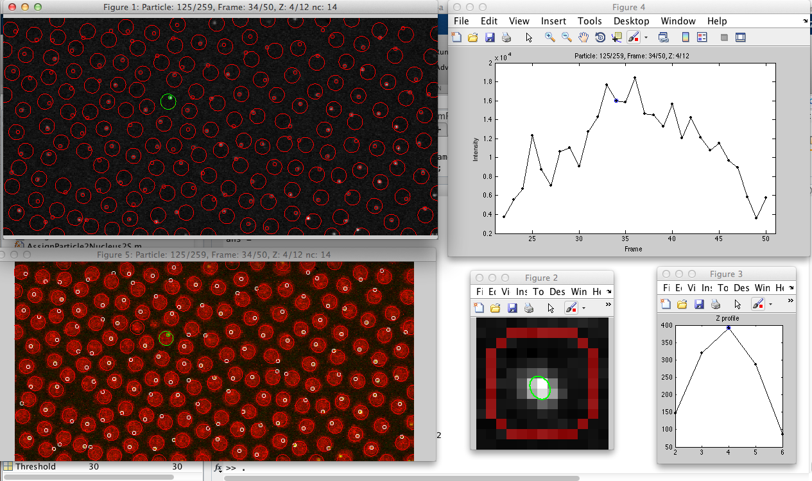

## Find the AP axis

%This finds the AP axis. Look into ManualAPStitch.m if there are problems

%here.

FindAPAxis(Prefix);

%If the embryo could fit in one of the images then run this

FindAPAxisFullEmbryo(Prefix);

%If this is failing then use this program to manually do the alignment.

%Tihs is meant for embryos consisting of two images for now

ManualFindAPAxis(Prefix)

%Check the detection by going to the Dropbox folder.

%If we need to find it manually run this

CorrectAPAxis(Prefix)

## Data structures and variables

In the Dropbox folder corresponding to the Prefix you’ll find several folders with diagnostic plots as well as .mat files that include lots of information (these are the output of the CompileParticles script among others). The folders are:

* APDetection: AP orientation images and matching of frame-of-imaging to the position on the embryo.
  + AlignmentOverlay.tif: Shows the superposition of the low and high magnification images in the histone channel.
  + AlignmentCorrelation.tif: This is the correlation between the low and high magnification images. It should show a clear maximum which determines the overlay for “AlignmentOverlay.tif”
  + FullEmbryo.tif: Image of the full. stitched embryo. This is in 16-bit format.
* APMovie: Plots of the mean line traces for every frame over the AP section imaged. As a default, data is binned into 0.025 x/L bins. The error bars are SD.
* CytoFluo: These are plots related to the cytoplasmic fluorescence. They give a sense of how the background of MCP-GFP evolves over time and space.
* Offset: Plots related to the offset fluorescence around each detected spot. They are related to CytoFluo.
* ParticleTraces: Particle traces for each particle imaged over the period that the particle was on during imagining. This includes the spot position within the nucleus outline, over time, and snapshots of the spot itself.
* Probabilities: Plots related to the fraction of ON nuclei vs. time and AP.
* TracesFluctuations

Note that many of these folders are legacy features that will be removed. You should probably write your own code to generate these plots so you know exactly what went into them.

In the folder the file CompiledParticles.mat include:

* CompiledParticles
  + Frame: Frame numbers where this particle was detected.
  + Index
  + xPos
  + yPos
  + APpos: AP position of the particle as a function of time. Note that this variable will disappear in favor of APPos (see below).
  + MeanAP
  + MedianAP
  + APposPOarticle
  + APPos: AP position of the particle as a function of time.
  + FirstFrame
  + Approved
  + Fluo: Particle fluorescence for each time point.
  + Off
  + Off2
  + Fluo2
  + FluoOld
  + FluoRaw
  + FluoError: Error associated with all fluorescence readings. Note that there is only one value per particle.
  + optFit1
  + FitType
  + nc
  + Nucleus
  + PParticle
  + DParticle
  + EParticle
  + NucStart
  + NucEnd
  + SlopeTrace
  + SDSlopeTrace
  + TotalmRNA
  + TotalmRNAError
  + NuclearAP

**Taking the flat field**

\section{Preface}

\begin{itemize}

\item Description of different font sizes used to specify commands, variables, etc.

\end{itemize}

\section{Introduction}

\section{Installation guide}

\begin{itemize}

\item Getting the software from GitHub

\item Setting up the right folders and paths

\end{itemize}

\section{Quick start usage}

\section{Live transcription analysis using mRNADynamics code}

\subsection{Finding fluorescent spots}

\begin{itemize}

\item Choosing a threshold

\end{itemize}

\subsection{Finding and tracking nuclei}

\begin{itemize}

\item Dealing with mitotic waves.

\end{itemize}

\subsection{Tracking spots}

\subsection{Checking spot tracking}

\subsection{Experiment-specific features}

\subsubsection{AP detection}

\section{CheckParticleTracking command reference}