Predicted Probabilities

Table of Contents

### Some Descriptive Tables and Graphs

Here I am adding some text

load(url("http://www.openintro.org/stat/data/evals.RData"))

evals %>%   
 count(gender) %>%   
 mutate(Pct = prop.table(n)) %>%   
 pander()

|  |  |  |
| --- | --- | --- |
| gender | n | Pct |
| female | 195 | 0.4212 |
| male | 268 | 0.5788 |

dist_gender <-   
evals %>%   
 count(gender, rank) %>%   
 mutate(Pct = prop.table(n))   
  
ggplot(dist_gender, aes(x = gender, y = Pct, fill = rank)) +  
 geom_col(position = position_dodge()) +  
 scale_fill_brewer(palette = "Accent",   
 labels = c("Teaching ", "Tenuere Track", "Tenured")) +  
 theme_bw() +  
 labs(x = "Gender", y = "% Frequency",   
 title = "Distribiution of Rank and Gender",  
 fill = "Rank") +  
 theme(legend.position = "bottom") +  
 ggsave("dist_graph.pdf")

## Saving 5 x 4 in image

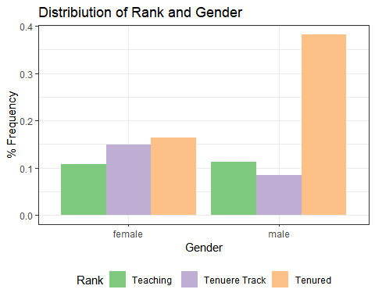

stargazer(evals, type = "html")

##   
## <table style="text-align:center"><tr><td colspan="8" style="border-bottom: 1px solid black"></td></tr><tr><td style="text-align:left">Statistic</td><td>N</td><td>Mean</td><td>St. Dev.</td><td>Min</td><td>Pctl(25)</td><td>Pctl(75)</td><td>Max</td></tr>  
## <tr><td colspan="8" style="border-bottom: 1px solid black"></td></tr><tr><td style="text-align:left">score</td><td>463</td><td>4.175</td><td>0.544</td><td>2.300</td><td>3.800</td><td>4.600</td><td>5.000</td></tr>  
## <tr><td style="text-align:left">age</td><td>463</td><td>48.365</td><td>9.803</td><td>29</td><td>42</td><td>57</td><td>73</td></tr>  
## <tr><td style="text-align:left">cls_perc_eval</td><td>463</td><td>74.428</td><td>16.756</td><td>10.417</td><td>62.696</td><td>87.249</td><td>100.000</td></tr>  
## <tr><td style="text-align:left">cls_did_eval</td><td>463</td><td>36.624</td><td>45.018</td><td>5</td><td>15</td><td>40</td><td>380</td></tr>  
## <tr><td style="text-align:left">cls_students</td><td>463</td><td>55.177</td><td>75.073</td><td>8</td><td>19</td><td>60</td><td>581</td></tr>  
## <tr><td style="text-align:left">bty_f1lower</td><td>463</td><td>3.963</td><td>1.874</td><td>1</td><td>2</td><td>5</td><td>8</td></tr>  
## <tr><td style="text-align:left">bty_f1upper</td><td>463</td><td>5.019</td><td>1.934</td><td>1</td><td>4</td><td>7</td><td>9</td></tr>  
## <tr><td style="text-align:left">bty_f2upper</td><td>463</td><td>5.214</td><td>2.018</td><td>1</td><td>4</td><td>6</td><td>10</td></tr>  
## <tr><td style="text-align:left">bty_m1lower</td><td>463</td><td>3.413</td><td>1.637</td><td>1</td><td>2</td><td>5</td><td>7</td></tr>  
## <tr><td style="text-align:left">bty_m1upper</td><td>463</td><td>4.147</td><td>2.111</td><td>1</td><td>3</td><td>5</td><td>9</td></tr>  
## <tr><td style="text-align:left">bty_m2upper</td><td>463</td><td>4.752</td><td>1.575</td><td>1</td><td>4</td><td>6</td><td>9</td></tr>  
## <tr><td style="text-align:left">bty_avg</td><td>463</td><td>4.418</td><td>1.527</td><td>2</td><td>3.2</td><td>5.5</td><td>8</td></tr>  
## <tr><td colspan="8" style="border-bottom: 1px solid black"></td></tr></table>

### Models

#### Bivariate Model

m_gend <- lm(score ~ gender, data = evals)  
  
  
stargazer(m_gend, type = "text")

##   
## ===============================================  
## Dependent variable:   
## ---------------------------  
## score   
## -----------------------------------------------  
## gendermale 0.142***   
## (0.051)   
##   
## Constant 4.093***   
## (0.039)   
##   
## -----------------------------------------------  
## Observations 463   
## R2 0.017   
## Adjusted R2 0.014   
## Residual Std. Error 0.540 (df = 461)   
## F Statistic 7.753*** (df = 1; 461)   
## ===============================================  
## Note: *p<0.1; **p<0.05; ***p<0.01