LightPen for Oscilloscope

Software Design Document

Xavier Garcia

December 16, 2015

Contents

1. Introduction 3

a. Purpose 3

b. Scope 3

c. Definitions and Acronyms 3

2. System Overview 3

3. System Architecture 4-5

a. Architectural Design 4

b. Design Rationale 4-5

4. Human Interface Design 5

a. Overview of User Interface 5

b. Screen Images 5

# Introduction

## Purpose

This design document describes the architecture and design of a light pen for use with CRT oscilloscope, and the system design.

## Scope

This software aims to allow one to draw images on an oscilloscope using off the shelf components and a Data Acquisition Card (DAQ). The design can be adapted to many light pen accepting machines, most notably Vectrex and Atari Computers.

## Definitions and Acronyms

CRT: Cathode Ray Tube

DAQ: Data Acquisition Card

LV: LabVIEW 2015 64-bit

# System Overview

CRT televisions are operated using a vacuum tube. The tube is reverse biased from an anode to a cathode, and when the cathode is heated by a voltage electrons are emitted; these electrons are then swept at high speed toward the anode end. These electrons are funneled to hit a phosphor screen which phosphoresces, producing light, and therefore a visible image. The way these electrons are directed to hit specific parts of the screen is with vertical and horizontal deflection coils wrapped around the tube. By applying an appropriate potential to these coils, the electrons are shifted in direction to different parts of the screen. By severing the vertical coil from the input signal, and connecting the horizontal coil to the standard vertical coil source a line is produced, this line will be located on the horizontal plane and position dictated by the input to the vertical (now horizontal) coil. Then by connecting a voltage source that corresponds to the desired input signal you effectively have an oscilloscope. Most such oscilloscopes can display +10/-10 V, and accurately portray a signal, though with no available trigger or scaling. By applying a regulated square pulse from a DAQ and sweeping the screen in a predictable manner you effectively have a scan rate. If you connect a signal to measure when the scan hit a certain part of the screen by measuring timing, this can be exploited by replicating that signal after scanning. The light pen thus works by using a sensitive phototransistor that works on a circuit and sends a high +5 V when the scan passes it. The 5 V signal is sent to the DAQ which then measures time elapsed and by referencing an array of values for amplitude and position vs. time the signal is sent over the second analog output of the DAQ. In this way a light pen can create designs on the screen.

# 

# System Architecture

## Architectural Design

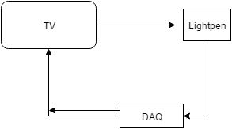 Fig. 1. Block diagram showing the basic design of the structure.

The block diagram provided shows the basic design, by inputting a signal to the TV/Oscilloscope, and measuring how long has passed between the sending of a signal and a received signal from the light pen, a second output puts out a constant signal for that illuminates the screen where the pen was located. The light pen is compact and packaged into a standard marker case, with a 3 wire output, corresponding to ground, 5V in, and the signal line.

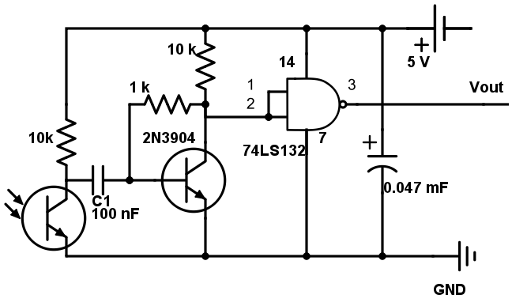 Fig. 2. Circuit diagram of the constructed light pen. Vout is the signal sent to the DAQ, the Phototransistor on the left is the means of reading in the television input signal.

## Design Rationale

The main reasons for picking this method were based primarily on:

1. Portability, the light pen made is expected to be functional and compatible with other systems that may make use of a light pen. In this way the light pen is a more versatile device than a design that relies on the other components involved. It is a standalone circuit used easily in many other architectures.
2. Lack of available CRT Oscilloscope/Proper RF modulation: To make a light pen work requires a CRT type display. The oscilloscope is an easy way to control the scan rate and inputs, but they are pricey, while a standard television may not have the ability to have directly controllable voltages, but is today extremely inexpensive and has input ports. Due to the inability to properly produce a signal of at minimum 3 MHz reliably and so make use of RF HF, VHF, or UHF is seemed most practical to instead use the oscilloscope. However due to cost converting a cheap CRT television into an oscilloscope seemed the most reasonable option.
3. Ease of use of DAQ: The DAQ is capable of multiple inputs and outputs in both digital and analog form, and many logic and timing operations could be performed using such a device. The difficulty in programming say a Programmable Interrupt Controller (PIC), or Arduino to perform this task makes them less appealing modules, and my familiarity with LabVIEW exceeds my familiarity with PIC Assembly, or C++. Thus the use of a DAQ to perform this task seemed a natural one.

Of course given greater resources the architecture of my system could be altered. Most ideally, by using a device capable of outputting HF, VHF, or UHF frequencies, one would simply modulate a signal to be passed into the RF input of a standard television, thus making the device compatible with any CRT television monitor. Some equipment is also capable of natively handling light pen input and output, therefore had I used a computer with such ability, the signals could have been more reliably interfaced without the need for extensive programming and potential overloading of a DAQ. The light pen could also have been more simply constructed if designed for use exclusively with a DAQ. However the current design was most advantageous for the desired functionality and availability of materials.

# Human Interface Design

## Overview of User Interface

The user is meant to merely start the LabVIEW program written and then take up the pen and draw. Once finished the user presses the STOP button written into the program and the program will stop. There will be another button that wipes the current screen and allows the user to begin their designs anew.

## Screen Images

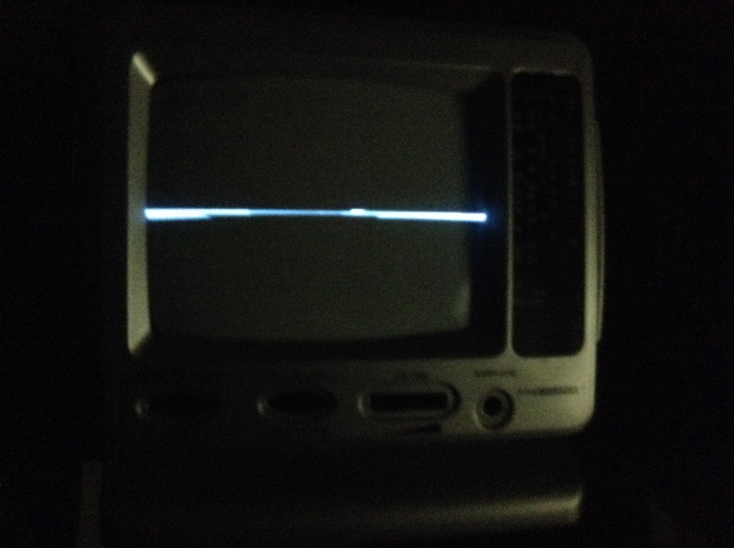 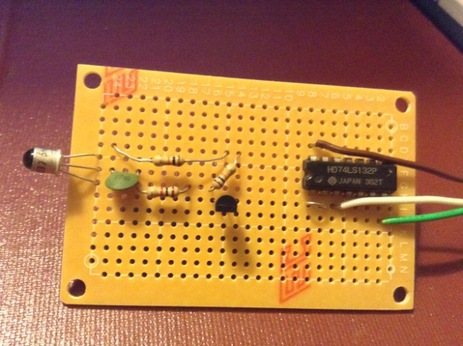 Fig.3. Oscilloscope made from mini-TV Fig.4. Lightpen design on protoboard