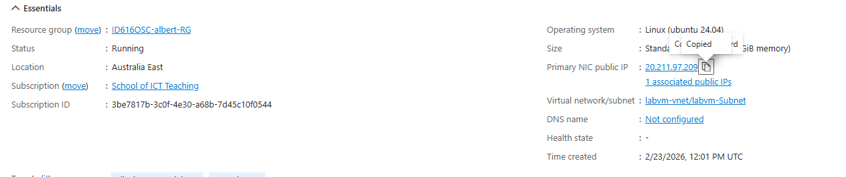
The Ip address is 20.211.97.209

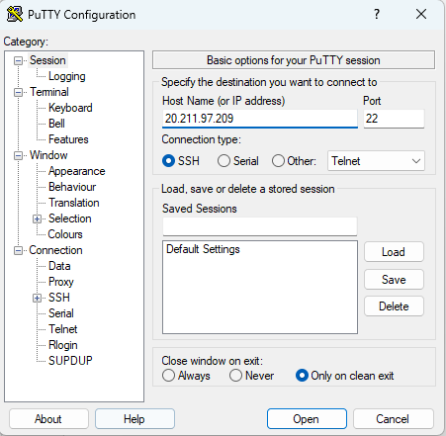
Used the ip to log in to the vm
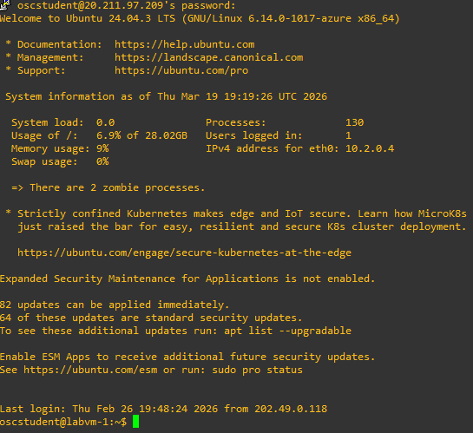
Logged in to the vm as oscstudent

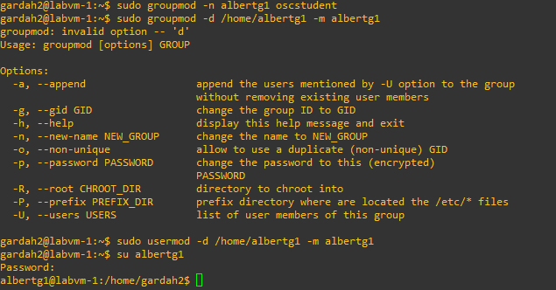

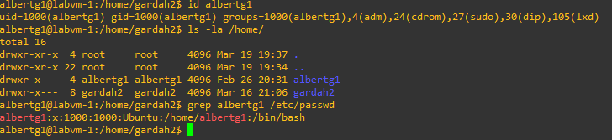
Verifies tha all the changes were made
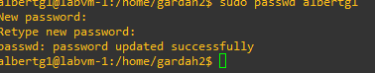
New password is set

