|  |  |  |
| --- | --- | --- |
| For office use only | Team Control Number | For office use only |
| **43557** |
| T1___________________ _______________________ | F1 ___________________ |
| T2 __________________ | F2 ___________________ |
| T3 __________________ | Problem chosen  **A** | F3 ___________________ |
| T4 __________________ | F4 ___________________ |
|  |  |
|  |  |  |

**2016**

**MCM/ICM**

**Summary Sheet**

In our life, we will add the hot water from the faucet every once in a while to reheat the cool bathing water. In this paper, we develop models considering the heat variations and transfer among water, tub wall and so on step by step to figure out the beat strategy to meet the demand of a person without wasting too much water. Specifically, we accomplish the following:

* **Initial heat distribution:** We use t*he Fourier law, Newton’s cooling law* and *the formula for specific heat* to model the heat distribution in time and space. This distribution is based on the reasonable assumption and the theoretical foundation that the water makes the heat transfer with other medium, like the tub wall and the hot water with the different temperature.
* **Model development and sensitivity analysis:** We use our model to analysis the process of heat transfer and consider the processes of a single injection and multiple water injection. Then we consider the tidy quantitative changes of tub wall density, environmental temperature, other parameters, etc., making the sensitivity analysis.
* **Search patterns:** We implement three independent search patterns including target planning algorithm, numerical algorithm on ODEs and the algorithm of difference equation, then develop some scientific methods to measure their effectiveness based on the boundary conditions and other limiting factors.
* **The best strategy and the results:** We explore variations of the time interval and the quantity of added hot water, then we calculate and analyze the different situations via the computer simulation and the models. Finally, we have come to conclusions that a person should add the hot water every 217.9 seconds and the quantity of single injection can be obtained and the value is 284.09 kg. Moreover, the impact of other factors such as the properties of tub and human characteristics. The further details are shown below.
* **Versatility:** According to the actual process, we’ve made further analysis about the variations of a series of independent variables. The model’s adaptability is achieved through the incorporation of adjustable input parameters that reflect unique circumstances.

The main strength of our model is the definition of the index, the simplification for the model and the scientific simulation, which directly helps us to determine the best strategy.

**Contents**

# Introduction

## Background

When we are bathing in the bathtub, there is a problem often bothers us as the time changes. The water’s temperature in the tub will be lower and lower. Besides, the traditional bathtub is not a spa-style with a secondary heating system and calculating jets, but rather a simple water containment vessel.

We all hope that the water in the bathtub can maintain as the initial temperature so that we have to add a constant trickle of hot water from the faucet but not waste too much water, since the water in the tub will overflow when the tub reached its capacity.

Under the background of this issue, we have studied the heat transfer during the whole process, and figured out the suitable time interval and the quantity of adding water to help us make the decisions. In this paper, we will detail a serials of generic mathematical models that describe and optimize the best strategy.

## 1.2 Intuitive concepts of heat transfer

Before we use the heat equations, let's first accustom ourselves to some intuitive concepts about how the bath gets cooler. Thermal energy can be transferred in three fundamental ways: conduction, convection and radiation.

Conduction happens between objects in physical contact. It is the most direct way to transfer heat when you bath.

Convection is distinguished by the flow of thermal energy caused by fluids, which is almost negligible in heat transfer between solids.

Radiation transfers energy by either emission or absorption of electromagnetic waves. We consider that thermal radiation absorbed by the pan can be neglected because of the little impact.

## The symbols of parameters

|  |  |  |
| --- | --- | --- |
| Parameter | Symbol | Value |
| Environmental temperature |  | 293K |
| Initial temperature of water in the bathtub |  |  |
| Temperature of water from the faucet |  | 313K |
| Temperature of the bathtub wall |  | 293K |
| Density of water |  | 1000kg/m³ |
| Density of acrylic |  | 1200 kg/m³ |
| Density of air(Standard conditions) |  | 1.29 kg/m³ |
| Specific heat capacity of water |  | 4200 J/ KgK |
| Specific heat capacity of acrylic |  | 1500 J/ KgK |
| Specific heat capacity of air |  | 1005 J/ KgK |
| Thermal conductivity of water |  | 0.6 W/mK |
| Thermal conductivity of acrylic |  | 0.07 W/mK |
| Thermal conductivity of air |  | 0.0245 W/mK |
| Size of the (cuboid ) bathtub |  | 1.7m0.8m0.7m |
| The thickness of the tub wall |  | 0.1m |
| Size of water outlet (square) |  | 0.05m0.05m |
| Size of water outfall (square) |  | 0.05m0.05m |

# 2. Simplifying Assumptions of the whole process

1. The general bathtubs are cuboid in shape, with length *L*, width *W*, height *H*, and the tub wall thickness *D.* All of the bathtubs are identical. The standard shape is as follows:

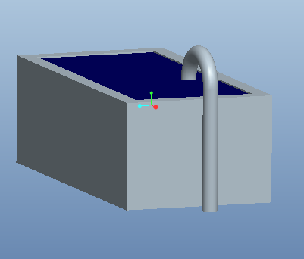

Fig. Three-dimensional figure of the bathtub

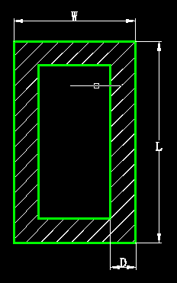 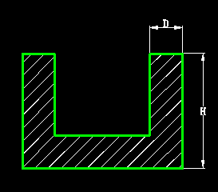

Fig 2. Cross sectional image of the bathtub Fig 3. Longitudinal sectional image

1. The bathtubs are made of homogenous material, more specifically, acrylic, which is lightweight, good insulation performance.
2. We consider the single water outlet, and water outfall is in the same size and shape, both of them are square.
3. For being filled with the hot water, we can consider the process can be complete instantaneously, and keep the initial temperature even. The temperature of the  initial modulus can be expressed by the following equation:





1. The physical quantities are constant with regard to temperature, an approximation that greatly simplifies our model and calculation while still producing reasonable results.

# 3. Model Development and Results

For a quantitative and qualitative analysis, the entire bath process is divided into two parts. For the partⅠ, we add the hot water into the empty tub from a single faucet until the tub is full of hot water, with the temperature of 313K. In this part, a person haven’t yet go into the tub so that we only consider the heat exchange between the tub wall and the water, and the temperature will finally be even and we could obtain a certain equilibrium temperature as the initial temperature just before people settle into it. Since the heat exchange with wall is far more intense than that with air, so we can neglect the thermal conduction with air in this process.

For the part Ⅱ, when a man settles into the tub to cleanse, we can regard the wall and the water as the entirety. Under the circumstances, we can concentrate on the exchange between water and air. After adding hot water from faucet to the tub, we then consider the water heat exchange with the added water.

## 3.1 Part Ⅰ: Build a Model for the Temperature Distribution

It is easy to know the temperature here varies greatly between the water filling the tub and the tub wall, and has the temperature difference with the external air temperature. We can firmly determine there must have a heat exchange among them. In the three-dimensional Cartesion coordinates, the temperature distribution of every point in the constant medium at the same time is so called temperature field. It can be expressed generally by the equation:



*t* is a symbol of time.

If the temperature is constant, does not change with time, we call it stable temperature field, resulting in the stable thermal conductivity. Reversely, if the temperature is the time-dependent thermal variation, it is unstable temperature field with the unstable temperature field. Our task is to learn and develop the model to describe the unstable temperature field in that condition.

### 3.1.1 Important hypothesis

Since the bathtub is placed in room and the air is circulating slowly, we can ignore the impact of the airflow.

### 3.1.2 The first step based on the Fourier law

First, we use the Fourier law according to the heat conduction of basic law. There are three basic formulas listed here:

* One-dimensional:



* Two-dimensional:



* Three-dimensional:



* *t* is the symbol of the time;
* *x, y, z* is the space coordinates.
* is the density.
* is the Thermal conductivity
* *L* is the latent heat.
*  is the specific heat.

Then we can try to solve the equations according to our practical problems.

### 3.1.3 The second step based on the Finite Difference Algorithm

In the process of solving the equations, we find it is difficult to get the answer for the partial differential equation under the initial value problem. Therefore, we adopt discrete method based on finite difference method to solve this unstable temperature field problem. Our specific analyses are as follows:

In three-dimensions, we should first use the finite difference discrete method to solve the partial differential equation. The segmentation method is shown as Fig.4. Every unit, that is, *i,* is a regular hexahedron with the edge length, which exchanges heat with the adjacent six units.

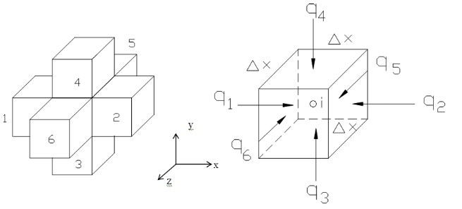

Fig 4. Heat balance diagram of the three-dimensional difference unit *(i)*

For simplifying our model and calculation, we consider that the whole water in the tub and the tub wall compose the entirety, but we must consider the water heat exchange with the tub wall, so we can assume =0.1m, in this way, the length of the unit is exactly equal with the thickness of the tub wall, we can make sure that every unit has no intertexture that is made up of the wall and the water.

For each unit, we can describe the heat variation in terms of two sides. According to the calculation formulas of conductivity coefficient and specific heat, in tiny period of time (△t), the unit will absorb a certain quantity of heat that is Q:



On the other hand, the unit will absorb the heat from adjacent six units, the total is ：



Considering the energy conservation law, we can find the equation:



After the equation’s simplification:



The equation can be converted into:



But we have pay attention to the following In order to obtain stable numerical solutions, must meet certain conditions. From above all, the temperature of the unit at the moment of  is the linear combination of two parts, one is the temperature at the moment of *t,* the other is the heat absorbing from six units. Obviously, the temperature of the six units will impact the unit *i’*s temperatureat the time of*.*Similarly, if the *i* has the higher temperature at the time of *t,* it will have higher temperature after *△t. T*hat is to say, the first coefficient in the right side of the equation must be not less than zero, that is:



After the equation’s simplification:



### 3.1.4 The modeling results

Now, we have determined the iterative relationship for thermal variation in space and time of every unit. (The unit is taken out from the entirety composing of whole water in the tub and the tub wall).According to this theory, we can get numerical solution of water temperature variation in the tub. The result of this model is the stable temperature after the heat transfer between wall and water, that is,



The result also provides us with an initial temperature for the PartⅡ.

To describe the answer more clearly, we can also illustrate the solution via MATLAB. The time-space distribution graph of thermal variation is following:

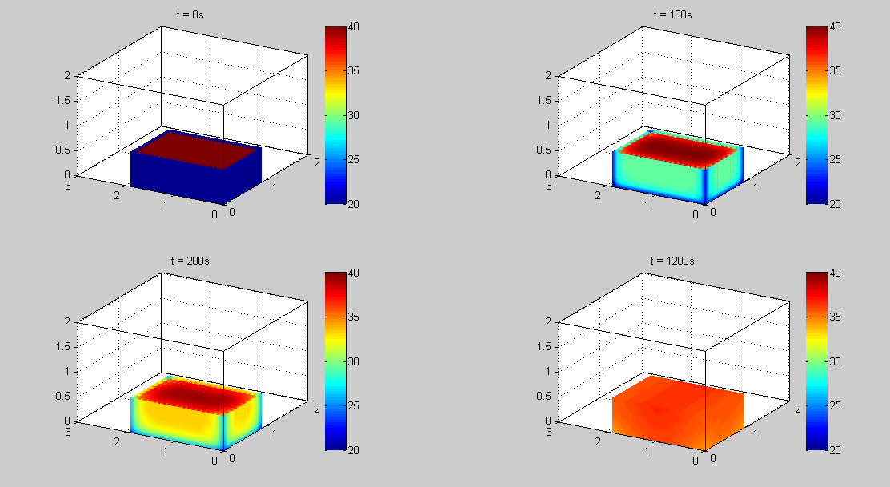

The spatial distribution of bath and water

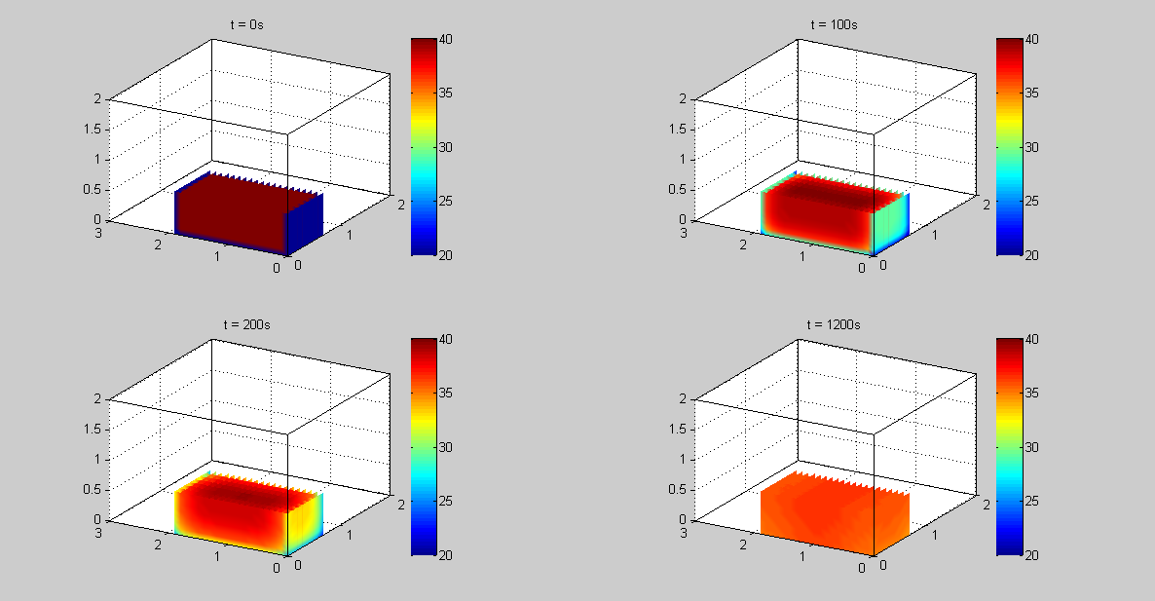

Section of spatial distribution of bath and water

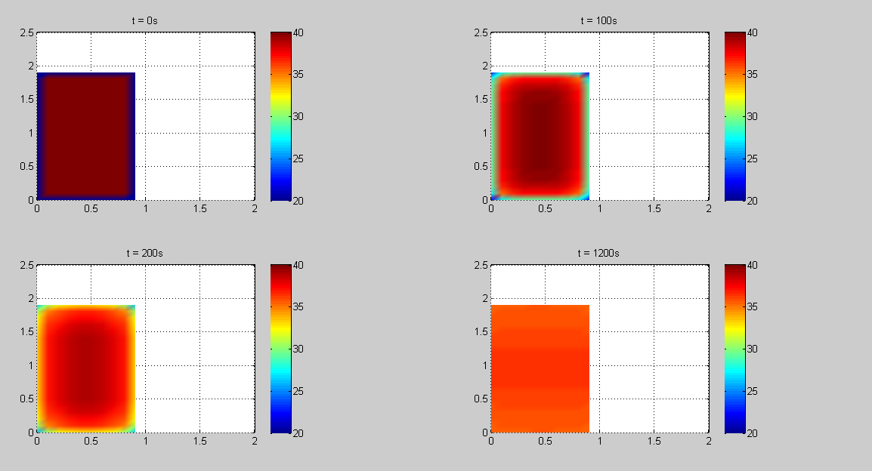

The temperature distribution of the surface

## 3.2 Part Ⅱ: Modeling after adding hot water

### Important hypothesis

* In this process, we consider the heat conduction process has already reach the steady state. Namely, the heat transfer process between water and tub wall can be ignored. Besides, the water has reached tub’s capacity exactly before a person settles into it.
* Since the process of adding water spends little time, we could simplify that the process of injection is completed instantaneously, only considering the results of injection and neglecting the intermediate processes. In this process, excess water comes from the original water before adding water, that is to say, the added water would not overflow at all.
* Via the hot water injection from the faucet, a new added trickle of water will make the heat conduction with the original water, in which the heat transfer is mainly by thermal convection. Based on the life experience and theoretical foundation, the convection costs little time, so it is assumed in our paper that the process of tending to the steady state of the mixed water also becomes instantaneous.
* We will add hot water if the bath temperature decrease to a certain value, **. Making the water temperature rise back to the initial temperature is the person’s final objective.（**should be kept above lower limit that makes people fill cold, that is **30℃)
* We assume that each person takes a warm bath half an hour according to the content knowledge. Moreover, the temperature will naturally go down by 8℃ in an hour.

### 3.2.2 The first step of modelling

According to our life experience, the temperature will go down after a while of bathing it if you don’t have any heat source to supplement it. We’d like to learn the thermal body’s temperature variation in time, which is combined with tub wall and water. So we use the Newton’s cooling law ([Wikipedia 2013]):



After separation of variables and integral transformation,

(is an arbitrary constant)



*  is a constant which is related to the heat transfer properties of the object, describe its inherent properties. We regard this value as  via our calculation and theoretical analysis.
*  is the temperature at a certain time, *t.*
* is the environmental temperature, =293K

Accordingly, we obtain the function relation between water temperature, *T* and the time, *t* under the natural cooling condition. What’s more, we regard the occasion, when the tub wall the initial water temperature reach to the steady state, as the zero hour in Part Ⅱ, denoted as *t=0*. From the result of PartⅠ,we have already known the value of steady state, that is, . So the result provides us with an initial value conditions: . We compute the constant, and the calculations give us a number, =2.7712.



### 3.2.3 The second step of modelling: A single injection

In order to let the water temperature throughout the tub as close as possible to the initial temperature, a person use the trickle of water to reheat the water. Based on the assumptions of the mentioned above, we want to use the N-S partial differential equations to solve this problem. Unfortunately, duo to the complexity of the convention process and the N-S’s solution, we do not adopt quantitative analysis about the temperature distribution with time and space. Instead, we place more emphasis on the temperature distribution and the common temperature after the two parts of water reaching the steady state. Therefore, we could have the following equation:



*  is the heat emission of the new added trickle of hot water.
*  is the heat emission of the remainder water in the water (that is, except the excess water).
*  is the numerical changes of temperature of the new added trickle of hot water.
*  is the numerical changes of temperature of of the remainder water in the water.
*  is the quantity of the new added trickle of hot water.
*  is the quantity of the remainder water in the water.



* is the quantity of the whole water in the tub.
* is the total amount of water that a person need to add in the process.
*  is the temperature afterhours, it is the point temperature when t=.

A single injection of process aims at making the steady-state temperature as close as possible to the initial temperature. Considering the equations above, we can find the relations between the final steady-state temperature and the quantity of the added water at a time:





Subsequently, we could deduce the relation between the total quantity of added water and the time interval () of each injection.



More clearly，we can describe the temperature change along with time via the diagram made by MATLAB:

the temperature change along with time 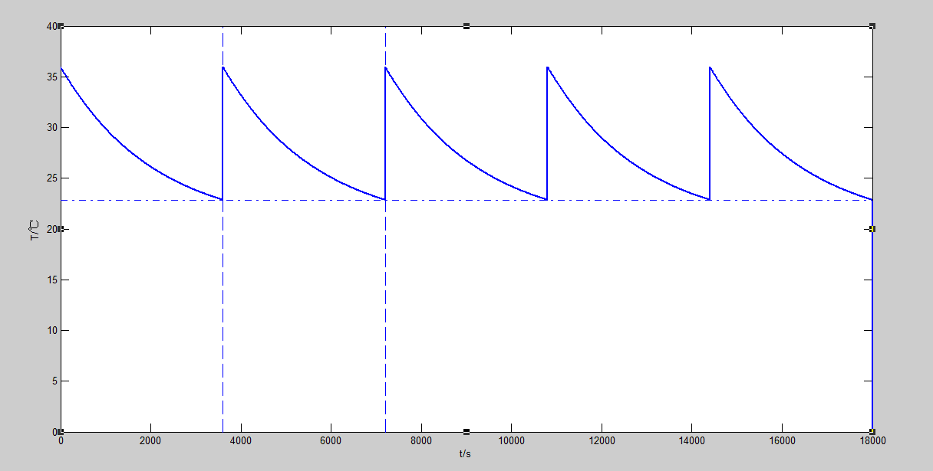

### 3.2.4 The third step of modelling: Multiple water injection

According to the hypothesis above, we believe that the process of adding water is instantaneous. Each injection’s the ultimate goal is trying the beat to make the bath tub water temperature rise back to the initial temperature.

Hence, it is easy for us to deduce that the multiple injection process is in fact a periodic process of a single injection process

The diagram of the temperature change along with time is as follows:

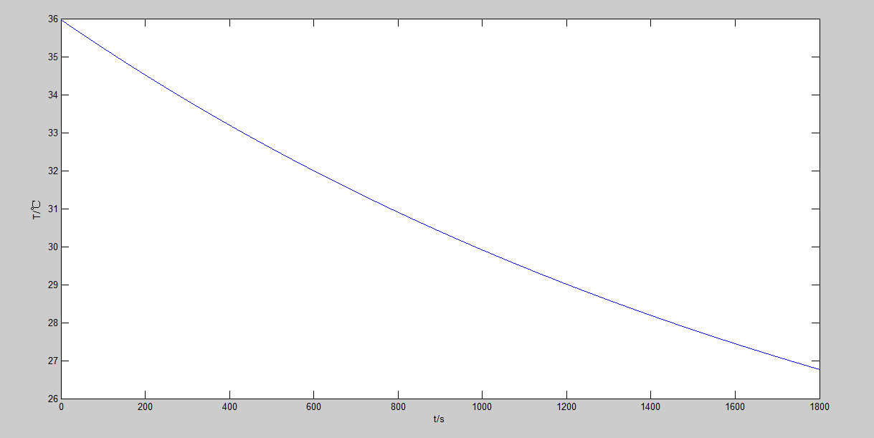

The temperature of time in the case of nature cooling

Then, the total amount of water that a person need to add in the process of multiple water injection is:



The relational graph about the total amount of water and the time interval () is following:

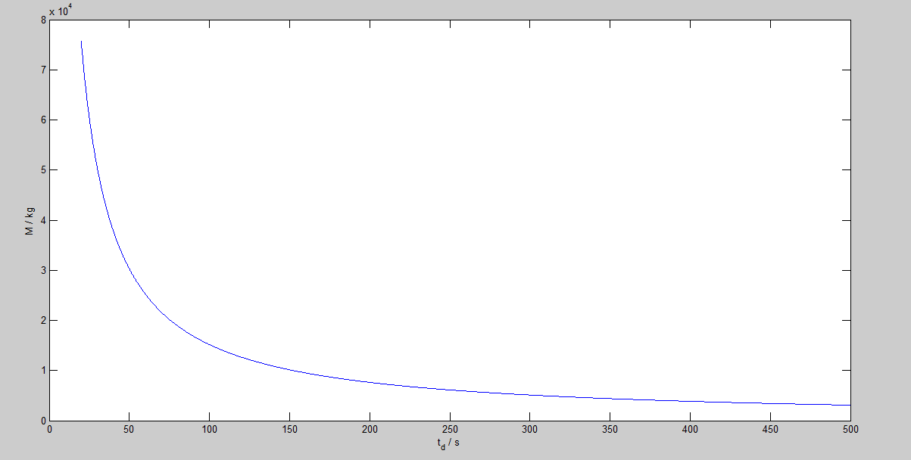

The total added water’s quality of △t

### 3.2.5 The modeling results

From the graph above, we can see as the time interval () getting longer, the amount of added water () will be shorter. Simultaneously, the (at this time, a person will add hot water) will be shorter as well. Then we could arrive at the conclusion that there has a positive correlativity between the value of and . The relationship between them can be demonstrate as follows:

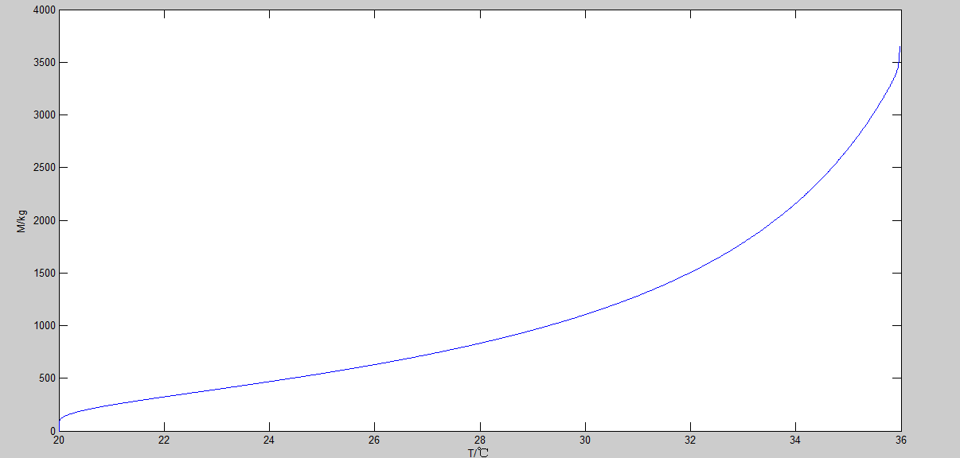

The total quality of water added change along with 

The simulation result is consistent with we have mentioned above. As the  becoming shorter, the value of will decrease accordingly. But the smaller the becomes, the amplitude of reduction is smaller. On the other hand, the higher ,can make the water temperature much closer to the initial temperature, so a person can be more comfortable under the circumstances.

To achieve our goals that keeping the temperature as initial temperature with saving water, we can figure out that our potential goal is making the value of  as smaller as possible, and  as bigger as possible. In order to describe the extent of the impact, we can calculate the reduction of added water quantity every 0.1℃, which is equivalent to the derivative of the graph.(We let it discretized to simplify the subsequent discussion). In the case, we think **30℃, =35.97℃, so the range of the abscissa changes from 30℃ to 35.97℃. The following table has shown us the temperature change in value:

表表

The scatter diagram is following:

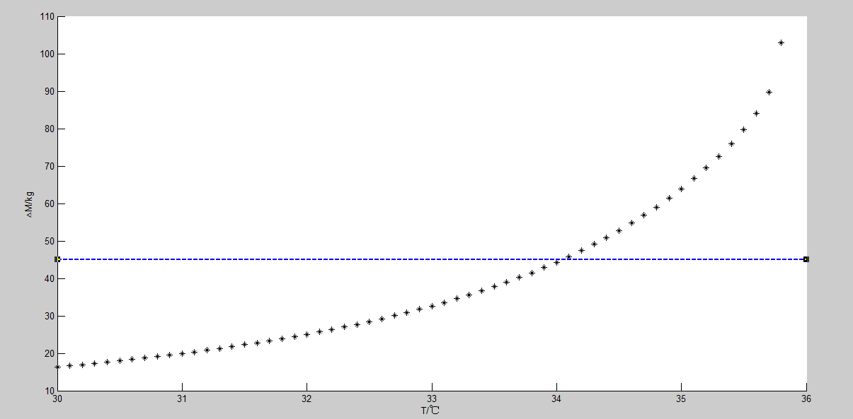

Discrete diagram of  changed per 0.1℃

As we can see from the picture, as the closer to the 35.97℃,the quantity reduction of added water will be bigger when reducing every 0.1℃. We can regard the value of x-axis () as the cost of lowering the temperature, and the value of y-axis () as the revenue. In this case, we think that if the increment of revenue is less than 45kg for every 0.1℃, the cost we pay for will larger than the revenue we obtain. Once the temperature reach to 34.4℃,the quantity reduction of water is only 44.31kg.If the temperature is lower than 34.4℃,the cost performance will decrease.

According to our assumption, the best strategy is that a person should add the not water at 33.5℃ until the temperature increase to the initial temperature ,35.97℃. In the case, the value of  is 217.9 seconds, and the quantity of a single injection is 284.09 kilograms. In the process of bath, he should add 8 times and the total amount of added water is 2272.7 kilograms.

## 3.3 Part Ⅲ: The impact of various factors

In the model development in the part A and part B, we have made a series reasonable assumptions, for example, we simplify the bathtub as simple cuboid and single material acrylic when considering the diversity of bathtub shape and the properties of heat conduction. Besides, due to shape complexity of the person and the random uncertainty of human activities, we establish the model of *water-bathtub-air system* without considering any impact of person’s motions.

In the following part, we will start the qualitative analysis of the impact of the various factors for the whole process of thermal transmission.

### 3.3.1 The properties about bathtub

1. **The properties about tub’s thermal transmission**

In our model 1,we use the Fourier law and adopt discrete method based on finite difference method to solve this complex process, then we obtain the iterative equation:



As we can see from the equation, the thermal conductivity λ and the density ρ of the tub is introduced in the iteration. In the real life, because of the diversity of tub materials and the development of the technology, the parameters *λ*and *ρ* will decrease gradually. From above all, we can realize that  will go down as λ and ρ going down. That is to say, the changing temperature in time will reduce. Then we can easily explain that the tub’s insulated effect is getting better and better.

1. The shape of the bathtub

After the tub’s profile generalization, the planform is the rounded rectangle with the length *W*, width *L* and corner radius *R.* Under the circumstances, other conditions keep unchanged all the time. The general shape is shown in the figure:

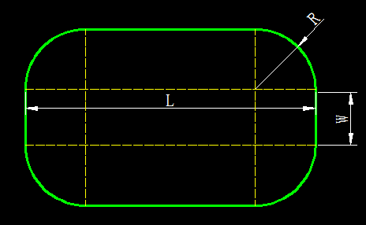

Fig. The general shape of the tub

When *R*=0, the shape becomes rectangle which is the ideal situation in the model 1, we would find the thermal distribution of the tub and water in space:

（1）…………………………………………???

From the picture, we can see the thermal distribution is zonal and the center is the intersection points of diagonals in the same profile. We take t=100s as an example:

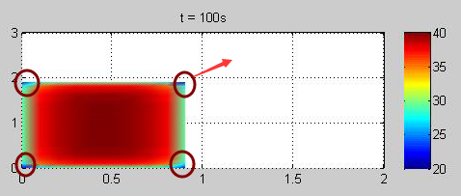

Fig. The thermal distribution in the same profile of rectangular bathtubs

As the picture shows to us, we find there has the significant thermal difference at the four corners (we have marked it on the picture).This phenomenon is caused by the mutation of the angular shape.

So we bring out an idea that for the general shape, rounded rectangle, the temperature will be evenly distributed at four corners due to the smooth connection of fillet. Letting the value of *R* increase generally until meet the condition: *W=L=2R*, the planform will become a circle, the edge of tub is smooth transition. Then the thermal distribution becomes concentrically ringed.

1. The shape of the bathtub

It is assumed that the tub’s height is constant and all tub is prism or cylinder, then the volume change will only have affected on the size of surface area. Considering the impact in terms of two sides:

* When we change a larger tub, the surface area will get larger. In the second model, we apply Newton's law of cooling to study the process of natural cooling of water:



The value of coefficient *k* depends on the water contact area with air. As the volume getting larger, the contact area and coefficient *k* will be larger, so the heat transfer velocity between water and air will be greatly increased. It makes the process of natural cooling becomes faster than ever. To keep the temperature as close as the initial temperature, we think that the process of adding hot water will be more frequent, moreover, the added water volume will also increase at the same time.

* As the volume getting larger, the quantity of water in the tub will increase. In the second model, a person should add more water to keep the water temperature at the initial level.

1. **The properties about a person**
2. The volume of the person

In consideration of the person’s existence, he would occupy some space in the tub, so we can infer that the greater volume of the person can make the water tank capacity smaller. Then the issue can transfer to the effects after the tub volume change we have mentioned above.

1. The shape of the person

The person’s shape can be regarded as the body posture in the tub. Generally speaking, there are three basic positions when bathing: Sitting cross-legged or squat, sitting stretched out and lying in the tub, like this:

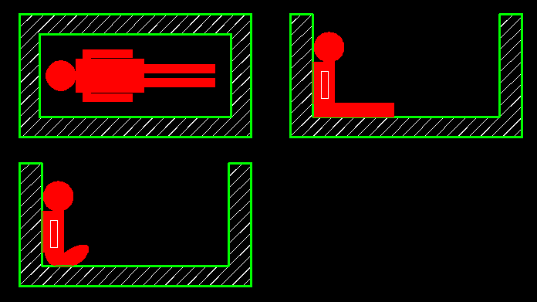

Fig. Schematic diagram of three basic positions when bathing

Considering the shape will influence the contact area of tub wall and hot water (the person’ back is close to one side of the wall, and the legs is close to undersurface), we can find something listed in the following table:

|  |  |  |
| --- | --- | --- |
| Person’s shape | Analysis | Effect |
| Sitting cross-legged/ squat | The contact area of tub wall and hot water is larger, the heat loss will increase because of the heat conduction between wall and water. | The time interval () of adding hot water will be longer. |
| Sitting stretched out | The contact area of tub wall and hot water is less than the first situation. | The time interval () of adding hot water will be shorter than the first situation. |
| Lying in the tub | The contact area of tub wall and hot water is less than both of two situations above. | The time interval () of adding hot water will be shorter than both of two situations above. |

1. The temperature of the person

It is well known that human being is homothermal, and a person can regulate his own temperature to keep it at a normal level via the mechanism of the body. So it can be analyzed in the following two situations:

If the skin surface temperature is higher than water temperature, people is equivalent to the heat source, and the heat distribution in space will appear higher temperature distribution near the surface of the skin. Conversely, the heat around human body will appear lower value than other place.

1. The effect about the motions

The person’s motions can be achieved via the change of body posture. Since these process is uncertain and random, the impacts of motions is also difficult to describe quantitatively. In order to illustrate this issue, we assume that the motions are some certain simple mechanical motions. To simplify our study and calculation, the motion is regarded as a process of harmonic vibration of the water.

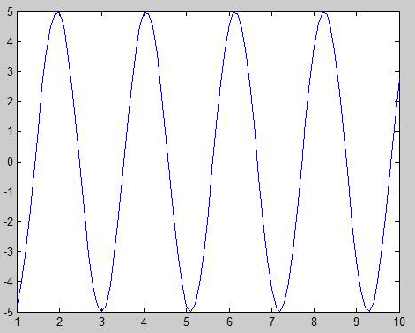

Fig. The graph of water’s harmonic vibration

Considering the impact in terms of two perspectives:

* The movement of water:

The motions will accelerate the diffusion of molecules, further accelerate the conduction of heat. These all make the steady-state temperature lower under the same conditions.

* Working physically by the motions :

When a person motions during the tub, he will generate energy by work, resulting in the demand’s reduction for hot water.

To sum up, when the quantity of heat production by work is greater than the quantity of heat dissipation, the demand of adding water will decrease and the time interval () will be longer. Actually, a person has little motion during the bathing, and the effect of heat dissipation plays a leading role in the process, therefore, he would add the hot water more frequently to keep the bath warm.

1. The effect about a bubble bath additive

Using a bubble bath additive will directly influence the physical property of water, making the water change into the emulsion. We can take soapy water as an example to analyze the effects:

* If the person used a bubble bath additive while initially filling the tub, the clear water change into the emulsion, caused the increase of surface tension, as well as the density of water, specific heat capacity and thermal conductivity. According to the formula,, the quantity changes of temperature is very small on the occasion of equivalent thermal absorption or thermal release.
* In addition, for the second model, the water added a bubble bath additive has the bigger value of both specific heat capacity and thermal conductivity, but small value of viscosity coefficient than ever. These are beneficial to heat transfer and convective heat transfer. So the miscible liquids is a better heat transfer medium. When adding the equivalent quantity of water, heat exchange would be faster. Considering thermal transfer of soapy water and air as natural convection, and thermal transfer of soapy water and added water as forced convection, we can infer from the theoretical knowledge that the former effects are not really obvious, but the latter effects playing a major role to speed up the progress of heat transfer.
* Finally, as we can see obviously from our daily life the bath additive will produces large amounts of bubbles on the surface of the water exposed to the air. To some extent, it will prevent heat transfer process between air and water, which reduce the amount of heat loss.

In other words, the process of keeping the temperature as initial is much easier by adding hot water. So the time interval of adding water will getting longer according to this perspective.

Above all, the effects on one’s strategy depends on which mechanism is the most important. It is more likely to reduce the frequency of adding the water because of the third point.

## 4.5 Model Variation and Comparison

# 5. Sensitivity Analysis

# 6. Final Remark

## 6.1 Strengths and Weaknesses

## 6.2 Future Model Development

## 6.3 Conclusions

# 7. References

# 8. Appendix