模型优化部分

1. 加水时的空间分布。加入热水流时，我们考虑水中的对流换热比较剧烈，认为热水均匀的过程可以瞬间完成。然而在实际过程中，我们可以知道温度分布依然是从中心向四周扩散的。同样使用模型一中建立的傅里叶离散模型，考虑在此过程中对每个小正方体使用牛顿冷却定律，我们可以预见到热量散布的空间模型和无对流情况下是相接近的。接下来我们将定性地分析加入热水后空间分布的大致情况

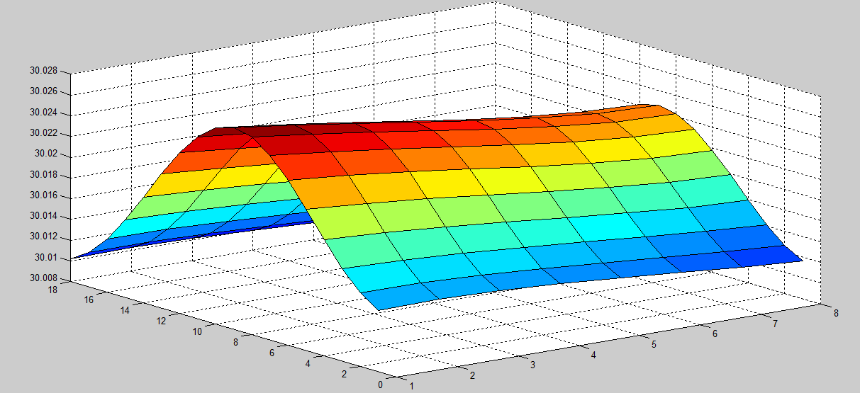

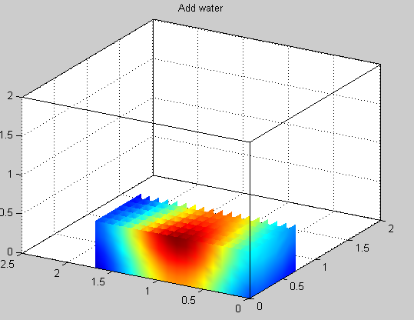

在x轴值为0.9，y轴值为0.2处放热水最后形成的图像如上图所示。

2. 在模型二中，我们得到了最终的策略，让用户每隔一个确定的时间加水，但由于策略的操作者为人，所以在实行的时候可能会根据自己的生活习惯，感觉到的舒适温度的不同可能有较大的不同。我们采用神经网络的算法对每一次用户自身的生活习惯产生“记忆”，让我们的算法可以逐步贴近人的生活习性，成为更加贴近用户生活习惯，用户体验更加舒适的算法。

具体的做法为，每次用户操作的实际数据以0.05的比重和原 0.95比重加权相加后为下一次操作时的 。流程图如下

 = 0.95(k = 0,1,2,3,.....)

 = 0.05(k = 0,1,2,3,......)

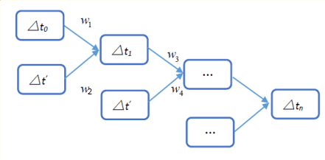

使用模型二中得到的数据  = 217.9s，在这里假设一个用户感到舒适的温度的下限为33℃.我们做了50次迭代，下图为 随着迭代次数的变化：

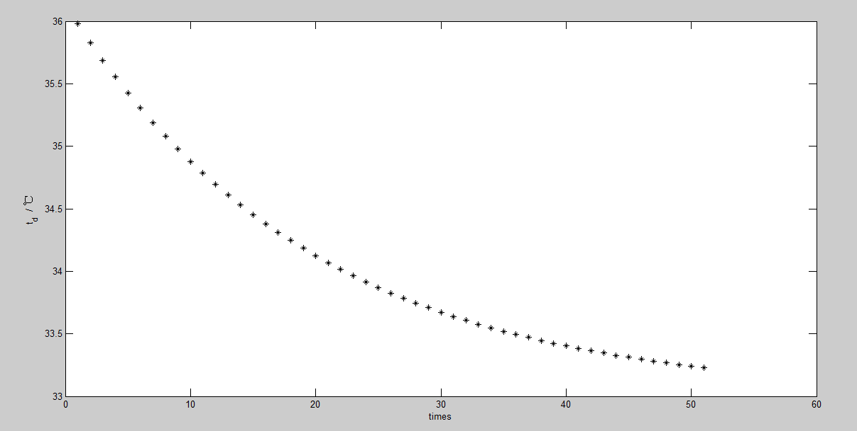

从图中可以看出，洗20次澡会使减小为34.1℃左右，而到50次就会使变化为33.2℃。这意味着，经过大约两个月的使用，的值就会比较接近用户生活习惯，从而模型二能够适应更多不同的人群。

**Optimization Of Model**

1. **The Spatial Distribution When water was added**

When we take add hot water into consideration ,we think that Convective heat transfer is so rapid that can be considered completed at he moment.However in the practice,we know that the temperature is also diffusion from the central of the point below the faucet. Analysis on every small cube using the Newton’s law of cooling,we can predicate that the tendency of Spatial Distribution remain unchanged.Next The Spatial Distribution will be discussed qualitatively.



Two images above showed The Spatial Distribution where faucet above the point(0.9,0.2,0)

1. **Neural network algorithm in customize **

Model two gives a final ploy ,which let people add water after a constant value of time ,And when the actual situation is considered ,human won’t strictly accordance with ploy due to his/her private habits and the lower limit of the temperature he/she fells comfortable.Neural network algorithm is sought out to ”remember” the habit of the person,which can make the model more humanize .

Specially,the actualweights 0.05,and the theoretical value weights 0.95 and sum them as the theoretical value of next time.The flow chart is shown:



where

 = 0.95(k = 0,1,2,3,.....)

 = 0.05(k = 0,1,2,3,......)

Use = 217.9s ,T = 35.9783℃in model two .Assume that a certain person who’s lower limit of comfortable temperature is 33℃.The chart shows how changes when number of times grow.



When the number of times is 20,decreases to 34.1℃.And When the number of times is 50,decreases to 33.2℃.It can be summed up that After about 2 months ,will become close to the person’s habit which means The model two can adapt different people.