灵敏度分析

**模型一**

在模型一的讨论中，我们假定了浴缸的材质（温度系数（λ），比热容（C），密度（ρ））以及室温（），热水温度（）保持恒定。然而实际中的浴缸有多种材质，不同的情景下室温和热水温度温度也不尽相同。接下来的部分我们将使这些数值产生变化以考虑我们模型中对环境变量的敏感系数以及平衡程度。

我们最先考虑浴缸的材质导致其参数变化，以及由此引起的最终稳定温度的变化和整个系统内的温度分布的变化。由Fourier定律



我们可以知道，密度和比热对于模型的影响在数值上近似，故我们仅考虑**密度**变化的情况。

由于在模型一的过程中，水和浴缸的其他参数等数据不会改变，我们设置从0.9 kg/到1.5kg/的密度梯度来运行我们的模型一，在此过程中，所有其他的敏感变量，如室温（），热水温度（）等均视为与模型标准值相同。我们在下表中列出每个密度值和对应的系统平衡温度T。

|  |  |
| --- | --- |
| ρ（kg/） | T（） |
| 0.9 | 36.8240 |
| 1.0 | 36.5323 |
| 1.1 | 36.2506 |
| 1.2 | 35.9783 |
| 1.3 | 35.7149 |
| 1.4 | 35.4601 |
| 1.5 | 35.2135 |
|  |  |

如下图为密度分别是0.9和1.5的模型在t = 200 s 时横截面的热度分布图.

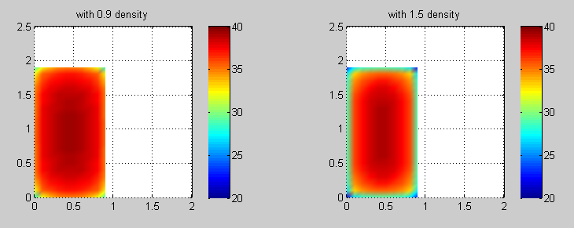

从上述数据可以明显看出，随着浴缸密度的逐渐增大，最终的稳定温度会逐渐变低，但在密度变相差较大的情况下，我们的模型的差值也不会超过一度。同时我们注意到，虽然最终的温度和达到的时间会变化，水中的基本空间分布却基本没有变化，但在高密度时，浴缸温度变化会明显的减慢。

接下来我们令浴缸的数据和热水温度使用模型中的标准数据，同时设置室温的变化范围为15℃到25℃，由于在与浴缸作用的过程中我们忽略了空气与水，空气与浴缸的热交换，所以室温对模型一的影响可以简化为浴缸的温度。下表列出的是每一个温度值和其对应的最后平衡温度，我们将标准室温下的结果放在第一的位置。

|  |  |  |
| --- | --- | --- |
| T室温 | T | 温度升高两度最终温度的变化 |
| 20 | 35.9783 | NAN |
| 15 | 34.9728 | NAN |
| 17 | 35.3750 | 0.4022 |
| 19 | 35.7772 | 0.4022 |
| 21 | 36.1793 | 0.4021 |
| 23 | 36.5815 | 0.4022 |
| 25 | 36.9837 | 0.4022 |
|  |  |  |

如下图为15，20，25

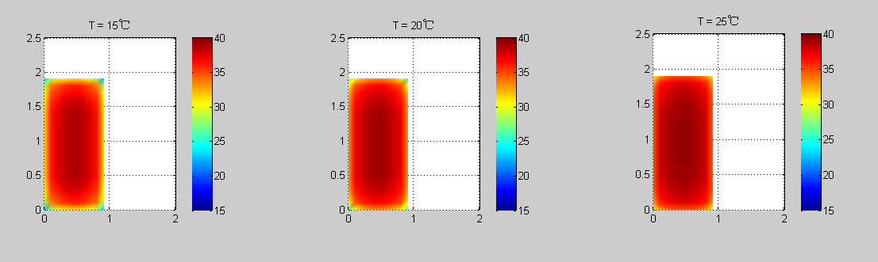

综合上述数据可以看出，室温对于最终平衡温度的影响比较大，15℃与25℃的温度差值达到了2.01℃，同时从第三列的数据可以看出，每上升两度，温度的差值都是0.4722℃，有很大的可能性平衡温度和室温为线性关系，并且从200s之后的温度截面图来看，室温越低温度下降速度越快，但对其空间分布影响较小。

**模型二**

在考虑模型二的时候，我们在浴缸和水达到平衡，所以浴缸的各项参数并不直接影响模型二的过程，而是通过影响影响模型二的**初始温度**来影响整个模型二的过程。所以我们结合模型一考虑初始温度对于模型二的影响，即可确定浴缸材质等参数对于模型二的影响。

由对模型一的灵敏度分析，我们可以知道初始温度的置信区间大约为[34，37]，我们将落在这个区间内的整数值作为灵敏度的分析。根据第二模型中由牛顿冷却定律求出的温度关于时间的表达式：

。。。。。。。。。。。。。。。。。。。。。。。。。。。。。。。。。。。。。。。。。。。。。 （*）

将初始温度带入t = 0时刻得到具体的表达式，得到C的值如下表

|  |  |
| --- | --- |
| 初始时刻温度 | 系数C |
| 34 | 2.6391 |
| 35 | 2.7081 |
| 36 | 2.7726 |
| 37 | 2.8332 |

根据如上的C值，可以分别求出自然冷却状态下温度关于时间的函数图如下：

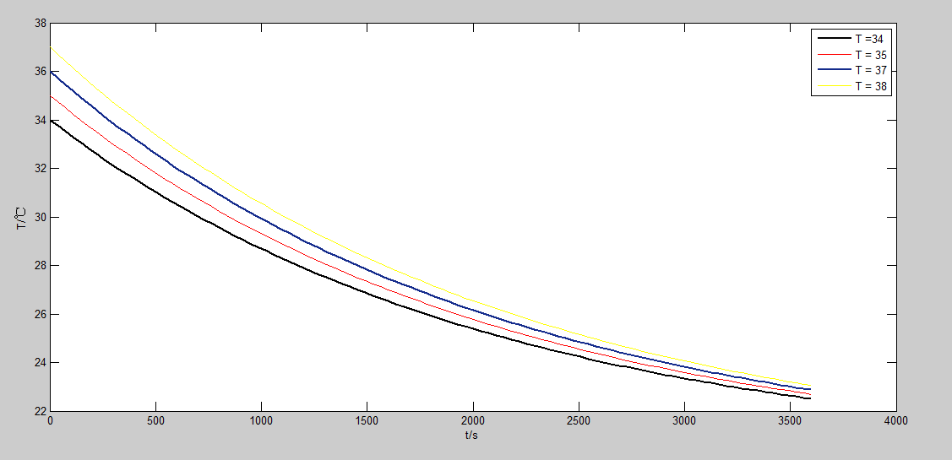

图中可以看到，在合理的温度取值范围内，图像只是初始点有明显的变化（实质上它就是我们改变的那个干扰变量）而总体趋势较为稳定，模型对初始温度敏感度较小。

初始温度对于T-t函数的影响已经在上图中表现得非常明白了，接下来我们考虑这样的T-t函数对于加水量，加水间隔时间的影响。在讨论过程中我们假设每次加水的温度恒定为。可以看到温度较低的情况下到达的速度越快，所以加水的时间间隔随之变小，由于需要到达的初始温度也较低，所以每次的加水量减少，综合来看总的加水量减少。

总结上述即为：随着初始温度的降低，每次加水量减少，加水次数增多（加水间隔减小），总加水量减小

接下来我们保持其他因子保持模型中的标准量，考虑（*）式中的k变化的影响。k是热传递系数，和发生热交换的物体（模型中两物体为水和空气）的接触面积、材质、形状、体积都有关系，每一种不同的情况都会有一个确定的k值相对应，所以在这里考虑不同的k值相当于我们考虑了浴缸和水的物理性质，浴缸形状导致的面积不同等因素。

结合实际，我们以下几个k值0.0003，0.0004，0.0005，0.0006.与分析初始温度对模型影响的方式相同，我们将不同的k值带入表达式画出如下图像

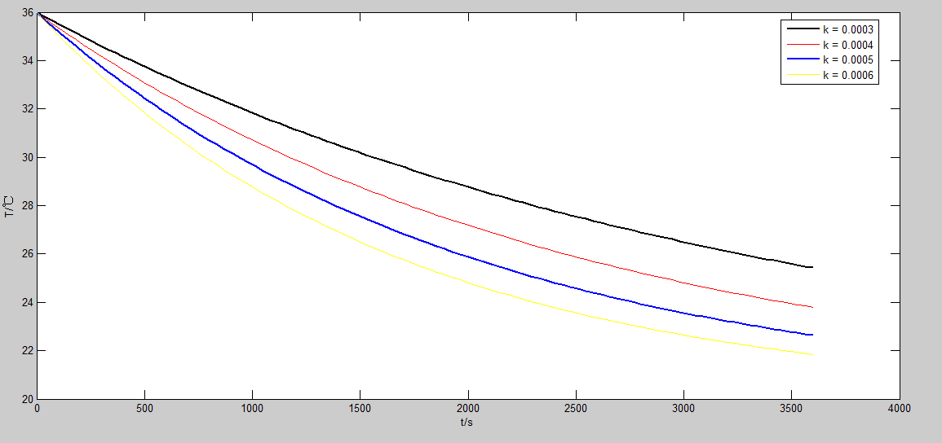

k原值为0.00047716，改变幅度较大时图像趋势保持不变，模型对k的灵敏度较低。

从图像可以直观地看出T-t的变化趋势。而当k值较大时，到达的速度较快，所以加水的时间间隔随之变小。由于需要加水达到的目标温度T与k无关，故每次的加水量增加。加水次数增多，加水量也增多，总用水量也增加。

**Sensitivity Analysis**

**The First Model**

In the first model,it is assumed that the material of the bathtub remains constant(Include the Coefficient of Temperature(λ),specific heat capacity(C) density(ρ)) and indoor temperature() ,the temperature of hot water keeps constant.In fact, there are many different materials of bathtub.Indoor temperature and the temperature of hot water is not the same under different circumstances. The next section we will make them a difference to show how those values have affects on our model.

To begin with,These changes in the parameters of bathtub which are caused by the change of different materials . By the law of Fourier:



It is obvious that density and specific heat capacity is equivalent in the equation,so only the density is considered.

With all the other parameters are set to standard values in the model ,the density is set from 0.9 kg/ to 1.5kg/ ,respectively.

In table1.1, the (平衡温度final stable temperature )T for each value of density ρ is listed.

.......

.......

.......

Meanwhile ,the model is used to give heat distribution of intersecting surface when time is t = 200s.



Chart 1.2

It is apparent that, the (平衡温度final stable temperature ) is decreasing, while the density is increasing. But, when the difference in density is relatively large, the deviation of the first model is less than 1℃,which means the level of sensitivity is low when we talking about density. It is also noticed that the Spatial distribution of temperature in water remains unchanged,but the change bathtub wall is inversely proportional to density.

Secondly,we assign the parameters of bathtub and the temperature of hot water to standard values in model.At the same time ,we set the indoor temperature from 15℃ to 25℃.Remember that in the model,it is assumed that there is no interchange of heat between water and air ,the condition is simplified to the temperature of bathtub.The following chart lists every indoor temperature and corresponding (平衡温度final stable temperature )T,simultaneously ,we list the standard circumstances in the top of the chart.

.....

.....

.....

The following image shows heat distribution of intersecting surface for temperature 15℃,20℃,25℃,respectively.



In the end,according to above charts,it is noticeable that the indoor temperature have a greater impact on (平衡温度final stable temperature )T than density.The difference of T between 15℃ and 25℃ is 2.01℃.Therefore,We can conclude from the third column of the chart that every 2℃ cause 0.4722℃ change of T.It has a great chance that T is proportional to indoor temperature.And,the result is that the lower indoor temperature,the faster temperature of water increases.But,indoor temperature has little influence on its Spatial distribution.

The Second Model

In the second model, it is assumed that there is a balance of the bathtub and water. So,the parameters we considered in model one influence the second model by influence the temperature at the start of the second model.So we integrate the sensitivity analysis in model one and T_s to make the affect of the material of bathtub clear.

According to the sensitivity analysis in model one,we can learn that the confidence intervals of T_s is [ 34,37 ],we will take all integers into our sensitivity analysis.In line with the Newton’s law of cooling , the following T-t function is obtained:

.................................................................................... (*)

We employ direct substitution when t = 0 s, T = T_s, we can get the corresponding C as is shown below:

.....

.....

.....

Apply C to the expression(*), the following graph can be obtained:

In the range of the initial temperature,Only the beginning of the plot is obviously changed(and in fact it is the value we set to change),the tendency of the chart remain unchanged which means the sensitivity of initial temperature is relatively small.

The influence of initial temperature in T-t function is obvious in the chart,so next we will discuss its influence of the quality of all water added and the interval value of time .With the temperature when add water is constantly 。We can see that when the lower the initial temperature is the faster the temperature arrives  ,and the interval time become smaller.Because the initial temperature we approaching is smaller ,the value of quality of water used one time become smaller.And finally ,the value of total quality of water added become smaller.

In summary,when the initial temperature decreases,the value of quality of water we used one time decreases, number of time of add water increases,and the value of total quality of water added is smaller.

The next part we will discuss the change of k in (*).k is the Heat transfer coefficient which is decided by the physical properties of the two objects in heat exchange(which is water and air in our model),the contact area, shape and volume,every different circumstances corresponds a certain k.So when we talk about k,we are talking about the material of bathtub ,the area contacted and other parameters.

Considered concrete situation,we will set k to 0.0003,0.0004,0.0005,0.0006.Same with the discussion above,we take different k to the expression,and the graph below is drawn:



The original k is 0.00047716. When k changed rapidly ,the tendency of the chart is not changed and the model is not sensitive to k.

We can visually see the relation between temperature and time.On the other hand the larger the k is the faster we achieve Because the initial temperature of bathtub is constant,the value of quality of water used one time increases,the interval time decreases.,the value of total quality of water added become larger(最后一段不明白什么意思，中文也看不懂，)