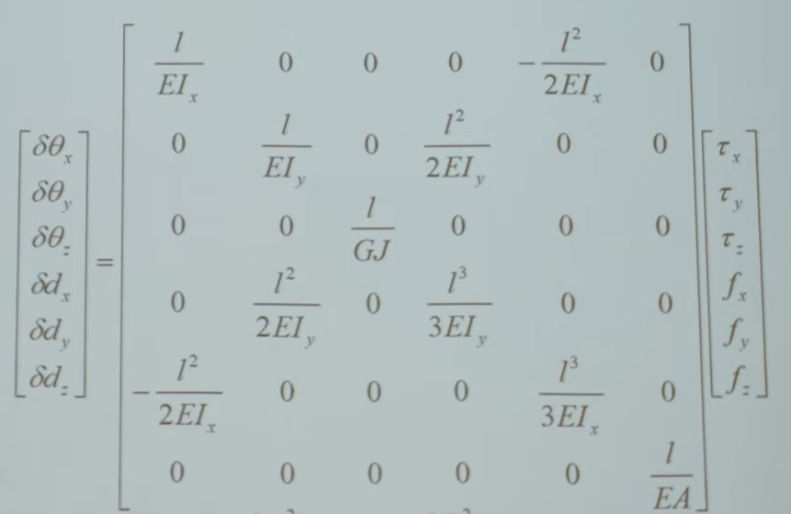
^ compliant matrix?

Using similar eqn on given compliant matrix V
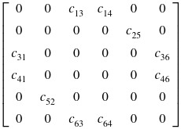
This gives dx = C46*Fz & dz = C64*Fx, instead of C41 & C63…. Why?????

Cuz the force matrix is like this; [Fx Fy Fz Tx Ty Tz]
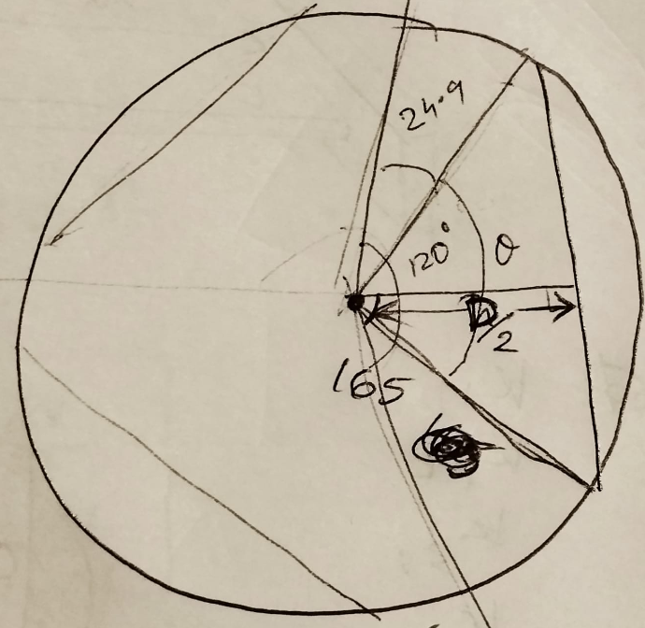

From fig, theta = 120 – 2*24.9 = 70.2
D/2 = 165*cos(theta/2) = 134.995 mm

