**A High-Quality Reprocessed MODIS Leaf Area Index Dataset (HiQ-LAI)**

**1．Data Description**

The High-Quality Leaf Area Index (HiQ-LAI) is derived from reprocessed MODIS LAI C6.1 product by Spatio-Temporal Information Compositing Algorithm (STICA). This method integrates information from multiple dimensions, including pixel quality information, spatiotemporal correlation, and original observations, to improve the raw MODIS LAI retrievals with poor quality. The HiQ-LAI is available in various projections and spatial resolutions. Essential details regarding the product are outlined in Table 1.

**Table 1.** Dataset characteristics of the HiQ-LAI Product

|  |  |
| --- | --- |
| Characteristics | HiQ-LAI Product |
| Temporal Coverage | February 18, 2000 – December 31,2022 |
| Area | Global Vegetated Land |
| Projection | Sinusoidal/WGS1984 |
| Spatial Resolution | 500m/5km |
| Temporal Resolution | 8 days |
| Fill Value | 255 |
| Data Type | Uint8 |
| File Format | TIFF(.tif) |

The HiQ-LAI product offers a 5 Science Datasets (Fig. 1), comprising LAI, original quality control information, relative temporal stability of MODIS LAI and HiQ-LAI, and the absolute difference between HiQ-LAI and MODIS LAI. To address considerations regarding data storage size, the original values have been adjusted to integers. Users are advised to refer to the scaling factors provided in Table 2 for value restoration when utilizing the data.

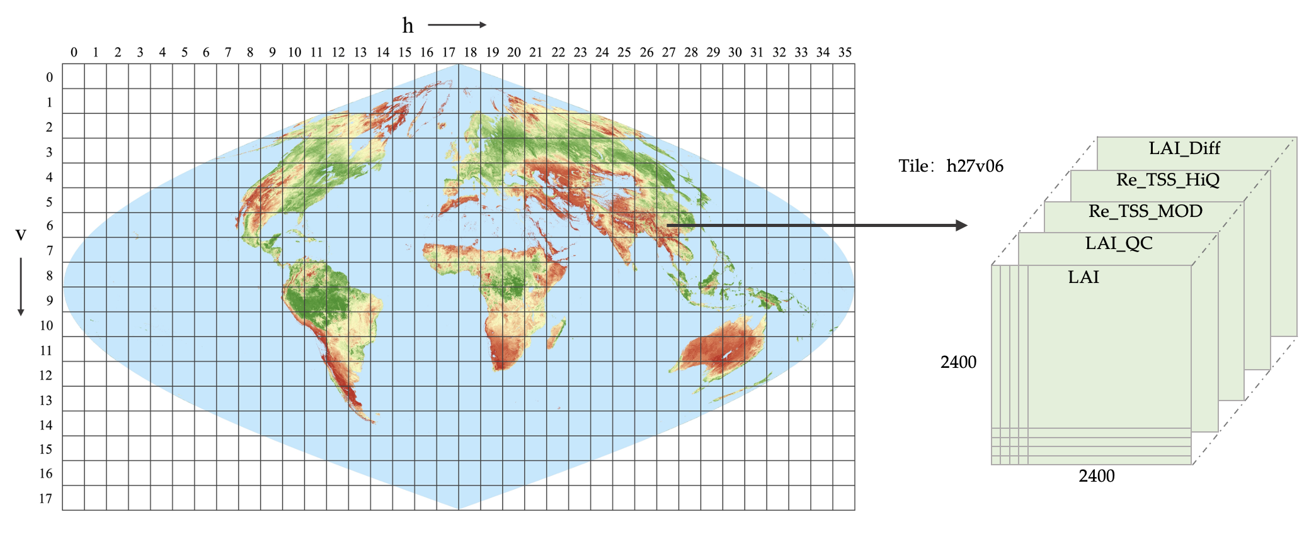

Fig. 1 Scientific Datasets of the HiQ-LAI

**Table 2.** Scientific Datasets included in the HiQ-LAI Product

|  |  |  |  |  |  |
| --- | --- | --- | --- | --- | --- |
| **Scientific**  **Data Sets** | **Definition** | **Bite Type** | **Fill Value** | **Valid Range** | **Scale Factor** |
| LAI | HiQ 500M Leaf Area Index | uint8 | 249-255 | 0-100 | $×$ 0.1 |
| LAI_QC | QC for LAI | uint8 | 255 | 0-254 | Null |
| Re_TSS_MOD | Relative Time-series Stability  for MODIS-LAI | uint8 | 255 | 0-10 | $×$ 0.001 |
| Re_TSS_HiQ | Relative Time-series Stability  for HiQ-LAI | uint8 | 255 | 0-10 | $×$ 0.001 |
| LAI_Diff | Difference of Leaf Area Index between MODIS LAI and HiQ-LAI | uint8 | Null | 0-255 | $-$ 100 |

The HiQ-LAI is available in two projections of different spatial resolutions (Table 3). Data sets at 500m were stored in Google Earth Engine for users to mix and match with other datasets and the availability of this dataset in the GEE platform would significantly benefit the GEE community, fostering easier access and utilization of this valuable resource. A 5km projection of HiQ-LAI for WGS84 (EPSG:4326) can be found in Zenodo.

**Table 3. Projections and spatial/temporal resolutions of HiQ-LAI**

|  |  |  |  |  |
| --- | --- | --- | --- | --- |
| Dataset | Projection | Spatial Resolution | Temporal Resolution | Repository |
| 500m_8day | WGS1984/ Sinusoidal | 500m | 8 days | GEE |
| 5km_8day | WGS1984 | 5km | 8 days | Zenodo |

**2. Filenames Convention**

The HiQ-LAI product file name follows certain naming convention, providing useful information about a specific product. For example, the filename HiQ_LAI_WGS84_5km_8day_2022361.tif indicates:

* HiQ：Product Short Name
* LAI：Land Surface Type
* WGS84：Projection Information.
* 5km: Spatial Resolution
* 8day: Temporal Resolution
* 2022361：Julian Date of Acquisition（YYYYDDD）, DDD=DOY (Day of Year)
* .tif：Data Format

**3. Data Availability**

The dataset links are as follows:

1) <https://doi.org/10.5281/zenodo.8296768> (spatial resolution is 5km and temporal resolution is 8 days)

2) <https://code.earthengine.google.com/?asset=projects/verselab-398313/assets/HiQ_LAI/wgs_500m_8d> (spatial resolution is 500m and temporal resolution is 8 days)

**4.** **Data Read Example (For Google Earth Engine)**

Here is a Google Earth Engine example for the version that spatial resolution is 500m and temporal resolution is 8 days:

var Year = 2021

var HiQ = ee.ImageCollection('projects/verselab-398313/assets/HiQ_LAI/wgs_500m_8d')

print(HiQ) // // print HiQ dataset information to console

var HiQ _filter = HiQ.filterDate(Year+'-01-01', Year+'-12-31')

//.select('LAI', 'LAI_QC')

// // If user wants to filter the year or month:

// var HiQ_Filtet_Y = HiQ.filter(ee.Filter.calendarRange(i, j, 'year'))

// var HiQ_Filtet_M = HiQ.filter(ee.Filter.calendarRange(i, j, 'month'))

var colorizedVis = {

min: 0,

max: 100, // 10, 100,

palette: [

'FFFFFF', 'CE7E45', 'DF923D', 'F1B555', 'FCD163', '99B718', '74A901',

'66A000', '529400', '3E8601', '207401', '056201', '004C00', '023B01',

'012E01', '011D01', '011301'

],

};

var LandCoverVis = {

min: 1.0,

max: 10,

palette: [

'05450a', '086a10', '54a708', '78d203', '009900',

'dade48', 'fbff13', 'b6ff05', '27ff87', 'c24f44',

],

};

// // add special band to map layer

// .first(): add the first image of imageCollection

Map.addLayer(HiQ _filter.select('LAI').first(), colorizedVis, 'LAI');

Map.addLayer(HiQ _filter.select('LAI_QC'), {}, 'QC');

Map.addLayer(HiQ _filter.select(' Re_TSS_MOD'),{}, 'TSS_M');

Map.addLayer(HiQ _filter.select(' Re_TSS_HiQ'),{}, 'TSS_Overall');

Map.addLayer(HiQ _filter.select(' LAI_Diff'),{}, 'Diff');

**5. Data Read Example (For Python)**

Here is a python example for the version that spatial resolution is 5km and temporal resolution is 8 days:

import numpy as np

from osgeo import gdal

import matplotlib.pyplot as plt

def readTif(fileName):

dataset = gdal.Open(fileName)

if dataset == None:

print(fileName+" Failed to open")

return dataset

def render_Img (data, title='', savepath='', color=plt.cm.jet, axisType = 'off'):

plt.imshow(data, cmap = color) # cmap= plt.cm.jet

plt.title(title, family='Times New Roman', fontsize=18)

plt.rcParams['font.size'] = 13

plt.rcParams['font.family'] = 'Times New Roman'

# plt.colorbar()

plt.axis(axisType)

if issave :plt.savefig(savepath, dpi=300)

plt.show()

year = 2021

for idx in range(1, 362, 8):

## read data

file = readTif(f'HiQ_LAI_WGS84_5km_8day_{year}{idx:03d}.tif').ReadAsArray()

## Visually display the HiQ-LAI and LAI_QC

render_Img(file[0]/10, title=’LAI’)

render_Img(file[1], title=’QC’)

**6. Data Read Example (For Matlab)**

Here is a matlab example for the version that spatial resolution is 5km and temporal resolution is 8 days:

clear;clc

% set the input dir

inpath = '.\HiQ_LAI\WGS84_5km_8d\';

year = 2021;

for doy=161 %1:8:361

% check the prefix

prefix = ' HiQ_LAI_WGS84_5km_8day_ ';

inname = strcat(inpath,prefix,num2str(year*1000+doy),'.tif');

% read data

data = imread(inname);

data = double(data);

data(data == 255) = nan;

LAI=data(:,:,1)/10;

LAI_Diff=data(:,:,7)-100;

% Visually display the HiQ-LAI, Difference of LAI between MODIS LAI and HiQ-LAI

figure(1); imagesc(LAI);

figure(2); imagesc(LAI_Diff);

end

**7. Contact**

<kaiyan@bnu.edu.cn>