**Sprint Report 2**

**VTP**

**Team Members:**

Anudeep Potlapally and Travis Rous

**Client:**

Nick Newell of EchoStar

**Summary:**

For this sprint there was mostly research and learning of how to implement some of the features that we will be trying to use in the project. Anudeep had discovered and Implemented the Popcorn.js which is designed create videos with an features such as what we are trying to implement.

**Sprint 2 Backlog:**

* Database Design (In Progress...)
* Creating a favorites page (In Progress...)

**Sprint 2 Burndown:**

RESEARCH

Anudeep had researched the Youtube data API and found that we needed to get permission from Google to use it which allows VTP to search, upload videos. Travis sent google a request to use the data api and we are currently waiting for a response.

DATABASE DESIGN

The current host location is just local on our personal machines. There is a database that we can both access that is being hosted on Travis’ desktop. We are using MySQL via the phpMyAdmin tool.

We currently have a database with three tables; users,yttags,favorites. In the users table there an auto incrementing ID number, the user id that is a 50 char array for the userId, a dateRegistered date that is auto timestamped, and a hostSite variable that is going to tell us what site the user is logging in with(e.g. facebook, google account, ...etc). In the ytTags table we have an auto incrementing ID number, a videoId which is an the ID that the site that we get the video from uses to ID the video, a userId is used to associate the tag that is added with a specific user, and other video details used to create the tags. In the favorites table there is another auto incrementing ID, along with a userId to tell us which user’s favorites this is, an auto timestamp, and a videoId to tell us the video ID that is a favorite.

Anudeep created a database connector class to interact with MySQL from PHP and as we go we will be adding functions for frequent DB queries.

The current database is not the final version and will continue to change as the project grows.

INTEGRATION OF POPCORN.JS

Popcorn.js is an open source library developed by Mozilla Corporation which allows audio, videos to interact with HTML elements. Anudeep researched and integrated popcorn.js into the system and also automated displaying image tag’s for videos with tag entries in database. Popcorn.js supports HTML5, Youtube, Viemo videos in future adding these supporting

CREATING A FAVORITES PAGE

Travis started the favorites page, it currently gets the favorites for a dummy user named “123” who has five videos saved as favorites. Currently the page will only display the thumbnails and titles of the favorites of the videos.

LOGIN VIA GOOGLE AND FACEBOOK

Anudeep Integrated facebook PHP SDK and Google PHP API to allow users to login via Facebook or Google. Google API does not provide access to user’s friends list. We might need to disable filter tags by friends option to google users or create additional feature to support managing friends.

ERROR LOG

Anudeep created error log function to keep track of all PHP generated errors. This function will create detailed entry for each error so that developers can attend the server-side bugs.

**Current Prototype**

The current prototype has gained a favorites page and is now using a database to get and store the information about users. We also can now login using facebook and google accounts. Anudeep has begun use of the popcorn.js.

**Prototype images**

Current look:

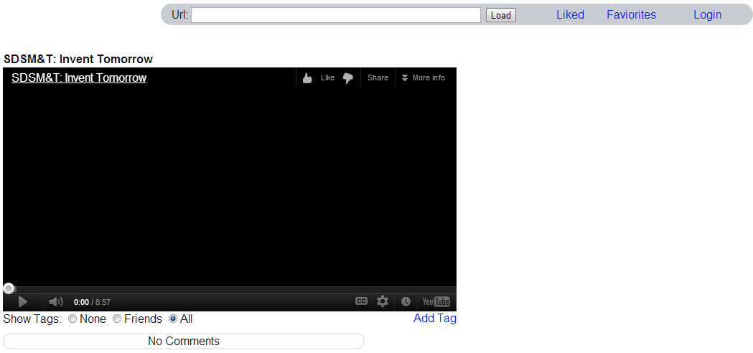

Login dialog:

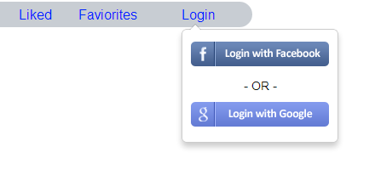

Current Favorites page:

