Garrett Warr

**warrgj@gmail.com | 801-671-3331 | Riverton, Utah**GitHub: https://github.com/Gare-Warr01 |

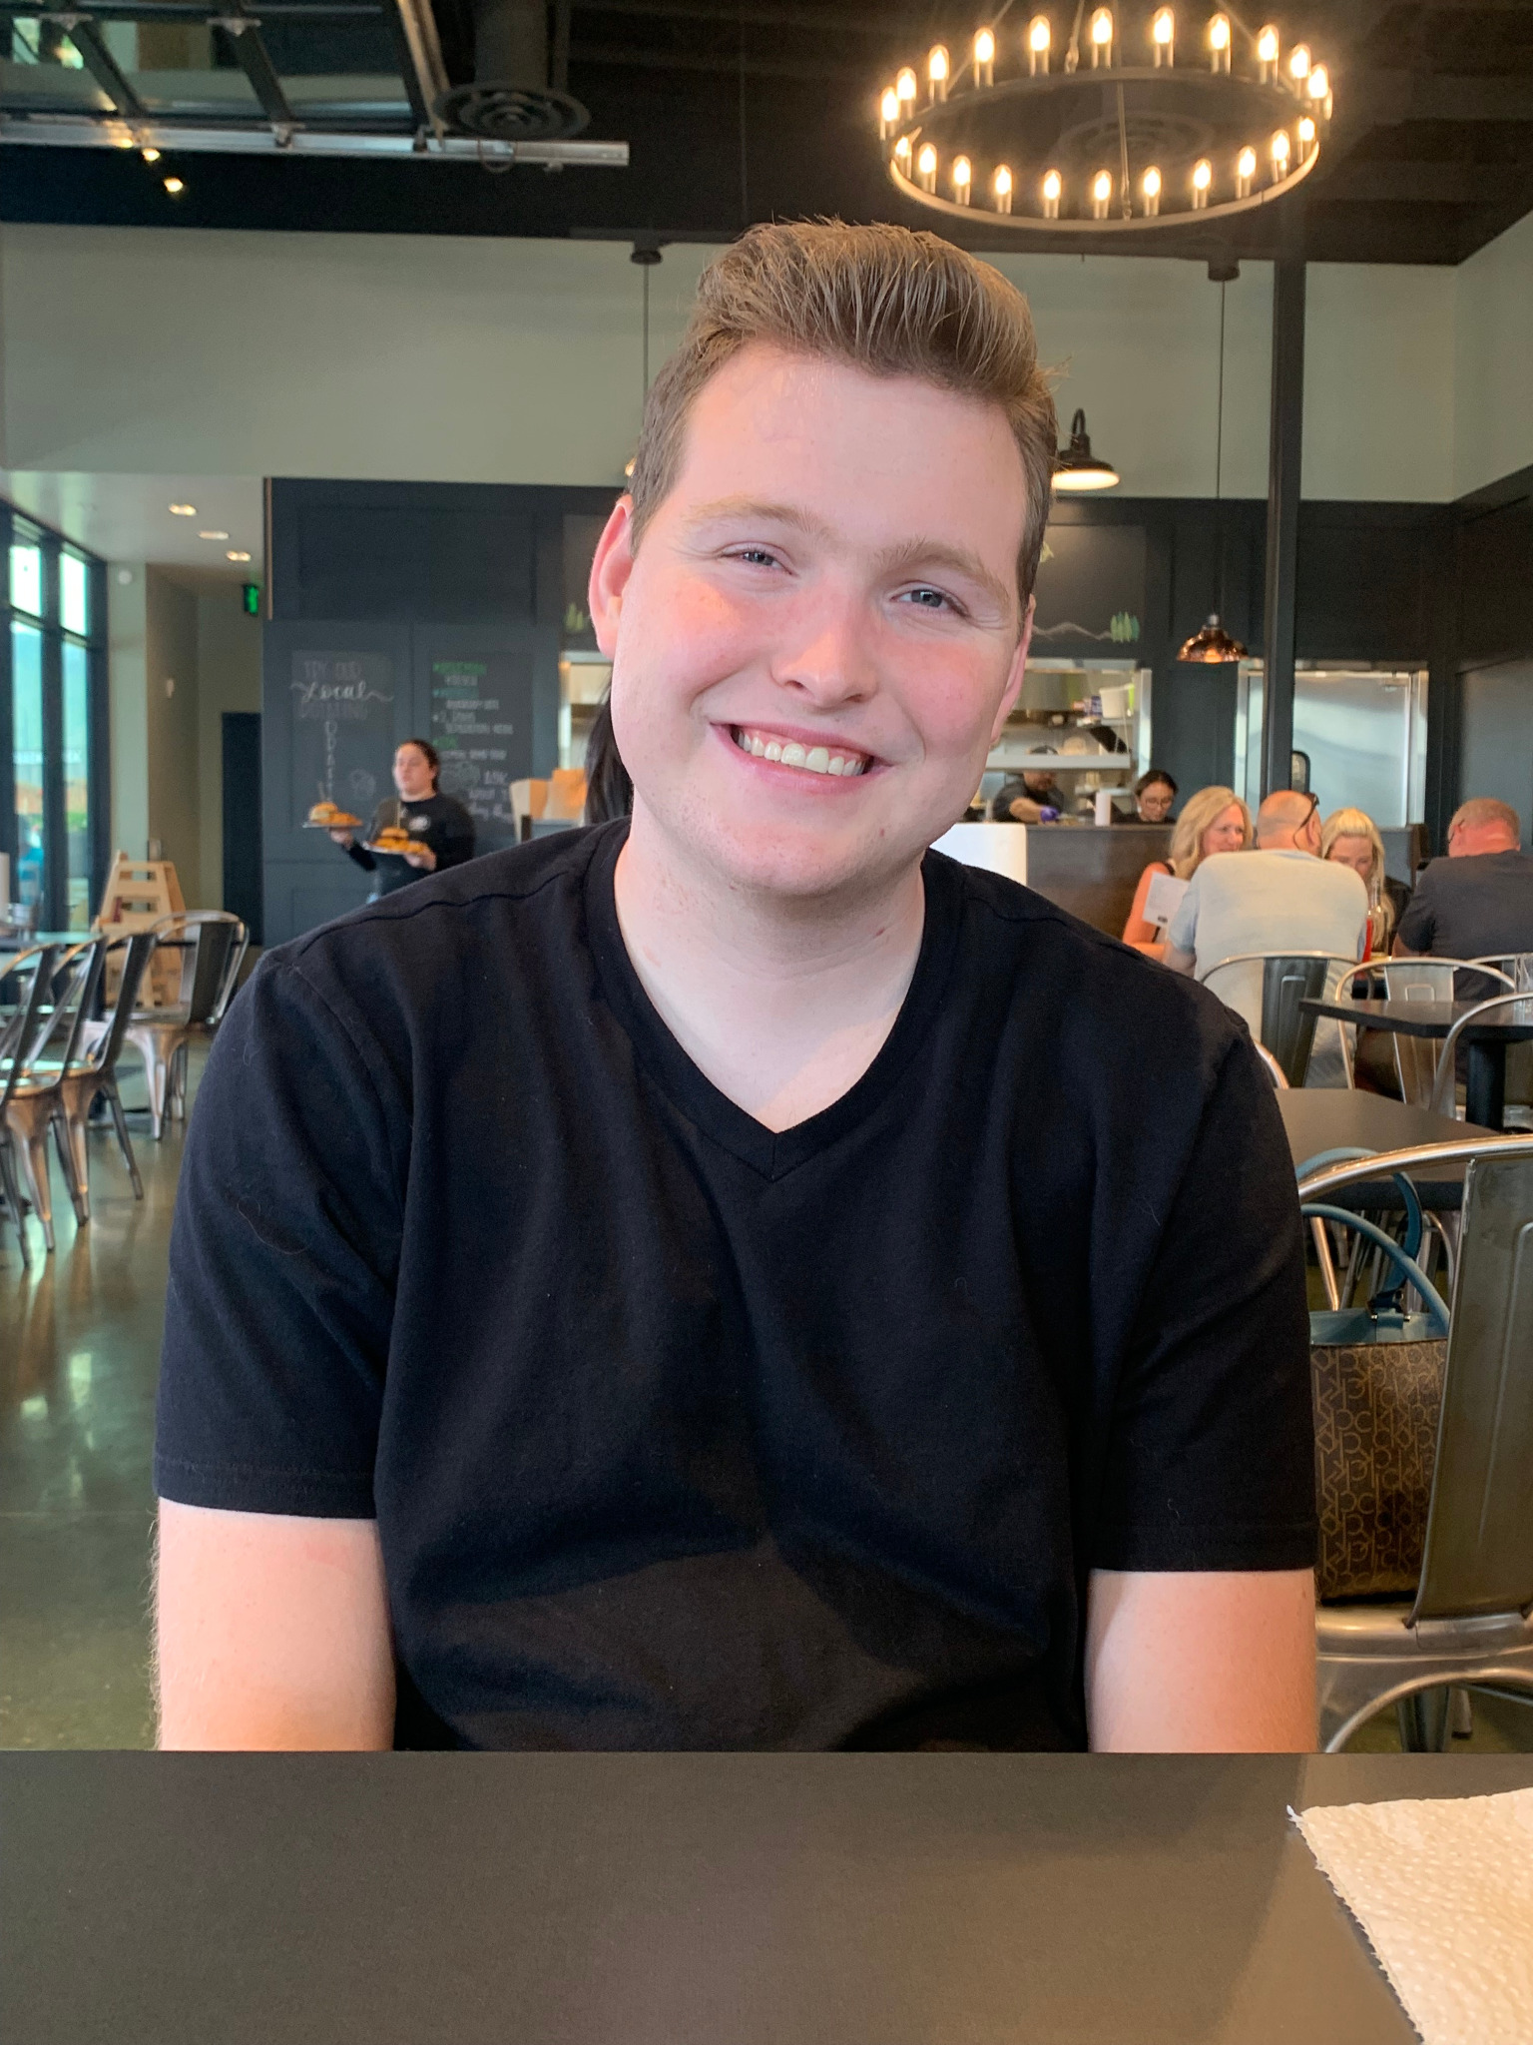

# Professional Summary

Dedicated and detail-oriented biotechnology professional with hands-on experience in laboratory research, data analysis, and experimental design. A hardworking and adaptable team player with over a year of lab experience, skilled in laboratory protocols, data collection, and interpretation. Committed to accuracy, efficiency, and delivering meaningful research results.

# Education

**Bachelor of Science in Biotechnology**  
Utah Valley University – Expected December 2025  
**Associates in Biotechnology and Biology**  
Salt Lake Community College – Completed May 2023 & December 2024

# Laboratory Experience

**Lab Analyst**  
Nelson Labs, Taylorsville, Utah | May 2023 – August 2024  
- Conducted routine and specialized laboratory analyses, ensuring accuracy and compliance.  
- Assisted in writing and refining laboratory protocols.  
- Maintained laboratory equipment and collaborated with team members to troubleshoot.

# Research Experience

**Independent Researcher**  
Salt Lake Community College | May 2024 – December 2024  
- Designed and executed an independent research project.  
- Collected, analyzed, and interpreted experimental data.  
- Developed proficiency in various laboratory techniques and documented findings.

# Key Skills

• Laboratory Analysis & Data Interpretation  
• Protocol Development & Documentation  
• Research Design & Execution  
• Attention to Detail & Accuracy  
• Teamwork & Communication  
• Adaptability in Laboratory Settings