

EDUCATION SYSTEM AND LEARNING HABITS NOW DAYS

KUNAL MALHOTRA

Computer Science and Big Data Analytics Student, GNA University, Punjab, India.

Author. Tel.: +91 9877769078; Email: Kunal9988243618@gmail.com.

ABSTRACT:This study examined the effects of the COVID-19 outbreak on Education systems and the learning habits of individuals, with the help of quantitative research for different people’s opinions on social media platforms for their online education. We begin with sentiment analysis on twitter tweets data with natural language processing and analyze what are their opinions on social meeting applications for their online learning or training process positive, negative, and neutral by any online sentiment analysis model. Then next we perform context word count analysis to find the popularity between the various social meeting applications with the same twitter tweets data as we used for sentiment analysis. And us to visualize the results in a report to understand what the trends of social meeting applications towards nowadays education system are and learning habits of peoples.

INTRODUCTION:This report helps to show which online social meeting applications are used or reviewed by peoples during COVID-19[1]. And how new E-learning platforms are growing with the usage of online meeting applications by students, employees and, researchers to interact with each other, or gain knowledge. As because of lockdown in many countries due to COVID-19[1] usage of social meeting apps or E-learning apps are increasing exponentially. And therefore, here we analyze what are their opinions about online social meeting apps, which are the most engaged online social meeting platforms and weather peoples are satisfied or dissatisfied with services that they get by sentiment analysis[12]. For which we are using some online tools[14] and services. And then we do context word count analysis to measure the popularity of online social meeting applications among the population.

SOURCE OF DATA:The behavior of populations on online meetings and E-learning platform applications is collected by analyzing different social media applications like Twitter, Facebook, and LinkedIn. In this paper, we focus on twitter data analysis in which we analyze the different text data which were given by twitter as a tweet[2]. This tweet, provided by twitter can be treated as feedback or opinion which can be negative, positive, and neutral by an individual or say as the sentiment.

## DESIGN OF THE STUDY:

Data Type: Tweets[2] (Text, Paragraphs, and Numbers).

## **Data Collection:** The data for Analysis can be download from twitter Developers Console[4]. By providing twitter developer credentials for authorization.

Data Preprocessing: After data collection for analysis. Our data require text data preprocessing[8] because it contains many unwanted data or texts which include links, stickers, and characters that affect our analysis to obtain useful insights.

ANALYSIS OF DATA: As said above we are using quantitative research[5]. First, we perform sentiment analysis with natural language processing on our twitter tweets dataset. and this requires an online pre-built sentiment analysis model. Here we used a model which is provided by MonkeyLearn[15] and perform or sentiment analysis. And then begin with the context word count analysis as shown in steps in figure.1 below. Where we performed our data analysis with some statistic languages (R[10] and Python[11]).

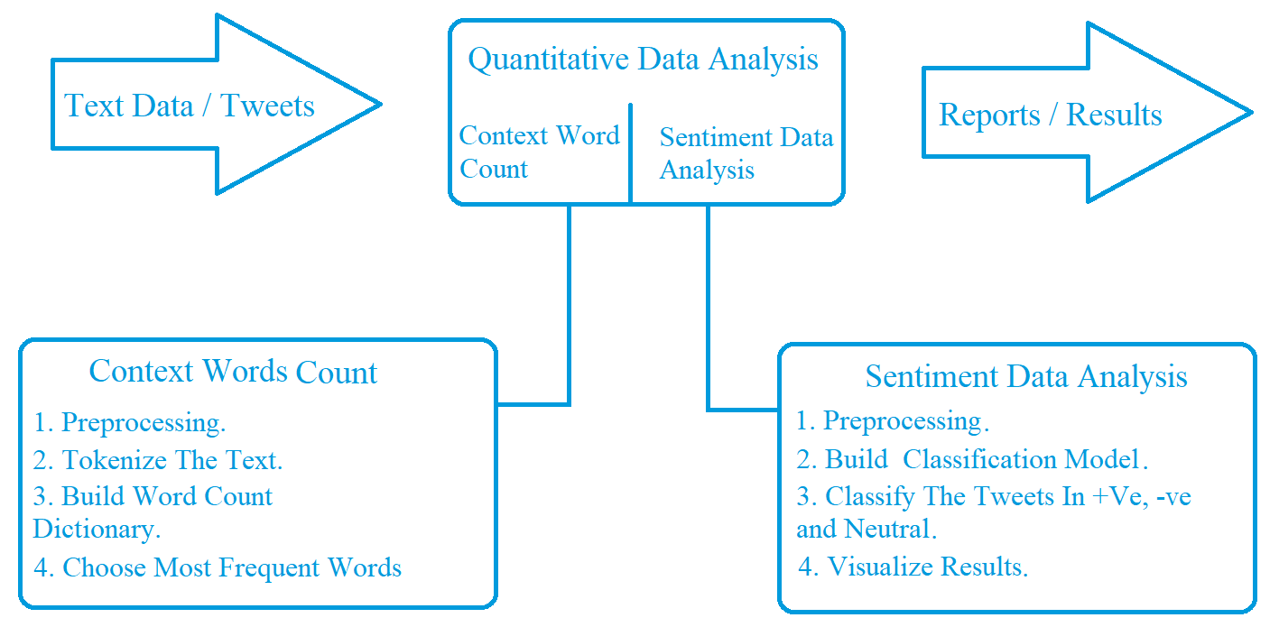

## Figure: 1

CONCLUSIONS:Students, employees, and organizations are very heavenly effected by COVID-19 in terms of training, education, and learning new skills. People are widely using mobile social meeting applications to interact with each other. However, by the study of context word count analysis of text or tweets data we reach on a result that people are ore more attracted to Zoom [6] and Hangout [7] for their online meetings as shown in Figure.2 and Figure.3. On the other hand, and by sentiment analysis on our text or tweets data we can say that Zoom has more positive popularity than any other online social meeting applications like hangout as shown in Figure.5 and Figure.4.

Context Word Count Analysis:

## Figure: 2

## Figure: 3

Sentiment Analysis:

## Figure: 4

## Figure: 5

## SOME WORD CLOUD FOR DIFFERENT #TAGS

## #Hangout #Online classes

## 

## #Online learning #Zoom

## 

## #Lockdown #Virtual internship

## 

## APPENDIX:

## WORDS COUNTS ON DIFFERENT #TAGS ON TWITTER

## 

## Figure: 6

## Figure: 7

## REFERENCES:

[1] COVID-19. From <https://en.wikipedia.org/wiki/Coronavirus_disease_2019>

[2] Twitter. From <https://en.wikipedia.org/wiki/Twitter>

[3] F. Heimerl, S. Lohmann, S. Lange, and T. Ertl, "Word Cloud Explorer: Text Analytics Based on Word Clouds," 2014 47th Hawaii International Conference on System Sciences, Waikoloa, HI, 2014, pp. 1833-1842, doi: 10.1109/HICSS.2014.231.

[4] Twitter Data for Research. From <https://developer.twitter.com/en/use-cases/academic-researchers>

[5] Quantitative Research. From <https://www.journal-publishing.com/blog/example-quantitative-research-paper/>

[6] Zoom app. From <https://zoom.us/support/down4j?from=launch&u=zoomus%3A%2F%2Fzoom.us%2Fjoin>

[7] Google Hangout. From <https://apps.google.com/meet/?utm_source=google&utm_medium=cpc&utm_campaign=1008070-googlemeet-apac-in-en-bkws-exact-regular&utm_content=utm_content=text-ad-none-none-DEV_c-CRE_435105143937-ADGP_Hybrid+%7C+AW+SEM+%7C+BKWS+~+EXA+%7C+Meet+%7C+%5BM:1%5D+%7C+EN+%7C+Meet-KWID_43700053720690246-kwd-293231125089-userloc_1007802-network_g&utm_term=KW_google%20hangouts%20meet&gclid=CjwKCAjwk6P2BRAIEiwAfVJ0rH1pFR13a4f9O8TY8-wM-5voelSnkSlsey014cFjMJlVFMvlEE35iRoCc28QAvD_BwE&gclsrc=aw.ds>

[8] Gurusamy, Vairaprakash & Kannan, Subbu. (2014). Preprocessing Techniques for Text Mining.

[9] Jupyter Notebook. From <https://en.wikipedia.org/wiki/Project_Jupyter>

[10] R Programming. From <https://en.wikipedia.org/wiki/R_(programming_language)>

[11] Python Programming. From <https://en.wikipedia.org/wiki/Python_(programming_language)>

[12] Alsaeedi, Abdullah & Khan, Mohammad. (2019). A Study on Sentiment Analysis Techniques of Twitter Data. International Journal of Advanced Computer Science and Applications. 10. 361-374. 10.14569/IJACSA.2019.0100248.

[13] A. Gelbukh, "Natural language processing," Fifth International Conference on Hybrid Intelligent Systems (HIS'05), Rio de Janeiro, Brazil, 2005, pp. 1 pp.-, doi: 10.1109/ICHIS.2005.79.

[14] <https://monkeylearn.com/blog/sentiment-analysis-tools/#lexalytics>

[15] <https://monkeylearn.com/sentiment-analysis-online/>