Garen Xade Ponsica BSIT – 2B

Github Username: Garensaid

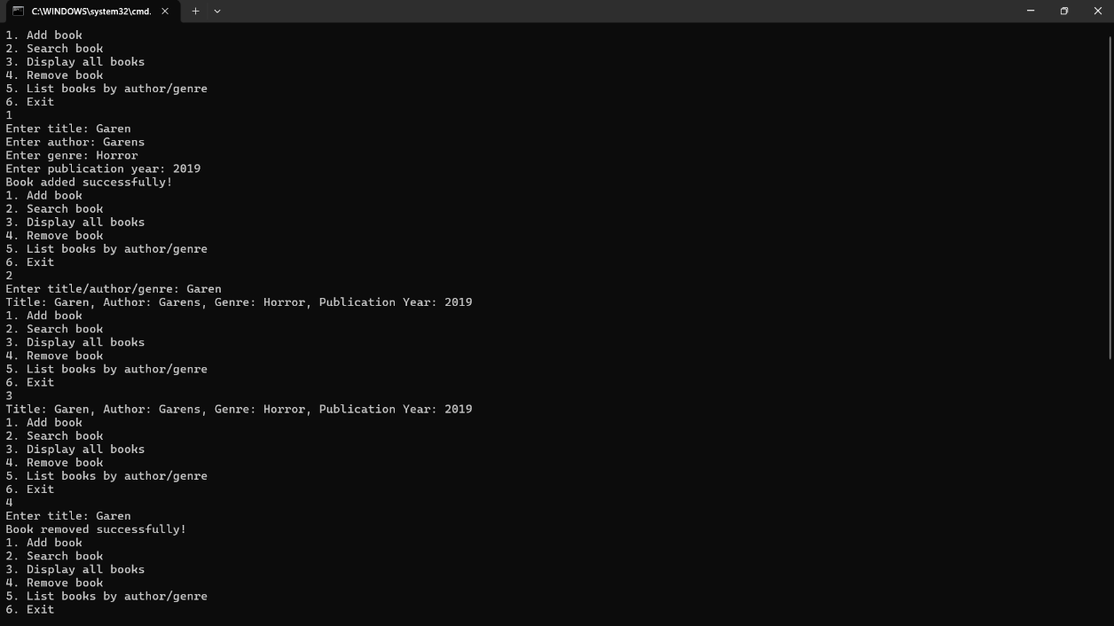Example of the console application:

**Library Management System** (LMS) is a console-based Java application designed to efficiently manage library book catalogs. It utilizes a graph data structure to represent book relationships and a hash table for fast data retrieval.

1. Add books with title, author, genre, and publication year.

2. Remove books from the catalog.

3. Search books by title, author, or genre.

4. Display all books in the catalog.

5. List books by author or genre.

**Why I Created the Library Management System**

To provide a basic library management tool for small libraries, personal book collections, or educational institutions.

A cost-effective solution for libraries or individuals.

**Personal Benefits**

Improved Coding Skills: Enhanced Java programming expertise.