Garen Xade Ponsica BSIT – 2B

Github Username: Garensaid

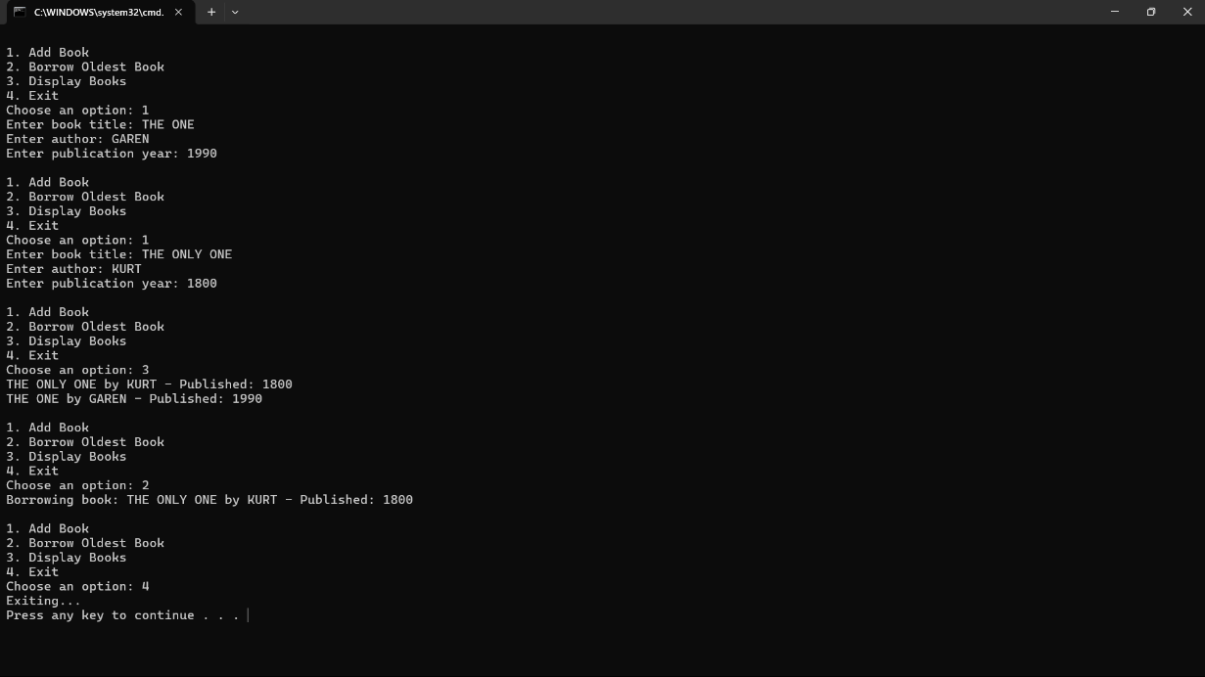Example of the console application:

**Library Book Management System**

This Java console application utilizes a heap structure to manage a library's book collection. It simulates a library's book management system, prioritizing books by publication year.

**Functionality**

1. Add Book: Adds books with title, author, and publication year.

2. Borrow Oldest Book: Removes and displays the oldest book.

3. Display Books: Lists all books with publication years.

4. Search Book: Searches by title or author.

5. Exit: Terminates the application.

**Why I Made This Application**

I created this application to: Demonstrate heap structure usage in real-world scenarios. Develop problem-solving skills in data structures and algorithms. Provide a simple, intuitive library management system.

**Contribution to Community**

This application contributes to the community by: Offering an open-source library management system. Serving as an educational resource for heap structure implementation. Providing a basic template for larger library management systems.