Gareth Harcombe – 33186156

Scene Description
The scene contains a steam train following a train track with many twists and turns. Starting at the station, the train begins to speed up, passing under a tunnel and over two road-track intersections. The train has right of way at these intersections, and any cars traveling on this one way road must stop as they are blocked by barrier arms. Traffic lights also notify cars as to when they are allowed to cross. The train then slows down as it approaches the station again, before stopping completely for a few seconds. It then begins the loop again.

Extra Features
Several changes were made to the train. The majority of the train has been textured: the wagon containers textured as shipping containers; the engine textured to appear metallic with rivets and reinforcement strips of metal; the wheels textured to appear like a generic wheel. The wheels also rotate as the train moves around the track. The front of the train has a red track guard which typical of steam trains. The engine is equipped with a smoke chimney complete with smoke particles. These smoke particles are not tied to the engine; they are emitted and then follow their own path irrespective of the train’s velocity or position. The smoke also interacts with other objects in the scene such as the tunnel. Wagon payloads include both shipping containers and stacks of logs. There is a red tail light at the end of the train which flashes every second.

A car moves around a circular road. If the train comes near, the traffic lights will turn red and the barrier arms will move down. If the car approaches a red light, it will stop and wait for the train to pass, the barrier arm to rise and the lights to turn green before continuing.

The train track follows the path pictured below. This curve is described as the piece wise parametric curve described below. This curve is then sampled at regular intervals using an external program to produce a text file of (x, z) coordinates. The tracks and sleepers are assembled using these points through the trigonometric method described in class.
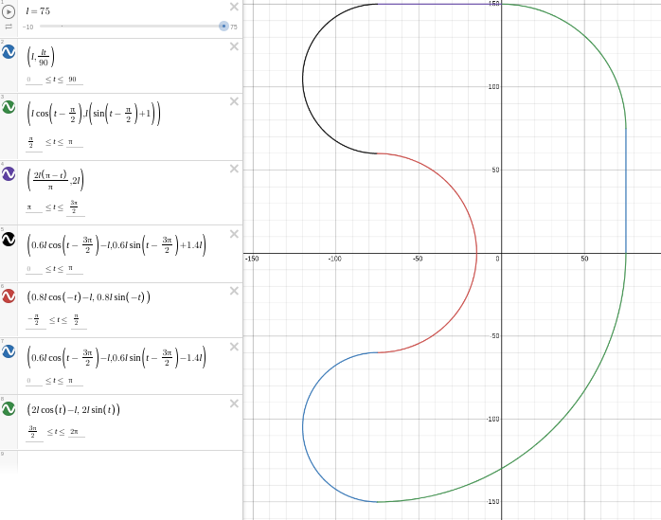

Controls
‘c’: Move between view options

Whilst in the default camera mode, the following keys can be used to control the camera:
Up arrow: Move camera forward in the current direction
Down arrow: Move camera backward in the current direction
Left arrow: Change the current direction towards left by a certain angle
Right arrow: Change the current direction towards right by a certain angle
Page-up: Increase camera height
Page-down: Decrease camera height

Instructions
Unzip the .zip file and navigate into the appropriate directory. Run the following commands to compile and run the program:
$ g++ RailModels.cpp RailwayWorld.cpp -o TrainWorld -lm -lGL -lGLU -lglut
$ ./TrainWorld

References
Textures:

Wheel texture: https://previews.123rf.com/images/metelevan/metelevan1810/metelevan181000226/112457096-wood-log-end-cut-annual-rings-and-cracks-running-from-the-center-abstract-texture-poplar-background.jpg
Shipping container texture: https://www.textures.com/download/MetalContainers0128/31224
Engine front texture: https://cdn1.vectorstock.com/i/1000x1000/63/30/cartoon-steam-train-vector-26576330.jpg
Engine texture: https://media.istockphoto.com/vectors/dark-metal-background-with-rivets-vector-id1175740249?k=20&m=1175740249&s=612x612&w=0&h=qr-cAE4taFxUG1iNPydx1b7M9Rl2RqKlNBXAbDqO_bA=
Tree end texture: https://www.google.com/url?sa=i&url=https%3A%2F%2Fmarketplace.secondlife.com%2Fp%2Ftree-rings-wood-end-textures%2F5001106&psig=AOvVaw0Otwj3wLBapy0Z3WhlgTey&ust=1647928371118000&source=images&cd=vfe&ved=0CAsQjRxqFwoTCOjuwLLC1vYCFQAAAAAdAAAAABAD
Tree texture: https://i.pinimg.com/originals/74/3b/d9/743bd9c15436ad5560e72c1b71fa298d.jpg
Brick texture: https://data2.polantis.com/image1000/data/699/24617/Brick%20Texture%2086_3D_p.png
Red and white stripes texture: https://media.istockphoto.com/vectors/patriotic-wallpaper-red-and-white-stripes-pattern-vector-american-vector-id1013587598?k=20&m=1013587598&s=612x612&w=0&h=9vbULjiYi3kgfrP5DP9cES_S0cyqQlidRSIbBxhNPwo=
Roof texture: https://www.goodtextures.com/cache/5f1afd3c/avb45ac1c4d70766a19e7.jpg

