Gareth Warren
Pet Registration Database

Completed: 5/5/2021
Database Systems CIT230-Z02

NARRATIVE OF THE PURPOSE OF THE CREATED DATABASE

Database Created: PetRegistrationDatabase.mdf
This project was created in Microsoft SQL Management Studio 2017

This database will serve as a backend data store for an app I am creating. The app aims to crowdsource the process of locating, and reuniting people with their lost pets. Users will be able to post profiles of their lost animals, and view listings of animals that are currently missing. If someone finds an animal, they will be able to use the app to contact the owner of the animal. Animal shelters will also be able to use the app to post profiles of resident animals, and cross reference those with existing records, in an effort to find their owners before placing them up for adoption. Right now, the most common method of notifying the public that an animal is missing is by utilizing localized Lost Pet signs. However, animals, especially dogs, are known for traveling very far. The app will extend the effective search area, by using location data from multiple cities. Also, users will be able to mark their pets as returned, so that people will know the search was successful. Although outside of the scope of this project, the final app will feature image processing AI to identify individual animals in an effort to enhance the chances they will be returned to the appropriate user.

List of Tables:

dbo.PERSONS
dbo.PETS
dbo.LOCATIONS
dbo.SHELTERS

Pet Dependency Tables:
dbo.SPECIES
dbo.PET_TYPES
dbo.BREEDS
dbo.COLORS
dbo.PATTERNS

Shelter Dependency Tables:
dbo.SHELTER_PHONE_NUMS
dbo.SHELTER_EMAIL_ADDS

A LISTING OF ALL OF THE DATABASE TABLE STRUCTURES

Persons
This table contains records of People, their address listing, an email address, and a phone number. The Phone field can accept nulls, because phone numbers will not be required to create an account on the app, but an email address will be required. The table includes a reference to the LocationId of the city, state, and zip, that the person's address is in. The first data listing is Unknown, so that Shelters can list animals that are surrendered to them as strays with no ownership information. Email validation will be done using a user defined function.

--Persons Table
CREATE TABLE PERSONS(
PersonId INT NOT NULL IDENTITY(1,1),
FirstName NVARCHAR(50) NOT NULL,
LastName NVARCHAR(50) NOT NULL,
StreetAddress NVARCHAR(200) NOT NULL,
Phone CHAR(13) NULL,
--Email Checks keep failing, create user function to validate email
Email NVARCHAR(200) NOT NULL,
FKPersonLocation INT NOT NULL,

CONSTRAINT PersonId PRIMARY KEY(PersonId),
CONSTRAINT FK_Person_Location FOREIGN KEY(FKPersonLocation) REFERENCES LOCATIONS(LocationId)
);
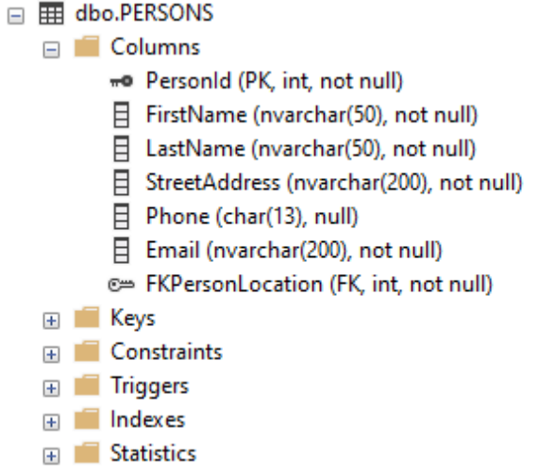

Pets
This table contains Pet records. A Pet record requires a reference to a Person record, making Pet records children of their Person record. Individual records must contain references to their species (FKPetSpecies to SpeciesName), pet type (FKPetType to Pet_Type, for example 'farm' vs 'dog or cat'), breed (FKPetBreed to Breed, if applicable), coat color (FKPetColor to Color), and coat pattern (FKPetPattern to Pattern), and have a PetId associated with them. Everything else is not required, though highly recommended. DateLost is the date the pet went missing. DateFound is the date the pet was found, if it has been returned to its owner. IsSpayNeuter identifies whether the pet has been fixed (1, true), or has not been fixed (0, false). Gender determines whether pet is Male, or Female, which is enforced through a check constraint. Unique Features, though a problematic “description” field, can be extremely helpful to determine the differences between similar looking animals. FKPetLocation references the LocationId of where the pet was last seen. If the pet is at an animal shelter, FKPetShelter references the ShelterId of that shelter. A constraint checks whether DateFound comes later than DateLost, and that all dates fall after the first day of the Year 2000.

--Pets Table to hold records of lost pets
CREATE TABLE PETS(
--A Basic Pet Record would require the things labeled Not Null
PetId INT NOT NULL IDENTITY(1,1),
PetName NVARCHAR(50) NOT NULL,
DateLost DATE NULL,
DateFound DATE NULL,
UniqueFeatures NVARCHAR(MAX) NULL,
IsSpayNeuter BIT NULL,
Gender VARCHAR(6) NULL CHECK (Gender = 'Male' OR Gender ='Female'),
FKPetPerson INT NOT NULL,
FKPetLocation INT NULL, --Not all lost pet records necessarily would have complete information about where they were last seen
FKPetSpecies VARCHAR(50) NOT NULL,
FKPet_PetType VARCHAR(50) NOT NULL,
FKPetBreed NVARCHAR(50) NULL, --Breed May Not be required, dependent on Species
FKPetColor VARCHAR(50) NOT NULL,
FKPetPattern VARCHAR(50) NOT NULL,
FKPetShelter INT NULL

CONSTRAINT PetId PRIMARY KEY(PetId),

CONSTRAINT FK_Pet_Location FOREIGN KEY(FKPetLocation) REFERENCES LOCATIONS(LocationId),
CONSTRAINT FK_Pet_Species FOREIGN KEY(FKPetSpecies) REFERENCES SPECIES(SpeciesName),
CONSTRAINT FK_Pet_PetType FOREIGN KEY(FKPet_PetType) REFERENCES PET_TYPES(PetType),
CONSTRAINT FK_Pet_Breed FOREIGN KEY(FKPetBreed) REFERENCES BREEDS(Breed),
CONSTRAINT FK_Pet_Color FOREIGN KEY(FKPetColor) REFERENCES COLORS(Color),
CONSTRAINT FK_Pet_Pattern FOREIGN KEY(FKPetPattern) REFERENCES PATTERNS(Pattern),
CONSTRAINT FK_Shelter_Pet FOREIGN KEY(FKShelterPet) REFERENCES SHELTERS(ShelterId),
--Updates to Person should cascade to Pets associated with that record
CONSTRAINT FK_Pet_Person FOREIGN KEY(FKPetPerson) REFERENCES PERSONS(PersonId)
ON UPDATE CASCADE
ON DELETE CASCADE
CONSTRAINT check_date CHECK(DateFound > DateLost AND DateLost >= '01-01-2000')
);
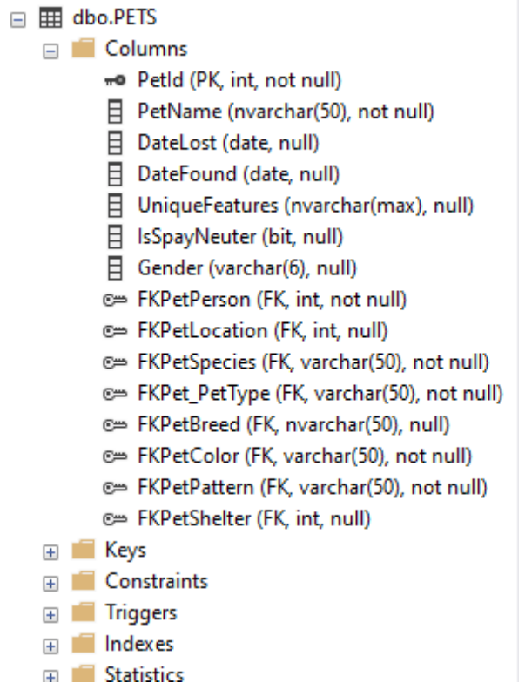

Locations
This table contains records for cities within the USA, and includes a LocationId, a City field for the city name, a US_State field for the state the city belongs to, and a Zip field for the zipcode. Zip values must be five digits long. This may be changed to allow for globalized records, if the app is successful.

--Pet and Person reference Location, however, Pet and Person locations do not have to match
CREATE TABLE LOCATIONS(
LocationId INT NOT NULL IDENTITY(1,1),
City VARCHAR(50) NOT NULL,
US_State VARCHAR(15) NOT NULL,
Zip CHAR(5) NOT NULL CHECK(Zip LIKE '[0-9][0-9][0-9][0-9][0-9]'),

CONSTRAINT LocationID PRIMARY KEY(LocationID)
);
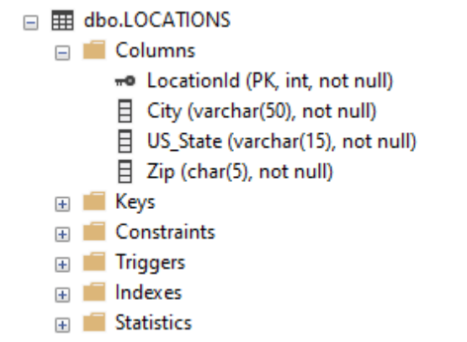
Shelters
This table contains some basic information for various animal shelters. The table contains a ShelterId, a ShelterName field for the shelter's name, and a reference to the LocationId of the Locations table where the shelter is found at.

--Animal Shelter Table
CREATE TABLE SHELTERS(
ShelterId INT NOT NULL IDENTITY(1,1),
ShelterName NVARCHAR(200) NOT NULL,
FKShelterLocation INT NOT NULL,

CONSTRAINT ShelterId PRIMARY KEY(ShelterId),
CONSTRAINT FK_Shelter_Location FOREIGN KEY(FKShelterLocation) REFERENCES LOCATIONS(LocationId)

);

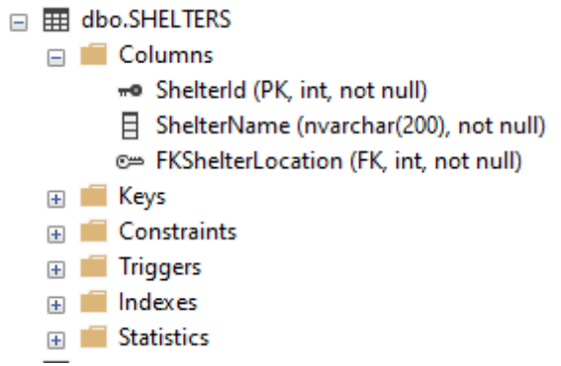

Pet Dependency Tables:
Species
Species table contains a single column that is its own primary key to hold a listing of animal species.
CREATE TABLE SPECIES(
SpeciesName VARCHAR(50) NOT NULL,
CONSTRAINT SpeciesPK PRIMARY KEY(SpeciesName)
);
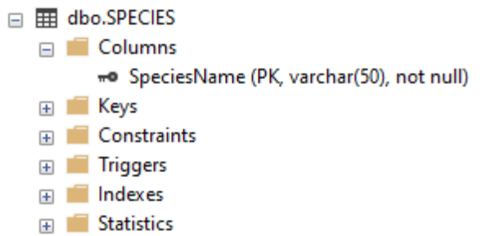

Pet_Types
Pet_Types table contains a single column that is its own primary key to hold a listing of Pet Types (“Farm” vs “Dog or Cat”, vs “Small Animal”, vs “Reptile” etc).
CREATE TABLE PET_TYPES(
PetType VARCHAR(50) NOT NULL,
CONSTRAINT PetTypePK PRIMARY KEY(PetType)
);
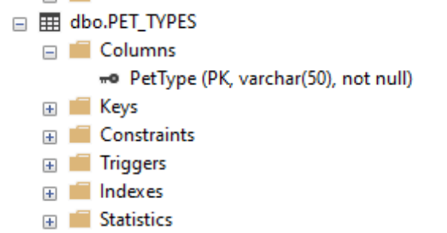
Breeds
Breeds table contains a single column that is its own primary key to hold a listing of domestic animal breeds.
CREATE TABLE BREEDS(
Breed NVARCHAR(50) NOT NULL,
CONSTRAINT BreedPK PRIMARY KEY(Breed),
);

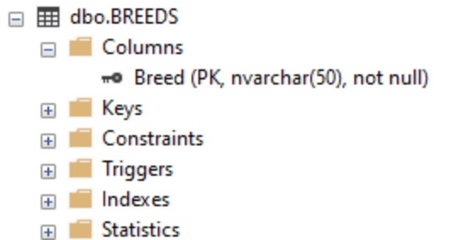
Colors
Colors table contains a single column that is its own primary key to hold a listing of animal coat colors.
CREATE TABLE COLORS(
Color VARCHAR(50) NOT NULL,
CONSTRAINT ColorPK PRIMARY KEY(Color)
);
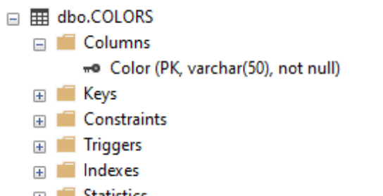

Patterns
Patterns table contains a single column that is its own primary key to hold a listing of animal coat patterns.

CREATE TABLE PATTERNS(
Pattern VARCHAR(50) NOT NULL,
CONSTRAINT PatternPK PRIMARY KEY(Pattern)
);
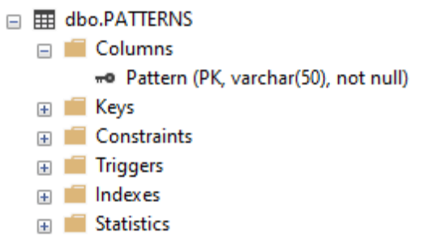

Shelter Dependency Tables:
Shelter_Email_Adds
Shelter Email Adds table contains email addresses for various animal shelters, in case shelters want to use multiple email addresses. It contains an EmailId, ShelterEmail field which holds an email address and a reference to the ShelterId it is linked to. Validation of email address will be done using a user defined function. When Shelter records are deleted, records in Shelter_Email_Adds associated with the ShelterId will be deleted.

CREATE TABLE SHELTER_EMAIL_ADDS(
EmailId INT NOT NULL IDENTITY(1,1),
ShelterEmail NVARCHAR(200) NOT NULL,
FKEmailShelter INT NOT NULL,

CONSTRAINT EmailId PRIMARY KEY(EmailId),
CONSTRAINT FK_Email_Shelter FOREIGN KEY(FKEmailShelter) REFERENCES SHELTERS(ShelterId)
ON UPDATE CASCADE
ON DELETE CASCADE
) ;
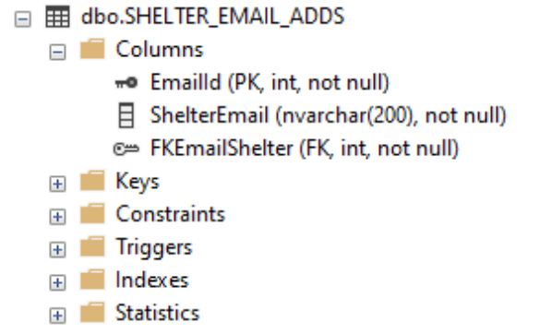

Shelter_Phone_Nums
Shelter Phone Nums table contains phone numbers for various animal shelters, in case shelters want to use multiple phone numbers. It contains a PhoneId, ShelterPhone field to hold the phone numbers, and a reference to the ShelterId it is linked to. Validation of phone numbers will be done using a user defined function. When Shelter records are deleted, records in Shelter_Phone_Nums associated with the ShelterId will be deleted.

CREATE TABLE SHELTER_PHONE_NUMS(
PhoneId INT NOT NULL IDENTITY(1,1),
ShelterPhone CHAR(13) NOT NULL,
FKPhoneShelter INT NOT NULL,

CONSTRAINT PhoneId PRIMARY KEY(PhoneId),
CONSTRAINT FK_Phone_Shelter FOREIGN KEY(FKPhoneShelter) REFERENCES SHELTERS(ShelterId)
ON UPDATE CASCADE ON DELETE CASCADE
)

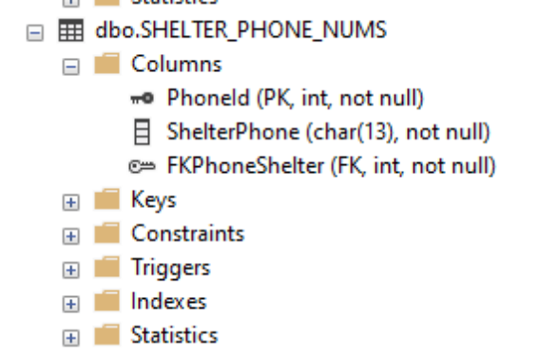

A LISTING OF THE DATABASE DIAGRAM
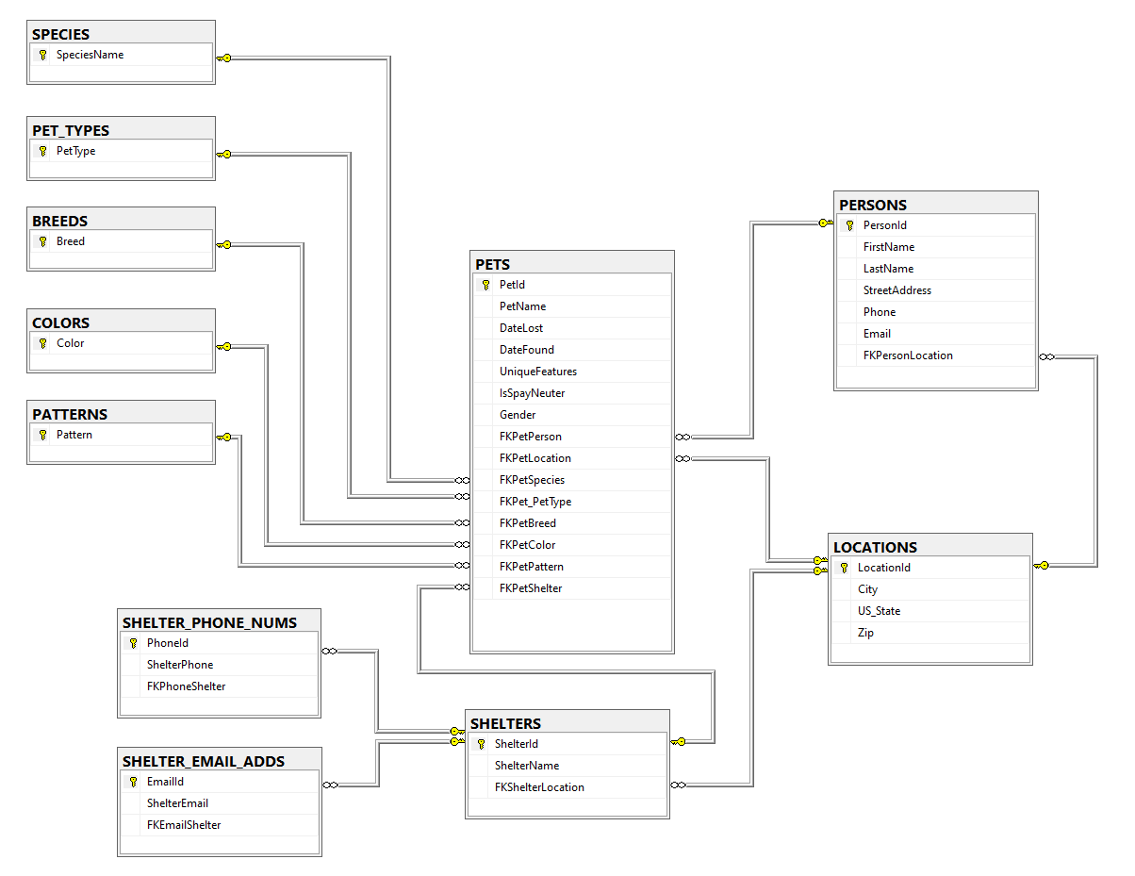

Persons to Pets is a one-to-many relationship where one person can have many pets.
Shelters to Pets is a one-to-many relationship where one shelter can house many pets.
Shelters has a one-to-many relationship to Shelter_Phone_Nums, and Shelter_Email_Adds, because a shelter can have many email addresses, and phone numbers.

Persons, Pets, and Shelters to Location are all one-to-one relationships, because it is impossible for either entity to exist in more than one location at a time.

Species, PetTypes, Breeds, Colors, and Patterns to Pet are one-to-one relationships. A pet can only have one value for each attribute, and Breeds includes a 'Mixed/Other' value for pets whose breed is unidentifiable, as in the case of “mutt” dogs.

A LISTING OF ALL OF THE DATA CONTAINED IN EACH TABLE

Identity Insert was used to explicitly determine Primary key values for example records.

Persons:
--Persons Table
--Unknown Value, for Pet Profiles posted by Shelters
SET IDENTITY_INSERT dbo.PERSONS ON
INSERT INTO dbo.PERSONS (PersonId, FirstName, LastName, Email, StreetAddress, Phone, FKPersonLocation)
VALUES
(1, 'Unknown','Unknown','Unknown','Unknown','Unknown',1),
(2, 'Bob','JimBob','BasicGuy@Ihuntthings.com','123 Street Street','(345)435-3453', 2),
(3, 'Guy','Handsome','AnotherBasicDude@FancierWebsite.com','456 Dewey','(567)986-4354', 3),
(4, 'Matt','Matterson', 'ILikeTouchingThings@ThingsToTouch.com','776 7th ct','(234)676-9890', 4),
(5, 'Stacy','AnnHopkins','MyNameIsNotStacy@WebsiteHere.com','234 Road Rd','(432)444-4444',5),
(6, 'Gordon', 'Freeman', 'StuckInCity17@GetMeOutOfHere.com', '2200 Sunport Blvd SE', '(222)222-2222', 9),
(7, 'Shepherd','Commander','SpectreForHire@SavingTheGalaxy.org','001 Normandy', '(111)111-1111',4),
(8, 'Garrus','Vakarian','TuriansAreAwesome@Archangel.net', '44 Palavan Ln', '000-000-0000', 4)
SET IDENTITY_INSERT dbo.PERSONS OFF

Pets:
--Pets Table
SET IDENTITY_INSERT dbo.PETS ON
--Basic Pet Records, with only required information
INSERT INTO PETS(PetId, PetName, FKPetSpecies, FKPet_PetType, FKPetBreed, FKPetColor, FKPetPattern, FKPetPerson)
VALUES(1, 'Turtle','Dog','Dog or Cat','Akita','Bicolor:Black/Tan','Standard',2),
(2, 'Dog','Russian Tortoise','Reptile',NULL,'Standard','Wildlife',2),
(3, 'George', 'Cow','Farm','Black Angus', 'Bicolor:Red/White', 'Spotted',5),
(4, 'Micah', 'Dog','Dog or Cat', 'Chihuahua', 'Brown', 'Standard', 4),
(5, 'Buster', 'Chicken', 'Bird', 'Jersey Giant' , 'Melanistic','Solid', 1),
(6, 'Larry','Cat','Dog or Cat','Ocicat','Tricolor:Black/Brown/White', 'Spotted', 6),
(7, 'Tony', 'Tiger', 'Exotic/Wild', NULL, 'Bicolor:Black/Orange','Wildlife',8)

--Basic Pet Records of Pets at Shelters with unknown owner
INSERT INTO PETS(PetId, PetName, FKPetSpecies, FKPet_PetType, FKPetBreed, FKPetColor, FKPetPattern, FKPetPerson, FKShelterPet)
VALUES(8, 'Mittens', 'Dog','Dog or Cat', 'Great Dane','Bicolor:Black/White','Harlequin', 1, 3),
(9, 'Boing', 'Blue Macaw', 'Bird', NULL , 'Standard','Standard', 1, 5),
(10, 'Snowflake','Cat','Dog or Cat','Persian','White', 'Solid', 1,1),
(11, 'Stormageddon','Hamster','Small Animal',NULL,'Bicolor:Black/Tan', 'Piebald', 1,1),
(12, 'Inclement Weather','Horse','Farm','Clydesdale','Bicolor:Brown/White', 'Saddleback', 1,1)

--Full Pet Records of Pets that Are Lost
INSERT INTO PETS(PetId, PetName, FKPetSpecies, FKPet_PetType, FKPetBreed, FKPetColor, FKPetPattern, FKPetPerson, DateLost, IsSpayNeuter, Gender, UniqueFeatures)
VALUES (13, 'Sparky', 'Ball Python', 'Reptile', NULL, 'Green', 'Spotted',7, '2009-04-24',0,'Male', 'Sparky is missing an eye, and has one yellow spot on his back'),
(14, 'Vargas', 'Duck', 'Bird', 'Muskovy', 'Melanistic', 'Solid',1, '2018-10-05', 0,'Female', 'Plumage almost glitters in the sun, and her eyes are red'),
(15, 'Bob', 'Raccoon', 'Exotic/Wild', NULL, 'Tan', 'Wildlife',7, '2006-03-14', 1,'Male', 'Bob is a light colored Raccoon, and is missing the stripes on his tail')

--Full Pet Records of Pets that Have Been Found
INSERT INTO PETS(PetId, PetName, FKPetSpecies, FKPet_PetType, FKPetBreed, FKPetColor, FKPetPattern, FKPetPerson, DateLost, DateFound, IsSpayNeuter, Gender, UniqueFeatures)
VALUES (16, 'Morty', 'Yellow Bellied Slider', 'Reptile', NULL, 'Standard', 'Wildlife', 4, '2007-12-14', '2008-12-14', 1,'Female', 'Morty is missing an arm'),
(17, 'Linda', 'Swan', 'Bird', NULL, 'Red', 'Masked',3, '2017-11-23', '2017-12-04', 1,'Female', 'The red on Linda''s face is darker than on her body, and her tail feathers are curled')
SET IDENTITY_INSERT dbo.PETS OFF

Locations:
--Locations Table
SET IDENTITY_INSERT dbo.LOCATIONS ON
INSERT INTO dbo.LOCATIONS (LocationId, City, US_State, Zip)
VALUES
(1, 'Unknown','Unknown','00000'),
(2, 'Pittsburgh', 'Pennsylvania','15209'),
(3, 'Savannah','Georgia','32345'),
(4, 'Citadel','Terran Alliance', '55555'),
(5, 'Kansas City', 'Missouri', '64001'),
(6, 'Las Angeles', 'California', '90220'),
(7, 'West Palm Beach','Florida', '33414'),
(8, 'Gainesville', 'Florida', '32608'),
(9, 'Wall Township', 'New Jersey', '07027'),
(10, 'New York City', 'New York', '10001'),
(11, 'Redmond', 'Washington','98033'),
(12, 'Portland', 'Oregon', '97221'),
(13, 'Salt Lake City', 'Utah', '84010'),
(14, 'Tucson', 'Arizona', '85701'),
(15, 'Nashville', 'Tennessee','37201')
SET IDENTITY_INSERT dbo.LOCATIONS OFF

Shelters:
--Shelters Table
SET IDENTITY_INSERT dbo.SHELTERS ON
INSERT INTO dbo.SHELTERS(ShelterId, ShelterName, FKShelterLocation)
VALUES (1, 'Animal Friends', 1),
(2, 'Western Pennsylvania Humane Society',1),
(3, 'Hello Bully', 1),
(4, 'Intergalactic Society for the Protection of Animal Sentients', 3),
(5, 'Great Plains ASPCA',4)
SET IDENTITY_INSERT dbo.SHELTERS OFF

Pet Dependency Tables:

Species:
INSERT INTO dbo.SPECIES(SpeciesName)
VALUES ('Dog'),('Cat'),('Hamster'),('Mouse'),('Rat'),('Rabbit'),('Chinchilla'),('Gerbil'),('Guinea Pig'),('Leopard Gecko'),('Crested Gecko'),('Green Anole'),('Bearded Dragon'),('Chinese Water Dragon'),('Iguana'),
('Vieled Chameleon'),('Savannah Monitor'),('Nile Monitor'),('Ball Python'), ('Rat Snake'),('Corn Snake'),('King Snake'), ('Burmese Python'),('Red Eared Slider'),('African Sideneck Turtle'),('Western Painted Turtle'),
('Mississippi Map Turtle'),('Common Musk Turtle'),('Yellow Bellied Slider'),('Eastern Box Turtle'),('Russian Tortoise'),('Leopard Tortoise'),('Indian Star Tortoise'),('Blue Macaw'),('Red Macaw'),('Parakeet'),('Cockatoo'),
('African Gray'),('Cockatiel'),('Parrotlet'),('Ring-Necked Parakeet'),('Amazon Parrot'),('Conure'),('Lovebird'),('Quaker Parakeet'),('Zebra Finch'),('Canary'),('Dove'),('Rock Pigeon'),('Chicken'),('Guinea Fowl'),('Turkey'),('Duck'),
('Goose'),('Swan'),('Pig'),('Cow'),('Horse'),('Goat'),('Donkey'),('Sheep'),('Llama'),('Alpaca'),('Tiger'),('Lion'),('Alligator'), ('Raccoon'), ('Fox'),('Bobcat'),('Wolf'), ('Coyote'),('Bear'),('Cougar'),('Ferret'),('Hedgehog');

Breeds:
INSERT INTO dbo.BREEDS(Breed)
VALUES ('Mixed/Other'),('Abyssinian'),('European Shorthair'),('British Shorthair'),('American Shorthair'),('Oriental Shorthair'),('Oriental Longhair'),('Siamese'),('Peke-Faced Persian'),('Persian'),('Turkish Angora'),
('Turkish Van'),('Maine Coon'),('Norwegian Forest Cat'),('Siberian Forest Cat'),('Russian Blue'),('Longhair'),('Toyger'),('Bengal'),('Egyptian Mau'),('Somali'),('Sphynx'),('Devon Rex'),('Cornish Rex'),('Munchkin'),('Japanese Bobtail'),
('Scottish Fold'),('Scottish Fold Straight Ear'),('American Curl'),('Ocicat'),('Polydactyl'),('La Perm'),('Manx'),('Lykoi'),('Himalayan'),('Burmese'),('Chausie'),('Savannah Cat'),('Ragdoll'),('Ragamuffin'),('Selkirk Rex'),('Singapura'),
('Dalmatian'),('German Shepherd'),('Belgian Tevuren'),('Belgian Malinois'),('Groenendael'),('Laekenois'),('Doberman Pinscher'),('English Sheepdog'),('Newfoundland'),('Saint Bernard'),('Great Dane'),('Irish Wolfhound'),('Finnish Spitz'),
('Norwegian Elkhound'),('Alaskan Husky'),('Siberian Husky'),('Malamute'),('Akita'),('Shiba Inu'),('Chihuahua'),('Pomeranian'),('Saluki'),('Borzoi'),('Afghan Hound'),('Greyhound'),('Boxer'),('American Bulldog'), ('English Bulldog'),
('Pug'), ('English Mastiff'), ('Shar-Pei'),('American Staffordshire Terrier'),('Staffordshire Bull Terrier'),('American Pitbull Terrier'),('Bull Terrier'),('Cardigan Welsh Corgi'),('Pembroke Welsh Corgi'),('Brittany Spaniel'),
('Cavalier King Charles Spaniel'),('English Springer Spaniel'),('English Cocker Spaniel'),('Standard Poodle'),('Miniature Poodle'),('Toy Poodle'),('Miniature Pinscher'),('Portugese Water Dog'),('Puli'),('Labrador Retriever'),('Golden Retriever'),
('Irish Setter'),('Bernese Mountain Dog'),('Anatolian Shepherd'),('Rhodesian Ridgeback'),('Basset Hound'),('Beagle'),('Basenji'),('Bloodhound'),('Coonhound'),('Dachshund'), ('Scottish Deerhound'),('American Foxhound'),('English Foxhound'),
('Great Pyrenees'),('Tibetan Mastiff'),('Samoyed'),('American Eskimo Dog'),('Canadian Eskimo Dog'),('Standard Schauzer'),('Giant Schauzer'),('Miniature Schauzer'),('Rat Terrier'),('Yorkshire Terrier'),('Silkie Terrier'),('Llhasa Apso'),
('Shih Tsu'),('Havanese'),('Tibetan Terrier'),('Pekenese'),('Bichon Frise'),('Maltese'),('Muskovy'),('Mallard'),('Pekin'),('Bantam'),('Silkie'),('Jersey Giant'), ('Leghorn'),('Rhode Island Red'),('Rhode Island White'),('California Gray'),
('Plymouth Rock'),('Americuana'),('Black Angus'),('Hereford'),('Texas Longhorn'),('Red Angus'),('Simmental'),('Holstein'),('Limousin'),('Highlands'),('Mustang'),('Arabian'), ('Clydesdale'),('Thoroughbred'), ('Shetland Pony'), ('Shire'),('Pinto');

Pet_Types:
INSERT INTO dbo.PET_TYPES(PetType)
VALUES ('Dog or Cat'),('Reptile'),('Farm'),('Bird'),('Small Animal'),('Exotic/Wild');

Colors:
INSERT INTO dbo.COLORS
VALUES ('Black'),('Brown'),('Gray'),('Red'),('Orange'),('Tan'),('White'),('Bicolor:Black/Tan'),('Bicolor:Black/Orange'),('Bicolor: Black/Brown'),('Bicolor:Brown/White'),('Bicolor:Black/White'),('Bicolor:Red/White'),('Bicolor:Tan/White'),
('Tricolor:Black/Brown/White') ,('Tricolor:Black/Orange/White'),('Tricolor:Gray/Tan/White')
,('Albino'),('Leucistic'),('Melanistic'),('Green'),('Standard')

Patterns:
INSERT INTO dbo.PATTERNS
VALUES('Solid'),('Standard'),('Brindle'),('Merle'),('Tabby'),('Tortoiseshell'),('Calico'),('Spotted Tabby'),('Marbled Tabby'),('Mottled'),('Spotted'),('Masked'),('Roan'),('Agouti'),('Harlequin'),('Sable'),('Tuxedo'),
('Salt & Pepper'),('Pointed'),('Particolour'),('Irish Spotting'),('Saddleback'),('Piebald'),('White Spotting'),('Wildlife')

Shelter Dependency Tables:

Shelter_Email_Adds:
SET IDENTITY_INSERT dbo.SHELTER_EMAIL_ADDS ON
INSERT INTO dbo.SHELTER_EMAIL_ADDS(EmailId, ShelterEmail, FKEmailShelter)
VALUES(1, 'shelterDirector@aspca.org',5),
(2, 'pitbullsAreBestDog@HelloBully.com',3),
(3, 'alienDogsAreBestDog@NonTerranDogs.com',4),
(4, 'adoptionOffice@wphs.org',2),
(5, 'humaneOfficer@aspca.org',5)
SET IDENTITY_INSERT dbo.SHELTER_EMAIL_ADDS OFF

Shelter_Phone_Nums:
SET IDENTITY_INSERT dbo.SHELTER_PHONE_NUMS ON
INSERT INTO dbo.SHELTER_PHONE_NUMS(PhoneId, ShelterPhone, FKPhoneShelter)
VALUES(1, '(412)123-4444',1),
(2, '(412)321-4567',1),
(3, '(999)999-9999',4),
(4, '(456)728-0000',2),
(5, '(709)777-6666',5)
SET IDENTITY_INSERT dbo.SHELTER_PHONE_NUMS OFF

LISTING OF FOUR SQL SELECT STATEMENTS FROM TWO OR MORE OF THE TABLES CONTAINED IN YOUR DATABASE

1:) This Select Statement retrieves all the pet listings that are Dogs, and includes their Breed.

USE PetRegistrationDatabase

SELECT PetName AS 'Pet Name', FKPetBreed AS 'Breed'
FROM dbo.PETS INNER JOIN dbo.SPECIES ON SpeciesName = FKPetSpecies
WHERE SpeciesName = 'Dog'
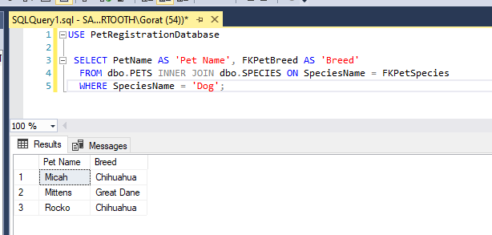

2:) This Select Statement retrieves the Person with the Most Missing Pets, not including the “Unknown” listing

USE PetRegistrationDatabase
--Find the Person With the Most Pets in System

SELECT TOP(1) MAX(NumberOfPets) AS 'Max Lost Pets', PetsPerPerson.FirstName AS 'First Name', PetsPerPerson.LastName AS 'Last Name'
FROM(
SELECT COUNT(DISTINCT PetId) AS NumberOfPets, PERSONS.FirstName, PERSONS.LastName, PersonId
FROM PERSONS INNER JOIN PETS ON FKPetPerson = PersonId
WHERE PersonId != 1
GROUP BY FirstName, LastName, PersonId
HAVING COUNT(DISTINCT PetId) > 0
) AS PetsPerPerson, PERSONS
GROUP BY NumberOfPets, PetsPerPerson.FirstName, PetsPerPerson.LastName
ORDER BY NumberOfPets DESC

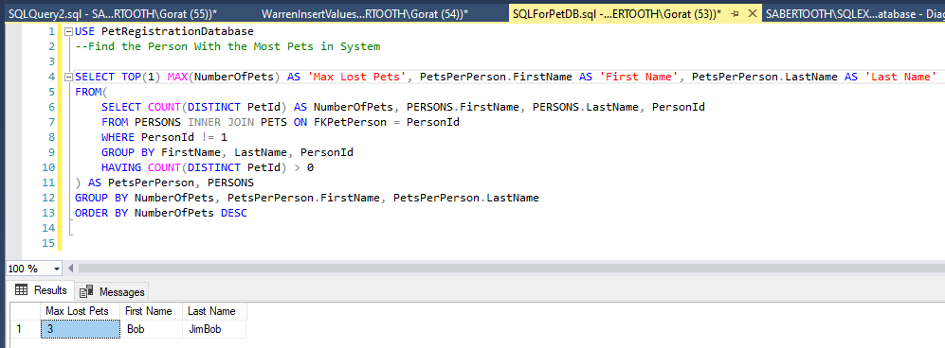

3:) This Select Statement retrieves all Pets who have Spotted Coats.

USE PetRegistrationDatabase

SELECT PetName AS 'Pet Name',FKPetSpecies AS 'Species', FKPetBreed AS 'Breed', FKPetColor AS 'Coat Color', FKPetPattern AS 'Coat Pattern'
FROM dbo.PETS INNER JOIN dbo.PATTERNS ON FKPetPattern = Pattern
WHERE Pattern = 'Spotted'

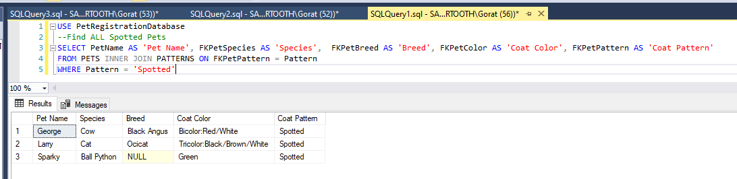

4:) This Select Statement retrieves all Records of Pets in Shelters whose Owner is known
USE PetRegistrationDatabase

SELECT PetName AS 'Pet Name', FirstName + ' ' + LastName AS 'Owner Name', ShelterName AS 'Shelter Name'
FROM PETS
JOIN PERSONS
ON FKPetPerson = PersonId
JOIN SHELTERS
ON FKPetShelter = ShelterId
WHERE PersonId != 1

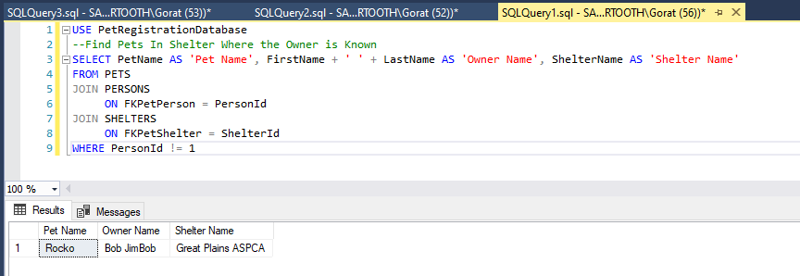

LISTING OF AN SQL INSERT STATEMENT TO ADD AT LEAST ONE RECORD INTO ONE (OR MORE) OF THE TABLE(S) CONTAINED IN THE DATABASE

This insert statement adds a record to the Pets table, which includes values for all fields except for DateFound, and FKPetLocation, since the dog is listed as being in a shelter. Result is last record in table.

INSERT INTO dbo.PETS(PetName, FKPetSpecies, FKPet_PetType, FKPetBreed, FKPetColor, FKPetPattern, FKPetPerson, DateLost, DateFound, IsSpayNeuter, Gender, UniqueFeatures, FKPetShelter)
VALUES('Sassy', 'Dog', 'Dog or Cat', 'Chihuahua', 'Tricolor:Black/Orange/White', 'Brindle',1, '2012-02-17', NULL, 1,'Male', 'Sassy has a star shaped white patch on his chest and a white spot near the base of his tail', 5);
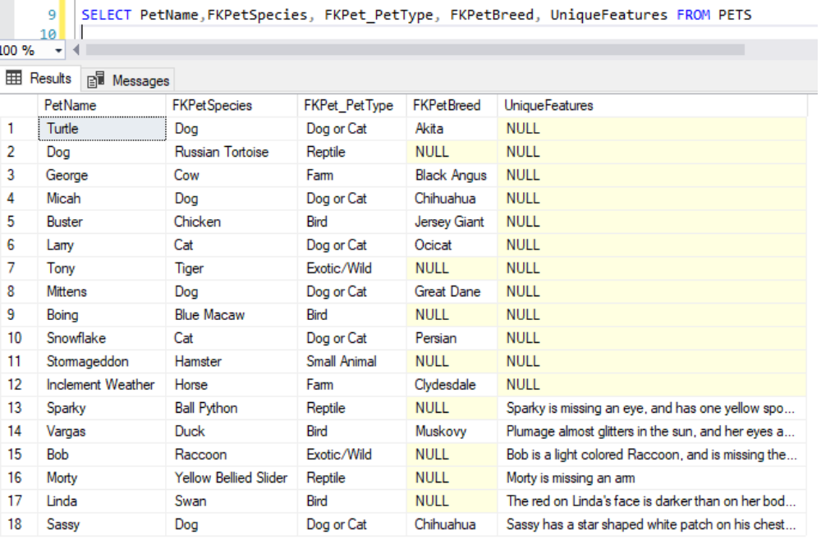

LISTING OF AN SQL UPDATE STATEMENT TO UPDATE AT LEAST ONE RECORD INTO ONE (OR MORE) OF THE TABLE(S) CONTAINED IN THE DATABASE

UPDATE statement:
This update statement changes the inserted pet record's name from Sassy to Rocko, and changes the Person (owner) from Unknown to Bob (PersonId 2 in dbo.Persons). Result is last record in the table.

UPDATE dbo.PETS
SET PetName = 'Rocko', FKPetPerson = 2, DateFound = CAST(GETDATE() AS DATE)
WHERE PetId = 18;
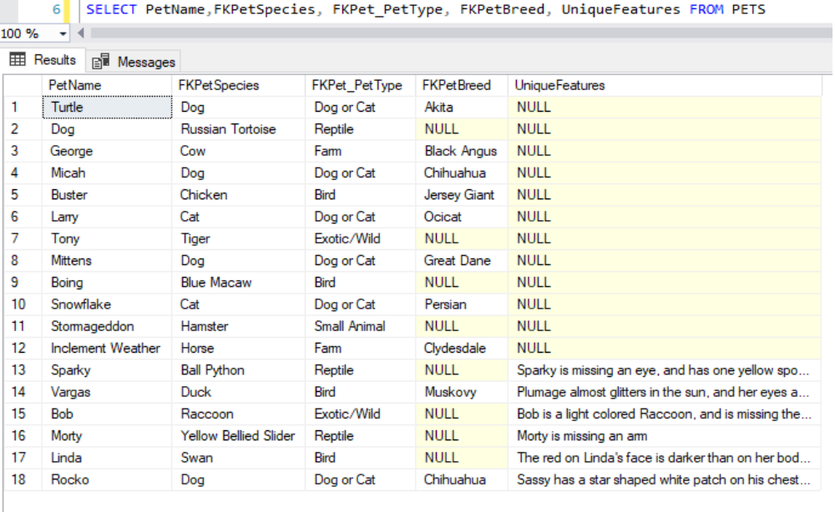

LISTING OF AN SQL DELETE STATEMENT TO DELETE AT LEAST ONE RECORD INTO ONE (OR MORE) TABLE(S) CONTAINED IN THE DATABASE

This delete Statement deletes Bob's record from the Persons table. It also deletes Pets from the Pets table with PetId 1 (A dog named Turtle), PetId 2 (A tortoise named Dog), and PetId18 (Rocko, the Chihuahua from the example Insert statement). Deletions cascade from the Persons Table to the Pets Table, under the assumption that the person no longer needs the system.

DELETE FROM dbo.PERSONS WHERE PersonId = 2;
Turtle, Dog, and Rocko are no longer in the result set.

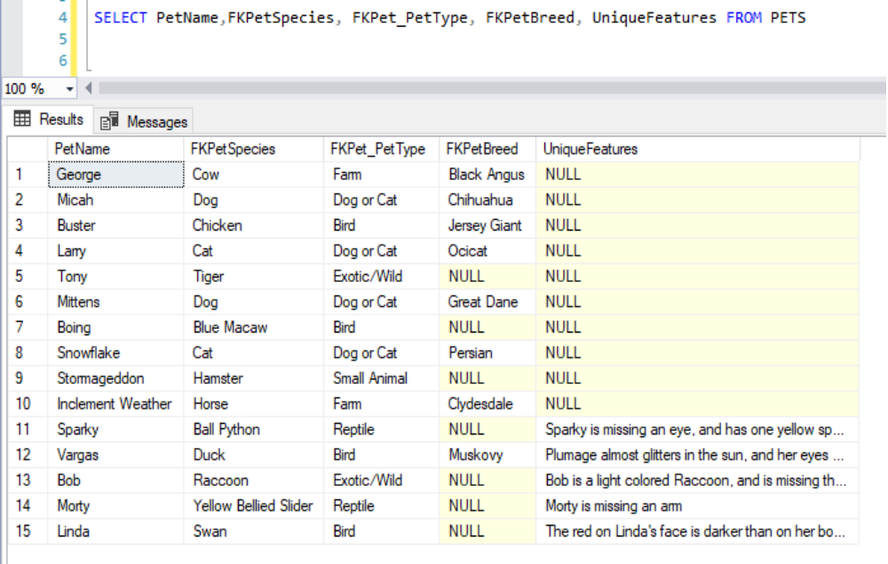
Bob is no longer in the Persons Table.
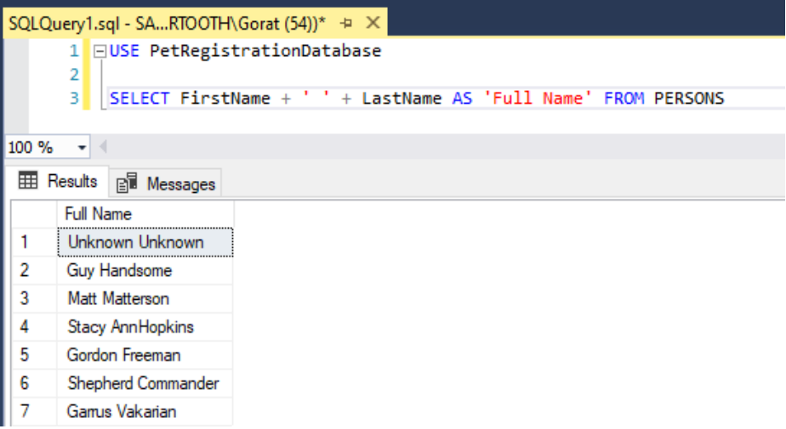
LISTING OF ONE STORED PROCEDURE OF YOUR CHOOSING (OPTIONAL)

This Stored Procedure updates Phone numbers in Persons, or Shelter_Phone_Nums, given a valid phone number, a PersonId, or a PhoneId, and either 'person' or 'shelter' as a table name.

USE [PetRegistrationDatabase]
GO
/****** Object: StoredProcedure [dbo].[sp_CheckPhoneNumber] Script Date: 5/8/2021 9:49:35 PM ******/
SET ANSI_NULLS ON
GO
SET QUOTED_IDENTIFIER ON
GO
-- =============================================
-- Author: Gareth Warren
-- Create date: 5/8/2021

-- Description: Given a Phone number, and a Person Id,
-- or the Id of a Shelter's Phone Number
-- update phone number listing if it is in one of three valid formats
-- =============================================
ALTER PROCEDURE [dbo].[sp_CheckPhoneNumber]
-- Add the parameters for the stored procedure here
@Phone VARCHAR(30),
@Id INT,
@TableName VARCHAR(25)
AS
BEGIN
SET NOCOUNT ON;
--This will match phone numbers in the form (111)111-1111, 111-111-1111, or 111 111 1111

-- Insert statements for procedure here

IF (@Phone LIKE '([0-9][0-9][0-9])[0-9][0-9][0-9]-[0-9][0-9][0-9][0-9]') OR
(@Phone LIKE '[0-9][0-9][0-9]-[0-9][0-9][0-9]-[0-9][0-9][0-9][0-9]') OR
(@Phone LIKE '[0-9][0-9][0-9] [0-9][0-9][0-9] [0-9][0-9][0-9][0-9]')
BEGIN
IF(@TableName = 'person')
BEGIN
SELECT PERSONS.Phone FROM PERSONS
WHERE PERSONS.PersonId = @Id
BEGIN TRY
BEGIN TRANSACTION
UPDATE PERSONS
SET PERSONS.Phone = CAST(@Phone AS CHAR(13))
WHERE PERSONS.PersonId = @Id;
COMMIT;
END TRY
BEGIN CATCH
ROLLBACK;
END CATCH;
END;
IF(@TableName = 'shelter')
BEGIN
BEGIN TRY
BEGIN TRANSACTION
UPDATE SHELTER_PHONE_NUMS
SET ShelterPhone = CAST(@Phone AS CHAR(13))
WHERE PhoneId = @Id;
COMMIT;
END TRY
BEGIN CATCH
ROLLBACK;
END CATCH;
END;
END;
END;

Here, Animal Friend's first phone number listing, with an Id of 1, has been updated.
Guy's Phone number was also updated using the same stored procedure, run at a different time.

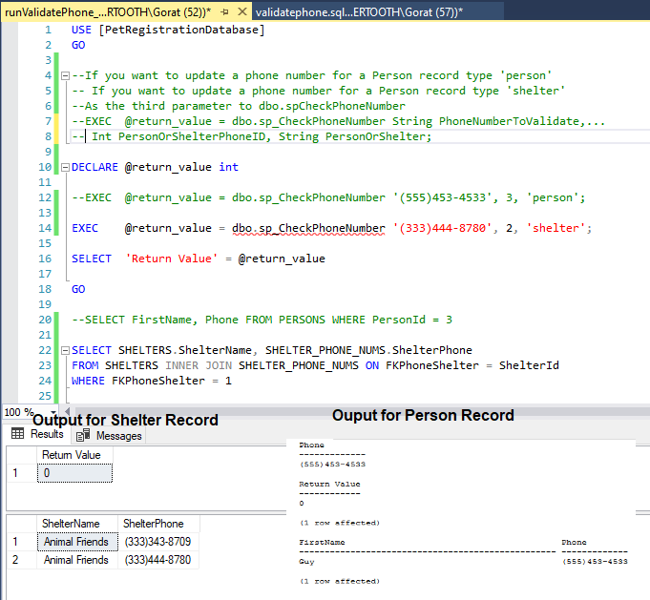

Validation of phone numbers was chosen for this stored procedure, because a working email validation function was discovered, when looking up how to perform pattern matching with email addresses, written by another programmer. It will be used for email validation purposes for this database. However, it can't be claimed as being written by this author.

OPTIONAL – PICTURE OF ONE OR MORE CREATED REPORT(S) USING MICROSOFT SQL SERVER REPORT BUILDER

Number of individual Pet records is the Y axis.
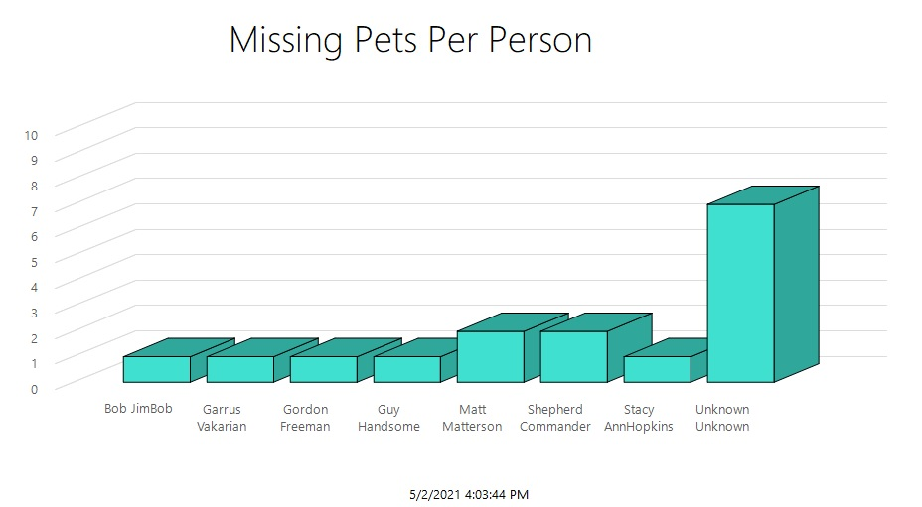

OPTIONAL – PICTURE OF ONE OR MORE CREATED FORMS

Form for Pets:
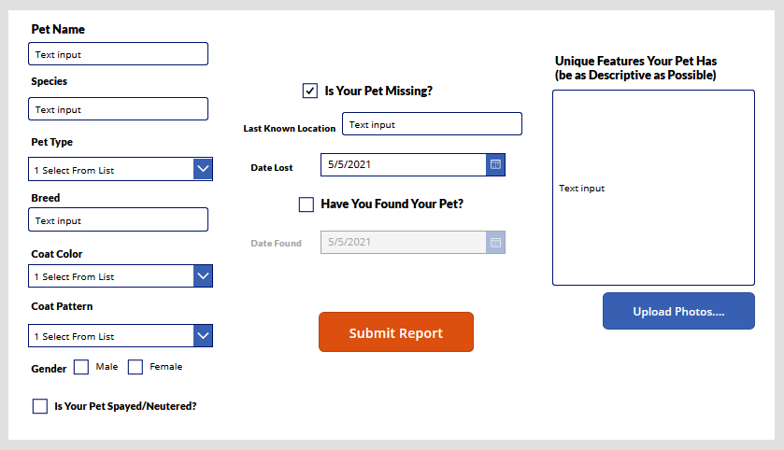

Pet form prototype was created using Power Apps through the Office 365 for Students. The app was not created, as the program was only used to create the visual layout of the form.

The sheer number of domestic pet breeds, animal species, and locales make selection boxes prohibitive. Therefore, Species, Breed, and Last Known Location should use autocorrect, and predictive typing to help minimize data anomalies due to misspelled words. Date Found date picker should not be available if Have You Found Your Pet is unchecked. If the user enters Date information, Pet records should not be created if Date Found is entered, but not Date Lost. Also, if provided, Date Found must be later than Date Lost. Species refers to FkPetSpecies. Pet Type refers to FKPet_PetType. Breed refers to FKPetBreed. Coat Color refers to FKPetColor. Coat Pattern refers to FKPetPattern. Last Known Location refers to FKPetLocation. FKPetShelter, and FKPetPerson, would be handled by a different form. Gender, isSpayNeuter, isLost, UniqueFeatures, DateLost, DateFound, Location all accept nulls in case the information is not known. Breed accepts nulls in case the animal breed is unknown, or nonexistent, as in the case of wild animals. Upload Photos would need a NoSQL solution. May also allow video uploads.

SUMMARY OF YOUR CREATED DATABASE MANAGEMENT SYSTEM

This project was done to simulate a data storage system for an app I am creating, to help reunite people with their lost pets. The database itself can be altered to work with any pet registration system. The data in the tables are easy to query, and cross reference to gain insights into things like, who owns what animal, what each animal is, and what they look like, number of animals at specific shelters, percentage of mammals vs reptiles, etc. Due to referential integrity constraints between PETS, PERSONS, and SHELTERS, the tables had to be created in a specific order. It was easier to use Identity Insert to specify Primary key values when creating the sample data, because the tables were created, and subsequently dropped or truncated, a few times during creation for this reason.

The app itself will leverage a REST Api to send data to the server, and data access will likely need to follow ODBC standards. Security of the database is a big issue, as this will be a public facing web app. It will be important to sanitize user input, and parameterize all queries to prevent SQL Injection attacks. The database structure will also need to work with No-SQL, or a hybrid solution will need to be found in order to support photo, and video data, as well as relational data. Additional tables may be required for user accounts, and a private messaging system that will allow users to contact each other without exposing sensitive information. However, the current prototype serves as a working example of what the app aims to accomplish.

