CS561 WS Exam

Your solutions have to be submitted as a single Word of PPT file. No other file format will be accepted

No handwritten solutions will be accepted.

Solutions must be submitted by the stated deadline. Submissions submitted even a minute later will not be accepted, and will get a failing grade.

1. We are given the following two table schemas

- Table2(E, F, G, H, I, J)
- Table3(K, L, M)

We are also given that there is a foreign key reference from {L, M} of Table3 to {G, H} of Table2.

Identify any key or foreign key constraint violations in the following instances of Table2 and Table3.

Table2
E | F | G | H | I | J
5 | 6 | 2 | 6 | 9 | 2
7 | 11 | 2 | 3 | 7 | 10
1 | 8 | 1 | 4 | 8 | 15
16 | 3 | 2 | 6 | 15 | 6
10 | 4 | 2 | 7 | 5 | 9

Table3
K | L | M
1 | 2 | 4
2 | 1 | 6
3 | 2 | 7
4 | 2 | 9

For the purpose to insert a new value under a column where the foreign key of the child table. We need to insert the values in parent table. For attribute G, all the values are 1 or 2 which are already exists in attribute L of table 3. It means that there is no violation here. But for attribute H, the value 3 is not there in attribute M of parent table. So the foreign key constraint is violated. Based on all the facts mentioned, the answer is:

Table2, Value 3 under attribute H violates the foreign key constraint.

2. How many rows are there in the value of the following relational algebra expression?

⬧ (_{EMP1}(EMPLOYEE) X DEPARTMENT X _{EMP2} (EMPLOYEE))
\
(EMP1.dno = DEPARTMENT.dnumber)
AND (DEPARTMENT.mgrssn = EMP2.ssn)

Hint: Express your answer in terms of number_rows(EMPLOYEE) and number_rows(DEPARTMENT)

ANS: There are number_rows(EMPLOYEE) rows because for each EMPLOYEE1 there is a unique department and for each department there is another unique EMPLOYEE2.

3. Write an SQL query – based upon the multi-company database schema in the SQL Chapter -- “For every company that has one or more divisions
find, and output, the company and the number of divisions it has.”
In this question you may not use any embedded SFW’s, nor may you use any embedding operators, i.e., no IN, no NOT IN, no EXISTS, no NOT EXISTS, and no <relational operator> ALL, <relational operator> SOME, or <relational operator> ANY.
Additionally, you may use GROUP BY, but you may not use HAVING.

Multi-Company ER Diagram as below:
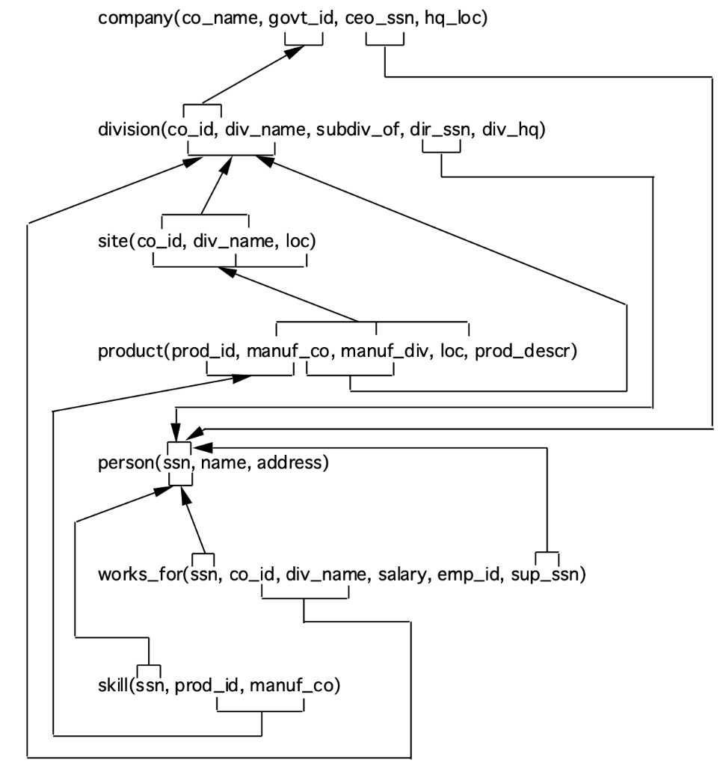

for i = 1 to no_rows(company)do
for j = 1 to no_rows(company) do
if(company [i][co_name] = company [j][co_name])
and(company [i][govt_id] = company [j][govt_id])
and(company [i][divison_of] <> company [j][division_of])
then outpurt(company [i][co_name])
SELECT *
FROM company AS company1,company2
WHERE(company1.co_name = company 2.co_name)
and(company 1.govt_id = company 2.[govt_id])
and(company 1.[divison_of] <> company 2.[division_of])

4. Write an SQL query – based upon the multi-company database schema in the SQL Chapter -- “For every company -- including companies with no divisions -- find, and output, the company and the number of divisions it has.”
In this question you may not use any embedded SFW’s, nor may you use any embedding operators, i.e., no IN, no NOT IN, no EXISTS, no NOT EXISTS, and no <relational operator> ALL, <relational operator> SOME, or <relational operator> ANY.
Additionally, you may use GROUP BY, but you may not use HAVING.

SELECT govt_id,
CASE WHEN co_id IS NULL THEN 0
ELSE COUNT(*) END AS number_of_Division
FROM company
LEFT JOIN division
ON company.govt_id=division.co_id
GROUP BY co_id, govt_id;

5. Write an SQL query – based on the single-company database –
“For every dependent, find, and output, the dependent and the number of siblings (brothers and sisters) of the dependent who are also dependents of the same employee.”

Single Company ER Diagram as below:
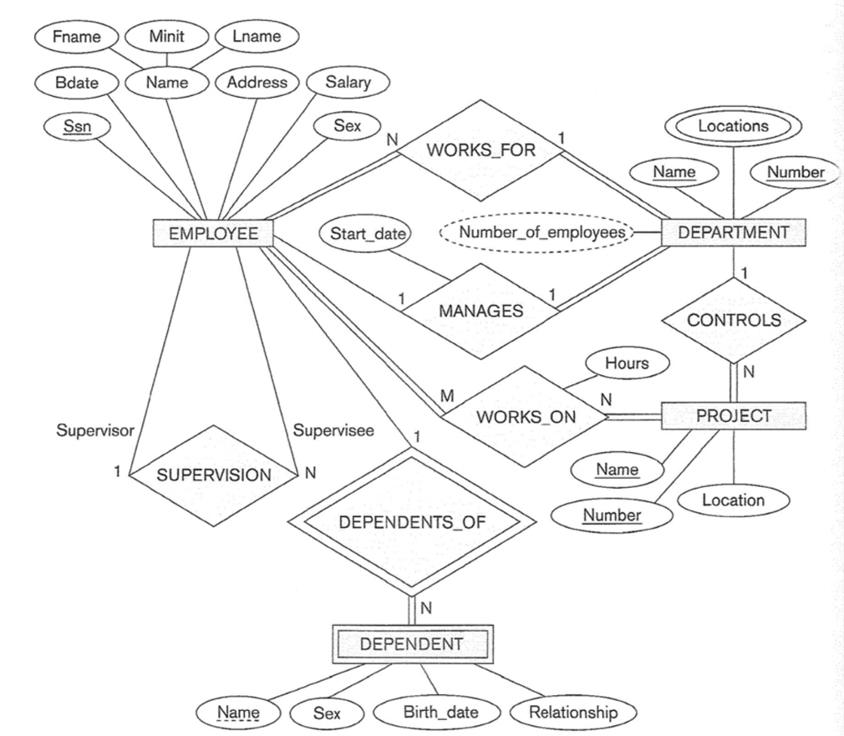

SELECT D.DEPENDENT_NAME, D.SEX, D.BDATE, D.RELATIONSHIP,
COUNT(*) AS "NUMBER OF SIBLINGS"
FROM DEPENDENT D
JOIN DEPENDENT D2 ON D.RELATIONSHIP = D2.RELATIONSHIP
AND D.SEX = D2.SEX
AND D.BDATE = D2.BDATE
JOIN EMPLOYEE E ON D.ESSN = E.SSN
GROUP BY D.DEPENDENT_NAME, D.SEX, D.BDATE, D.RELATIONSHIP, E.FNAME, E.MINIT, E.LNAME
HAVING COUNT(*)>1

The above code is a SQL query that finds the number of siblings for every dependent in a single-company database. The query first joins the DEPENDENT and DEPENDENT2 tables on the basis of relationship, sex, and birthdate. It then joins the EMPLOYEE table on the basis of employee SSN. The query then groups the results by dependent name, sex, birthdate, relationship, and employee first, middle, and last name. Finally, the query selects only those groups that have more than one dependent.

This query is useful for finding out how many siblings a dependent has in a single-company database. The query can be used to help identify employees who have multiple dependents, and to determine whether or not those dependents are siblings.

6. Write an SQL query – based on the single-company database – “For every dependent, find, and output, the dependent, the number of siblings (brothers and sisters) of the dependent who are also dependents, and the first, middle, and last name of the employee whose dependents they all are.”

The SQL query for the single-company database is given below:

SELECT D.DEPENDENT_NAME, D.SEX, D.BDATE, D.RELATIONSHIP,
COUNT(*) AS "NUMBER OF SIBLINGS"
FROM DEPENDENT D
JOIN DEPENDENT D2 ON D.RELATIONSHIP = D2.RELATIONSHIP
AND D.SEX = D2.SEX
AND D.BDATE = D2.BDATE
JOIN EMPLOYEE E ON D.ESSN = E.SSN
GROUP BY D.DEPENDENT_NAME, D.SEX, D.BDATE, D.RELATIONSHIP, E.FNAME, E.MINIT, E.LNAME
HAVING COUNT(*)>1

Note: This is a SQL query for every dependent, find, and output, the dependent, the number of siblings(brothers and sisters) of the dependent who are also dependents, and the first, middle, and the last name of the employee whose dependents they all are. In the above query, we have assumed the table because in the question there is no given table. So, first joints the DEPENDENT and DEPENDENT2 tables on the basis of relationship, sex, and birth date. Then it joins the EMPLOYEE table on the basis of employee SSN. Then the query, groups the results on the basis of the dependent name, sex, birthdate, relationship, and employee's first, middle, and last name. At last, the query only selects those groups that have the dependent value of more than one.

7. Write an SQL query – based on the SQL Chapter multiple-company database – “Find every company that produces no products.”
You may have an SFW embedded in the outer SFW, but it may not be embedded using embedding operators, i.e., no IN, no NOT IN, no EXISTS, no NOT EXISTS, and no <relational operator> ALL, <relational operator> SOME, or <relational operator> ANY.
Additionally, you may not use GROUP BY or HAVING anywhere in your answer.

SELECT company.govt_id
FROM company
WHERE ( (SELECT COUNT(*)
FROM product
WHERE company.govt_id = product.manuf_co)

8. Write an SQL query – based on the SQL Chapter multiple-company database – “Find every company that produces no products.”
This time you may have an SFW embedded in the outer SFW, and it must be embedded using either the IN or NOT IN operator, whichever makes the complete SFW simpler.
(You may not use GROUP BY or HAVING anywhere in your answer.)

This query should return every company that produces no products.
We use NOT IN in this case. So, the answer is:

SELECT co_name
FROM company
WHERE co_name NOT IN (SELECT manuf_co
FROM product
WHERE company.co_name=product.manuf_co)

9. Write SQL for the query – based on the SQL Chapter multiple-company database – “Find every company that produces no products.”
This time you may have an SFW embedded in the outer SFW, and it must be embedded using either the EXISTS or NOT EXISTS operator, whichever makes the complete SFW simpler. (You may not use GROUP BY or HAVING anywhere in your answer.)

This query should return every company that produces no products.
We use NOT EXIST in this case. So, the answer is:

SELECT co_name
FROM company
WHERE NOT EXISTS (SELECT manuf_co
FROM product
WHERE company.co_name=product.manuf_co)

10. Write an SQL query – based on the airline database schema –
“Find the average number of airplane types that can land at (the various) airports in Nebraska.”
This time you can use any SQL constructs that have been discussed in the lectures.

Airline Database Schema as below:
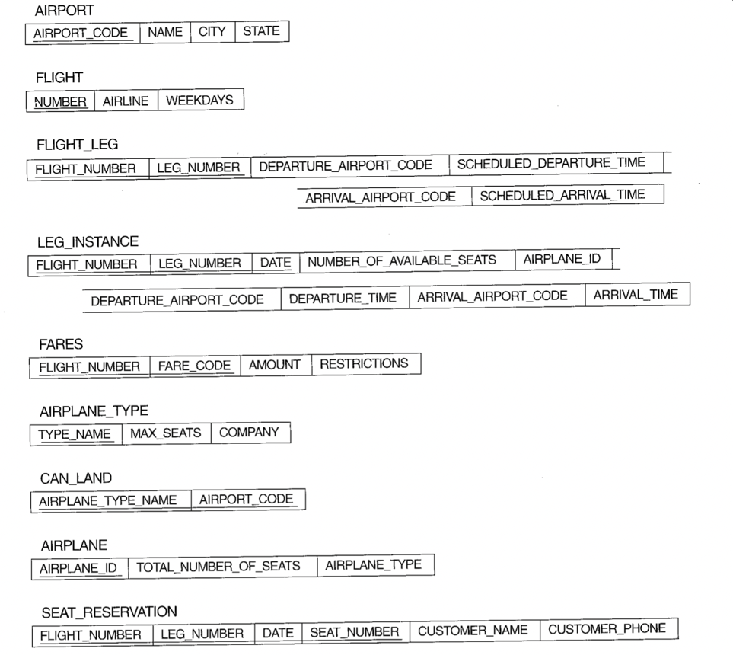

SELECT AVG(AIRPLANE_TYPE)
FROM AIRPLANE
LEFT JOIN AIRPLANE_TYPE ON AIRPLANE_TYPE.TYPE_NAME = AIRPLANE.AIRPLANE_TYPE
LEFT JOIN CAN_LAND ON CAN_LAND.AIRPLANE_TYPE_NAME = AIRPLANE_TYPE.TYPE_NAME
LEFT JOIN AIRPORT ON AIRPORT.AIRPORT_CODE = CAN_LAND.AIRPORT_CODE
WHERE AIRPORT.NAME = "Nebraska";

AVG

11. Write an SQL query – based on the single-company database – “For every salary paid by the company, find the number of employees who make that salary.”
In this question you may use any SQL constructs discussed in the lectures.

SELECT COUNT(Ssn) AS 'Number of Employees'
FROM Employee
WHERE Salary > 0;

Note: This is a SQL query for every salary paid by the company, find the number of employees who make that salary

