If the user clicks on sign in on AbeBooks.com's Homepage,

the system returns the Customer to the Login Page.

Then, System displays sign in page for user/customer to login

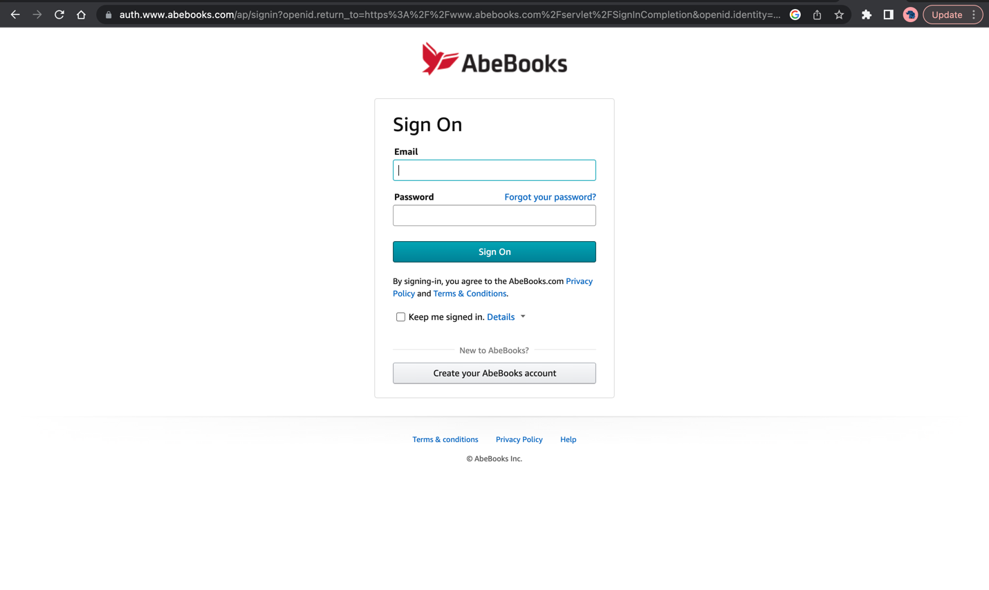

The user enters his/her email address and password If the user clicks on the checkbox.

If the user has not typed anything into the email or password boxes, has typed invalid information into one of these boxes, the system returns an error message that enables the user to correct the error(s)