**Construct a GUI prototype for the Internet Bookstore’s Log In Use Case.**

* The Customer clicks the Log In button on the Home Page.
* The system displays the Login Page.

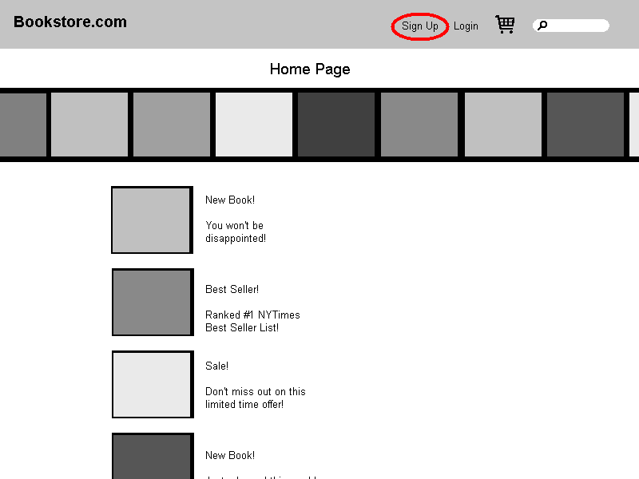

Sign up

* The Customer enters his or her user ID and password and then clicks the Log In button.

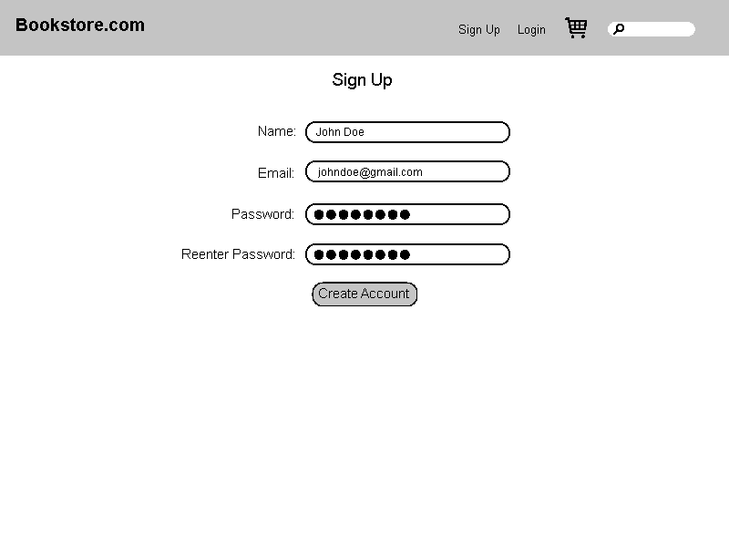

Login

Login Page

* The system validates the login information against the persistent Account data and then returns the Customer to the Home Page.

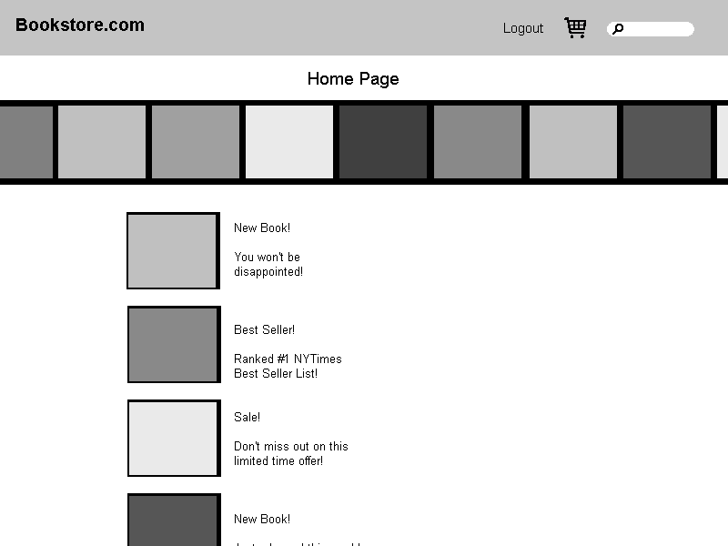

* + If the Customer clicks the New Account button on the Login Page, the system invokes the Open Account use case.

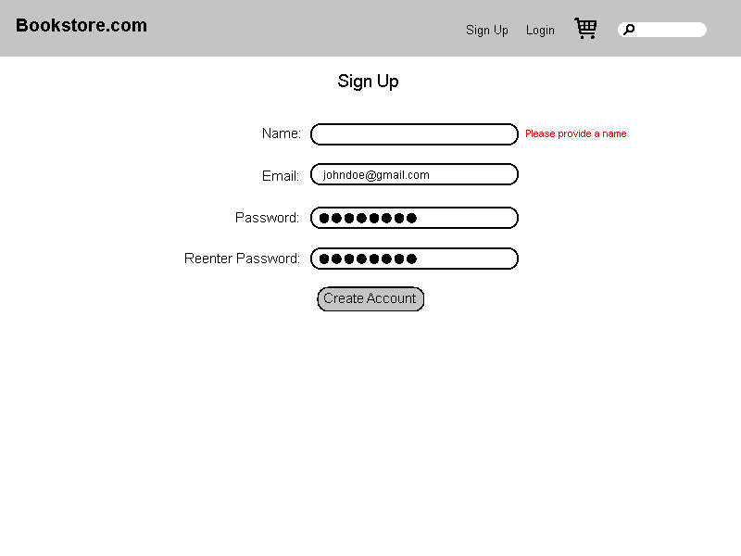

* + If the Customer clicks the Reminder Word button on the Login Page, the system displays the reminder word stored for that Customer, in a separate dialog box. When the Customer clicks the OK button, the system returns the Customer to the Login Page.

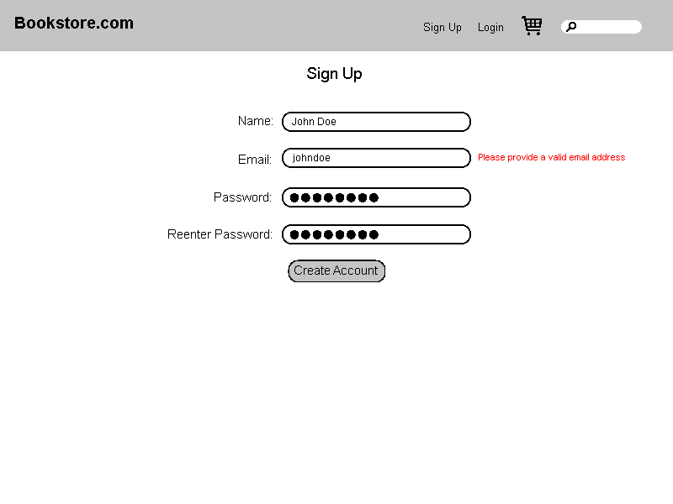

Password: Your mom’s birthday

Reminder Word Page

OK

* + If the Customer enters a user ID that the system does not recognize, the system displays a message to that effect and prompts the Customer to either enter a different ID or click the New Account button.

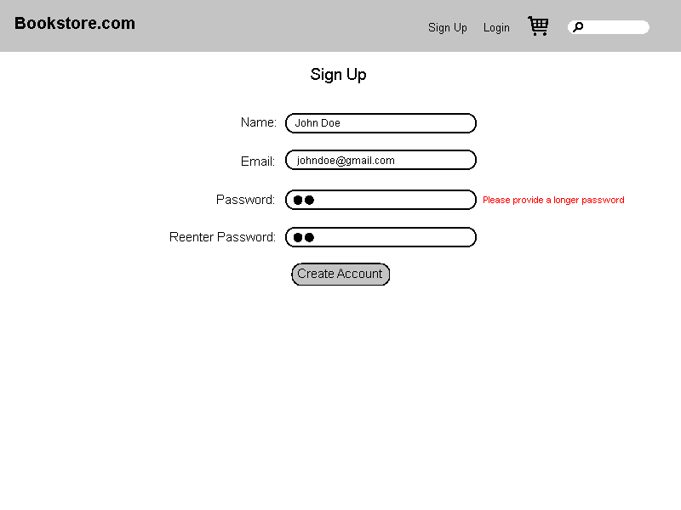

User ID not recognized, Please enter a different ID or click the “Sign up” button to create a new account

Login Page

Login

* + If the Customer enters an incorrect password, the system displays a message to that effect and prompts the Customer to reenter his or her password.

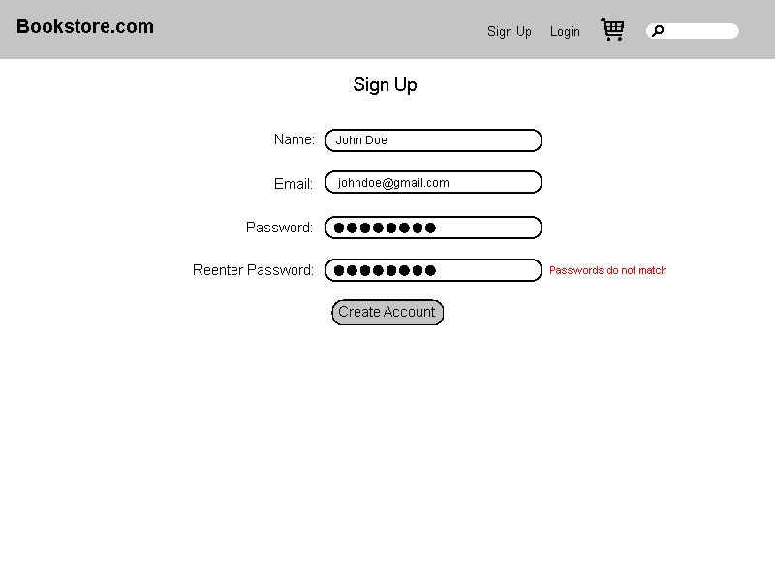

Incorrect password, please reenter your password

Login

Login Page

* + If the Customer enters an incorrect password three times, the system displays a page telling the Customer that he or she should contact customer service, and also freezes the Login Page.

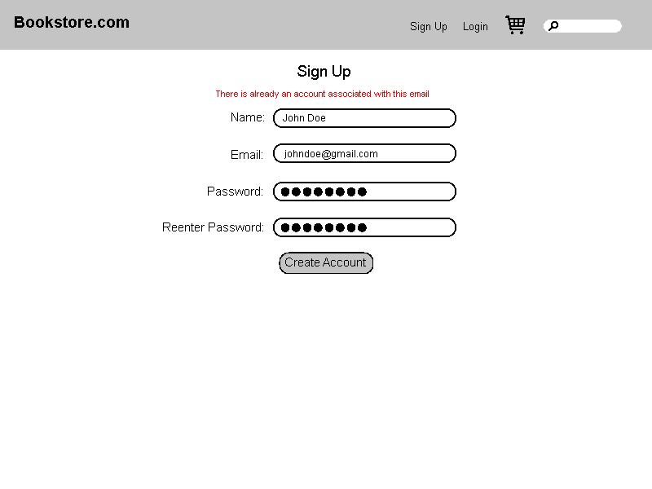

You have entered an incorrect password three times and your account has locked. Please contact customer service

Login Page

Login