DX REQUIREMENT SHEET
General Information

Application Name | X-ray app auto measurement
No | DX/PED/FY26/***
Date | 29 06 2026

Document Sections:
1. Application Development Baseline
2. Project Schedule
3. Application Information
4. Application Feature
5. Business Process
6. UI/UX
7. Release Judgment Condition

DX | Approved | Approved | Approved | Checked | Prepared
*** | *** | *** | *** | *** | ***

PT. Denso Indonesia, 3rd Factory
Jl. Selayar III Blok K-2, Industrial Estate MM 2100
West Cikarang, Bekasi 17845, Jawa Barat, Indonesia

1. Application Development Baseline

1.1 Background
Measuring IC position in X ray process is currently still using manual method. The method is applying film jig which has been determined on a scale on monitor. The weakness of this method have possible miss judgement from MP and possible flow out due to there is no POKAYOKE system.

1.2 Target Objectives
The software can measure & judgement OK or NG IC position in X ray process by converting image (pixel) to value measuring. And has system POKAYOKE and interface alarm if there any NG during processing.

1.3 Purpose
1. Measure position of IC in the hosing part
2. Able judgement OK and NG
3. Software judgement able connect to PLC for develop system interlock in the future.
4. Alarm treatment indication same as machine standard DENSO (indication alarm name, reset, and auto)

1.4 Benefit System
Quality : The part 100% check by system and has the data measure for each part. Has system POKAYOKE if there any NG for prevent flow out. (rank C B)

Productivity : Reduce xxx MH

Safety : Reduce potential excessive radiation exposure from X ray machine

2. Project Schedule (Not Update)
The following phases are included in the project schedule:
- Study
- Business Requirement Development
- Business Requirement Approval
- Development
- Install and Testing
- Improvement
- User Acceptance Test
- Go Live
- Monitoring

(Insert project timeline / Gantt chart here)
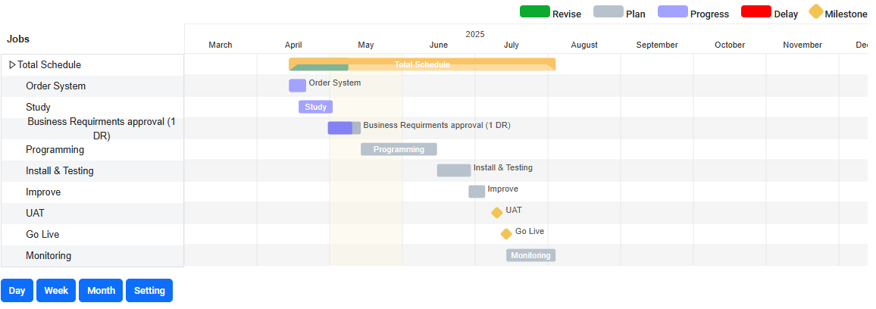
Figure 1 Example Schedule from Prosysta
PROSYSTA

3. Application Information

3.1 Application Overview
Application Name : X-ray app auto measurement
Type : Desktop
Main Functionality : Measuring image from x ray
Author : Giandi, Nugroho
Version : Version development of this system

4. Application Feature

4.1 Feature Table
No | Feature | Detail Feature | Remarks
1 | Calibration (menu) | Compare pixel measurement with master jig dimension | Interval check calibration 1/day
2 | Qty Counter (display) | Show qty product (reset every day)
3 | CT actual vs target (display) | Show actual CT AI vs CT target (x-ray)
4 | History output (menu) | History data csv (1 file 1 day)  - Measurement results each part  - Date  - Operator name  - Time  - Sequence  - Part number  - Image compress, able to remeasure | - Before software running, MP log in name and P/N, if dandory only scan kanban  - Number image and csv same for identification
5 | Option save data: all, NG only, OK only (menu) | For support in learning AI, and traceability | Menu setting
6 | Menu learning ai image sample (menu) | Menu for learning AI from history | Menu learning AI, AI will be learning by PE (QR access)
7 | Transfer history data to server (other PC), for analyze | For easy output data from PC AI (secure) for analysis.
8 | Menu log in before running. (menu) | MP must be log in before app running, the item is MP name & NPK | - Log in by QR  - Auto log out 07.00 & 20.30
9 | Alarm/ abnormality handling (display) | Indicator alarm must be show :  - Measurement amount  - Image  - Reset by leader (QR)  - Menu double check. | Leader must be reset by QR for continuing running, optional leader can double with remeasure or manual measure)
10 | Position adjustment | Ai can position adjustment if position part does not center at jig
11 | Receive format image png. And jpg. | The software can choose image form auto capture with format jpg. or png. For measure
12 | Manual Measure | Has option manual measure for double check | Manual Measurement is performed by defining two connected points that form a line. This line represents a measurement in millimetres (mm), which has been converted from pixels and calibrated to ensure accuracy
13 | Role | Admin :  Full access  User :  TL :  - Log in  - Normal Operation  - Re-check  - Manual measuring  Operator :  - Log in  - Normal operation
14 | Dandori | Process Dandori only scan by QR | QR already attach in kanban production

Total Feature Development: 14

5. Business Process

5.1 General Flow Process
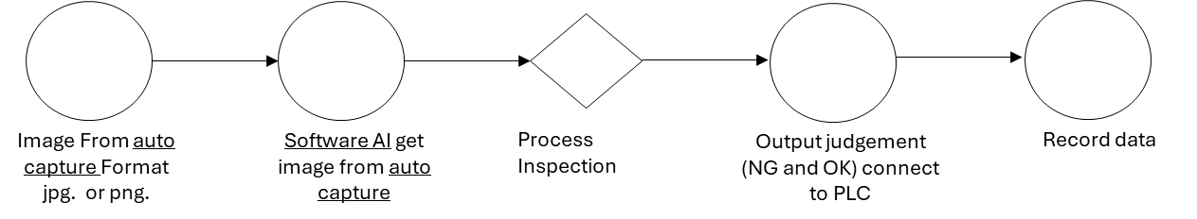
AI check flow process

5.2 Detail Process

Log in
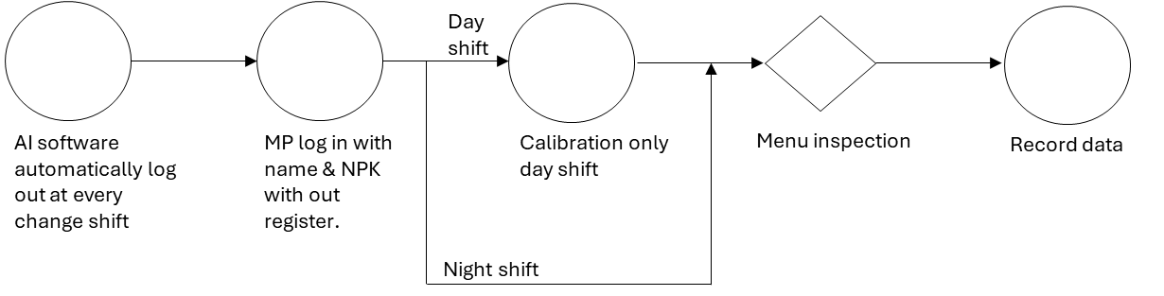

Calibration
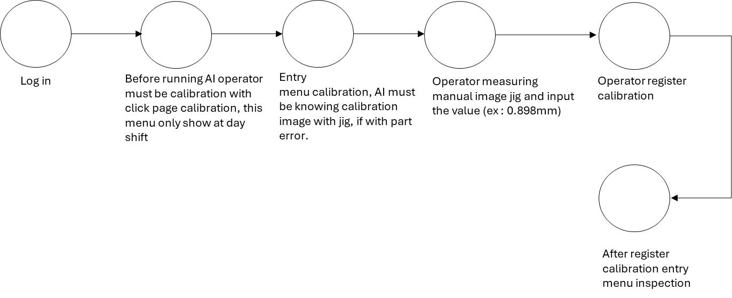

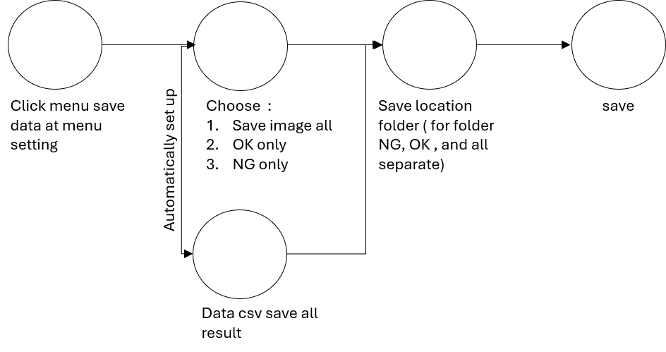
Save data

History output
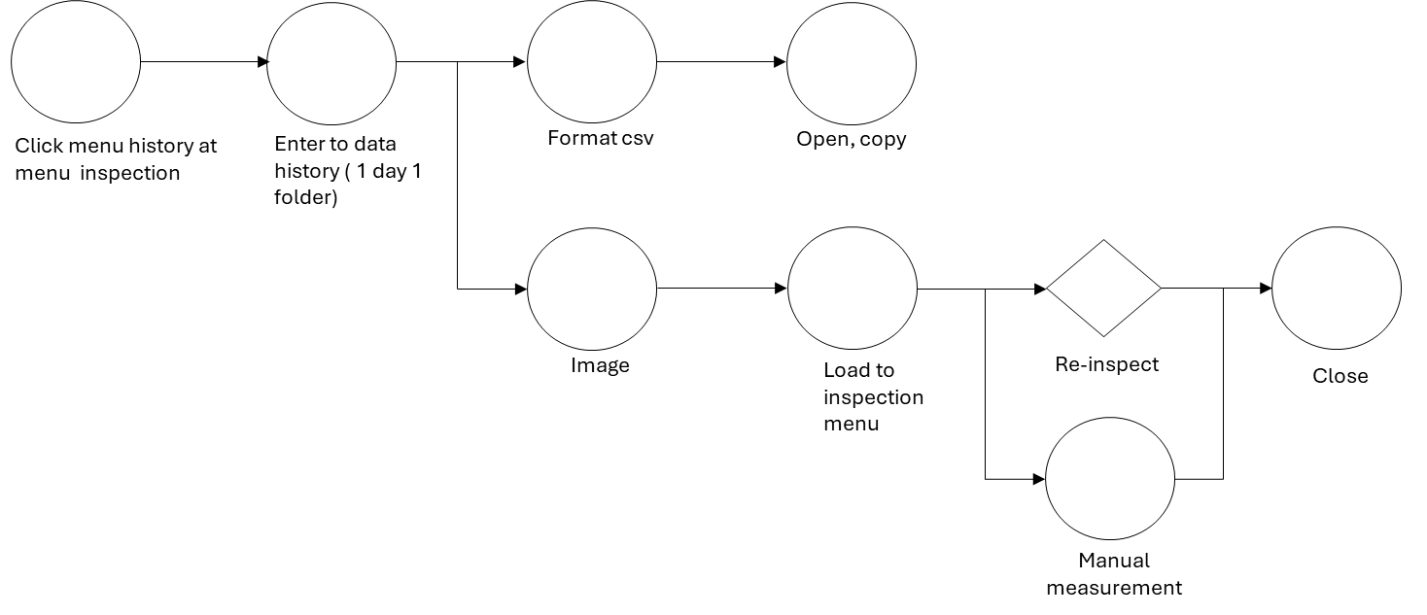

Learning AI
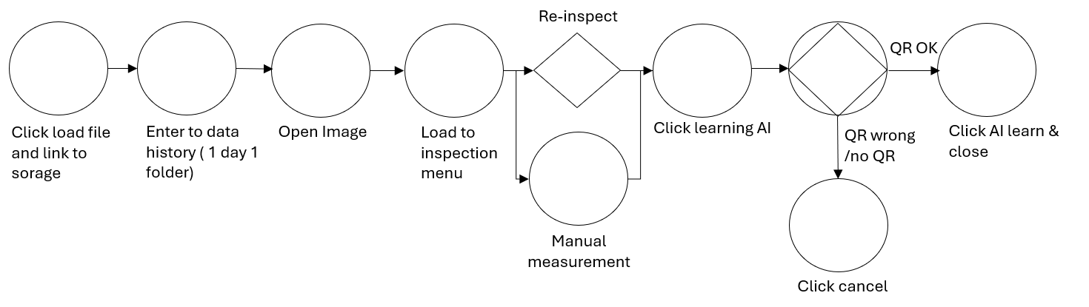

Abnormality handling (alarm)
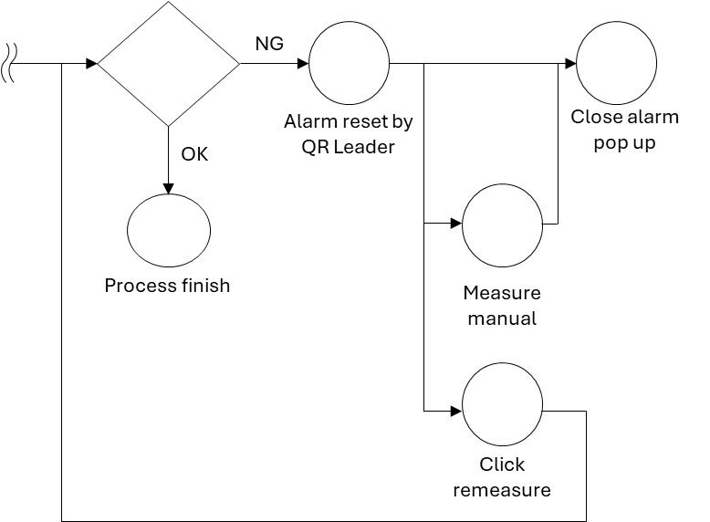

Manual measurement

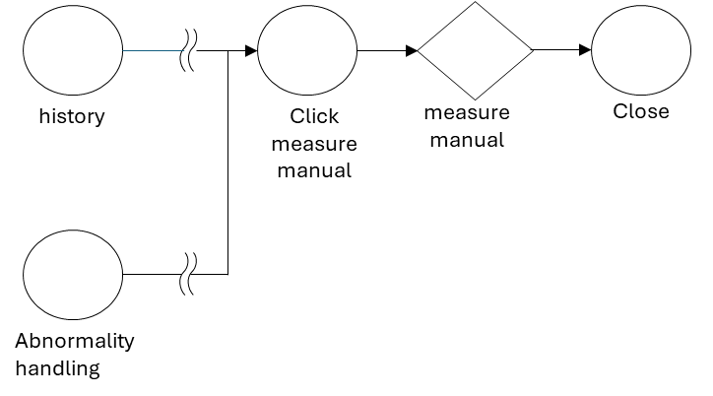

6. UI/UX ( Not Update)

6.1 UI/UX Screens List
The following table lists the key screens in the application:
Example:
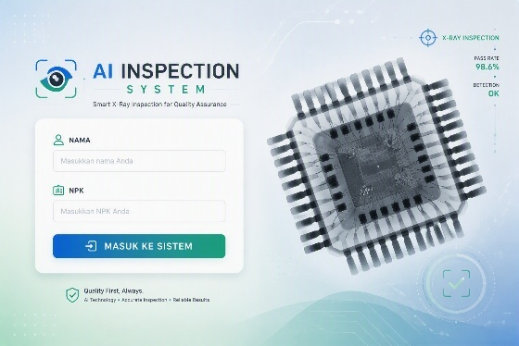
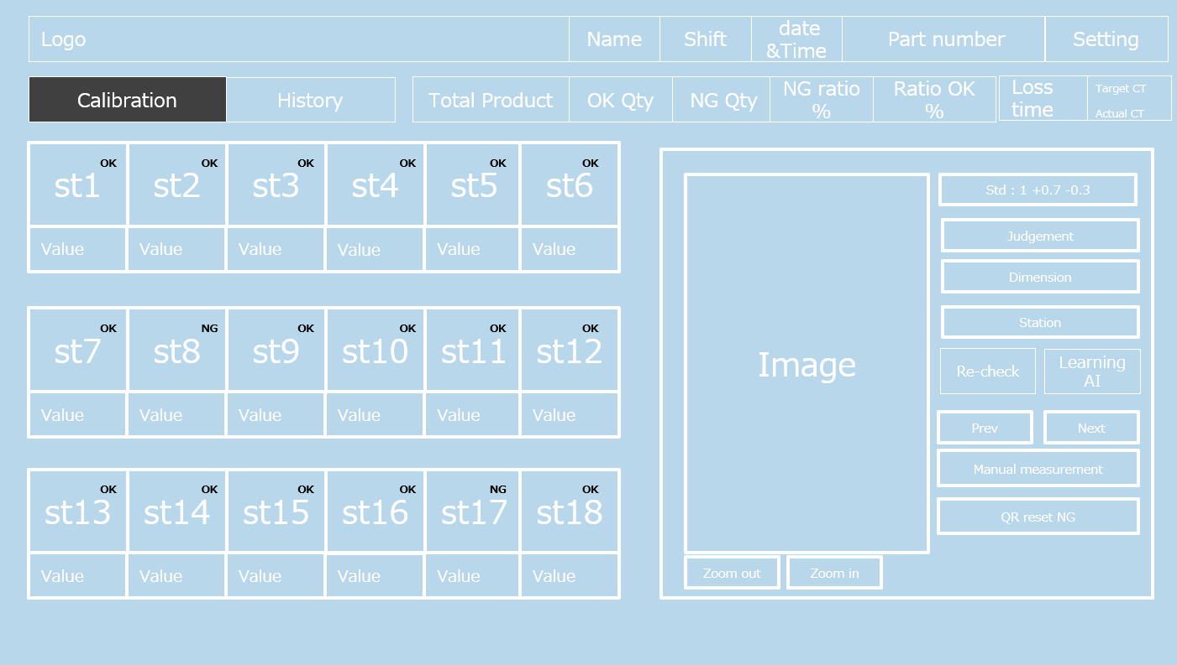
Log in page Main dashboard

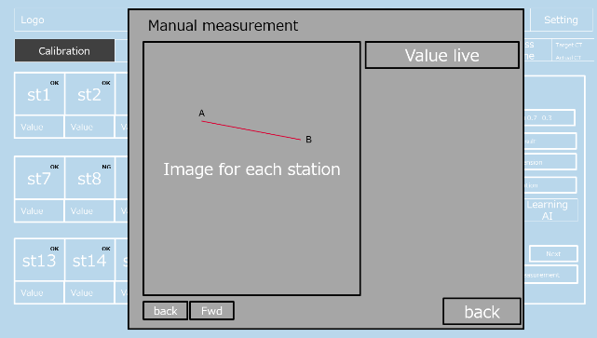
Calibration Manual measurement
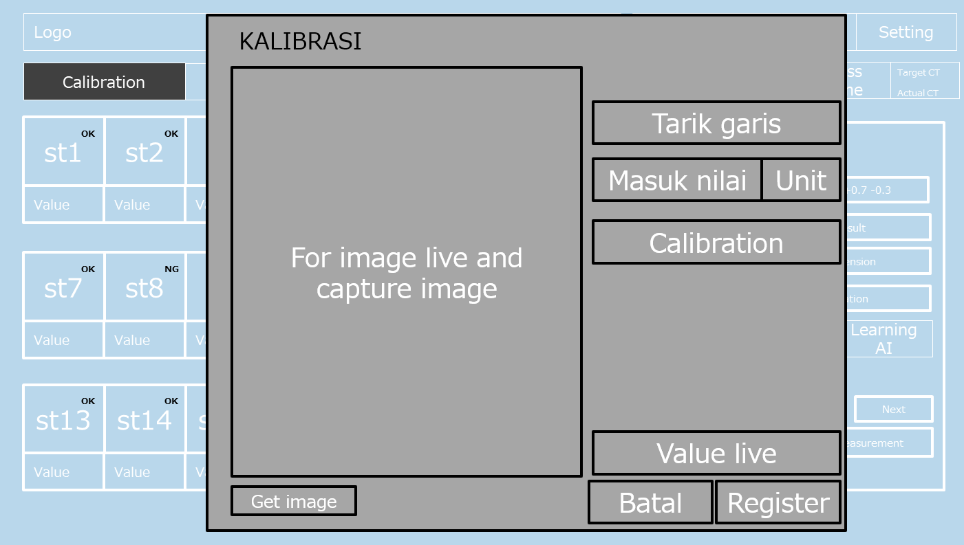

Setting learning AI
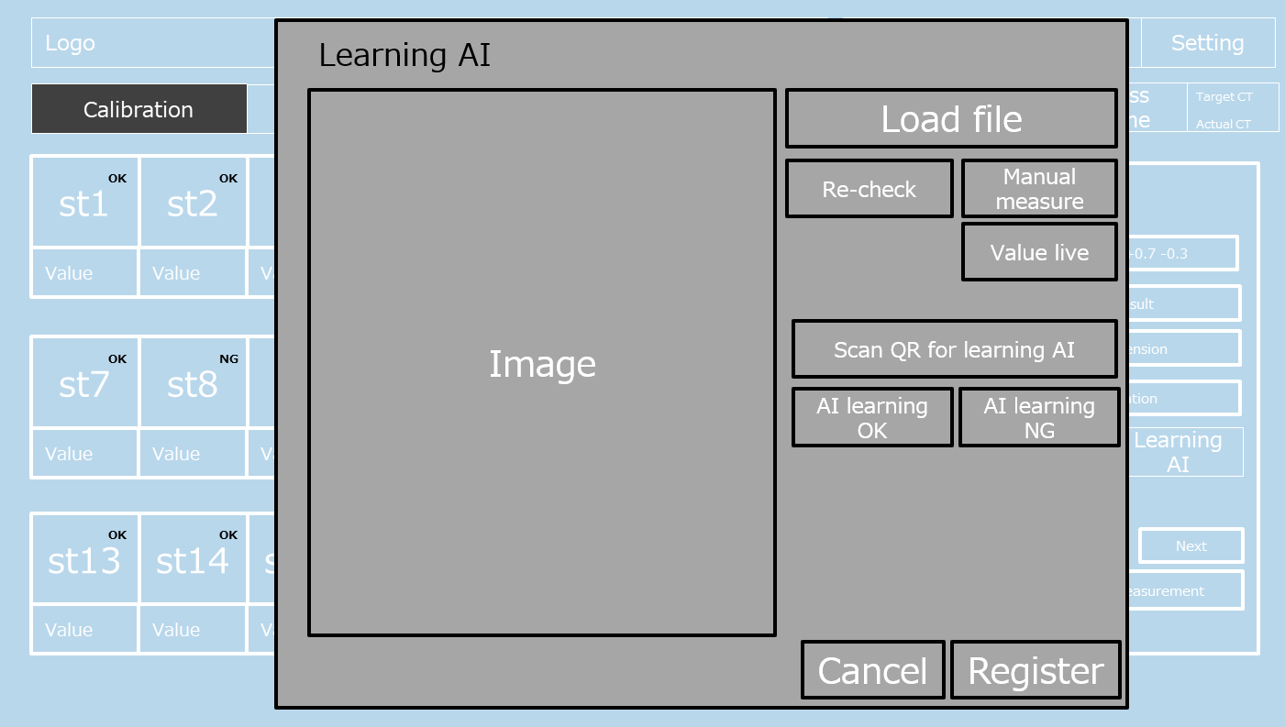
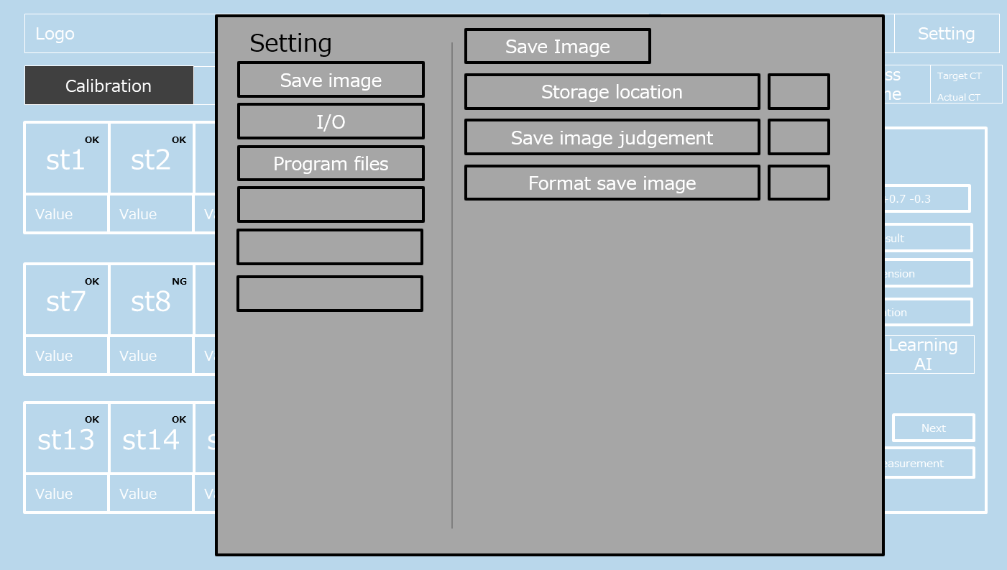

NG message
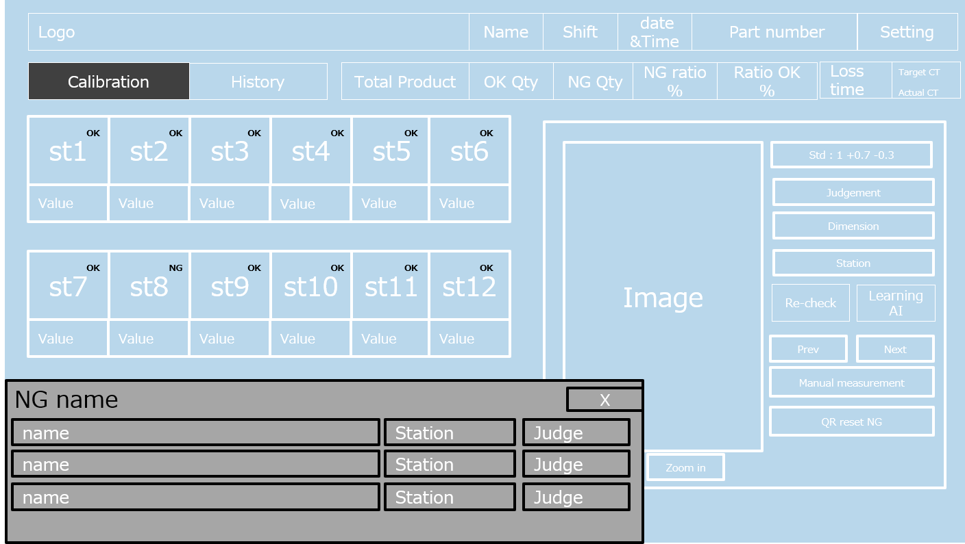

Screen Name | Purpose | Key Elements | User Role
Login Page | User authentication |  | All Users
Dashboard | Overview of system data |  | All Users
Calibration | For calibration software |  | All user
Manual measurement | For re-measuring by line |  | TL, admin
Setting | Setting save image, load program, I/O, others |  | Admin
Learning AI | For AI training from history data |  | Admin
NG message | For show kind of NG (measuring & others) |  | TL, admin

6.2 Wireframes or Mockups
Below are sample wireframes or mockups representing the layout and design of key screens.
(Insert wireframe / mockup images here)
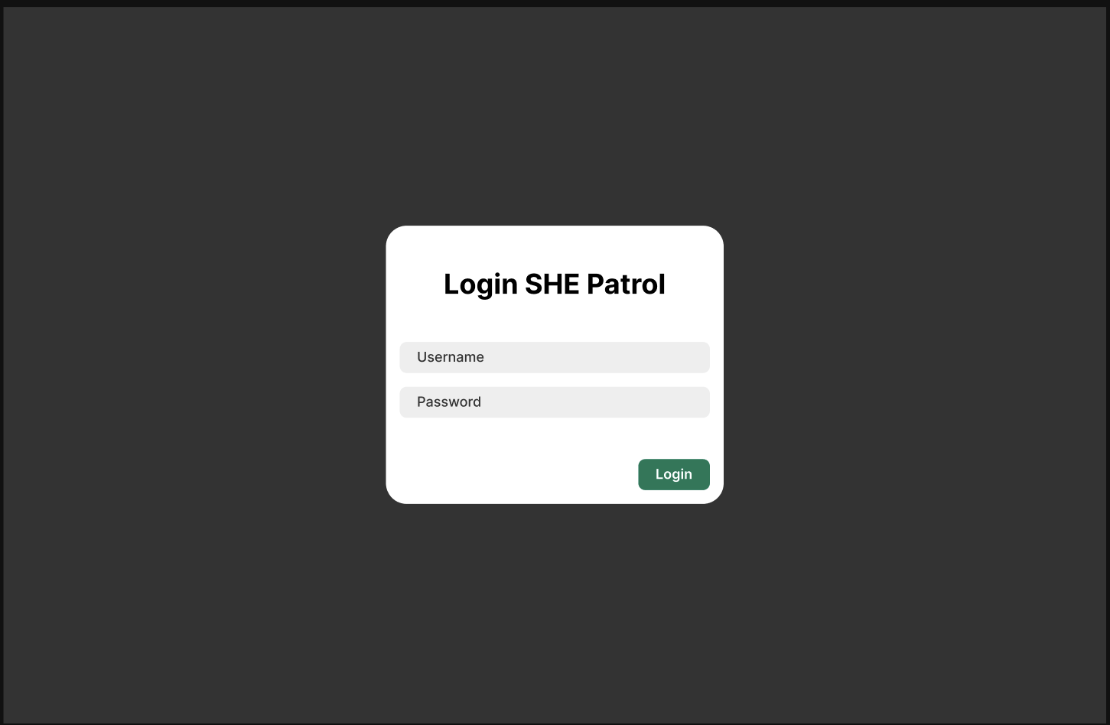

7. Release Judgment Condition

7.1 Overview
This section outlines the conditions that must be met before the application can be launched (go live).
Apps can go live when the terms & conditions below are achieved:
- Test Application: The application has undergone thorough testing, including functionality, security, and device compatibility testing.
- Stability: All bugs have been resolved and the system operates without critical issues.
- Performance Optimization: The application has functioned optimally.
- All specifications in this document are completed.
- All source code is open source.
- UAT (User Acceptance Test) has been completed and approved.

