**Garett MacGowan  
10197107  
CISC 452  
January 29, 2018**

**Intro**

For the KNIME implementation of my perceptron, I used a classification model where the class with the highest probability was predicted. This is not what I did in my python version of the perceptron. My python version shows a bias for selecting class 1, followed by class 2 and class 3. This may explain the significant performance gap between the two models (or the Dense layer defined in KNIME is more than 2 layers deep… I could not find a resource for single layer perceptron in KNIME).

**Model**

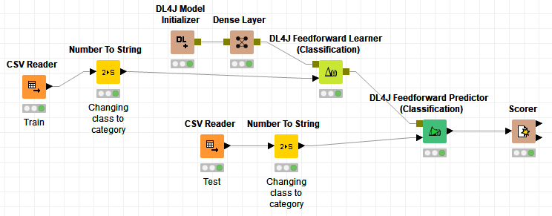

**Confusion Matrix**



**Precision and Recall**

