LABORATORY EXERCISE 9

SEARCH AND FILTERING SYSTEM

Learning Objectives
By the end of this laboratory exercise, students should be able to:
- Implement client-side search filtering using jQuery for dynamic user experience.
- Develop server-side search functionality using CodeIgniter's database queries.
- Create a responsive search interface using Bootstrap components.
- Integrate AJAX techniques to display search results without page reload.
- Understand the differences between client-side and server-side search approaches.

Prerequisite student experiences and knowledge
Before starting this exercise, students should have:
- Completed Laboratory Exercise 8 (Real-time Notifications with jQuery).
- Solid understanding of CodeIgniter's MVC architecture and database operations.
- Proficiency in writing jQuery and JavaScript code for DOM manipulation.
- Experience with AJAX requests and handling JSON responses.
- Familiarity with Bootstrap form components and grid system.
- Knowledge of SQL queries, particularly LIKE operators for search functionality.

Background
An effective search system is crucial for any Learning Management System (LMS) to help users quickly find relevant courses and content. This exercise focuses on implementing a dual-approach search system: client-side filtering for immediate feedback and server-side searching for comprehensive results. jQuery provides the tools for dynamic client-side filtering, while CodeIgniter's database class enables efficient server-side search using SQL LIKE queries. The combination creates a seamless user experience where search results update in real-time without page refreshes, enhancing the overall usability of the application.

Materials/Resources
- Personal Computer with Internet Access
- XAMPP/WAMP/LAMP server installed
- CodeIgniter Framework
- Visual Studio Code or any code editor
- Git and GitHub Account
- Web Browser (Chrome, Firefox, etc.)
Laboratory Activity
Step 1: Project Setup
- Open your existing ITE311-LASTNAME CodeIgniter project.
- Ensure your database has a courses table with sample data for testing search functionality.
- Verify that your course listing page is functional from previous exercises.

Step 2: Create Search Controller Method
- Navigate to your Course.php controller in app/Controllers/.
- Add a new method named search():
  - This method should accept GET or POST requests with a search term parameter.
  - Use CodeIgniter's Query Builder to search the courses table using LIKE queries.
  - Return the results as JSON for AJAX requests or render a view for regular requests.
- Implement the search logic
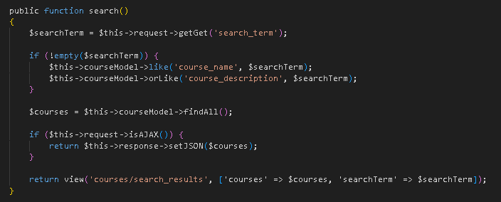

Step 3: Add Search Route
- Open app/Config/Routes.php.
- Add routes for the search functionality:
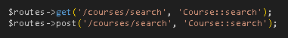

Step 4: Create Search Interface
- Modify your courses view file (app/Views/courses/index.php).
- Add a search form with Bootstrap styling
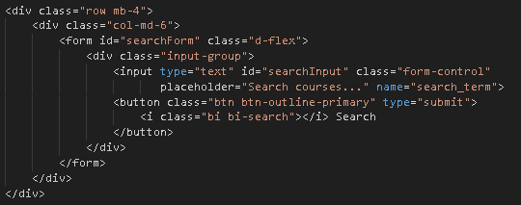

Step 5: Implement Client-Side Filtering with jQuery
- Add jQuery script for instant client-side filtering
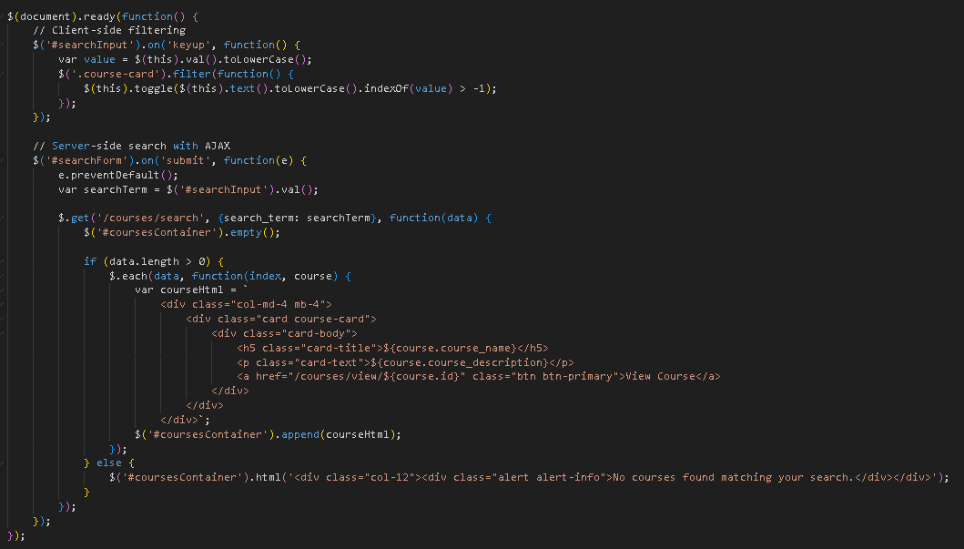

Step 6: Update Courses View Structure
- Modify your courses listing to work with the search functionality
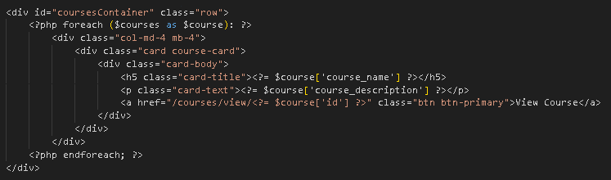
- To simulate real-time updates, you can set an interval to fetch notifications every 60 seconds (optional advanced task).

Step 7: Test the Search Functionality
- Load the courses page in your browser.
- Test the client-side filtering by typing in the search box courses should filter instantly.
- Test the server-side search by submitting the form results should load via AJAX without page refresh.
- Verify that both empty search results and successful searches display appropriate messages.

Step 9: Push to GitHub
- Stage and commit your search functionality
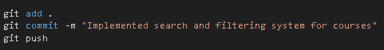

Output / Results
- Screenshot of the courses page with the search interface implemented.
- Screenshot showing filtered courses during client-side search.
- Screenshot of browser Developer Tools Network tab showing AJAX request to server-side search.
- Screenshot of search results displaying when no courses match the search term.
- Screenshot of GitHub repository with the latest commit.

QUESTIONS:
- What are the advantages and limitations of client-side filtering compared to server-side search?
Client side filtering is fast because your browser handles the filtering without a new request. This gives quick results and reduces server load. It also keeps the interaction smooth. The limitation is performance when the data set is large because your device handles all processing. It also uses more memory on your side and the results can become outdated when the data changes on the server. Server side search handles large data better and always returns fresh results but it responds slower and adds more load on the server.
- How does using AJAX for search improve the user experience compared to traditional form submission?
AJAX improves the search experience because the page stays in place. You get results without a reload so the process feels faster. Your input stays on the screen and you can continue typing while results update. You also use less data because the system fetches only the needed results instead of the whole page.

- What security considerations should be taken when implementing search functionality with user input?
Search input needs protection because users can submit harmful text. You sanitize the input to block SQL injection. You escape all output to stop XSS. You also control request limits to prevent abuse. You avoid returning sensitive fields and you validate every query on the server even when the request uses AJAX.

Output / Results
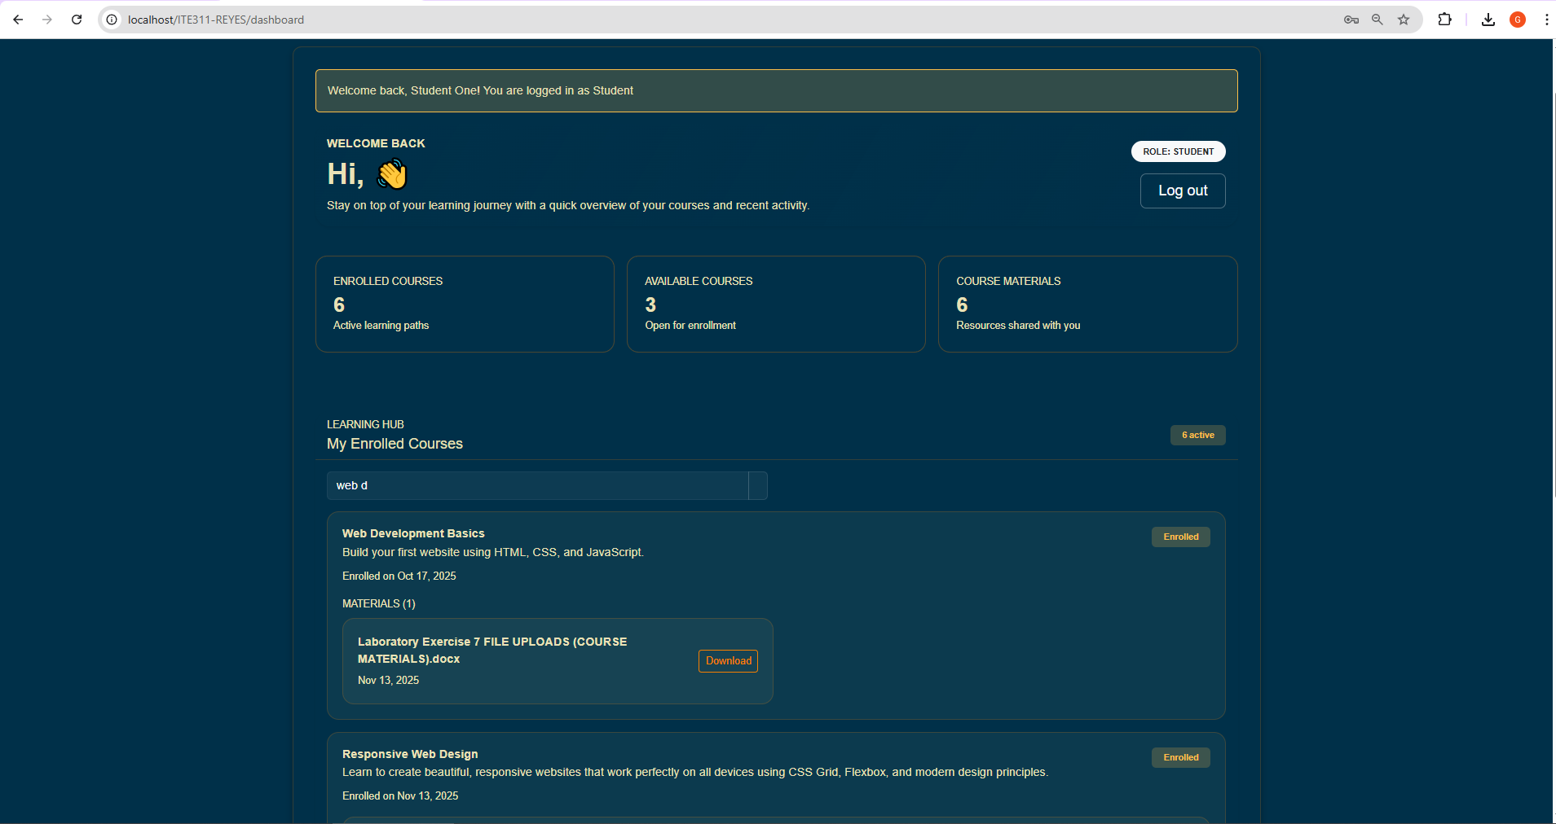
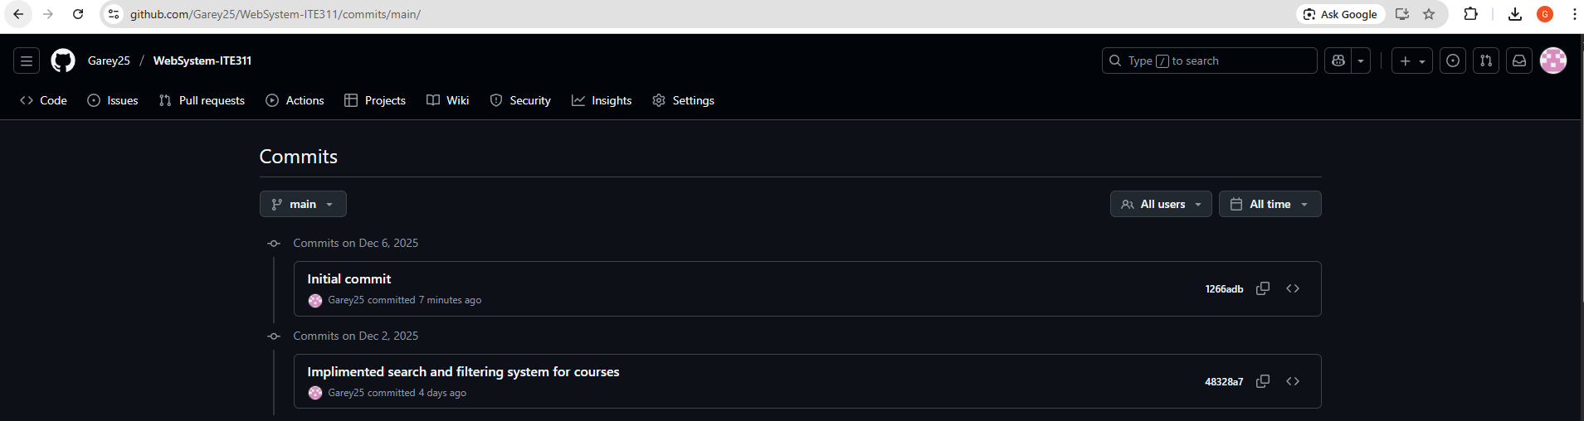
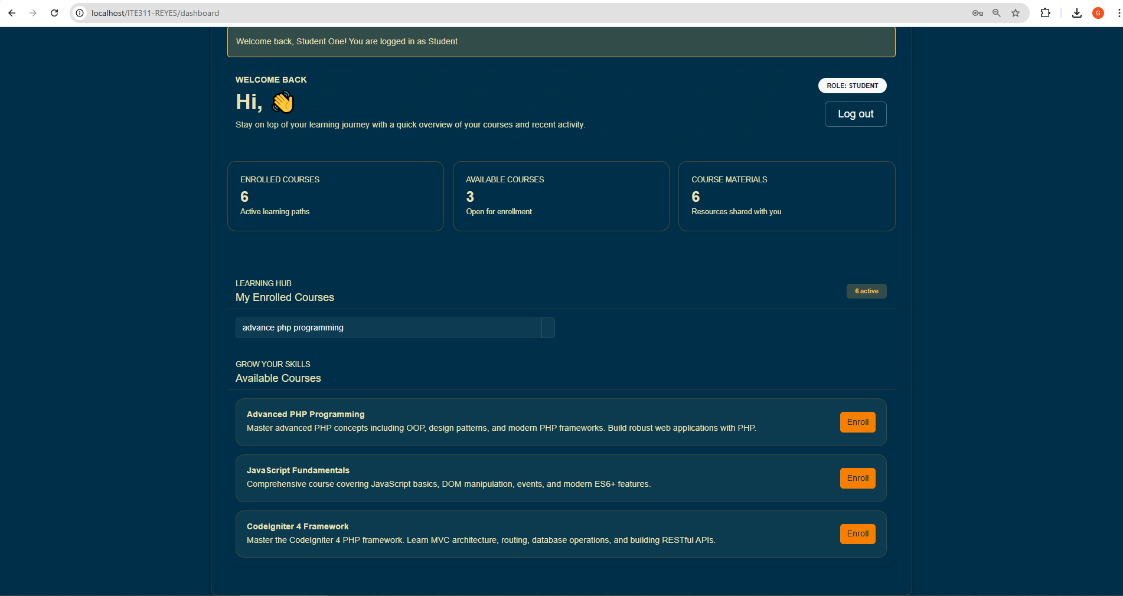

Conclusion
Client side filtering and server side search both play important roles in building a smooth search feature. Client side filtering gives fast results and reduces server load, but it becomes slow with large data and can show outdated information. Server side search handles big data well and returns fresh results, but the response time depends on the server. AJAX improves the experience because it removes page reloads and delivers faster feedback. Security stays important in every approach. You protect the system by cleaning user input, escaping output, limiting requests, and hiding sensitive fields. These steps keep the search feature responsive and safe.

