Sequential execution

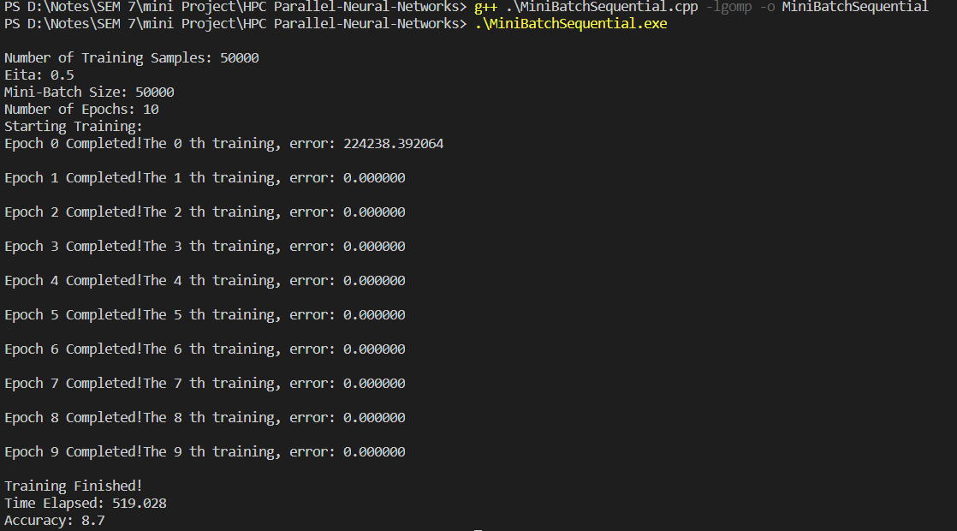

Parallel execution

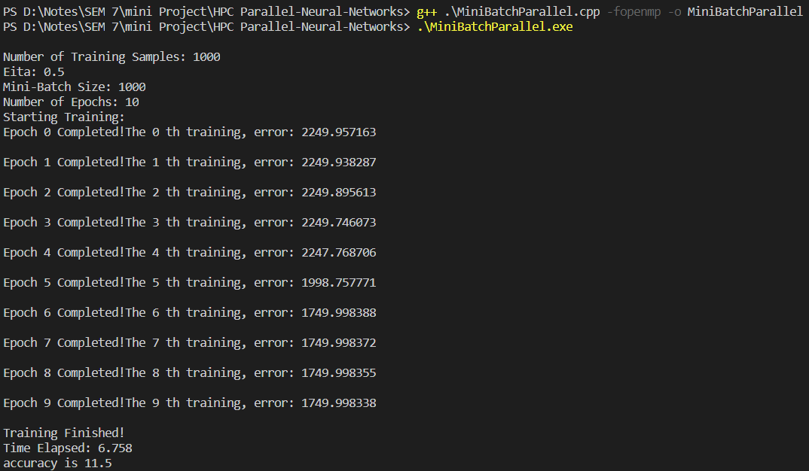

|  |  |  |  |  |  |  |  |  |
| --- | --- | --- | --- | --- | --- | --- | --- | --- |
| Train Size | Algorithm | Ittrations 1 time(sec) | Ittrations 2 time(sec) | Ittrations 5 time(sec) | Ittrations 10 time(sec) | Accuracy | | Speed Up |
| 500 | Sequential | 1.05 | 2.01 | 5.72 | 10.06 | 8.7 | 1.5x | |
| Parallel | 0.63 | 1.45 | 4.25 | 6.68 |
| 1000 | Sequential | 2.25 | 4.3 | 12.30 | 22.26 | 10.7 | 1.4x | |
| Parallel | 1.21 | 2.55 | 9.13 | 16.85 |
| 10000 | Sequential | 31.20 | 65.77 | 161.62 | 311.70 | 11.6 | 1.6x | |
| Parallel | 13.17 | 35.68 | 88.11 | 197.79 |
| 50000 | Sequential | 80.16 | 138.80 | 316.88 | 592.22 | 20.5 | 1.6x | |
| Parallel | 51.71 | 86.95 | 192.42 | 372.05 |