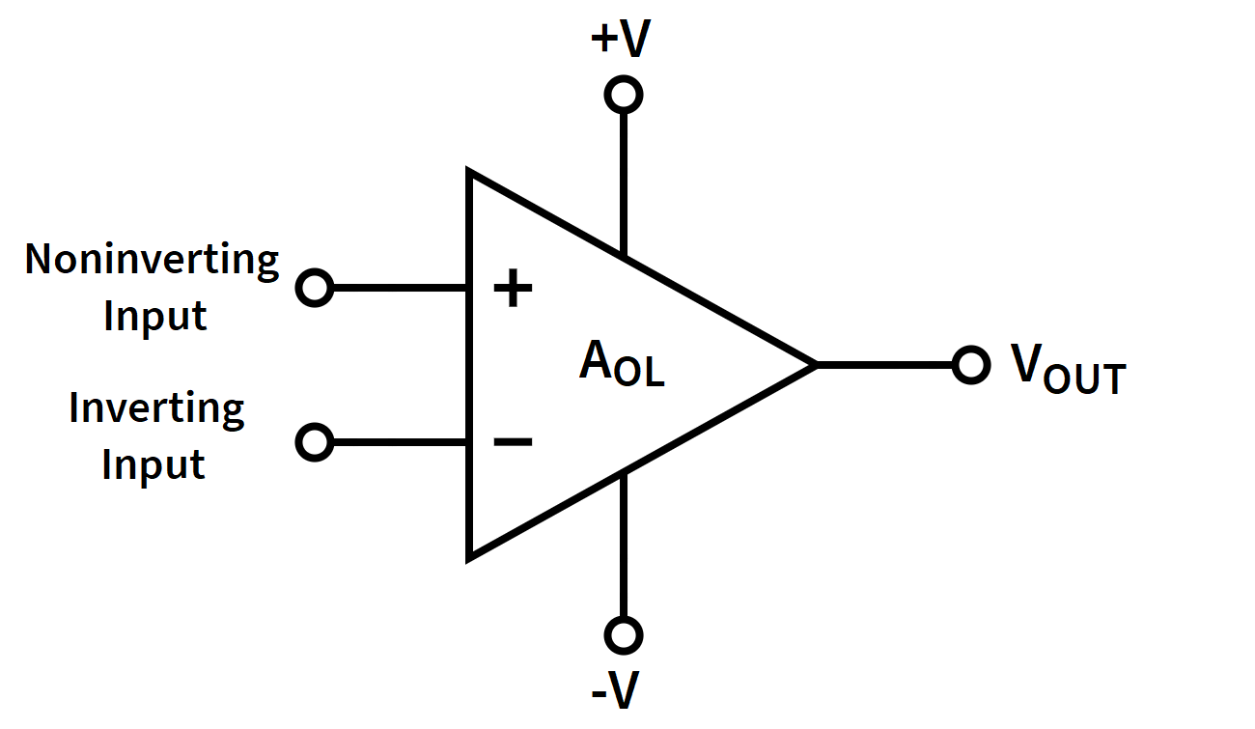

**What is an Operational Amplifier (Op-Amp)?**

An operational amplifier, often referred to as an "Op-Amp," is an electronic component that is widely used in analog electronic circuits. It is a versatile and essential building block in electronics, known for its ability to amplify, filter, and process analog signals.

**Key Characteristics of Op-Amps:**

1. High Gain: Op-Amps have very high voltage gain, typically in the range of 100,000 to 1,000,000. This means they can amplify small input signals significantly.
2. Differential Inputs: Op-Amps have two input terminals - the non-inverting (+) and inverting (-) inputs. The difference in voltage between these two inputs determines the output.
3. High Input Impedance: Op-Amps typically have very high input impedance, making them suitable for interfacing with various input sources without loading them.
4. Low Output Impedance: The output impedance of an Op-Amp is typically low, allowing it to drive loads without significant signal loss.
5. Linear Operation: Op-Amps are designed to operate linearly within their specified voltage and current ranges, making them suitable for a wide range of applications.

**Op-Amp Applications:**

1. Amplification: Op-Amps are often used to amplify weak signals, making them suitable for audio amplifiers, instrumentation amplifiers, and more.
2. Voltage Follower: In this configuration, the output voltage follows the input voltage, offering high input impedance and low output impedance.
3. Inverting and Non-Inverting Amplifiers: Op-Amps can be configured as inverting and non-inverting amplifiers to control the gain and phase of a signal.
4. Summing Amplifiers: Op-Amps can be used to sum multiple input signals, which is useful in applications like audio mixers.
5. Integrator and Differentiator: Op-Amps can be used to perform mathematical operations, such as integration and differentiation, which are useful in signal processing.
6. Active Filters: Op-Amps are employed in active filter circuits to filter specific frequencies from signals.
7. Comparators: Op-Amps can be used as comparators to compare two input voltages and provide a digital output based on the comparison result.

**Power Supply:** Op-Amps typically require dual power supplies, often labeled as +V and -V, to operate properly. Some Op-Amps can also work with a single power supply.

**Feedback:** Feedback plays a critical role in controlling the behavior of Op-Amps. Negative feedback is commonly used to stabilize and control their performance.

**Limitations:** Op-Amps have practical limitations, including bandwidth limitations, finite open-loop gain, and noise. These limitations must be considered in circuit design.

**Op-Amp Varieties:** There are various Op-Amp models available, each with specific characteristics, such as general-purpose Op-Amps, high-speed Op-Amps, low-power Op-Amps, and more.

**Common Op-Amp Types:** There are numerous Op-Amp models available, each designed for specific applications. Some common types include:

1. General-Purpose Op-Amps: These are versatile and used in a wide range of applications.
2. High-Speed Op-Amps: Designed for applications requiring fast signal processing.
3. Low-Noise Op-Amps: Used in applications where noise is a critical factor, such as audio amplification.
4. Low-Power Op-Amps: Ideal for battery-operated devices, as they consume minimal power.
5. Rail-to-Rail Op-Amps: These can operate with input and output voltages that cover the entire supply voltage range.