OLA
Data Analyst Project Report
Bengaluru City · July 2024 · End-to-End Analytics

TOOLS USED
🐍 Python | 🗄️ MySQL | 📊 Power BI

KEY METRICS SNAPSHOT
Total Bookings | 103,024
Successful Bookings | 63,967 (62.09%)
Cancelled Bookings | 84,590
Total Booking Value | ₹35 Million
Date Range | 01-07-2024 to 31-07-2024
City | Bengaluru, India

01 · PROJECT OVERVIEW
This end-to-end Data Analyst project simulates a real-world analytics workflow for OLA, India's leading ride-hailing platform. The dataset covers one full month of ride operations in Bengaluru with 1,00,000+ rows spanning all booking statuses, vehicle types, payment modes, cancellation reasons, and ratings.

▌ Project Pipeline
STEP 1  Data Generation  ChatGPT prompt → 1L row CSV dataset | STEP 2  Data Cleaning  Python (Pandas) in Jupyter Notebook | STEP 3  EDA & SQL Analysis  MySQL — 10 key business queries
STEP 4  Dashboard — Power BI  5 pages: Overall, Vehicle, Revenue, Cancellation, Ratings | STEP 5  Insight Extraction  Business questions answered from visuals | STEP 6  Documentation  This project report

▌ Dataset Specifications
Total Rows | ~1,00,000 (1 Lakh)
Time Period | July 2024 (1 Month)
City | Bengaluru — 50 pickup/drop locations
Vehicle Types | 7 (Prime Sedan, Prime SUV, Prime Plus, Mini, Auto, Bike, E-Bike)
Booking Status Split | Success 62% | Driver Cancel 18% | Customer Cancel 7%
Payment Methods | Cash, UPI, Credit Card, Debit Card
Incomplete Rides | < 6%

02 · DATA CLEANING (Python / Pandas)
The raw CSV dataset was cleaned and preprocessed using Python in a Jupyter Notebook. Below are the key data cleaning operations performed:

Cleaning Operations Performed

- ● Removed duplicate Booking IDs
- ● Handled null values in Driver_Ratings and Customer_Rating (only for successful rides)
- ● Standardized date/time formats to YYYY-MM-DD and HH:MM:SS
- ● Validated Booking_Status values against expected categories
- ● Filled cancellation reason columns with 'N/A' for non-cancelled rides
- ● Ensured Incomplete_Rides_Reason is blank when Incomplete_Rides = 'No'
- ● Converted Booking_Value and Ride_Distance to numeric types
- ● Cross-validated cancellation rates against defined thresholds (customer < 7%, driver < 18%)

Python Snippet — Data Quality Check

import pandas as pd

df = pd.read_csv('Data_SET_OLA.csv')

# Check nulls
print(df.isnull().sum())

# Validate booking status categories
print(df['Booking_Status'].value_counts())

# Cancellation rate check
cust_cancel = (df['Booking_Status']=='Cancelled by Customer').mean()
drv_cancel = (df['Booking_Status']=='Cancelled by Driver').mean()
print(f'Customer cancel rate: {cust_cancel:.2%}')
print(f'Driver cancel rate: {drv_cancel:.2%}')

03 · SQL EXPLORATORY DATA ANALYSIS
10 business questions were answered using MySQL. All queries were saved as views for efficient re-use in the Power BI dashboard.

Q1. Retrieve all successful bookings
SELECT * FROM bookings
WHERE Booking_Status = 'Success';

Q2. Find the average ride distance for each vehicle type
SELECT Vehicle_Type, AVG(Ride_Distance) AS avg_distance
FROM bookings
GROUP BY Vehicle_Type;

Q3. Get the total number of cancelled rides by customers
SELECT COUNT(*) AS total_customer_cancels
FROM bookings
WHERE Booking_Status = 'Cancelled by Customer';

Q4. Top 5 customers who booked the highest number of rides
SELECT Customer_ID, COUNT(Booking_ID) AS total_rides
FROM bookings
GROUP BY Customer_ID
ORDER BY total_rides DESC
LIMIT 5;

Q5. Rides cancelled by drivers due to personal & car-related issues
SELECT COUNT(*) AS personal_car_cancels
FROM bookings
WHERE Cancelled_Rides_by_Driver = 'Personal & Car related issue';

Q6. Max and min driver ratings for Prime Sedan
SELECT MAX(Driver_Ratings) AS max_rating,
MIN(Driver_Ratings) AS min_rating
FROM bookings
WHERE Vehicle_Type = 'Prime Sedan';

Q7. All rides where payment was made via UPI
SELECT COUNT(*) AS upi_rides
FROM bookings
WHERE Payment_Method = 'UPI';

Q8. Average customer rating per vehicle type
SELECT Vehicle_Type, AVG(Customer_Rating) AS avg_customer_rating
FROM bookings
GROUP BY Vehicle_Type;

Q9. Total booking value of successfully completed rides
SELECT SUM(Booking_Value) AS total_successful_value
FROM bookings
WHERE Booking_Status = 'Success';

Q10. List all incomplete rides with reason
SELECT Booking_ID, Incomplete_Rides_Reason
FROM bookings
WHERE Incomplete_Rides = 'Yes';

04 · POWER BI DASHBOARD
The Power BI report is structured into 5 dedicated pages, each targeting a specific analytical domain. Below are screenshots from each page with commentary.

▌ Page 1 — Overall
High-level KPIs: Total Bookings (103,024), Total Booking Value (₹35M), Booking Status Breakdown pie chart, and Ride Volume Over Time trend line.
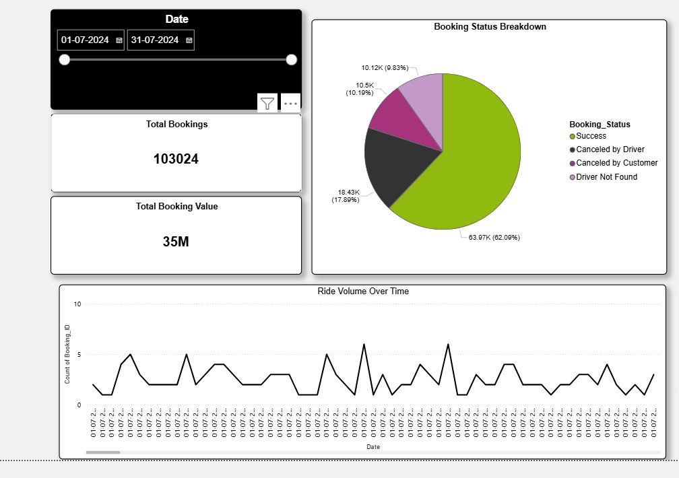
Figure 1: Overall Dashboard — Booking Status Breakdown & Ride Volume Over Time
▌ Page 2 — Vehicle Type
Comparative performance of all 7 vehicle types across Total Booking Value, Successful Booking Value, Avg. Distance Travelled, and Total Distance Travelled.
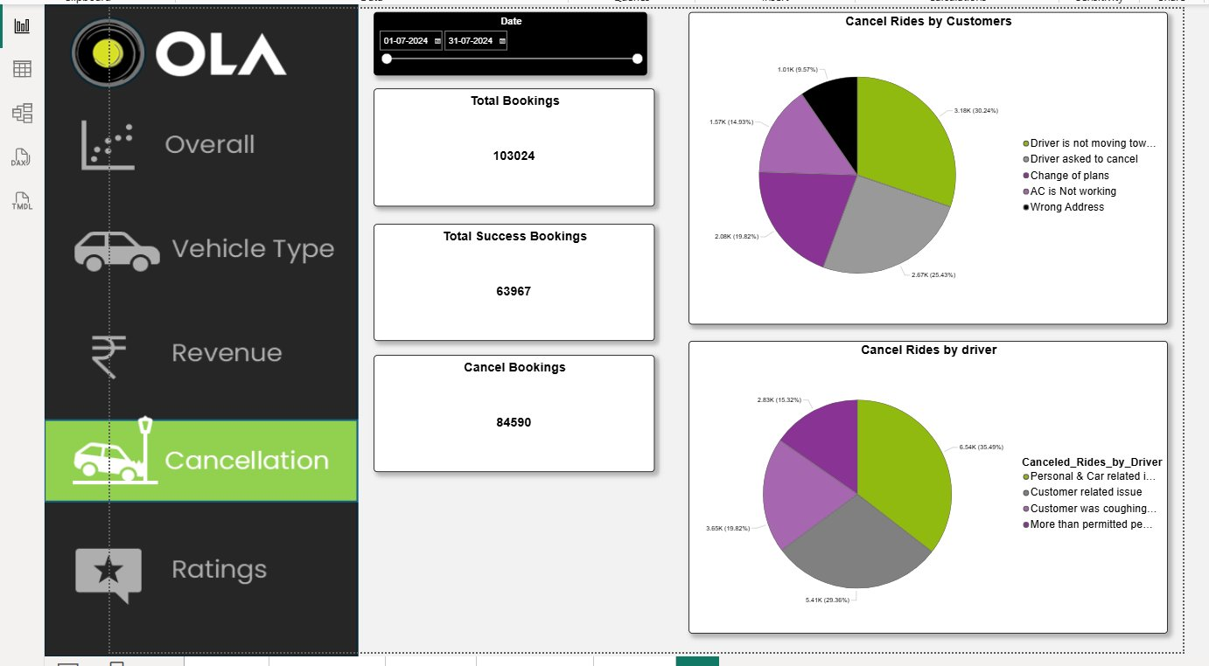
Figure 2: Vehicle Type Page — Performance comparison table
▌ Page 3 — Revenue
Revenue by Payment Method (Cash dominates at ~₹20M, followed by UPI at ~₹14M), Top 5 Customers by Booking Value, and Ride Distance Distribution per day across July.
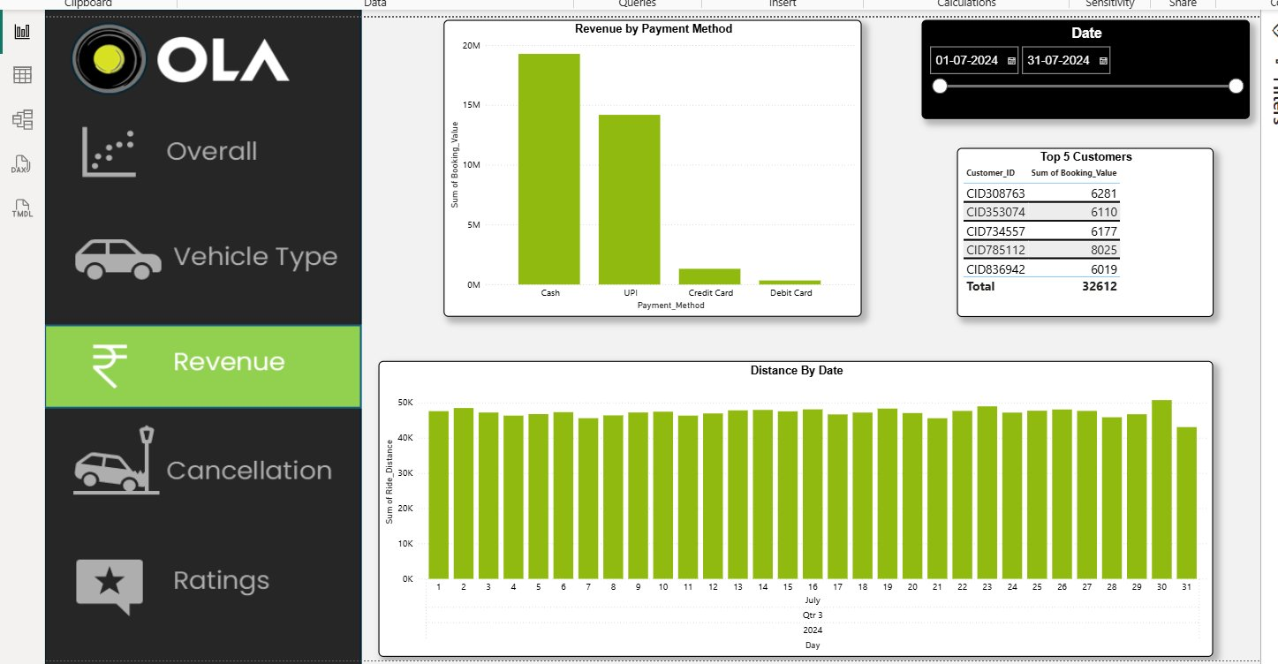
Figure 3: Revenue Page — Payment methods and distance trends
▌ Page 4 — Cancellation
Cancel Bookings: 84,590 total. Two pie charts show reasons for customer cancellations (top: 'Driver not moving' 30.24%) and driver cancellations (top: 'Personal & Car related issue' 35.49%).
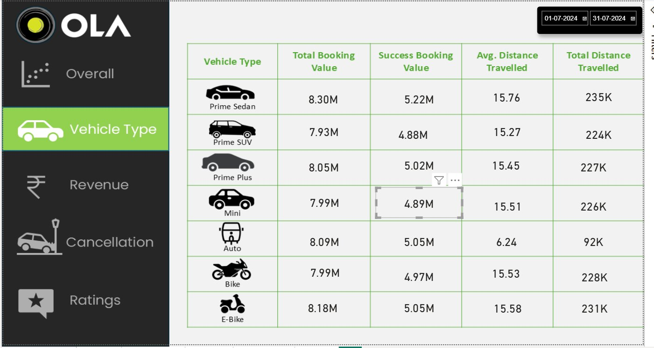
Figure 4: Cancellation Page — Reason breakdowns for customer and driver cancels
▌ Page 5 — Ratings
Driver and Customer ratings shown per vehicle type. Ratings are consistently near 4.00 across all categories indicating a well-balanced service quality.
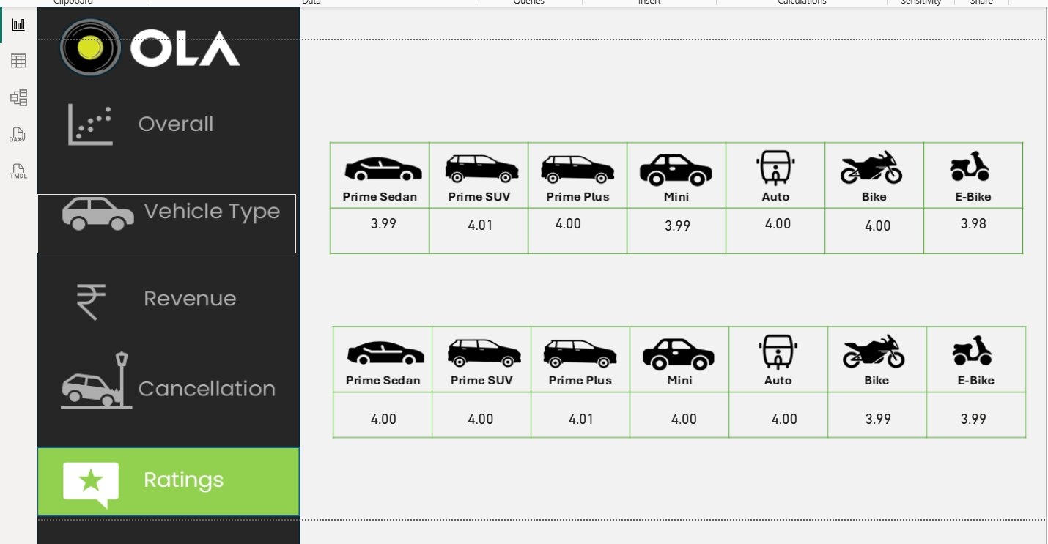
Figure 5: Ratings Page — Driver and Customer ratings by vehicle type

05 · VEHICLE TYPE ANALYSIS

Vehicle Type | Total Booking Value | Success Booking Value | Avg. Distance | Total Distance
Prime Sedan | ₹8.30M | ₹5.22M | 15.76 km | 235K km
Prime SUV | ₹7.93M | ₹4.88M | 15.27 km | 224K km
Prime Plus | ₹8.05M | ₹5.02M | 15.45 km | 227K km
Mini | ₹7.99M | ₹4.89M | 15.51 km | 226K km
Auto | ₹8.09M | ₹5.05M | 6.24 km | 92K km
Bike | ₹7.99M | ₹4.97M | 15.53 km | 228K km
E-Bike | ₹8.18M | ₹5.05M | 15.58 km | 231K km

▌ Key Observations
- ● Prime Sedan leads in average ride distance at 15.76 km, indicating long-haul preference.
- ● Auto has the shortest average distance (6.24 km), typical for short intra-city trips.
- ● E-Bike has the highest Total Booking Value at ₹8.18M, showing strong eco-vehicle demand.
- ● All premium vehicles (Sedan, SUV, Plus) maintain consistent success booking values around ₹5M.

06 · RATINGS ANALYSIS

Vehicle Type | Driver Rating | Customer Rating
Prime Sedan | 3.99 | 4.00
Prime SUV | 4.01 | 4.00
Prime Plus | 4.00 | 4.01
Mini | 3.99 | 4.00
Auto | 4.00 | 4.00
Bike | 4.00 | 3.99
E-Bike | 3.98 | 3.99

▌ Key Observations
- ● All vehicle types maintain driver and customer ratings tightly clustered between 3.98 – 4.01.
- ● Prime Plus leads customer ratings at 4.01, reflecting superior ride comfort.
- ● E-Bike and Bike show the lowest driver ratings (3.98–3.99), suggesting room for improvement.
- ● High consistency in ratings signals a well-controlled service quality across OLA's fleet.

07 · CANCELLATION ANALYSIS

Total Cancellations | 84,590
Cancelled by Customer | ~10,500 (10.19%)
Cancelled by Driver | ~18,430 (17.89%)
Driver Not Found | ~10,120 (9.83%)

Top Customer Cancellation Reasons
Driver not moving towards pickup | 30.24% — highest
Change of plans | 25.43%
AC is not working | 19.82%
Driver asked to cancel | 14.93%
Wrong Address | 9.57%

Top Driver Cancellation Reasons
Personal & Car related issues | 35.49% — highest
Customer related issue | 29.36%
Customer was coughing/sick | 19.82%
More than permitted passengers | 15.32%

08 · REVENUE ANALYSIS

Total Revenue (All Bookings) | ₹35 Million
Revenue — Successful Rides | Highest contribution
Top Payment Method | Cash (~₹20M)
2nd Payment Method | UPI (~₹14M)
Top Customer (CID785112) | ₹8,025
Top 5 Customers Combined | ₹32,612
Consistent Daily Distance | ~43K – 50K km/day

▌ Revenue Insights
- ● Cash remains the dominant payment method, suggesting many riders prefer offline payments.
- ● UPI has strong traction at ~40% of cash volume — digital payment adoption is growing.
- ● Ride distances are highly consistent throughout July, indicating stable operational demand.
- ● The top 5 customers account for only ₹32K out of ₹35M — revenue is well-distributed.

09 · CONCLUSIONS & RECOMMENDATIONS

Business Conclusions
- ● 62% booking success rate is a solid operational baseline, but the 38% failure gap presents a major improvement opportunity.
- ● Driver cancellations (17.89%) are the single largest leakage point — reducing personal/car issues through vehicle maintenance programs could yield significant revenue gains.
- ● The 'driver not moving towards pickup' reason (30.24% of customer cancels) points to GPS or incentive alignment issues.
- ● Auto vehicles serve a distinct short-distance market (6.24 km avg.) — pricing and promotions should be calibrated differently from premium vehicles.
- ● Ratings near 4.0 across the board indicate consistent service quality, which is a strong trust signal.

Analyst Recommendations
- ● Implement driver location nudges and penalties for early-stage non-movement cancellations.
- ● Introduce cashless incentive programs to shift more payments to UPI/Cards, reducing cash handling risk.
- ● Use weekday/weekend demand data to introduce dynamic pricing models and driver surge bonuses.
- ● Create a dedicated Auto micro-segment analytics track given its distinct usage patterns.
- ● Set up real-time cancellation reason dashboards for operations teams to act within the same day.

OLA Data Analyst Project · Top Varsity · July 2024 · Bengaluru

