**ALT_24**

**Team Members:**

1. **Adit Shah**
2. **Dhruv Bhaip**
3. **Gargeya Parab**
4. **Isha Diwale**
5. **Soham Lotlikar**
6. **Suman Swain**

**Schematic File:**

**Printable Circuit Board File:**

**Schematic:**

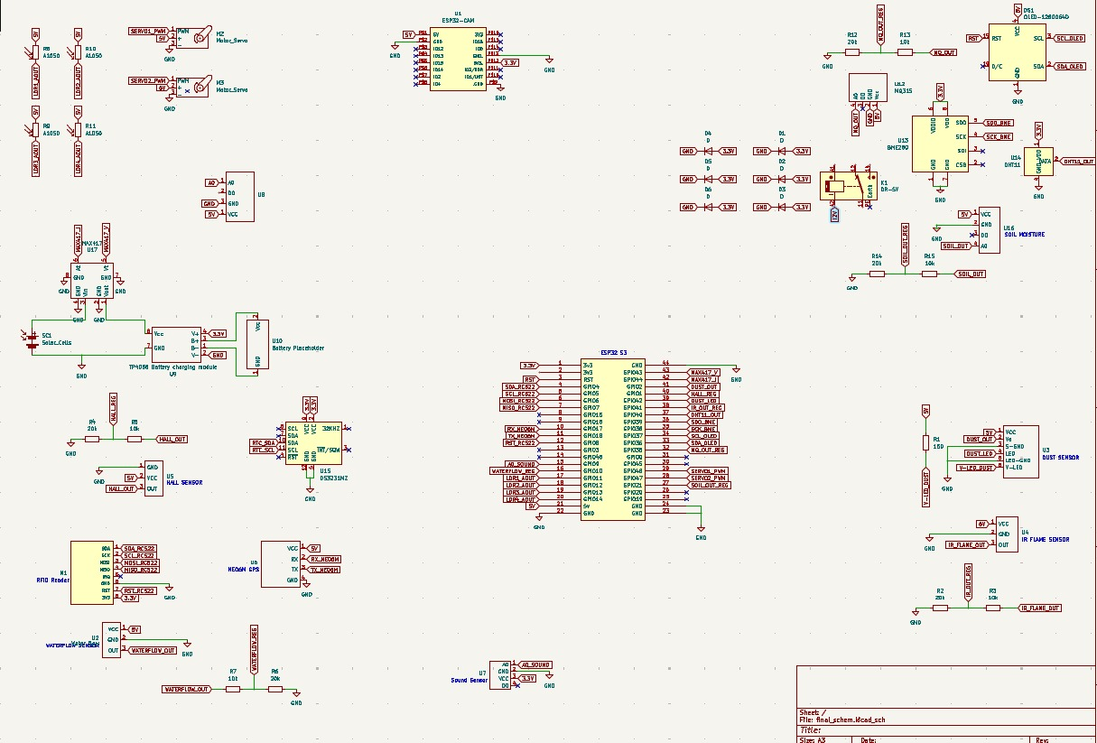

**Front Copper Layer:**

**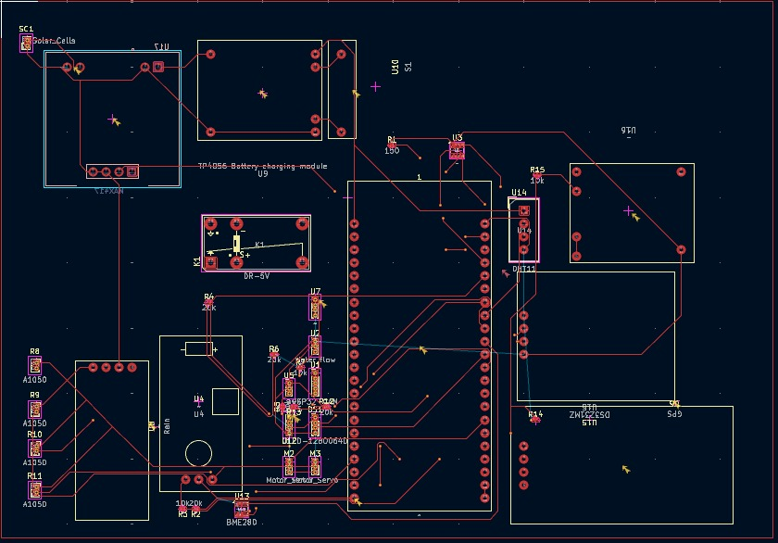  
 Back Copper Layer:**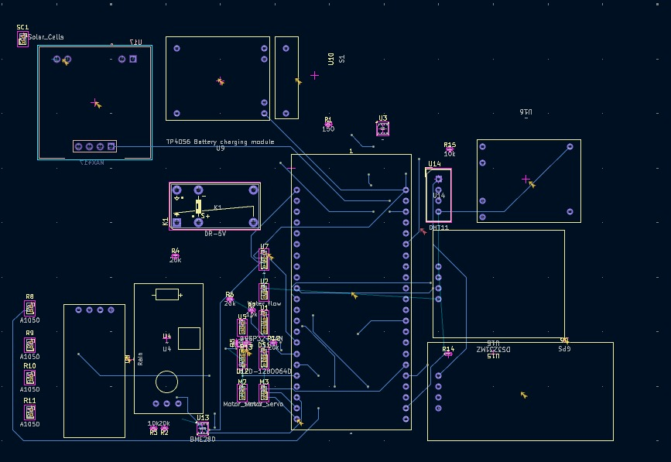

**3D/Rendered Image:**

**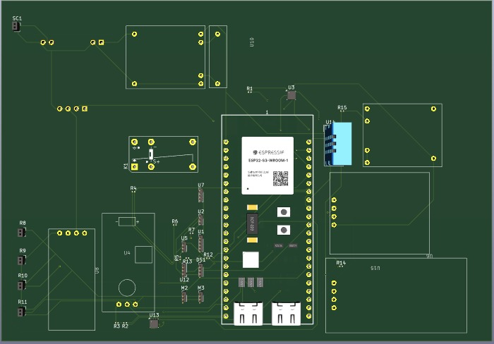  
  
DRC Check:**

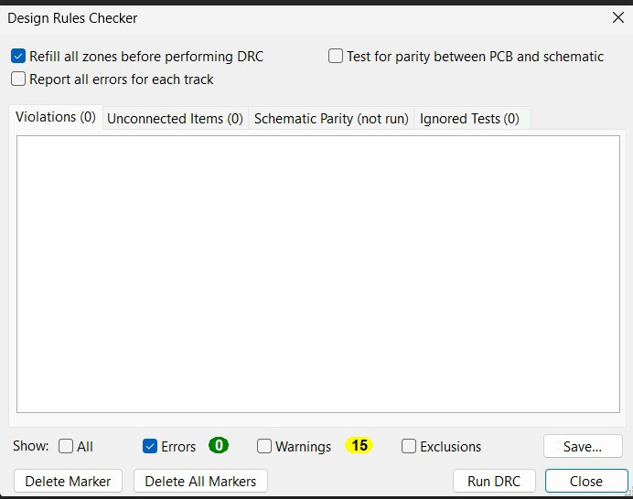

**ERC Check:**

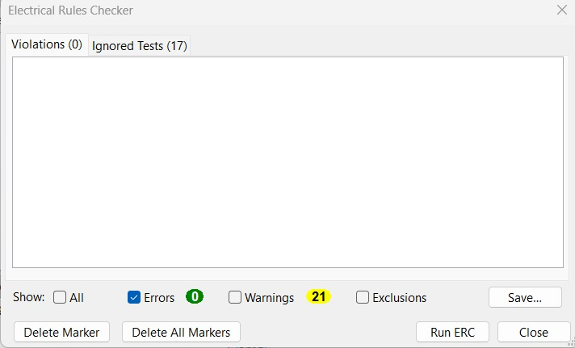

**CAD File:**

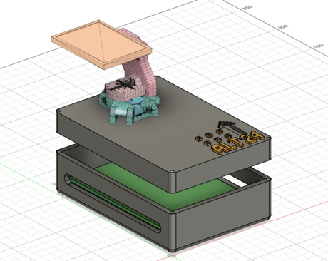

**This CAD design showcases a solar panel pan-tilt mechanism that dynamically tracks the sun for optimal energy absorption. It uses two servo motors to control horizontal (pan) and vertical (tilt) movement. The top section securely holds the solar panel, while the lower enclosure houses the PCB and electronics. The design ensures efficient solar tracking, making it ideal for automation and renewable energy applications.**

**Front View**

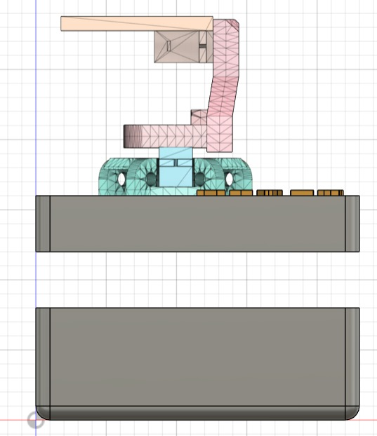

**Top View**

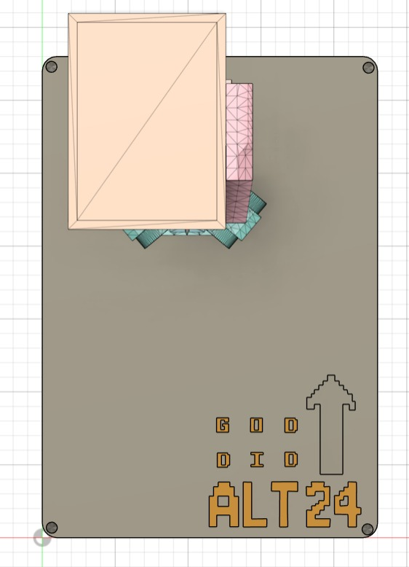

**Side View**

