**Experiments -2 Design of Logo using GIMP.**

**Step – 1:**

Open GIMP, go to file->new file-> choose 1080x1080 size screen with white as background.

**Step – 2:**

Open GIMP, and go to file->Open As Layers-> And open the picture/drawing as a layer.

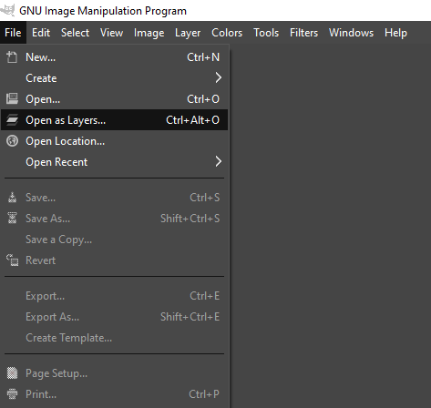

**Step – 3:**

Now choose free select tool from toolbar, and start selecting the border/boundaries of the picture.

**Step – 4:**

After selecting all the boundaries, connect the last point with the first one and cur that portion from that image using CTRL+X.

**Step – 5:**

Paste this image on the white background layer from the Layers column.

**Step – 6:**

Select Paintbrush tool from the toolbar and a colour from colour palette,

**Step – 7:**

Start drawing the boundaries of the letter with steady hand, so that you could get a layer like this.

**Step – 8:**

Now select the Bucket fill tool from toolbar and modify it’s setting according to your creativity.

**Step – 9:**

Repeat Step 2 and add another image.

**Step – 10:**

To add Text to your image select Text Tool from toolbar.

**Step – 11:**

Save the output and export it as png.