

**UNIVERSITY OF PETROLEUM & ENERGY STUDIES**

**SCHOOL OF COMPUTER SCIENCE**

***Department of Cybernetics***

**GRAPHICS AND ANIMATIONS TOOLS**

**VIVA ASSIGNMENT**

SESSION (2020-21)

Course: B.Tech with specialization in Open Source & Open Standards

Submitted to: Submitted by:

Dr. Durgansh Sharma Gargi Jaiswal

Associate Professor SAP: 500062353

Department of Cybernetics Roll no: R100217024

**Aim:** Create a hand sanitizer spray bottle using blender

**Step 1.** Open your Blender and create a new file, now delete the default cube.

**Step 2.** Now use Shift+A to open the mesh and from there select circle shape,

**Step 3.** Open the new and then scale it with S and duplicate it just above the first circle.

**Step 4.** Loft the circle using Z and move it upwards to give it thickness. Now scale it out to make the bottom part of the Bottle.

**Step 5.** Select all the circle and convert them to mesh using loop tool.

**Step 6**. Take a point on the bottom and extrude it outwards to fill the bottom.

**Step 7.** Press F to fill up the empty parts.

**Step 8.** Choose another circle from the mesh, now from the Ortho-view. Set it just aligned to the bottom

**Step 9.** To make the nozzle of the rocket use another circle and loft it to a certain thickness and then add one more circle on it.

**Step 10.** Select and add new material and now add colors to the Spray bottle.

**Step 11**. Add a camera and light.

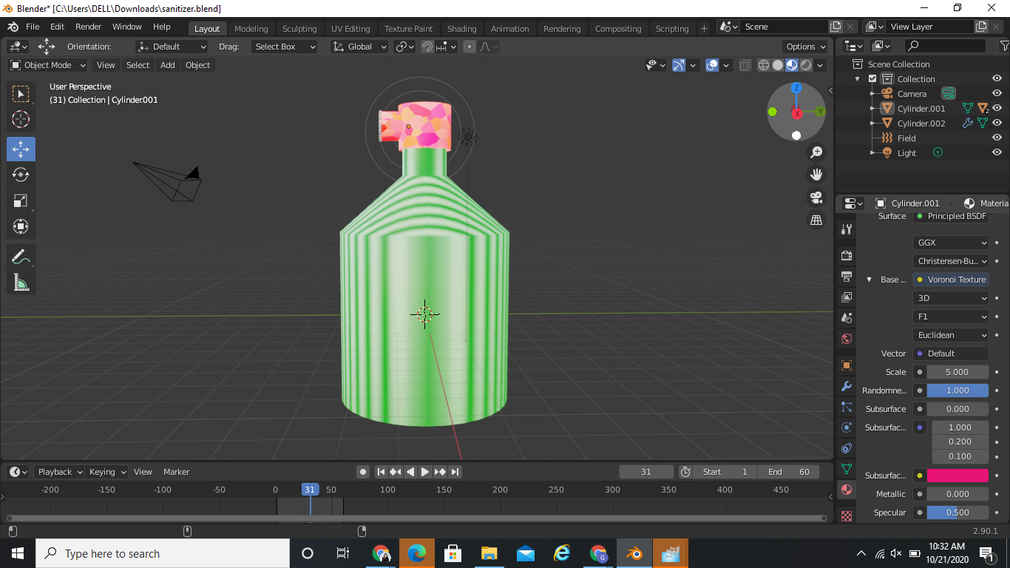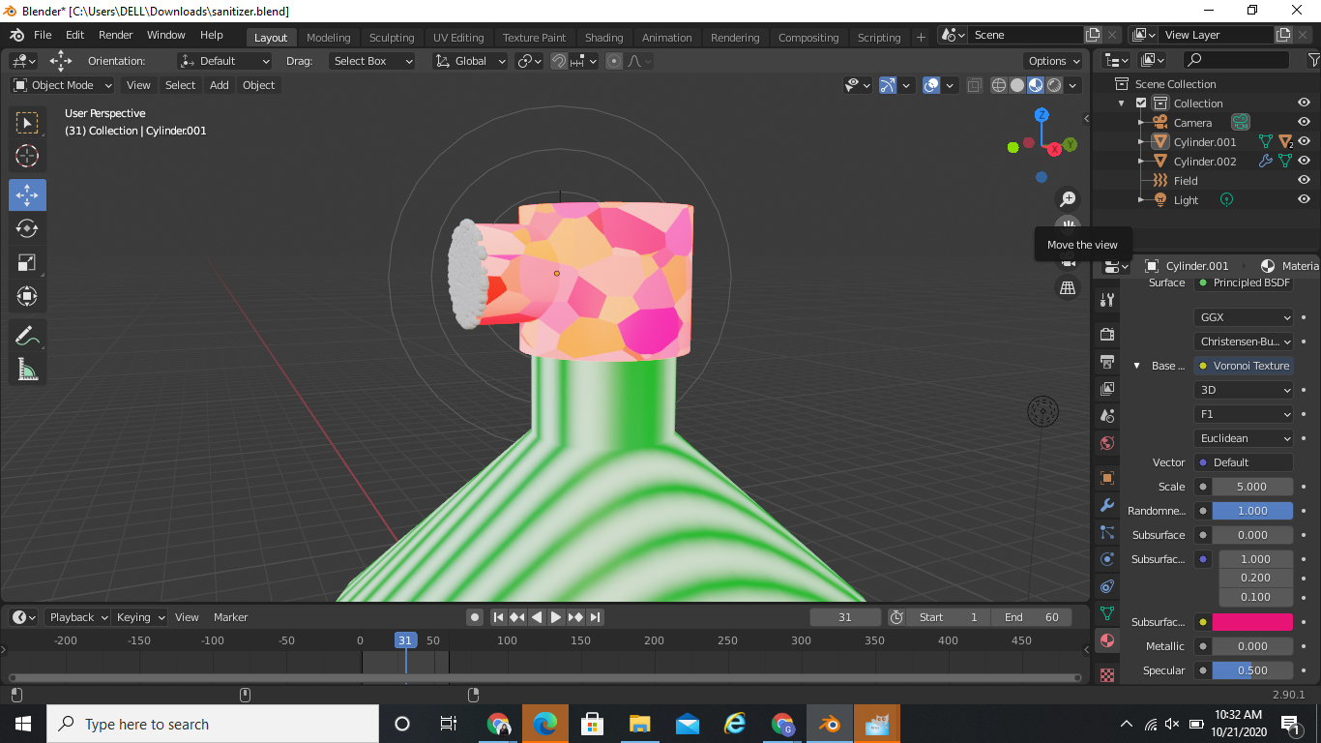

**AIM:** Create a logo of any water bottle of any brand using GIMP.

**Step1:** Open GIMP, go to File→ New file→ choose 1080x1080 size screen (keep the background white).

**Step2:** Go to Image→ Guides→ New Guides by %→ and choose the 50% horizontal guide and 50% vertical guide.

**Step3:** Now choose the Ellipse tool from toolbar, and start drawing a circle at the quadrant of your choice. Use Ctrl + Shift to position it at the center.

**Step4:** Go to select→ none.

**Step5:** Go to path→ make the selection visible→ now, add it to the text.

**Step6:** Right-click on the text layer, choose text along path→ go to path and add a new layer to it.

**Step7:** Go to Path, Text1→ Transparent, Fill the path→ solid color→ delete text1 path.

**Step8:** Now for Text2, click on Toolbar→ Flip tool→ Transform row→ Direction Flipping.

**Step9:** Now go to the Text layer→ right-click on Text-2→ Text along path→ Adjust the position of 2nd text by rotate tool under the toolbar box.

**Step10:** Add new layer from Text2, select that Layer→ Go to the path→ Right click on it, select text along path. Select Fill with solid color option.

**Step11:** Go to File and open the Google logo as layer and place it in the center and make other layers invisible using the eye sign on the right of the layers/selections.

**Step12:** Save the output and export it at another location using .XCF extension.

**SNAPSHOT:**