**Steps:**

1. **Setup the Kubernetes Cluster:**

1. **Create dashboard-adminuser.yaml and cluster_role_binding.yaml:**

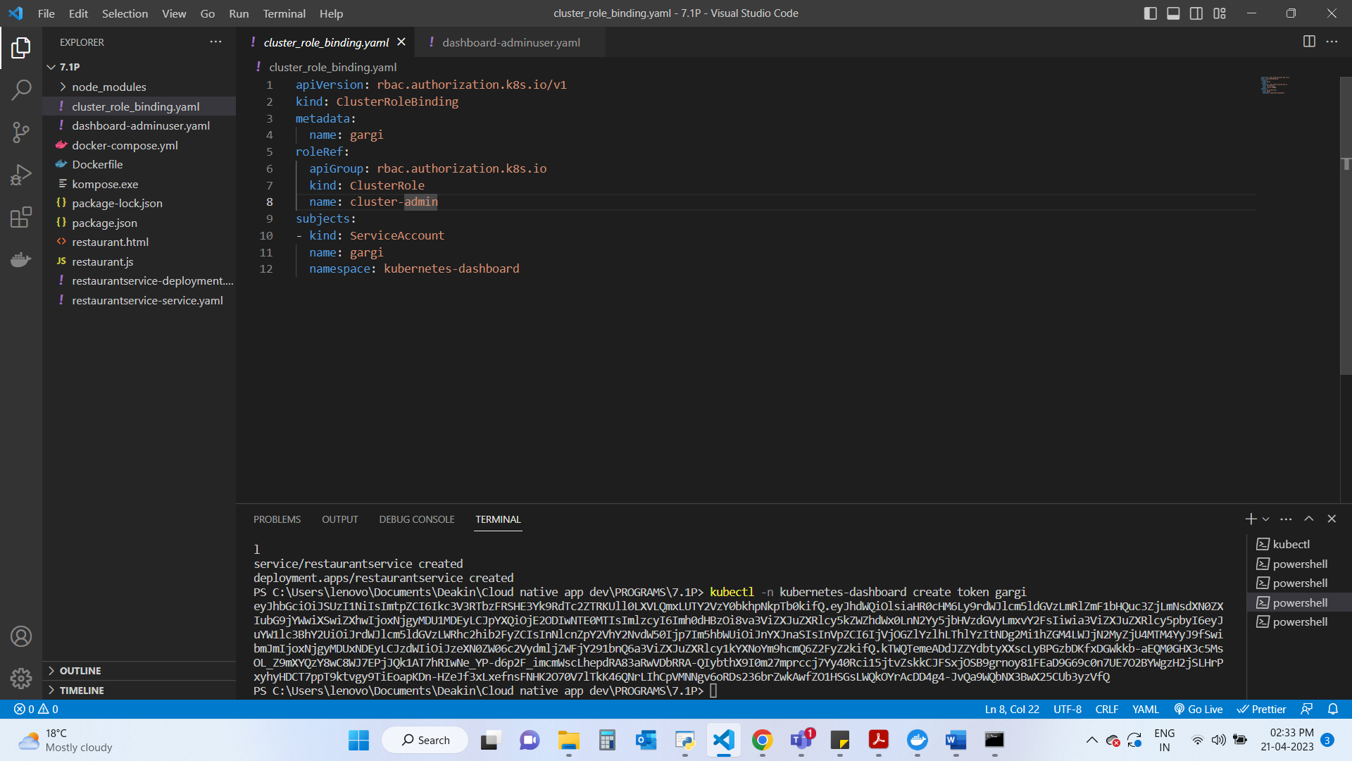

1. **Create docker image:**

1. **Start the Dashboard with command:​**

kubectl proxy​

1. **Generate token for logging in to the dashboard using:**

1. **Create the Kubernetes Deployment and service files:**

To generate the yaml files I have used Kompose as follows…

This will convert the docker-compose.yml to Kubernetes service and deployment files.

1. **Upload these files using following command:**

PS C:\Users\lenovo\Documents\Deakin\Cloud native app dev\PROGRAMS\7.1P> kubectl apply -f restaurantservice-service.yaml,restaurantservice-deployment.yaml

1. **Successfully deployed application “restaurantservice” running on the Kubernetes cluster:**



